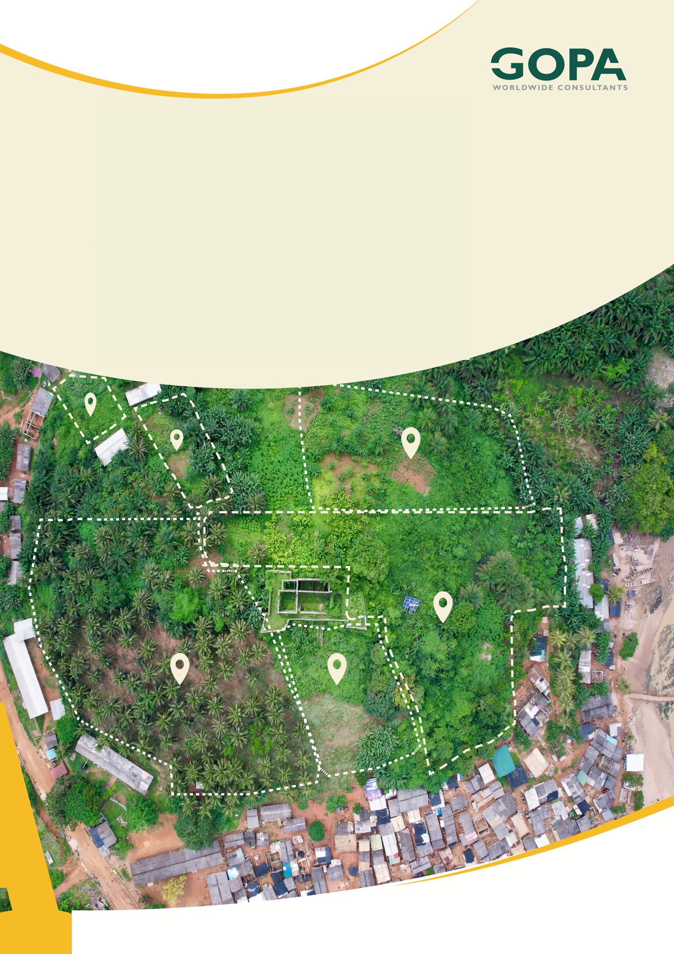
GHANA
Development of a Spatial Planning and Management Information System for Ghana
LUPMIS2 Training — Topic 5 Exercises
Drawing and editing tools with ol-ext · self-paced · September 2026

Topic 5 — Drawing and editing tools with ol-ext
Self-paced exercises for Training Plan section 6.5 · LUPMIS2 capacity building for LUSPA

1. How to use these exercises
Section 6.5 sets four learning outcomes and one hands-on task: reproduce and fix a realistic editing defect in a training branch — an operation that cannot be undone in a single step. Exercises 1 to 5 take the drawing rail apart on the real application; exercise 6 is the task itself, and the defect in it is a real one that was found and fixed in LUPMIS2. Each exercise has a goal, numbered steps and Check yourself questions; the answers, with the full fix for exercise 6, are in section 5.
Exercise | Learning outcome (Training Plan 6.5) | Time
1 The rail, and what is behind it | Configure the EditBar and its interactions | 60 min
2 Draw, modify, transform | The drawing and modifying interactions | 75 min
3 Selecting one thing, or several | Single, multiple and box selection | 75 min
4 Undo, redo and blocks | How undo works, and why blocks matter | 75 min
5 Three faults, and how to find them | Diagnose geometry not saving, undo misbehaving | 60 min
6 A change that will not undo | The hands-on task | 3 hours

About eight hours in total, inside the four days the Training Plan gives the topic.
Work on a branch. Exercises 1, 5 and 6 change files. Start a branch before you touch anything (git switch -c topic5-practice, Topic 2), and you can always get back with git switch main. Exercises 2, 3 and 4 only read the code and experiment in the Console, where nothing survives a reload.

2. Before you start
1. Finish Topic 4. These exercises assume you know what a layer, a source and a feature are, and that you are comfortable in the Console.
2. Start the development server in your clone (npm run dev) and open the application.
3. Two pieces of vocabulary, because ol-ext uses them everywhere. An interaction is a piece of code that turns mouse and touch events into changes on the map — Draw, Modify, Select and Transform are all interactions. A control is something visible you press. The EditBar is a control that switches interactions on and off; the drawing itself is always done by an interaction.
4. ol-ext is a separate library from OpenLayers. Its source is in node_modules/ol-ext/, it is readable, and exercises 4 and 6 ask you to read it. Reading the library rather than guessing at it is the point of the topic.

3. Exercises

Exercise 1 — The rail, and what is behind it
Outcome: configure the EditBar and the drawing, modifying and transform interactions · About 60 minutes
Goal. Open the drawing rail, name every button on it, and find in the code what put each one there.
1. Open the application and press the Draw / Edit Features button in the bottom dock (dock-btn-draw). The rail appears on the left of the map.
2. Hover over every button and write down its tooltip. Note the four grey labels — DRAW, EDIT, SHAPE, FILE — and note that one group, EDIT, shows a small floating panel beside it with further buttons in it.
3. Open src/components/MapView.js and find initEditBar(). Read the new EditBar({ source, interactions: { … } }) call and compare that list with the rail.
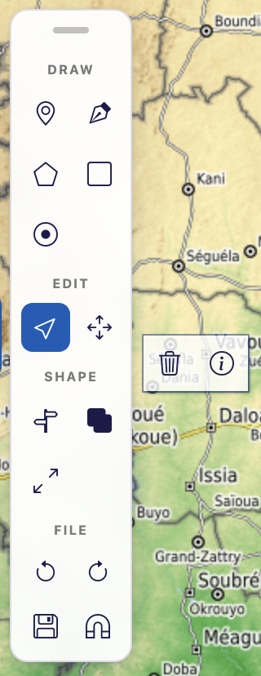
The rail in Digitise mode, with the Select tool active. The floating panel beside EDIT is ol-ext’s option bar — Delete and Info; exercise 5 asks why it sits exactly there.
4. Two entries in that list are not true. Select and ModifySelect are given interactions that were built above, and Split is given false. Find where each of those comes from, and find the Split button that is on the rail anyway.
5. The Undo, Redo, Save and magnet buttons are not EditBar tools at all. Find where they are created and how they get into the bar.
6. Find _buildToolbarRail() and the _applyToolbarRail(bar) it calls. It does three things — swap every icon, re-sort the controls into groups, and add the drag grip. Read TOOLBAR_GROUPS near the top of the file and check it against what you wrote down in step 2.
7. Read the comment above the icon swap, about using a <span> rather than an <i>, and the catch in _buildToolbarRail. Both record a decision; make sure you can say what each one protects against.
8. Leave Digitise mode by pressing another dock tool, then come back to it. Watch the rail appear and disappear, and find the two separate places in the code that can switch edit mode on and off.
Check yourself
a) Which buttons on the rail come from ol-ext, and which does LUPMIS2 add itself?
b) Split: false is passed to the EditBar — so why is there a Split button on the rail?
c) Why does Select get a ready-made interaction instead of just true?
d) If _applyToolbarRail throws, what does the user see? Find the answer in the code, and say why it was written that way rather than letting the error escape.
e) Edit mode can be switched on from two places. What are they, and why is the second one there?

Exercise 2 — Draw, modify, transform
Outcome: configure the drawing, modifying and transform interactions · About 75 minutes
Goal. Use each tool and watch, from the Console, what it puts where.
1. Expose the map object, as in Topic 4. In main.js, just after loadUpnGrid(); in initApp, add:
window.mapView = mapView; // temporary, for topic 5

2. Reload, enter Digitise mode, and start with an empty sheet:
const mv = window.mapView;
mv.drawingsSource.getFeatures().length; // 0

3. Draw a polygon with the rail's polygon tool — click each corner, double-click the last one to finish. Then ask the source what it received:
mv.drawingsSource.getFeatures().length;
const f = mv.drawingsSource.getFeatures()[0];
f.getGeometry().getType();
f.getGeometry().getCoordinates()[0][0]; // one corner

5. Those numbers are large. Say what units they are in before you read on — Topic 4, exercise 1 is the same question.
6. Select the shape (click it) and drag one of its vertices. Watch the coordinate change:
f.getGeometry().getCoordinates()[0][0]; // run again after dragging

7. Attach a listener and drag another vertex, so you can see the event the application itself reacts to:
mv.onFeatureModified((feat) => console.log('modified:', feat.getGeometry().getType()));

8. Find onFeatureModified in MapView.js, then find the one place in main.js that uses it. Note carefully which features it acts on and which it ignores — this comes back in exercise 5.
9. Pick the Transform tool (the four arrows, in the floating panel beside EDIT) and scale and rotate the shape. Then check the geometry again: Transform rewrites the same feature.
10. Now the odd one out. Pick Draw ▸ Point and click on the map. A form appears instead of a sketch staying behind. Cancel it, then check:
mv.drawingsSource.getFeatures().length; // unchanged
mv._undoRedo.length('undo'); // unchanged

11. Read step 5a in initEditBar() — the drawend handler on DrawPoint — and work out how both of those stayed unchanged. Pay attention to the setTimeout(…, 0).
12. Try DrawRegular (the square) and DrawHole (the ring), and say in one sentence each what they produce.
Check yourself
a) Which source do drawn shapes land in, and which layer draws them on screen?
b) You moved a vertex. Which ol event fires, and on which object — the layer, the source or the feature?
c) Why does the DrawPoint handler pause recording with a setTimeout(…, 0) instead of simply setting the flag to false and leaving it?
d) onFeatureModified is registered once in main.js. For which features does it actually do something, and what does it do?
e) DrawHole needs an existing polygon to work on. What does that tell you about the order in which a user has to use the tools?

Exercise 3 — Selecting one thing, or several
Outcome: work with selection — single, multiple and box — and act on a selection · About 75 minutes
Goal. Build a selection three different ways, see what it is allowed to contain, and act on it.
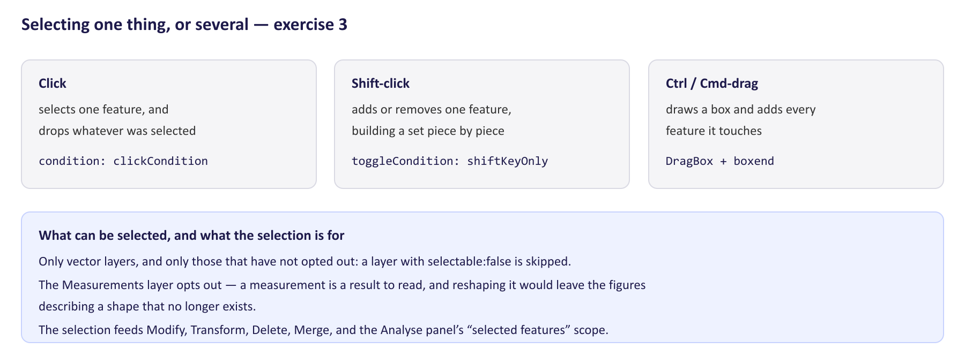
The three selection gestures, and the rule about what may be selected.
1. In Digitise mode, draw three shapes well apart from each other.
2. Click one. It is highlighted, and small blue dots appear at each of its vertices. Count them from the Console:
const sel = mv._selectInteraction.getFeatures();
sel.getLength(); // 1
mv._vertexOverlaySource.getFeatures().length; // one per vertex

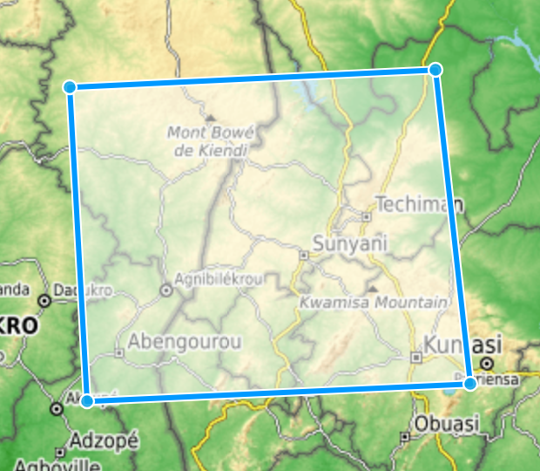
A selected rectangle: ol-ext highlights the shape, and LUPMIS2’s own overlay marks every vertex so the editable nodes can be seen at a glance.
3. Shift-click a second shape, then Shift-click it again. Watch sel.getLength() after each.
4. Hold Ctrl (or Cmd on a Mac) and drag a box across all three shapes. Check the length again.
5. Find the three pieces of code that made those three gestures work: the Select interaction, its toggleCondition, and the DragBox with its boxend handler.
6. The box only works while the Select tool is active. Find the four lines that arrange that, and say what would go wrong without them.
7. Now measure something: leave Digitise mode, use the Area tool to measure a shape, and go back into Digitise mode. Try to select the measurement. You cannot. Find out why — search MapView.js for selectable — and read the comment that explains the decision.
8. With something selected, press the Delete key. Then read _deleteSelectedFeatures() and note that it does not remove the features itself.
Check yourself
a) The Select interaction is given filter: (feature, layer) => !!layer. What is it rejecting?
b) Why is box-select armed and disarmed together with the Select tool, rather than left on?
c) Which layers can be selected, and how does a layer opt out?
d) Why should a measurement not be editable? Give the answer in terms of what the officer would see, not in terms of the code.
e) _deleteSelectedFeatures() calls the EditBar's own Delete interaction instead of removing features from the source. Why does that matter? (Exercise 4 gives the full answer.)

Exercise 4 — Undo, redo and blocks
Outcome: explain how undo/redo works, and why grouping operations into blocks matters · About 75 minutes
Goal. Watch the undo stack grow, entry by entry, and understand the two rules that keep the application's own housekeeping off it.
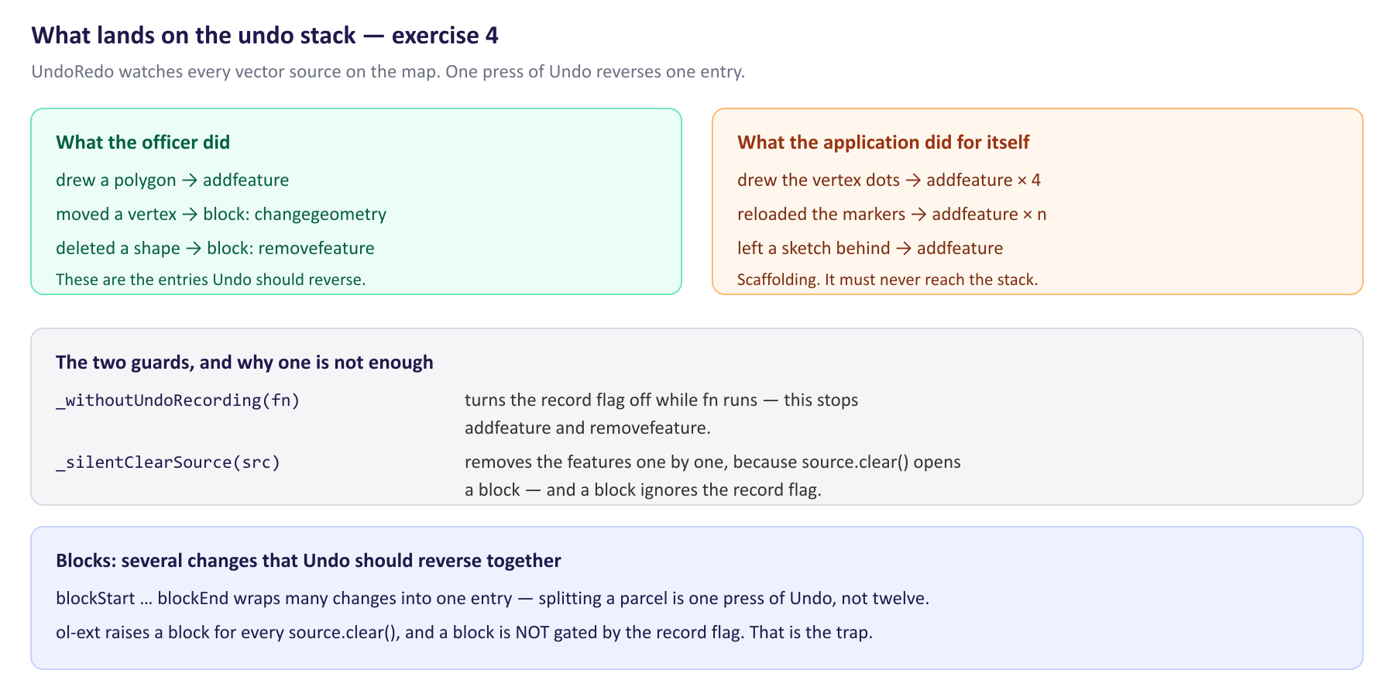
What UndoRedo records, what must be kept off the stack, and the one case a single guard does not cover.
1. Enter Digitise mode and look at the stack before you do anything:
const u = mv._undoRedo;
u.length('undo'); // 0
u.getStack('undo').map((e) => e.type); // []

2. It is empty even though the map has been loading layers since start-up. Find the reason in setEditMode(active) — two calls, one after the other, both with a reason in the comment above them.
3. Draw a polygon, then look again:
u.length('undo'); // 1
u.getStack('undo').map((e) => e.type); // ['addfeature']

4. Select the polygon. Four vertex dots appear — four new features in the overlay source — and yet:
mv._vertexOverlaySource.getFeatures().length; // 4
u.length('undo'); // still 1

6. That is the whole point of the exercise. Find the two helpers that make it true: _withoutUndoRecording(fn) and _silentClearSource(source), and the method that uses both, _refreshVertexOverlay().
7. Now read the library, so you know the helpers are not superstition. Open node_modules/ol-ext/interaction/UndoRedo.js and find _onAddRemove(e) and blockStart(name). One of them begins with if (this._record). The other does not.
8. Find, in the same file, _watchSources(), and the four events it subscribes to on every vector source it finds. Two of those four are the reason _silentClearSource exists.
9. Press Undo once. The polygon goes. Press Redo; it comes back. Then check u.length('redo') before and after drawing something new, and explain what you see.
10. Delete a shape with the Delete button rather than the keyboard, and look at the stack: you will see blockstart and blockend around the removal. That is a block.
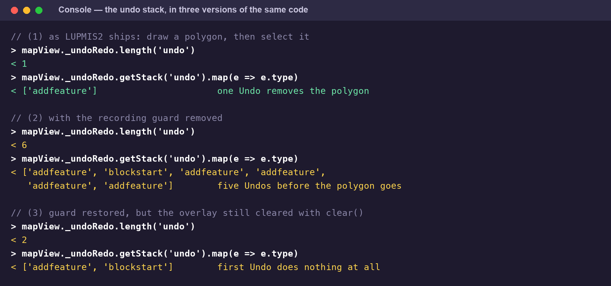
The same three Console commands against three versions of the code. The middle and bottom blocks are the defect in exercise 6, measured.
Check yourself
a) setEditMode calls _watchSources() when edit mode is switched on. Why is that necessary, given that the EditBar already called it once at start-up?
b) Why is the undo history cleared on entering edit mode, rather than kept?
c) _record is already false inside _withoutUndoRecording. So why is _silentClearSource needed as well? Answer from the two functions you read in ol-ext.
d) What is a block for? Give an example from LUPMIS2 where one press of Undo has to reverse several changes at once.
e) In the Console, expanding u lists its properties alphabetically, not in the order the code assigns them. Why is that worth knowing when you are reading an unfamiliar object in DevTools?

Exercise 5 — Three faults, and how to find them
Outcome: diagnose the common editing faults — geometry not saving, undo behaving unexpectedly · About 60 minutes
Goal. Three complaints of the kind that arrive from the field. All three are real. For each one, find the cause in the code before you read the answer.
Fault A — “I pressed Save and nothing happened”
1. An officer draws a parcel boundary, presses the floppy-disk button on the rail, closes the browser, and comes back to an empty map. Follow the button: find its handleClick in initEditBar(), then follow the method it calls.
2. That method reads a list of listeners. Search the whole project for the method that adds to that list, and count how many places call it.
3. Now answer the officer's question properly: what does the Save button do today, what is actually persisted when an officer edits, and where is it persisted to? onFeatureModified in main.js — which you read in exercise 2 — is the other half of the answer.
Fault B — “A button is hidden behind a white box”
The floating panel next to EDIT used to sit on top of the rail's second column and cover the Transform button. It was fixed in the release you have, which makes it the best kind of exercise: you can put it back, find it the way it was found, and then compare your fix with the one that shipped.
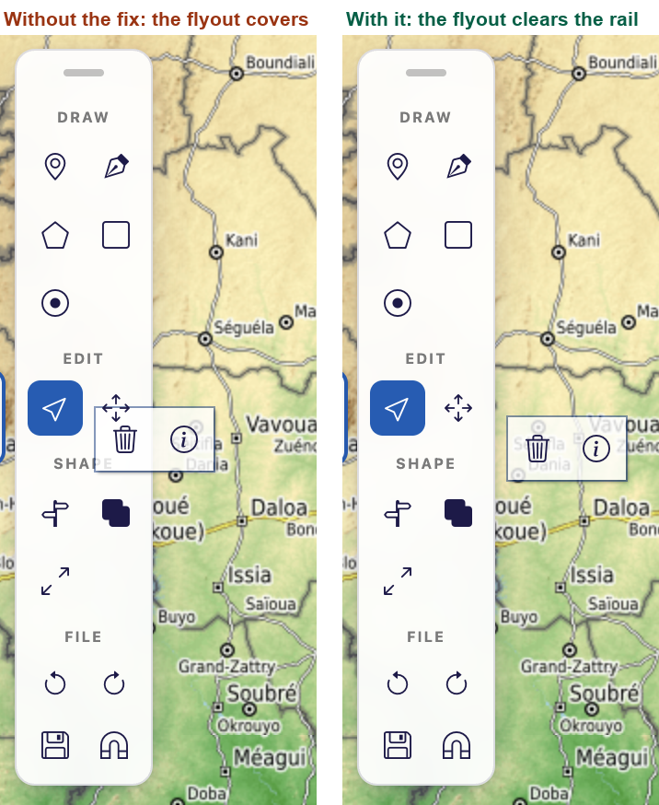
The option bar with and without the fix. On the left it covers the Transform tool; on the right it clears the rail, which is what the CSS was written to do.
1. In index.html, find the rule that sets position: static on the rail's controls — search for ol-option-bar and read the comment block above it. Take one class off the front of the selector, save, and reload. The panel jumps on top of the rail.
2. Now diagnose it as if you had never seen the code. In DevTools, select the floating panel — it has the class ol-option-bar — and look at its parent element in the Elements tree.
3. In the Styles pane, look at the parent's position. The rule you just weakened is there, and struck through.
4. Find the rule that is beating it, and work out why. Count the classes in each selector; you should find that they tie, and that something other than specificity decided the winner.
5. Work out what the parent's position has to do with where the panel lands. left: 100% of what, exactly, in each case?
6. Put the class back, reload, and confirm the panel clears the rail. Note what was not used to fix it, and be ready to say why.
Fault C — “Undo does not undo”
An officer reports that after selecting a shape, the first press of Undo does nothing at all, and a second press removes the shape. Nothing is corrupted; it just takes two presses. You have read everything you need in exercise 4. Write down, in two sentences, what you would look for first. Exercise 6 is that fault.
Check yourself
a) Fault A: is the Save button broken, or is it unfinished? What is the difference, and which one would you write in a ticket?
b) Fault A: an officer edits an imported feature and an officer draws a new shape. Only one of those survives a reload. Which, and why?
c) Fault B: which rule won, and by what rule of CSS did it win?
d) Fault B: why is !important the wrong fix here, even though it would work?
e) Fault C: the shape is never actually lost, and the count of features is right throughout. What does that tell you about where the extra entries on the stack came from?

Exercise 6 — Hands-on: a change that will not undo
Hands-on (Training Plan 6.5): reproduce and fix a realistic editing defect in a training branch · About 3 hours
Goal. Break the vertex overlay on a branch, reproduce fault C exactly, measure it, fix it in two stages — a half fix that still fails, and the real one — and leave a note that stops it coming back. This is a defect that really happened in LUPMIS2, and the two-stage fix is how it was really found.
Part A — break it
1. Make your branch: git switch -c topic5-practice.
2. In src/components/MapView.js, find _refreshVertexOverlay(). Replace the guarded opening — the this._withoutUndoRecording(() => { and its matching close — so that the body runs directly, and clear the overlay with the source's own clear():
// BROKEN ON PURPOSE - exercise 6
this._vertexOverlaySource.clear();
// … the rest of the method unchanged, no longer wrapped …

Watch the closing brace. _refreshVertexOverlay ends with }); — the close of the arrow function and the call. If you remove only the opening line, the body becomes a function that is defined and never run, the overlay stops appearing entirely, and you will be debugging the wrong thing. Make the ending match whatever you did at the start.

Part B — reproduce and measure
3. Reload, enter Digitise mode, draw a polygon with four corners, then select it. Now measure:
const u = window.mapView._undoRedo;
u.length('undo');
u.getStack('undo').map((e) => e.type);

4. Write down both answers. Then press Undo repeatedly and count how many presses it takes before the polygon disappears.
5. Explain every entry on the stack. Each one came from something you can name: say which came from your drawing and which came from the application drawing its own vertex dots.
6. One entry is not an addfeature at all. Find in UndoRedo.js what produced it, and confirm from that file that the record flag could not have stopped it.
Part C — the half fix
7. Put the guard back — wrap the body in this._withoutUndoRecording(() => { … }); again — but leave the this._vertexOverlaySource.clear(); line exactly as it is.
8. Reload and repeat the measurement from Part B. The stack is much shorter now, but the fault the officer reported is still there: the first press of Undo does nothing.
9. Write down why. This is the whole lesson of the topic, and it is worth being able to say it out loud: which of the two guards covers which events.
Part D — the real fix
10. Replace this._vertexOverlaySource.clear() with a call that removes the features one at a time. Write it yourself first, as a small private method, before you look at _silentClearSource in the file — yours should end up close to it.
11. Restore _refreshVertexOverlay() to the shape it had: the guard around everything, and the silent clear inside it.
12. Check that the second user of those helpers still works — search the file for the other place _silentClearSource is called and satisfy yourself that it is right.
Part E — prove it, and write it down
13. Reload, and run the acceptance test in order: draw a polygon, select it, confirm the vertex dots appear; then u.length('undo') and u.getStack('undo').map((e) => e.type); then one press of Undo.
14. Repeat with two shapes selected together, and with a shape deleted and then undone. The dots must still appear and the stack must still hold only your own edits.
15. Add a comment above _silentClearSource in your own words saying why removing features one by one is not a stylistic choice. There is already such a comment in LUPMIS2 — write yours before you compare.
16. Take out the window.mapView line from exercise 2 and reload once more to confirm nothing depended on it.
17. Commit on your branch with a message that says what the user saw, not what you changed (Topic 2). Do not push to the LUPMIS2 repository; show the branch to your trainer.
The question to take away. A recording flag that covers three events out of four looks like it works, and it does work, right up to the day somebody adds a clear(). When you add a guard to code that other people will extend, ask which paths it does not cover, and leave that in a comment.

4. After the exercises
Bring your branch and your answers to the next session. Two things are worth going through with your trainer. The first is fault A in exercise 5: it is not a bug in the editing code at all, and telling the difference between “broken” and “not built yet” is most of what makes a support ticket useful. The second is the half fix in exercise 6 — a fix that improves the symptom without removing the cause is the most dangerous kind, because it is the one that gets committed.

5. Answers
Every number quoted here was measured in a browser against the development server, in the three versions of the code the exercise asks you to build. The fault in exercise 5B is in LUPMIS2 as this document is written; the fix given was applied and re-measured before it was printed.
Exercise 1
a) From ol-ext: the five drawing tools, Select, Transform, Delete, Info, Merge and Offset. From LUPMIS2: the Undo, Redo, Save and magnet buttons — a second Bar with the class ol-editbar-actions, added to the EditBar with addControl — the custom Split tool, the four group labels, the drag grip, and every icon on the rail. ol-ext has no icon font and draws its own with CSS; _applyToolbarRail replaces all of them with Bootstrap Icons.
b) Split: false switches off ol-ext's own split tool, and LUPMIS2 builds its own a little further down initEditBar() — with Lines and Polygons as separate sub-categories — and adds that to the bar. The button you see is the second one.
c) Because the interaction has to be more than a default. It is created before the EditBar, starts inactive so it does not steal clicks from the ordinary map handlers, carries toggleCondition: shiftKeyOnly, a filter, and a layers predicate that implements the selectable:false opt-out — and ModifyFeature, the DragBox and the vertex overlay are all bound to its feature collection. An EditBar-built Select would be none of those things.
d) A warning in the console, and the default ol-ext toolbar instead of the rail: the catch removes the ol-left and ol-editbar-rail classes so nothing is half-styled. It is written that way because the rail is presentation only. If the exception escaped, it would abort initEditBar() and the officer would have no editing tools at all — a cosmetic failure must not cost a working feature.
e) main.js calls mapView.setEditMode(true) when the Digitise dock button selects the draw mode, and setEditMode(false) when any other mode is chosen. The second place is the change:visible listener on the Drawings layer group in initEditBar(): switching that group on or off in the layer switcher opens and closes the rail as well, because to the officer the drawings and the tools that make them are one feature.
Exercise 2
a) this.drawingsSource. It is drawn by this.drawingsLayer, which has the title sketches and sits inside the Drawings LayerGroup — the group is inserted just before the Overlays group so the switcher order stays predictable.
b) The feature itself fires change, and the source re-fires it as changefeature. That is why the vertex overlay listens on the feature (f.on('change', …)) while UndoRedo listens on the source. Note what UndoRedo does not do: it does not record changefeature. A vertex move is recorded by the ModifyFeature interaction instead, as a block containing one changegeometry entry per feature.
c) Because ol adds the finished sketch to the source after the drawend handler returns. Setting the flag false and leaving it would silence everything from then on; setting it false and restoring it immediately would be too early. The setTimeout(…, 0) restores it on the next tick — after ol has done the add, before the officer can do anything else.
d) Only for features that carry both _externalImportId and _clientUuid, which is to say features from a staged external import. For those it writes the new geometry, as WKT in EPSG:4326, back to the matching external_import_features row, so the next upload carries the corrected shape. Everything else returns on the first line.
e) That the tools are not independent of each other: DrawHole needs a polygon under the cursor, Split and Merge need a selection, Transform needs something selected. A drawing rail is a sequence, not a palette, and that is worth remembering when you write the training material for officers.
Exercise 3
a) Features that are not on any layer. While a shape is being drawn, and while ModifyFeature is showing its hover vertex, those are rendered on the interaction's own unmanaged overlay and reach the filter with layer === null. Without the filter, clicking your own half-finished sketch would select it.
b) Because the box is Ctrl/Cmd-drag, and that gesture has to belong to one tool at a time. If it stayed armed, Ctrl-dragging while the polygon tool was active would start a box selection in the middle of drawing. The change:active listener on the Select interaction ties the two together in four lines, so nobody has to remember to disarm it.
c) Only VectorLayers, and only those whose selectable property is not false: layers: (layer) => layer instanceof VectorLayer && layer.get('selectable') !== false. A layer opts out by setting selectable: false when it is created.
d) Because a measurement is a number reported about a shape. If the officer could drag its corners, the figure printed on the map — 4.2 ha, 350 m — would go on describing a shape that no longer exists, and there would be nothing on screen to say so. The measurement is a result to read, not geometry to edit.
e) Because the Delete interaction fires deletestart and deleteend, which UndoRedo turns into blockStart('delete') and blockEnd. Everything removed in between is one entry, so deleting five selected shapes is one press of Undo. Removing them from the source directly would push five separate removefeature entries and need five presses.
Exercise 4
a) Because _watchSources() subscribes to the sources that exist when it runs, and it only re-runs by itself when a top-level map layer is added or removed. Parcels, zones and imports are pushed into sub-groups after the EditBar was built, so their sources would never be watched — and a delete on an unwatched source records an empty block, which is to say Undo appears to do nothing. Calling it again on entering edit mode picks up everything loaded since.
b) So the history covers this editing session only. Everything the application did while loading — every parcel, every marker — went onto the stack as addfeature. Without the clear, Undo would begin by deleting data the officer never added.
c) Because source.clear() does not fire removefeature at all. ol-ext patches clear() on ol/source/Vector.prototype to fire clearstart and clearend, and _watchSources turns those into blockStart('clear') and blockEnd. Look at the two methods in UndoRedo.js: _onAddRemove begins if (this._record), and blockStart does not begin with anything — it pushes unconditionally. So a clear() inside _withoutUndoRecording still leaves a block on the stack. Removing the features one at a time fires only removefeature, which is gated, and the stack stays untouched.
d) So that one press of Undo reverses one thing the officer did, however many features that took. Deleting five selected shapes is one block. Splitting a parcel is one block containing the removal of the original and the addition of the pieces — the officer thinks “split”, not “one delete and two adds”, and Undo has to agree with them.
e) Because the order you see is the console's, not the object's. You cannot read anything into a property's position — not when it is set, not what it belongs with — and a property you expect to find beside another one is not missing just because it is listed twenty lines away. Look things up by name, and read the constructor for the order.
Exercise 5
a) Unfinished. dispatchEditEvent('save') is called by the button, but the method begins if (!this._editEventListeners) return; — and onEditEvent, the only thing that would create that object, is never called anywhere in the project. So the button dispatches into an empty room and returns on the first line. Nothing is broken; the wiring was put in and the consumer was never written. The ticket should say “the Save button on the drawing rail is not connected to anything”, which is a feature request, not a defect — and it should say so, because the two go into different queues.
b) The edit to the imported feature survives. onFeatureModified writes its new geometry back to external_import_features, keyed by _clientUuid. The drawn shape carries neither _externalImportId nor _clientUuid, so the callback returns at once; the shape lives in drawingsSource and nowhere else, and the reload takes it.
c) ol-ext's own rule, .ol-control.ol-bar .ol-control { position: relative }. Count the classes: three in that selector, and — once you have taken one off — three in the project's. The combinator and the element type count for nothing. Equal specificity is settled by source order, and ol-ext's stylesheet is injected after the inline <style> block in index.html, so ol-ext wins. With the control relative instead of static it becomes the containing block for the option bar, and the panel's left: 100% then means “past this button” instead of “past the rail”. The rule that ships carries enough classes to win on specificity alone, whatever the load order is — which is why taking one off is enough to break it:
.ol-control.ol-bar.ol-editbar.ol-editbar-rail > .ol-control {
position: static;
}

d) Because !important wins for the wrong reason. It buys nothing here that another class does not buy, and it makes the next override — a dark-mode rule, a media query, a fix six months from now — harder than it needs to be. Reach for specificity first; save !important for third-party styles you cannot out-specify at all. This is the second time the same tie has cost LUPMIS2 a defect: the v16 entry in the service worker's changelog is the first, and it was the phone layout.
e) That they were not added by the officer. The features are all still there and the counts are right, so nothing destructive is happening — something is recording more than it should. That points at the undo stack rather than at the geometry, and at code that runs when the selection changes, because that is when the officer noticed it.
Exercise 6
Part B — the measurement. With the guard removed, draw a four-corner polygon and select it. The stack holds six entries:
> u.length('undo')
6
> u.getStack('undo').map((e) => e.type)
['addfeature', 'blockstart', 'addfeature', 'addfeature',
'addfeature', 'addfeature']

One addfeature is your polygon. The four at the end are the vertex dots the overlay added, one per corner, and the blockstart in the middle is the clear() that emptied the overlay before it refilled it — pushed by blockStart('clear'), which has no record-flag test in front of it. Five presses of Undo go past the application's own housekeeping before the sixth reaches the polygon.
Part C — the half fix. Put the guard back and keep the clear(), and the stack is:
> u.length('undo')
2
> u.getStack('undo').map((e) => e.type)
['addfeature', 'blockstart']

The four dot additions are gone — those are addfeature, and the record flag does gate them — but the block is still there, because blockStart does not consult the flag. This is exactly the officer's report: the first press of Undo unwinds an empty block and appears to do nothing at all, and the second removes the polygon. It is worth stopping here and looking at what the half fix did: the symptom is four-fifths better and the cause is untouched. A fix like that is the easiest kind to commit and the hardest kind to find again.
Part D — the fix. Do not call clear() on a source that UndoRedo is watching. Remove the features one at a time, which fires only removefeature — gated by the flag — and keep the whole thing inside the guard:
_silentClearSource(source) {
if (!source) return;
const feats = source.getFeatures();
for (let i = feats.length - 1; i >= 0; i--) {
source.removeFeature(feats[i]);
}
}

_refreshVertexOverlay() {
if (!this._vertexOverlaySource) return;
this._withoutUndoRecording(() => {
this._silentClearSource(this._vertexOverlaySource);
… // detach listeners, re-read the selection, add one dot per vertex
});
}

Counting downwards matters: getFeatures() hands back a live array, so removing from the front while walking forwards skips every second feature. The other caller of the pair is setEditMode, which empties the overlay on the way out of edit mode — this._withoutUndoRecording(() => this._silentClearSource(this._vertexOverlaySource)) — and it needs the same treatment for the same reason.
Part E — what a correct run looks like. Draw a four-corner polygon, then select it:
> mv._vertexOverlaySource.getFeatures().length
4 // the dots are there
> u.length('undo')
1
> u.getStack('undo').map((e) => e.type)
['addfeature'] // only what the officer did
> u.undo() // the polygon goes, first time

And the note to leave behind. The comment matters as much as the code, because the next person to add a helper layer will reach for clear() — it is the obvious call. Something like: “clear() fires ol-ext's clearstart/clearend, which become an undo block, and blocks are not gated by the record flag. Remove features one by one instead.” Two sentences, and the defect does not come back.

