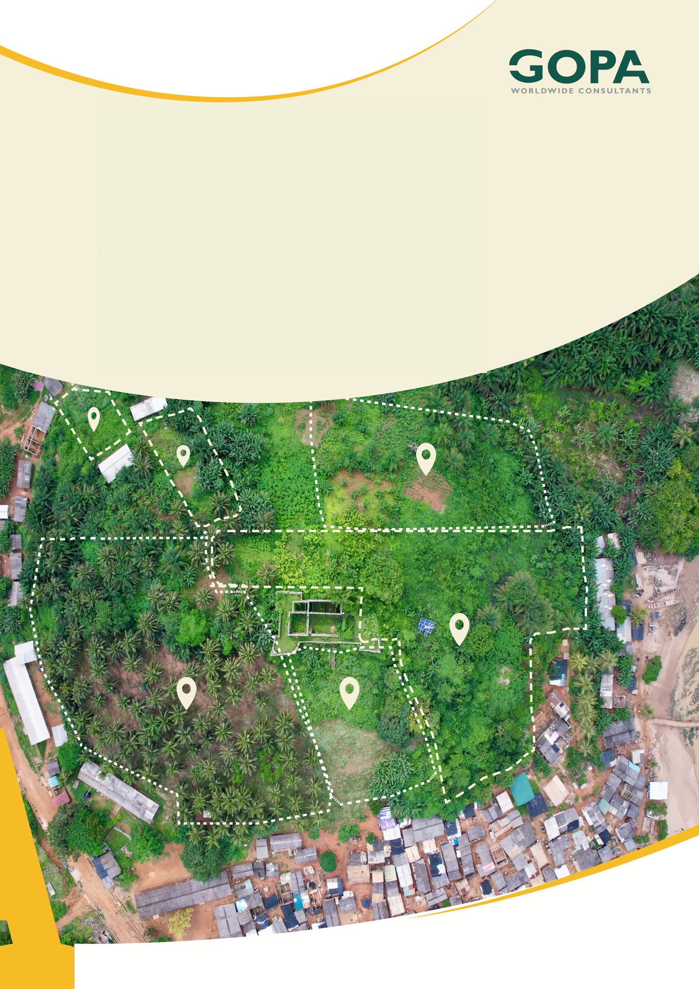
GHANA
Development of a Spatial Planning and Management Information System for Ghana
LUPMIS2 Training — Topic 7 Exercises
PostgreSQL and PostGIS · self-paced · October 2026

Topic 7 — PostgreSQL and PostGIS
Self-paced exercises for Training Plan section 6.7 · LUPMIS2 capacity building for LUSPA

1. How to use these exercises
Section 6.7 sets four learning outcomes and one hands-on task: write the spatial queries behind a real requirement — parcels per zone — and compare the result with the same analysis run in the application. Exercises 1 to 5 work on a copy of the real LUPMIS2 database; exercise 6 is the task itself, and the answer it produces is not the one most people expect. Each exercise has a goal, numbered steps and Check yourself questions; the answers, with every query written out and its measured result, are in section 5.
Exercise | Learning outcome (Training Plan 6.7) | Time
1 Getting in, and reading the schema | Read a database you did not design | 75 min
2 SQL that answers a question | Joins, grouping and aggregation | 90 min
3 Geometry, and what PostGIS adds | Store and query spatial data, the ST_ functions | 90 min
4 Indexes and query plans | Spatial indexing, and why a query is slow without it | 105 min
5 Backup, restore, and changing a schema | Back up, restore and migrate safely | 75 min
6 Parcels per zone, two ways | The hands-on task | 3.5 hours

About eleven hours in total, inside the six days the Training Plan gives the topic.
Two databases, and only one of them is precious. Exercises 1 to 4 read the LUPMIS2 database and never write to it. Exercise 1 also builds lupmis_training, a small copy of two districts, and everything that creates an index, changes a table or restores a dump happens there. Never run CREATE INDEX against the live database because an exercise told you to: an index on a table that size takes minutes and locks writes while it builds.

2. Before you start
1. Finish Topic 1. You need a terminal, and you need to be comfortable reading an error message rather than retyping the command until it works.
2. Install PostgreSQL 16 and PostGIS. On a Mac, brew install postgresql@16 postgis; on Ubuntu, sudo apt install postgresql-16 postgresql-16-postgis-3. Start the server and check:
psql -d postgres -c 'SELECT version()'
psql -d postgres -c "SELECT * FROM pg_available_extensions WHERE name='postgis'"

3. Get a copy of the LUPMIS2 database restored locally and call it spatial. Ask your trainer for the dump; do not point these exercises at the production server.
4. Everything below was measured on PostgreSQL 16.6 with PostGIS 3.4, against a copy holding 3 146 474 parcels. Your timings will be different. The shape of them will not: a query that takes seconds here will take seconds there, and the one that takes milliseconds will too.
A note on the examples. The district used throughout is 93, Sagnarigu Municipal — 67 560 parcels and 82 collector zones, which is small enough to wait for and large enough to be real. If your copy has a different district loaded, use it and expect different numbers; every query here takes the district as a parameter.

3. Exercises

Exercise 1 — Getting in, and reading the schema
Outcome: find your way around a database you did not design · About 75 minutes
Goal. Connect, find the tables that matter, and notice three things about them that the rest of the topic depends on.
1. Connect and look around. These are psql's own commands, not SQL — they are the fastest way into an unfamiliar database:
psql -d spatial
\dn -- schemas
\dt spatial.* -- tables in the spatial schema
\d spatial.lu_parcels -- one table: columns, types, indexes
\di spatial.* -- every index in the schema
\q

2. Find the four tables this topic uses, and write down what each holds: spatial.lu_parcels, spatial.area_collectorzones, reference.zones and public.area_distirct_0209. Count the rows in each.
3. Now look harder at spatial.lu_parcels, and find three things. How many indexes does it have? What is the declared type of sp_boundary? And what does geometry_columns say its SRID is, compared with what ST_SRID says about an actual value?
4. Look at spatial.area_collectorzones the same way, and in particular at the type of sp_polygon.
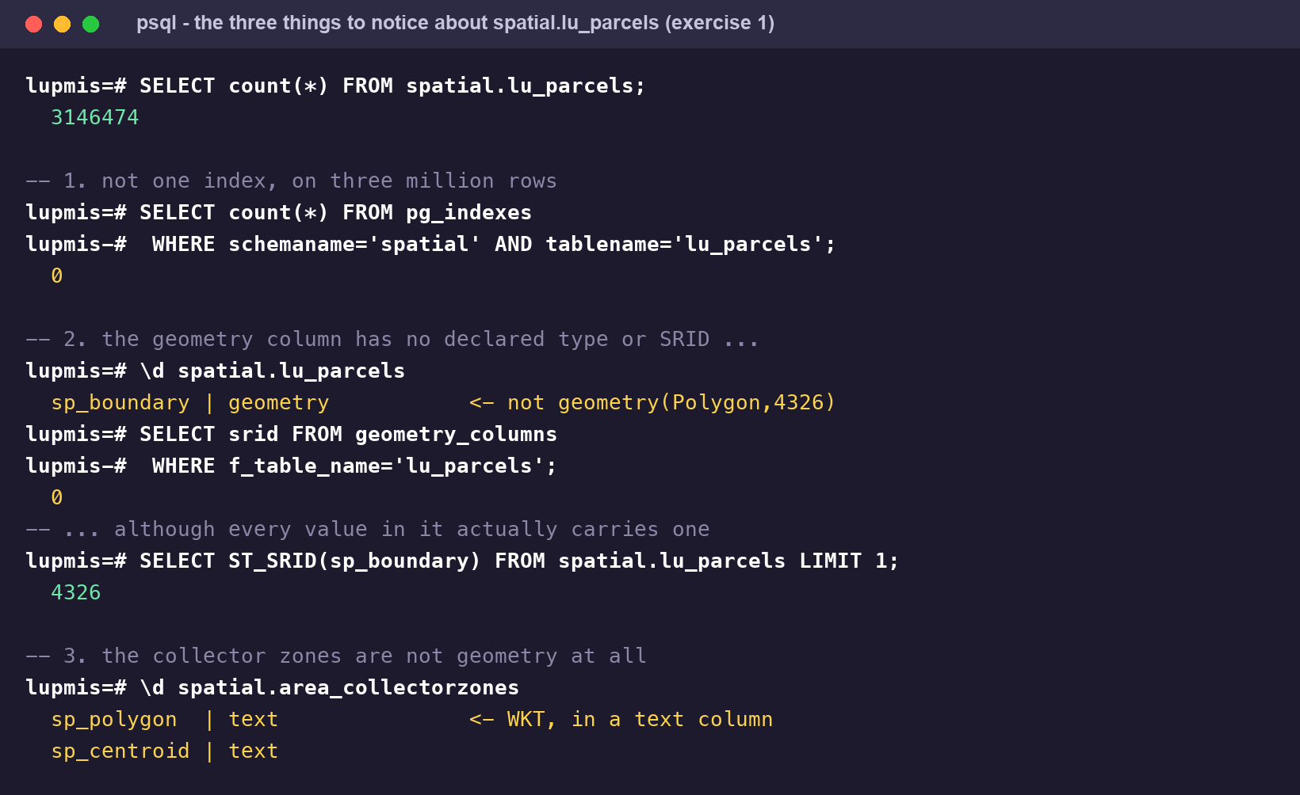
The three things to find in exercise 1. Each of them costs something later, and each is fixed in a different way.
5. Build the training copy. It takes two districts out of the live table and leaves everything about them exactly as the server stores it — the untyped geometry column, the zone geometry as text, no indexes — so that exercise 4 has something to improve:
createdb lupmis_training
psql -d lupmis_training -c 'CREATE EXTENSION postgis'
psql -d lupmis_training -c 'CREATE SCHEMA planning'

psql -d lupmis_training <<'SQL'
CREATE TABLE planning.parcels (
id bigint, upn varchar, landuse varchar, districtid varchar,
colzone_id varchar, tsczone_nr varchar, property_class varchar,
sp_boundary geometry);
CREATE TABLE planning.zones (
id integer, districtid integer, colzonenr integer,
colzonename text, sp_polygon text);
SQL

psql -d spatial -tAc "COPY (SELECT id, \"UPN\", \"Landuse\", districtid,
colzone_id, tsczone_nr, property_class, sp_boundary
FROM spatial.lu_parcels WHERE districtid IN ('44','93')) TO STDOUT" \
| psql -d lupmis_training -c 'COPY planning.parcels FROM STDIN'

psql -d spatial -tAc "COPY (SELECT id, districtid, colzonenr, colzonename,
sp_polygon FROM spatial.area_collectorzones
WHERE districtid = 93 AND sp_polygon IS NOT NULL) TO STDOUT" \
| psql -d lupmis_training -c 'COPY planning.zones FROM STDIN'

6. Check what you got: 300 459 parcels and 82 zones. If either number is different, stop and find out why before going on.
Check yourself
a) What is the difference between a database, a schema and a table, in this database?
b) \d and \dt are not SQL. What are they, and where would you look to find out what they actually run?
c) spatial.lu_parcels has no primary key. Name two separate things that costs you.
d) geometry_columns reports SRID 0 for sp_boundary, but every value in it reports 4326. How can both be true?
e) The zones store their geometry as text. Why would anyone do that, and what does it prevent?

Exercise 2 — SQL that answers a question
Outcome: write SQL confidently — joins, grouping and aggregation · About 90 minutes
Goal. Turn questions a planning officer would actually ask into SQL, and find out why two of the answers are lies.
1. Start with counting and grouping. Write queries for each of these against lupmis_training, and write the answer down before you run the next one:
· how many parcels are in district 93?
· how many districts are in the table, and how many parcels has each?
· how many distinct values does colzone_id take in district 93?
· which five collector zones hold the most parcels, by colzone_id?
2. Now join. planning.zones has the zone names; planning.parcels has the parcels. Produce a table of zone number, zone name and parcel count, for district 93. Mind the types — one side of that join is integer and the other is varchar, and PostgreSQL will not quietly paper over it.
3. Count how many rows your join returned in total, and compare it with the number of parcels in the district. If they differ, work out whether you have lost rows or multiplied them.
4. Now the land use. Run these three, in this order, and explain the third before you read on:
SELECT count(*) FROM planning.parcels WHERE districtid='93';
SELECT count(*) FROM planning.parcels
WHERE districtid='93' AND landuse IS NOT NULL;
SELECT landuse, count(*) FROM planning.parcels
WHERE districtid='93' GROUP BY landuse ORDER BY 2 DESC;

5. That result is the most important thing in this exercise. Write down, in one sentence, what landuse IS NOT NULL actually tested, and what you would have reported if you had stopped at the second query.
6. Finish with a LEFT JOIN: list every zone in district 93 with its parcel count, including the zones that have none. Compare the row count with your inner join.
Check yourself
a) What is the difference between count(*), count(landuse) and count(DISTINCT landuse)?
b) Your join needed a cast. Which direction did you cast, and why does that choice matter for performance later?
c) landuse IS NOT NULL returned every row. What are the values actually in that column, and what would it take to clean them up?
d) When does a join lose rows, and when does it multiply them? Give the LUPMIS2 example of each.
e) A planning officer asks for “parcels by land use in Sagnarigu”. On this data, what is the honest answer?

Exercise 3 — Geometry, and what PostGIS adds
Outcome: store and query spatial data, and use the common ST_ functions · About 90 minutes
Goal. Ask the geometry questions you cannot ask in plain SQL, and repair the two things that stop PostGIS from helping.
1. Start with the functions that tell you what you have. Run each against one parcel:
SELECT ST_GeometryType(sp_boundary), ST_SRID(sp_boundary),
ST_NPoints(sp_boundary), ST_IsValid(sp_boundary),
ST_AsText(ST_Centroid(sp_boundary))
FROM planning.parcels WHERE districtid='93' LIMIT 1;

2. Now measure something. ST_Area on a geometry in degrees returns square degrees, which is not a unit anybody can use. Compare these two and explain the difference:
SELECT ST_Area(sp_boundary) AS square_degrees,
ST_Area(sp_boundary::geography) AS square_metres
FROM planning.parcels WHERE districtid='93' LIMIT 5;

3. Find the extent of the district's parcels with ST_Extent, and the extent of the zones. Do they overlap? You will need ST_GeomFromText for the zones, because their geometry is text.
4. Repair the zones. Add a real geometry column, fill it from the text, and check it:
ALTER TABLE planning.zones
ADD COLUMN geom geometry(Polygon, 4326);
UPDATE planning.zones SET geom = ST_GeomFromText(sp_polygon, 4326);
SELECT count(*), count(geom) FROM planning.zones;
SELECT count(*) FROM planning.zones WHERE NOT ST_IsValid(geom);

5. Note what the column definition does that the live database's does not: it fixes the type and the SRID, so the database can reject anything that does not fit.
6. Now the first real spatial question. How many of district 93's parcels have their centroid inside any collector zone at all? Use ST_Union to merge the zones into one shape first. Write the number down — exercise 6 comes back to it.
7. Finally, try a join across mismatched SRIDs on purpose, so you recognise the error when it happens for real: compare a zone geometry with ST_SetSRID(ST_Centroid(p.sp_boundary), 32630). Read the message carefully.
Check yourself
a) What is an SRID, and what does PostGIS do differently when a geometry has one?
b) geometry and geography are two different types. When would you use each, and what does the cast in step 2 actually cost?
c) Your new column is geometry(Polygon, 4326). What will the database now refuse to store in it that the live table would accept?
d) What does ST_Union of the 82 zones give you, and why is it the right tool for step 7?
e) A query comparing two geometries fails with a message about mixed SRIDs. What are the two possible fixes, and which one is almost always right?

Exercise 4 — Indexes and query plans
Outcome: spatial indexing, query plans, and why a query is slow without one · About 105 minutes
Goal. Make the same query fast three times over, and be able to say which change did what. This is the exercise that pays for the topic.
1. Learn to read a plan before you change anything. Run this against the live database — it only reads — and look at three things: the scan type, the number of buffers, and the execution time:
EXPLAIN (ANALYZE, BUFFERS)
SELECT count(*) FROM spatial.lu_parcels WHERE districtid = '44';

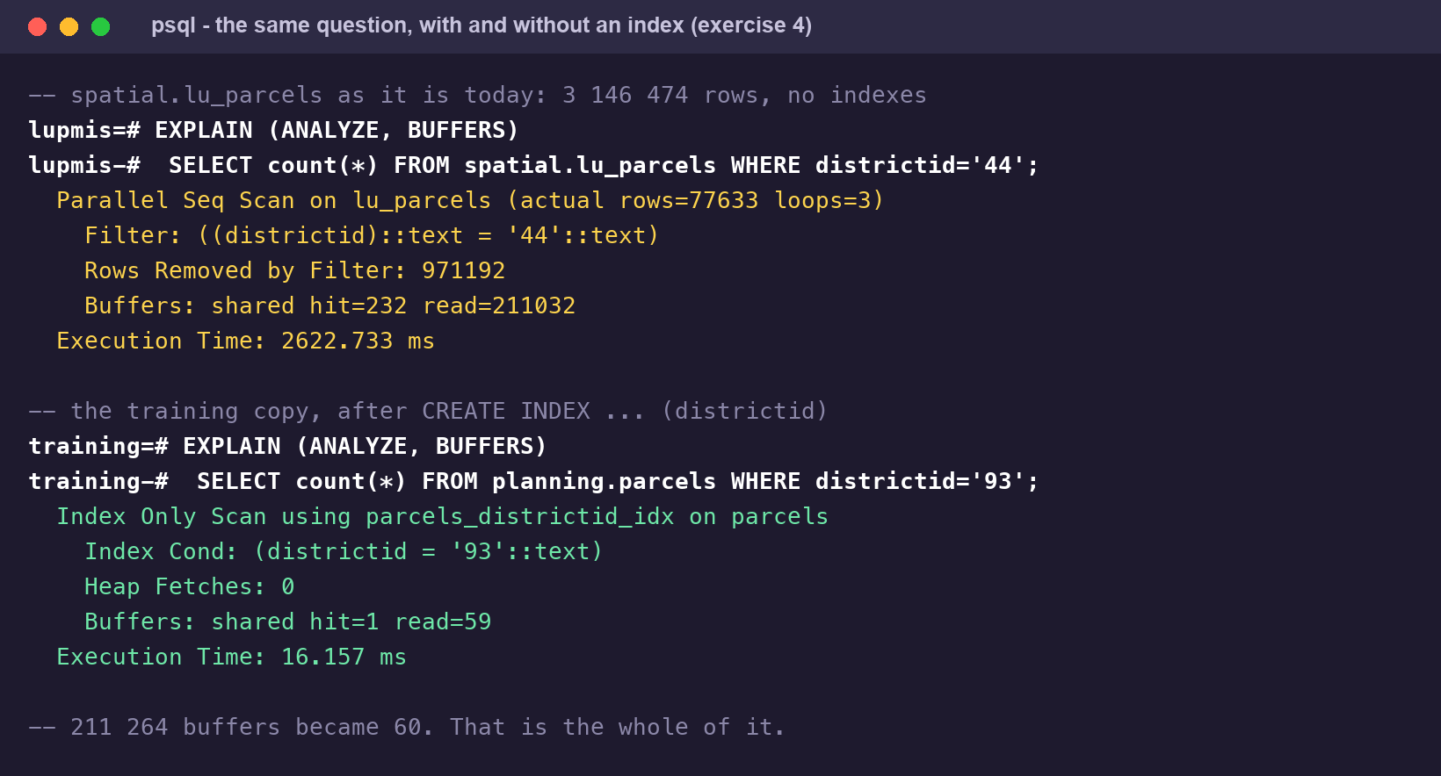
The same question against the live table and against an indexed copy. The buffer counts are the part to remember.
2. Now the same query on your training copy, which is smaller but equally unindexed. Add the index, run it again, and compare:
\timing on
EXPLAIN (ANALYZE, BUFFERS)
SELECT count(*) FROM planning.parcels WHERE districtid = '93';

CREATE INDEX parcels_districtid_idx ON planning.parcels (districtid);
ANALYZE planning.parcels;

EXPLAIN (ANALYZE, BUFFERS)
SELECT count(*) FROM planning.parcels WHERE districtid = '93';

3. The second plan should say Index Only Scan and Heap Fetches: 0. Find out what “index only” means and why ANALYZE was needed before it appeared.
4. Now the spatial side. Time the parcels-per-zone join three times, changing one thing between each run. First, exactly as the data is stored:
SELECT z.colzonenr, count(*) AS parcels
FROM planning.zones z
JOIN planning.parcels p
ON ST_Contains(ST_GeomFromText(z.sp_polygon, 4326),
ST_Centroid(p.sp_boundary))
WHERE p.districtid = '93'
GROUP BY z.colzonenr ORDER BY parcels DESC;

5. Second, with the geom column you built in exercise 3 and a spatial index on it:
CREATE INDEX zones_geom_gix ON planning.zones USING GIST (geom);
ANALYZE planning.zones;
-- then the same query, with ST_Contains(z.geom, ...)

6. Third, with the parcels indexed as well. Note that the index is on an expression, because that is what the query compares:
CREATE INDEX parcels_centroid_gix
ON planning.parcels USING GIST (ST_Centroid(sp_boundary));
ANALYZE planning.parcels;

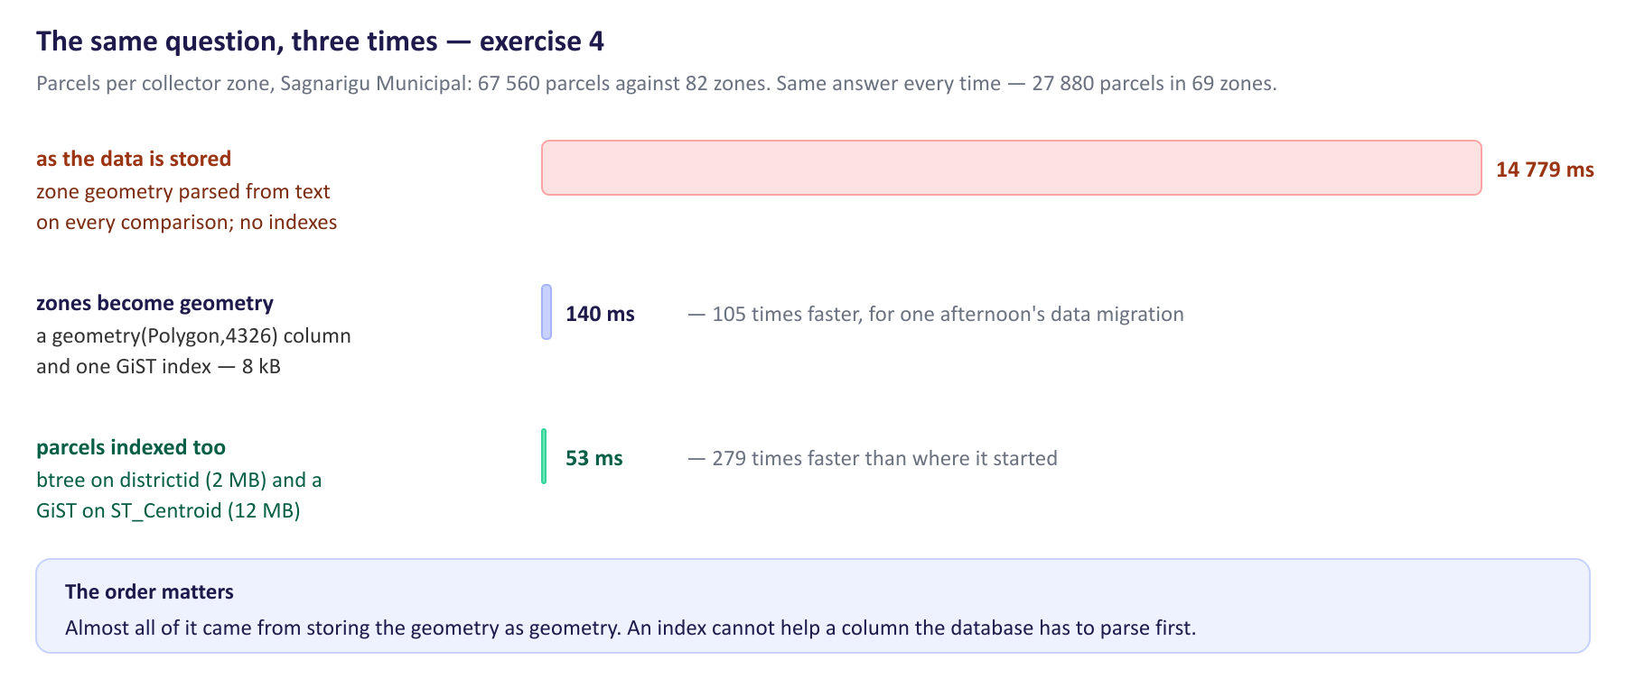
The three runs. Most of the gain is not where people expect it.
7. Now read the final plan with EXPLAIN (ANALYZE, COSTS OFF) and find the two different tests it is doing on each candidate row. One of them the index can answer; the other it cannot.
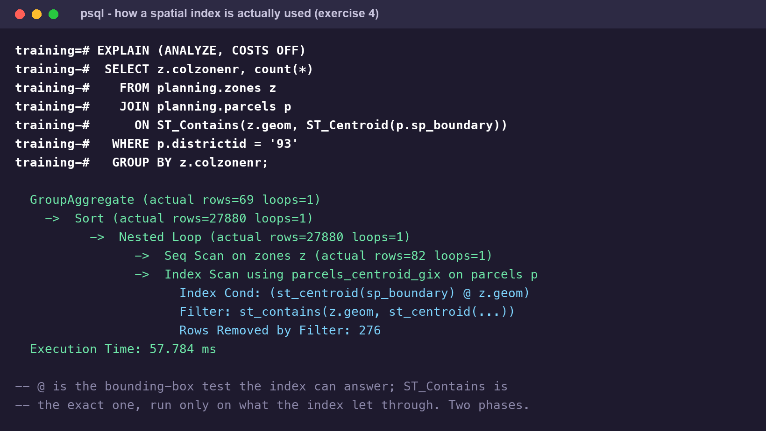
A spatial index works in two phases. The `@` is the cheap one.
8. Check what the indexes cost. Compare pg_relation_size for each index with the size of the table itself, and think about what that means for a table of three million rows.
9. Finally, break it on purpose: write the join with ST_Centroid(p.sp_boundary) replaced by something the index cannot match — ST_PointOnSurface, say — and watch the plan change back.
Check yourself
a) A sequential scan is not always wrong. When is it the right plan?
b) Why did the index-only scan need ANALYZE first, and what would have happened without it?
c) What is a GiST index storing, given that it cannot store a polygon in a sorted order?
d) Why does an index on sp_boundary not help a query that asks about ST_Centroid(sp_boundary)?
e) Of the three changes you made, which gave the largest improvement, and why is that the opposite of what most people guess?

Exercise 5 — Backup, restore, and changing a schema
Outcome: back up, restore and safely migrate the schema · About 75 minutes
Goal. Take a backup you have actually restored, and make a schema change you could undo.
1. Take a backup of the training database in the custom format, and look at how big it is against the database itself:
pg_dump -d lupmis_training -Fc -f lupmis_training.dump
ls -lh lupmis_training.dump
psql -d lupmis_training -tAc "SELECT pg_size_pretty(pg_database_size('lupmis_training'))"

2. A backup you have not restored is not a backup. Restore it beside the original and check the row counts match:
createdb lupmis_restore_test
pg_restore -d lupmis_restore_test --no-owner lupmis_training.dump
psql -d lupmis_restore_test -tAc 'SELECT count(*) FROM planning.parcels'
dropdb lupmis_restore_test

3. Read pg_dump --help and find the difference between -Fc, -Fp and -Fd. Say which you would use to restore one table out of a backup of the whole database, and try it.
4. Now a migration. Give planning.parcels the primary key and the typed geometry column the live table lacks, in a transaction, and check each step before you commit:
BEGIN;
ALTER TABLE planning.parcels ADD CONSTRAINT parcels_pkey PRIMARY KEY (id);
ALTER TABLE planning.parcels
ALTER COLUMN sp_boundary TYPE geometry(Polygon, 4326)
USING ST_SetSRID(sp_boundary, 4326);
-- look before you leap:
\d planning.parcels
SELECT count(*) FROM planning.parcels;
COMMIT; -- or ROLLBACK; if either of those surprised you

5. Both of those will probably succeed, and that is the interesting part: the data already satisfies constraints nobody ever declared. Prove the preconditions rather than hoping — one query for duplicate or missing id, one for the geometry types actually present, one for null geometries — and run them against the live table as well, not only your copy.
6. Write the migration out as a numbered file you could hand to somebody else: 001_parcels_pkey_and_geometry.sql, with the change, a comment saying why, and the SQL that would undo it.
7. Think about the live table while you are here. Your migration ran in seconds on 300 000 rows. Write down what you would have to find out before running it on 3 146 474.
Check yourself
a) What exactly is in a -Fc dump that is not in the .sql text you get from -Fp?
b) Why is a restore test part of taking a backup, and not a separate job for later?
c) Your ALTER TABLE ran inside a transaction. What does PostgreSQL allow you to roll back that many other databases do not?
d) ADD PRIMARY KEY and ALTER COLUMN TYPE both rewrite or scan the table. What does that mean for other users while it runs, and what would you do about it on a live server?
e) Why should a migration file say how to undo itself, even when nobody ever runs that part?

Exercise 6 — Hands-on: parcels per zone, two ways
Hands-on (Training Plan 6.7): write the spatial queries behind a real requirement, and compare with the application · About 3.5 hours
The requirement. A planning officer asks: how many parcels are there in each collector zone of Sagnarigu Municipal? It sounds like one query. It is two, they disagree, and the work is in explaining why.
Part A — the attribute answer
1. Every parcel carries a colzone_id. Write the query that groups by it and joins planning.zones for the zone name, for district 93. Order by count, descending.
2. Check it adds up: does every parcel in the district appear exactly once in your result? Prove it with a query rather than by eye.
Part B — the spatial answer
3. Now ignore the attribute and ask the geometry. Write the join on ST_Contains(z.geom, ST_Centroid(p.sp_boundary)) for the same district, grouped the same way.
4. Check this one adds up too — and this time it will not. Find the total, compare it with the district's parcel count, and find out where the difference went. ST_Union and ST_Intersects are enough to answer it.
5. Produce one more number: the area the zones actually cover, in square kilometres.
Part C — reconcile them
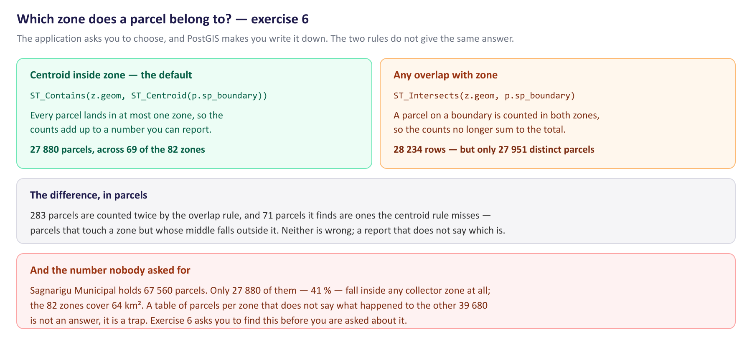
The two membership rules, and the number the requirement did not ask for.
6. Put the two answers side by side for the top five zones. They are not the same table.
7. The decisive question is not which total is bigger but whether the two methods disagree or whether one of them simply says less. Write a query that answers it: for the parcels the spatial join does place, how often does the zone it lands in match the colzone_id it carries?
8. Now run the overlap rule — ST_Intersects instead of centroid-in-zone — and count both rows and distinct parcels. Explain the gap between those two numbers.
Part D — the application's answer
9. Open LUPMIS2 against the same district. Switch on the Parcels and Zones layers, open Analyse, choose zonal statistics with Zones as the zone layer and Parcels as the input, and the count statistic.
10. Before you run it, find the membership setting and read both options. Then read src/analysis/zonal.js and find the default. Which of your two queries is it the same as?
11. Run it, export the result, and compare it with your SQL line by line. Where the numbers differ, the cause is one of three things: which parcels were loaded into the browser, which membership rule is in force, or a genuine difference. Work out which, for every row that disagrees.
Part E — answer the officer
12. Write the answer as you would send it: the table, one sentence saying which rule produced it, and one sentence saying what is not in it. The second sentence is the one that matters.
13. Add the two queries to a file in your branch with a comment above each saying what question it answers, so the next person does not have to reconstruct them.
14. Bring one open question to your trainer. There is at least one here that this exercise cannot settle: whether the zone polygons are incomplete, or the colzone_id attribute is being applied beyond them. Say which evidence would settle it.
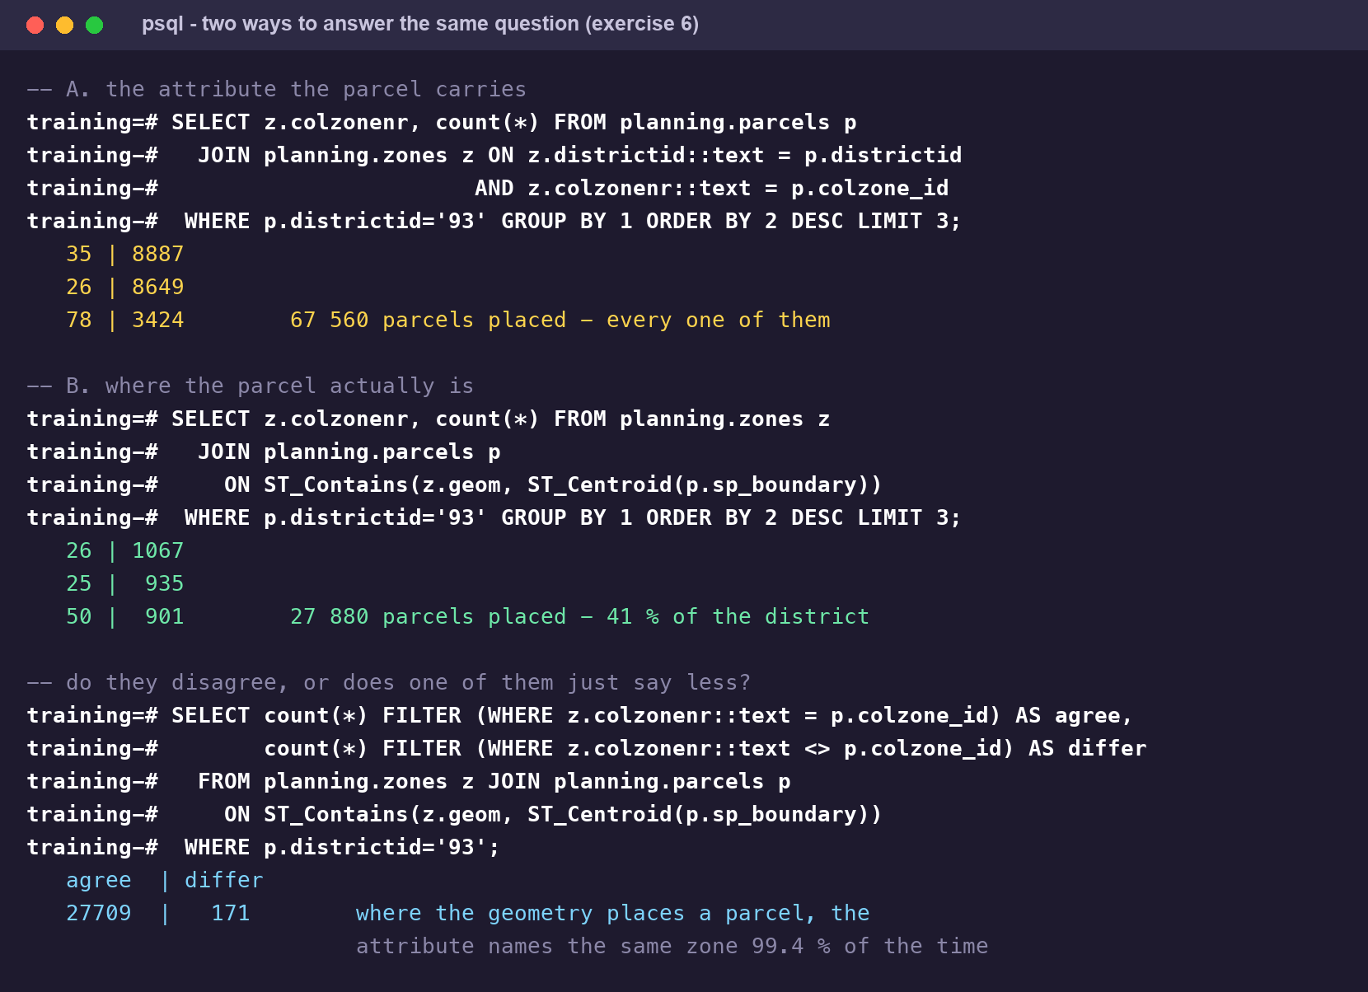
The two answers, measured on Sagnarigu Municipal, and the query that shows they are not contradicting each other.
The question to take away. Both answers are correct SQL over the same data, and they differ by a factor of two and a half. Nothing in the requirement said which one was wanted, and nothing in a spreadsheet of the result would show which one it was. Deciding what a number means — and writing that decision down beside it — is the part of this job that cannot be delegated to the database.

4. After the exercises
Bring your two queries, your migration file and your open question. Three things are worth going through with your trainer. The first is exercise 2's land-use column, because the habit it teaches — never trust a column until you have looked at its actual values — is worth more than any amount of SQL syntax. The second is exercise 4: almost all of the speed-up came from storing the geometry as geometry, not from the indexes, and that ordering is the general lesson. The third is the open question at the end of exercise 6, which is a real one about LUPMIS2's data and not a teaching exercise.

5. Answers
Every number here was measured against a copy of the LUPMIS2 database on PostgreSQL 16.6 with PostGIS 3.4 — 3 146 474 parcels in the live table, 300 459 in the training copy. Timings depend on the machine; the ratios between them do not.
Exercise 1
a) A database is the thing you connect to (spatial); you cannot join across two of them in one query. A schema is a namespace inside it — spatial, reference, planning, public — and it is why a table is written spatial.lu_parcels. A table holds the rows. The schemas here separate concerns: spatial for the operational data, reference for lookup lists, admin for accounts.
b) They are psql's own shortcuts, expanded into SQL against the system catalogues before being sent. Start psql with -E (or run \set ECHO_HIDDEN on) and it prints the query it used — which is the fastest way to learn the catalogue tables, and the only way to do the same thing from a script or from PHP.
c) Two things, at least. Nothing stops a duplicate id being inserted — the data happens to be clean, but the database is not enforcing it. And PostgreSQL has no fast way to find one row: WHERE id = … reads the whole table, which is the subject of exercise 4.
d) Because the column is declared as plain geometry, with no type modifier. geometry_columns reports what the column declares, which is nothing, so it shows 0; ST_SRID reports what a particular value carries, which is 4326. Every row happens to agree, but the database is not making them, and any client that trusts geometry_columns — QGIS, GeoServer, an ORM — will be told the data has no coordinate system.
e) Usually because it arrived that way: an import that wrote WKT into a text column and was never finished. It prevents everything PostGIS is for. A text column cannot carry a spatial index, cannot be validated, cannot be transformed, and has to be parsed afresh on every comparison — which is where the 14 seconds in exercise 4 come from.
Exercise 2
a) count(*) counts rows. count(landuse) counts rows where the column is not NULL. count(DISTINCT landuse) counts how many different values appear. On this data the first two are both 67 560 and the third is 2, which is the whole story of this exercise in three numbers.
b) planning.zones.colzonenr is integer and planning.parcels.colzone_id is varchar, so something has to give: z.colzonenr::text = p.colzone_id. Casting the small side — 82 zones — is the right direction, because casting the parcels column would stop any index on it being used. Casting a column in a WHERE or JOIN is one of the commonest reasons an index is quietly ignored.
c) It tested nothing. The column holds exactly two values in district 93 — the empty string (36 514 rows) and the four-character string NULL (31 046 rows). Neither is a SQL NULL, so IS NOT NULL is true for every row. District 44 is worse: all 232 899 rows are the empty string. Cleaning it up means deciding what the two mean — almost certainly both are “not recorded” — then UPDATE … SET landuse = NULL WHERE landuse IN ('', 'NULL') and a CHECK constraint so it cannot come back.
d) It loses rows when a key on one side has no match on the other — an inner join between parcels and zones drops every parcel whose colzone_id names a zone that is not in the table. It multiplies them when a key matches more than one row on the other side — which is what the ST_Intersects version of exercise 6 does, returning 28 234 rows for 27 951 parcels. Both are silent. Compare your row count with what you expected, every time.
e) That it cannot be answered from this data. There is no land use recorded for Sagnarigu Municipal, in either of the two forms the column uses. The honest answer names the column, says it is empty, and asks where land use is actually held — not a table of zeroes.
Exercise 3
a) A Spatial Reference IDentifier: the number of the coordinate system the numbers are in — 4326 for degrees of longitude and latitude, 32630 for UTM zone 30N metres. With one, PostGIS can refuse to compare geometries in different systems, can transform between them, and can tell geography what the numbers mean. Without one it does the arithmetic anyway and trusts you.
b) geometry does flat arithmetic on the numbers as given; geography does the calculation on the sphere and answers in metres. Use geometry for everything in a single projected system and for anything that has to be fast; cast to geography when you need a real distance or area out of degrees. The cast costs a per-row computation, which is fine for a report over a few thousand rows and not fine inside a join over a million.
c) Anything that is not a single polygon, and anything in another coordinate system — a MultiPolygon, a LineString, a geometry with SRID 32630 or no SRID at all. The live table accepts all of those. On the data as it stands nothing would be rejected, which is exactly why declaring it costs nothing and is worth doing.
d) One polygon covering everything the 82 zones cover, with the internal boundaries dissolved. It is the right tool because the question is “inside any zone”, not “inside which zone”: without the union you would get one row per zone a parcel is in, and have to deduplicate.
e) The message is specific — Operation on mixed SRID geometries (Polygon, 4326) != (Point, 32630). The two fixes are to transform one side (ST_Transform) or to relabel it (ST_SetSRID). ST_Transform is almost always right: it converts the coordinates. ST_SetSRID only changes the label and leaves the numbers alone, so it is correct only when the data really was in that system and was mislabelled.
Exercise 4
The three runs, on district 93 — 67 560 parcels against 82 zones. Each gives the same answer: 27 880 parcels across 69 zones.
What changed | Time | Against the previous
as stored — zone WKT parsed per comparison, no indexes | 14 779 ms | —
zones in a geometry(Polygon,4326) column + GiST (8 kB) | 140 ms | 105× faster
plus btree(districtid) 2 MB and GiST(ST_Centroid) 12 MB | 53 ms | 2.6× faster

a) When it is going to read most of the table anyway. Counting every parcel in the country, or filtering on something that matches a third of the rows, is faster sequentially — the index would be read and then the table. The planner decides this from the statistics, which is why ANALYZE matters more than people think.
b) Because the planner had no statistics on the new index and no idea the table's rows were physically grouped by district. Without ANALYZE it kept the sequential scan. An index nobody has analysed is an index the planner may never use.
c) Bounding boxes. A polygon has no useful sort order, so GiST stores each geometry's rectangle and a tree of rectangles containing those, and answers one question only: could these two overlap. That is why the plan has two steps.
d) Because an index records the value of whatever expression it was built on. sp_boundary and ST_Centroid(sp_boundary) are different values with different bounding boxes, and PostgreSQL will not assume a relationship between them. Index the expression the query actually uses — CREATE INDEX … USING GIST (ST_Centroid(sp_boundary)) — or store the centroid in a column.
e) Storing the zone geometry as geometry: 14 779 ms to 140 ms, before a single parcel was indexed. People reach for indexes first because that is the familiar lever, but an index cannot help a column the database must parse into a geometry before it can compare it. Fix the type first; index second.
Exercise 5
a) A -Fc dump is compressed, and it carries a table of contents, so pg_restore can list what is inside it and restore one schema, one table or only the data. A -Fp dump is a text file of SQL statements: readable and diffable, but all or nothing unless you edit it by hand. The training database was 85 MB and its -Fc dump 25 MB, written in 1.8 seconds.
b) Because the common failures are in the restore, not the dump: a missing extension, an owner that does not exist on the target, a dump that was truncated by a full disk. None of them show up until you try. The restore of the training dump took 1.7 seconds and the row count matched at 300 459 — that check is the backup, not the file.
c) DDL. CREATE TABLE, ALTER TABLE, CREATE INDEX and DROP are all transactional in PostgreSQL, so a migration that half-works can be rolled back as one unit. In MySQL and Oracle a DDL statement commits implicitly and you are left to clean up by hand. It is the single best reason to write migrations as explicit BEGIN … COMMIT blocks here.
d) ADD PRIMARY KEY takes an ACCESS EXCLUSIVE lock while it builds its index, and ALTER COLUMN … TYPE rewrites the whole table under the same lock. Nobody can read or write the table meanwhile — on 3 146 474 rows that is minutes, not seconds. On a live server you would build the index first with CREATE UNIQUE INDEX CONCURRENTLY, then attach it with ADD CONSTRAINT … PRIMARY KEY USING INDEX, and do the rest in a maintenance window.
e) Because the moment you need it, you will be in no state to work it out. Writing the undo while you still have the change in your head costs five minutes; reconstructing it during an incident costs an hour, and that is the hour somebody is waiting through.
Exercise 6
Part A — the attribute answer. Every parcel carries a colzone_id, and all 67 560 of them join to a zone:
SELECT z.colzonenr, z.colzonename, count(*) AS parcels
FROM planning.parcels p
JOIN planning.zones z
ON z.districtid::text = p.districtid
AND z.colzonenr::text = p.colzone_id
WHERE p.districtid = '93'
GROUP BY z.colzonenr, z.colzonename
ORDER BY parcels DESC;

-- 35 | 8887
-- 26 | 8649
-- 78 | 3424 … 67 560 parcels in total, every one placed

Part B — the spatial answer. The same question asked of the geometry places far fewer:
SELECT z.colzonenr, z.colzonename, count(*) AS parcels
FROM planning.zones z
JOIN planning.parcels p
ON ST_Contains(z.geom, ST_Centroid(p.sp_boundary))
WHERE p.districtid = '93'
GROUP BY z.colzonenr, z.colzonename
ORDER BY parcels DESC;

-- 26 | 1067
-- 25 | 935
-- 50 | 901 … 27 880 parcels in total, in 69 of the 82 zones

The missing 39 680 parcels are not a join fault. Their centroids fall outside every zone: ST_Union of the 82 zones covers 64.0 km², and the district's parcels spread well beyond it. The zone polygons describe part of the district, not all of it.
Part C — reconciling them. The decisive query is not which total is larger but whether the two methods ever name a different zone for the same parcel:
SELECT count(*) FILTER (WHERE z.colzonenr::text = p.colzone_id) AS agree,
count(*) FILTER (WHERE z.colzonenr::text <> p.colzone_id) AS differ
FROM planning.zones z
JOIN planning.parcels p
ON ST_Contains(z.geom, ST_Centroid(p.sp_boundary))
WHERE p.districtid = '93';

-- agree | differ
-- 27709 | 171

They agree 99.4 % of the time. So the two answers are not contradicting each other: the attribute and the geometry say the same thing wherever the geometry says anything at all. What differs is coverage — the attribute assigns a zone to parcels the zone polygons do not reach. The likeliest reading is that the collector-zone polygons are incomplete rather than that 39 680 parcels are mislabelled, but that is a reading, not a result, and Part E is right to send it to the trainer.
The overlap rule gives a third number again: ST_Intersects(z.geom, p.sp_boundary) returns 28 234 rows for 27 951 distinct parcels — 283 parcels sitting on a zone boundary and counted in two zones, and 71 parcels caught that the centroid rule misses because their middle falls just outside.
Part D — the application. src/analysis/zonal.js offers two membership rules, 'centroid' (“Centroid inside zone”) and 'intersects' (“Any overlap with zone”), and defaults to centroid. So the application's default is Part B's query, not Part A's — LUPMIS2 answers this question from the geometry. Rows will still differ from your SQL for one mundane reason before any of the interesting ones: the browser only has the parcels it downloaded for the current district and view, so check the feature count in the layer switcher against count(*) before concluding anything.
What to write down. The table, the sentence “counted by centroid-in-zone, from the parcel geometry”, and the sentence “27 880 of the district's 67 560 parcels fall inside a collector zone; the remaining 39 680 lie outside the mapped zones”. Three lines. Without the third one the table is wrong in a way the reader cannot see.

