
LUPMIS2
Development Status Report

Land Use Planning & Management Information System
Land Use and Spatial Planning Authority (LUSPA)
March 2026

1. Executive Summary
LUPMIS2 is a modern web-based application being developed to support land use planning and management across Ghana’s districts. It replaces the previous desktop-based LUPMIS system with a Progressive Web App (PWA) that works on any device — desktop, tablet, or mobile phone — including in areas with limited or no internet connectivity.
The application is accessible at https://pwa.lupmis4luspa.org and the design guidelines are documented at https://lupmis.ammonvictor.com. Development is progressing well, with core mapping, data management, and field-ready features now operational. This report includes a comparison against the agreed functional specifications, a summary of stakeholder engagements, and feedback from the pilot district workshops held in March 2026.

2. Project Background
LUSPA oversees land use planning and spatial development across Ghana. The original LUPMIS system served as a desktop tool for managing district-level planning data. LUPMIS2 modernises this by moving to a web-based platform that field officers, planners, and administrators can access from any device. The application connects to a central database server while maintaining full offline capability — a critical requirement for fieldwork in remote areas of Ghana.
The application’s visual identity follows the LUSPA Corporate Identity and Signage Specification (December 2017), which defines the official logo incorporating the Adinkra symbol “OSIADAN” (meaning “the builder”), the official colour palette based on Pantone references (2755 C navy, 290 C light blue, 7740 C green, 4645 C brown), and the Exo typeface family used throughout the interface.

3. Current Development Status
The following table summarises the current state of all major feature areas. All core features have been completed and are ready for field testing.
Feature Area | Status | Description
Interactive Map | Complete | Full mapping capability with five base map options (street map, satellite imagery, topographic, light and dark views). Users can search for locations, view their current GPS position, and switch between map styles.
District Data Layers | Complete | The system displays administrative boundaries, collector zones, land parcels, and building footprints for each district. Data is fetched from the central server and cached locally for offline access.
Location Management | Complete | Field officers can mark locations on the map with name, description, and category (water point, school, health facility, market, etc.). All locations are stored locally and displayed with category-specific icons.
Drawing & Sketching Tools | Complete | A full drawing toolbar allows users to create polygons, lines, and points directly on the map. Features include undo/redo, vertex editing, and alignment guides for precise drawing.
Measurement Tools | Complete | Three measurement modes: circle (radius and area), distance (path length), and area (polygon area and perimeter). Measurements display in metric and imperial units based on user preference.
Spatial Analysis | Complete | When a measurement overlaps with existing data layers, the system shows an intersection analysis. Results can be exported as branded PDF reports.
Data Import | Complete | Users can import spatial data from Shapefiles (.zip), GeoJSON, and KML files. Files can be imported via buttons or by dragging them onto the map.
Data Export | Complete | Locations and features can be exported as GeoJSON. The local database can be downloaded as a backup. Analysis results generate branded PDF reports with the LUSPA logo.
Offline Capability | Complete | The application works fully offline after the first visit. Map tiles, application files, and district data are cached on the device.
Server Connectivity | Complete | Smart server detection checks if the central database is reachable before attempting downloads. If unavailable, the app immediately loads cached data.
Dark Mode | Complete | A dark colour scheme option reduces eye strain during evening or indoor use. All interface elements, map controls, and pop-ups adapt to the dark theme.
Fieldwork Mode | Complete | A high-contrast display mode with larger touch targets designed for use in bright sunlight and challenging field conditions.
Measurement Units | Complete | Users can switch between metric and imperial measurement systems. The change is reflected across all tools, pop-ups, and the map scale bar.
PDF Report Generation | Complete | Analysis results can be exported as PDF documents featuring the LUSPA logo, a data table, and a date/time stamp. Reports open directly in the browser.
Message Logging | Complete | All application events are recorded in a persistent message log visible in the side panel, helping field officers track what happened during a session.
Cross-Tab Sync | Complete | When multiple browser tabs are open, changes made in one tab are immediately reflected in all others through real-time synchronisation.

4. Comparison with Functional Specifications
The LUPMIS2 Functional Specifications document (version 4, July 2025) defines the full scope of functionality agreed upon with the Technical Working Group (TWG). The table below maps each specification requirement to the current development status. Requirements are categorised as Complete, Partial (under active development), or Not Started (planned for future phases).
Of the 26 specification areas assessed, 13 are complete, 5 are partially implemented, and 8 are planned for upcoming development phases. The core mapping, spatial analysis, and offline capabilities are fully operational. The permitting module, external data integrations, and advanced features such as 3D visualisation and raster processing are scheduled for Phase 2.
Specification Requirement | Status | Notes
Interactive Map Viewer | Complete | Dynamic map with basemaps, overlays, and search
Layer Management | Complete | Add, remove, and toggle multiple vector layers
Map Drawing & Sketching | Complete | Create and edit points, lines, and polygons with undo/redo
Spatial Queries & Analysis | Complete | Buffering, overlay, and proximity analysis via measurement tools
Thematic Mapping | Partial | Basic symbology available; custom zoning styles planned
GPS & Geolocation | Complete | Real-time location tracking for field inspections
Touchscreen Optimised Mapping | Complete | Pinch-to-zoom, tap-to-select, fieldwork mode
Offline Support | Complete | Full PWA with service worker caching for offline use
Responsive UI Design | Complete | Bootstrap-based responsive layout for all screen sizes
Vector Data Import/Export | Complete | Shapefile, GeoJSON, and KML import; GeoJSON export
Raster Data Handling | Not Started | GeoTIFF import and terrain analysis deferred to Phase 2
Database Support (PostGIS) | Complete | Central PostgreSQL/PostGIS server with local SQLite cache
Web GIS Integration (WMS/WFS) | Not Started | External web service layers planned for Phase 2
Printing & Reporting Tools | Partial | PDF analysis reports complete; full map layout printing planned
Permit Application Management | Not Started | Separate permitting module under design (Public Portal)
Automated Zoning Compliance | Not Started | Depends on permitting module and zoning data integration
Fee Calculation & Payment | Not Started | Requires integration with Ghana.Gov and GhIPSS platforms
Document Management | Not Started | Upload and retrieval system planned for permitting module
User Access Control | Not Started | Authentication and role-based access planned as next priority
Audit Logging | Partial | Client-side message log complete; server audit trail planned
Mobile Data Collection | Partial | Location marking and GPS complete; photo attachment planned
Street Naming & Property Addressing | Not Started | Functionality to be integrated per Act 925 requirements
3D Visualisation | Not Started | Terrain and building models deferred to future phase
Parcel Auto-Generation | Not Started | Automated layout based on land use percentages under design
Administrative Hierarchy | Complete | National, regional, and district level data structure in place
Central Storage & Sync | Partial | Download from server complete; upload synchronisation in progress

The permitting and land use approval functions represent the largest block of work remaining. These features depend on the Public Portal and District Backend systems that are being developed in parallel, and on the data exchange agreements currently being formalised with stakeholder organisations (see Section 6).

5. Design & Brand Compliance
The LUPMIS2 interface has been developed in accordance with the LUSPA Corporate Identity and Signage Specification document (December 2017). Key aspects of compliance include:
Colour Palette: The application’s colour scheme draws from the official LUSPA palette. The primary navigation and header elements use the deep navy blue (Pantone 2755 C). Interactive elements and accents use colours derived from the specification’s defined spectrum.
Typography: The interface uses the Exo typeface family, as specified in the letterhead format section of the signage document.
Logo Usage: The LUSPA logo appears in the application’s PWA installation icon, the browser tab icon, and in generated PDF reports.
Visual Identity on Reports: Generated PDF reports follow the letterhead format principles from section 04 of the signage specification — centred logo placement, organisation name, and clean typographic hierarchy.

6. Stakeholder Engagement Summary
During the inception phase, the development team conducted structured engagements with 17 key stakeholder institutions in collaboration with LUSPA and GIZ. These consultations identified data requirements, existing systems, and the formal agreements needed for data sharing. The Stakeholder Engagements Report (February 2026) documents these findings in detail.

Key Findings
- 11 organisations were identified with specific data exchange requirements essential for the permitting and spatial planning modules
- 9 organisations require formal Memoranda of Understanding (MoUs) to facilitate data sharing, ensuring proper governance and data protection
- Most stakeholders use GIS-based systems (ArcGIS, QGIS) and can provide data in standard formats (Shapefile, GeoJSON, KMZ), facilitating integration
- All stakeholders emphasised the importance of metadata documentation and formal authorisation from Director Generals or equivalent authorities
- 6 additional organisations (Ghana Chamber of Telecommunications, NITA, Minerals Commission, Forestry Commission, Energy Commission, Data Protection Authority) were identified for future engagement
The table below summarises the organisations with confirmed data exchange requirements:
Organisation | Data to Exchange | Agreement Status
Inter-Ministerial Coordination Committee | District boundaries | MoU Required
Ghana Grid Company Ltd. | Transmission lines, towers, sub-stations | MoU Required
Ghana Maritime Authority | Marine boundaries, underwater topography | MoU Required
Department of Feeder Roads | Feeder road networks | MoU Required
Ghana Highways Authority | Highway design drawings | MoU Required
Department of Urban Roads | Road inventory, local plans | Consent Letter
Electricity Company of Ghana | Powerlines, poles, sub-stations (GeoJSON, API) | MoU Required
Ghana Civil Aviation Authority | Flight zones, height restrictions | MoU Required
Petroleum Commission | Seismic data, oil blocks, well positions | MoU Required
National Communication Authority | Fibre data, radio coverage, towers | MoU Required
Urban Observatory | Urban research and analysis outputs | Data User

Integration Priorities
- Electricity Company of Ghana (ECG): API integration is feasible and could enable automated checks of powerline proximity during permit applications
- Ghana Civil Aviation Authority: Building height restrictions should be integrated into the permitting module for automatic compliance verification
- Petroleum Commission: An existing interface can be extended for API integration in a later phase; some data is classified by sensitivity levels
- National Communication Authority: Telecommunications tower data and fibre routes are available in QGIS-compatible formats
The MoU process is recommended to follow a phased timeline: drafting templates in months 1–2, initiating discussions with priority organisations in months 2–3, executing agreements in months 3–4, and establishing technical data exchange protocols in months 4–6.

7. Pilot District Workshop Feedback
Workshops were held with pilot district representatives in Tamale (10–11 March 2026) and Koforidua (12–13 March 2026). Participants reviewed the LUPMIS2 system and provided detailed feedback on the Public Portal, District Backend, Drawing Tools, and Parcel Generator. The comments have been compiled in the Pilot District Workshop Comments report and are summarised below by theme.

Public Portal
- Simplify the document upload process: limit to one copy, clarify accepted formats (PDF) and maximum file sizes
- Add a certificate of habitation and land use certificate information to the FAQ section
- Include a disclaimer indicating applicants are responsible for data accuracy
- Lock applications once the district begins processing to prevent further editing
- Add a summary receipt after submission confirming that documents and payment are required before the application is formally received
- Add descriptive categories for permit types and remove building permit from the list of available permit types

District Backend
- Separate LUSPA users from district users and ensure districts can only see and manage users within their jurisdiction
- Add roles based on actual responsibilities of committee members, with a tracking table for recommendations and comments on specific applications
- Implement QR codes on permits to allow verification of authenticity
- Add a notification system for new permit applications arriving
- Include an approval-in-principle stage before the full permit is issued
- Auto-populate coordinates and begin counting processing days from the date of application receipt
- Lock approved certifications until payment is confirmed; apply penalties based on fee-fixing regulations

Drawing and Measurement Tools
- Add DXF to the supported import formats alongside Shapefile and KML
- Fix the delete function so that individual features can be removed without affecting other imported data
- Improve mobile responsiveness: fix scrolling issues, resize the editing dock for smaller screens
- Add a unit-of-measurement selector so users can switch between metres, feet, and other units
- Add location detection (current GPS position) and GPS trail recording for mapping movements in the field
- When a layer is imported, the map should automatically zoom to the extent of that data
- Add a report feature to the spatial analysis results and a buffer tool based on user-specified radius
- Clarify the icons and labels on the toolbar — for example, rename the export icon to “Saved Locations” and change “draw” to “digitise” where appropriate

Parcel Generator
- Parcels should be generated in blocks rather than as individual structures
- Provide guidelines for parcel generation including minimum and maximum acceptable areas to prevent the system running indefinitely
- Allow different road widths (Type 1, 2, 3) rather than a single default
- Address corner radius terminology: rename to “splay” as used in Ghanaian planning practice
- Add arc drawing capability alongside straight lines for parcel boundaries
- Enable deletion of individual vertices and specific lines during editing without removing the entire parcel
- Add numbering and zoning classification to generated parcels, distinguishing between residential and commercial land use densification standards
- Add a progress bar to show generation duration, and export to Shapefile and KML in addition to GeoJSON
Both workshops also emphasised the need for user manuals and video tutorials to support training and onboarding of district staff.

8. Technical Architecture Overview
How the Application Works: LUPMIS2 runs entirely in the web browser. Unlike the previous desktop software, there is nothing to install — users simply open the web address and the application loads. On subsequent visits, the app loads instantly from the device’s cache, even without internet.
Data Storage: Each device maintains its own local database using modern browser storage technology. Field officers can collect and edit data all day without needing internet access.
Server Communication: The application connects to the central LUSPA server to download district data. A smart connectivity check at startup determines within five seconds whether the server is available, preventing the application from becoming unresponsive when the server is down.
Map Technology: The mapping engine uses OpenLayers, an established open-source mapping library used by governments and organisations worldwide.
Progressive Web App (PWA): The application can be “installed” on any device — appearing as an icon on the home screen of a phone or tablet, or in the applications menu of a computer.

9. Deployment & Access
The application is deployed at https://pwa.lupmis4luspa.org. The server infrastructure includes a web server hosting the application files, an API server providing access to the central PostgreSQL database, and the design guidelines reference site at https://lupmis.ammonvictor.com. All API communication uses secure HTTPS connections.

10. Upcoming Work & Recommendations
Next Steps
- Complete the data synchronisation workflow so that field-collected data is uploaded to the central server
- Add user authentication and role-based access control so that each officer’s contributions are tracked
- Implement the pilot district workshop feedback, prioritising mobile responsiveness fixes, DXF import, and individual feature deletion
- Progress the MoU process with the 9 identified stakeholder organisations, beginning with ECG and Civil Aviation
- Develop the permitting module integration between the Public Portal, District Backend, and the PWA mapping tools
- Add support for attaching photographs to locations and parcels for field documentation
Recommendations
- Conduct further field testing with LUSPA district officers, incorporating the specific feedback from the Tamale and Koforidua workshops
- Establish a training programme for field staff including user manuals and video tutorials as requested by workshop participants
- Prioritise the MoU framework to unblock data integrations needed for the permitting module
- Define data validation rules for parcels and locations to ensure data quality from the field

11. Conclusion
The LUPMIS2 application represents a significant step forward in modernising Ghana’s land use planning infrastructure. Half of the functional specification requirements are fully implemented, with the core mapping, spatial analysis, offline capability, and data management features operational and ready for field use. The stakeholder engagements have established a clear roadmap for data integration with 11 key organisations, and the pilot district workshops in Tamale and Koforidua have provided valuable, actionable feedback that will guide the next phase of development.
With the upcoming additions of data synchronisation, user authentication, the permitting module, and the integration of stakeholder data sources, LUPMIS2 will provide a complete field-to-office workflow for land use planning across Ghana’s districts.
12. April 2026 Update
This section summarises development work completed in April 2026 since the previous status report. Two major themes covered the period: (a) substantial additions to the in-app drawing and editing toolkit, and (b) a programme of background-data integrations focused on topographic context for land-use planning.
12.1 Drawing & Editing Toolkit Enhancements
The polygon editing workflow was significantly expanded with new tools and refined feedback patterns:
- Polygon Divide tool — a new sub-button under the Split control divides a selected polygon into N equal-area pieces. The user picks the edge that defines the cutting direction and enters the number of divisions; the algorithm uses binary search per cut for accurate area distribution.
- UPN selection after Split & Divide — after splitting or dividing a parcel, the user is prompted to click the piece that should retain the original UPN identifier. All other pieces have their identifier fields cleared automatically, preventing duplicate identifiers in the database.
- Improved Merge algorithm — the shared-boundary detection now uses vertex-to-edge proximity (5 m tolerance) instead of strict vertex-to-vertex matching, allowing parcels digitised independently to merge cleanly. A hybrid lock-step extension handles polygons whose shared edge has different vertex counts on each side.
- A/B labels during Merge — the first selected polygon shows a bold "A" label, the second shows "B". This makes it immediately clear which polygon’s identifier will be retained when the merge popup appears.
- Toast notifications — merge, split, and divide operations now provide visible toast feedback for both success and failure cases, replacing the previous console-only logging.
- Persistent vertex highlights — when the drawing tool is active and the user selects a polygon for modification, every vertex is now displayed as a small blue dot. Previously only the closest vertex appeared on hover. The implementation uses a separate overlay layer rather than subclassing ol-ext’s ModifyFeature, leaving the existing hover behaviour intact.
12.2 External Data & Background Layer Integrations
- External Source layer tool — a green "+" button injected into the "External Source" group header in the LayerSwitcher opens a dialog letting users add WMS, WFS, or XYZ tile layers at runtime. URL, layer name, and display title are validated; tile-load errors surface as toast warnings.
- DEAfrica Coastlines & Slope layers — two layers from Digital Earth Africa’s OGC Web Service were added to the "Biophysical Environment" group. The Coastlines v0.4 layer shows annual shorelines and rates of change; the SRTM-derived Slope layer (style_slope) renders as a semi-transparent background, with hills and valleys reading like a traditional shaded-relief topographic map.
- Default base map setting — a new card in the Settings panel lets users choose their preferred base map (Topographic, OpenStreetMap, Satellite, Google Sat, Carto Light, Carto Dark). The selection is saved to localStorage and restored on every app load, so each device remembers its user’s choice. Topographic is the new factory default.
- Generic addWMSLayer / addXYZLayer methods — on MapView, accepting style, opacity, zIndex, attributions, and legendUrl. WMS layers were switched from ImageWMS to TileWMS to avoid the "Width 4366 exceeds supported maximum 512" errors on large screens.
- Legend panel — a floating card in the bottom-right of the map automatically shows legend images for any visible layer that has a legendUrl registered. Hidden when no relevant layers are visible.
- Contours hillshade layer — a new spatial-planning API endpoint (get_contours_hillshade.php) returns elevation contours imported from OpenTopography’s viz.hh_hillshade product. The PWA renders them as fine grey lines in the "Biophysical Environment" group.
12.3 Topographic Background Layers — Research Document
A separate research document, "Topographic Background Layers for LUPMIS2", was produced to evaluate options for integrating contour and elevation data. Its key findings are summarised below.
Categories of available data
Topographic sources fall into three categories with very different integration profiles:
- Pre-rendered tile services (OpenTopoMap, Esri World Topo Map, MapTiler Topo, Thunderforest Outdoors) — plug-and-play XYZ tiles that render immediately in OpenLayers. OpenTopoMap is the default choice: free, global, includes contours and hillshade, and is licensed CC-BY-SA 3.0 with attribution.
- Raw DEM / elevation APIs (OpenTopography, Digital Earth Africa) — provide elevation data that must be processed client- or server-side to produce contours or hillshades. OpenTopography is download-only with strict rate limits; DEAfrica provides DEM rasters as colour ramps via WMS.
- Self-hosted pipelines (MapTiler Africa contour vector tiles, custom GDAL workflows from SRTM) — most work, most control, and the only way to obtain cartographic-quality contours tailored to LUSPA’s specifications.
Why OpenTopography is not a runtime layer
OpenTopography is a download-focused DEM service, not a tile service. It offers no WMS, WMTS, or XYZ endpoints, and its non-academic API is rate-limited to fifty calls per twenty-four hours. Interactive panning would exhaust this quota within minutes. The realistic integration path is therefore a one-off ETL job rather than a runtime API call.
Recommended OpenTopography ETL pipeline
The following diagram illustrates the practical pipeline for incorporating OpenTopography data into LUPMIS2: a one-time download of the SRTM or Copernicus DEM clip covering Ghana, processing into contour polylines and a hillshade raster, serving via either GeoServer WMS or a pre-rendered XYZ tile pyramid, and consuming in the PWA through the existing addWMSLayer or addXYZLayer methods.
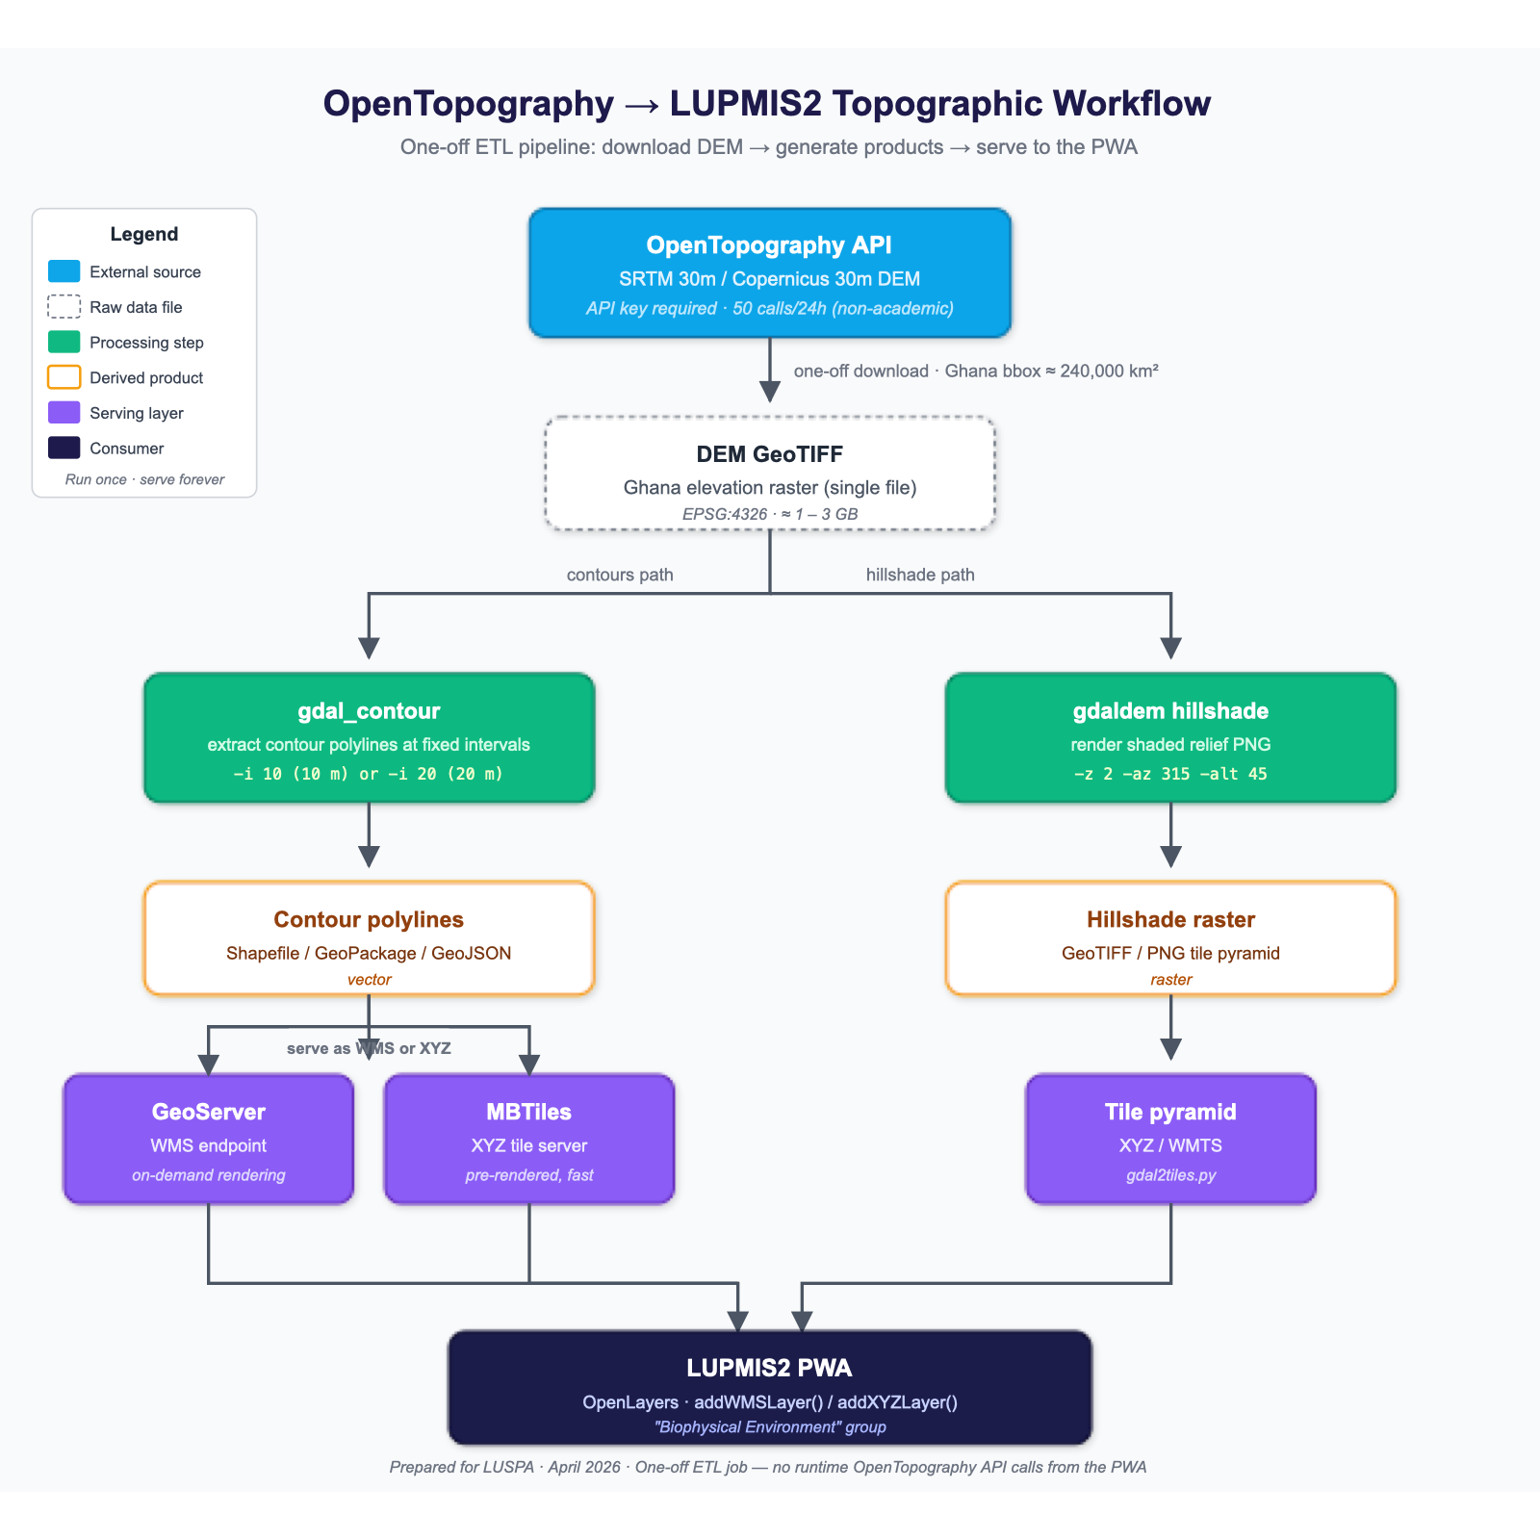
Figure 1. OpenTopography → LUPMIS2 topographic workflow. One-off ETL job; no runtime OpenTopography API calls.
Recommendations applied
- Primary — OpenTopoMap accepted as the default base map (selectable per device via the new Settings card). Provides immediate visual contours and hillshade across Ghana with zero server-side work.
- Secondary — DEAfrica SRTM-derived Slope WMS added as a "Biophysical Environment" overlay, rendered as a semi-transparent background layer behind vector overlays.
- Long-term — a custom Ghana contour service is recommended for parcel-level planning, using the OpenTopography ETL pipeline shown above. The first iteration of this is the Contours hillshade layer described in section 12.2.

