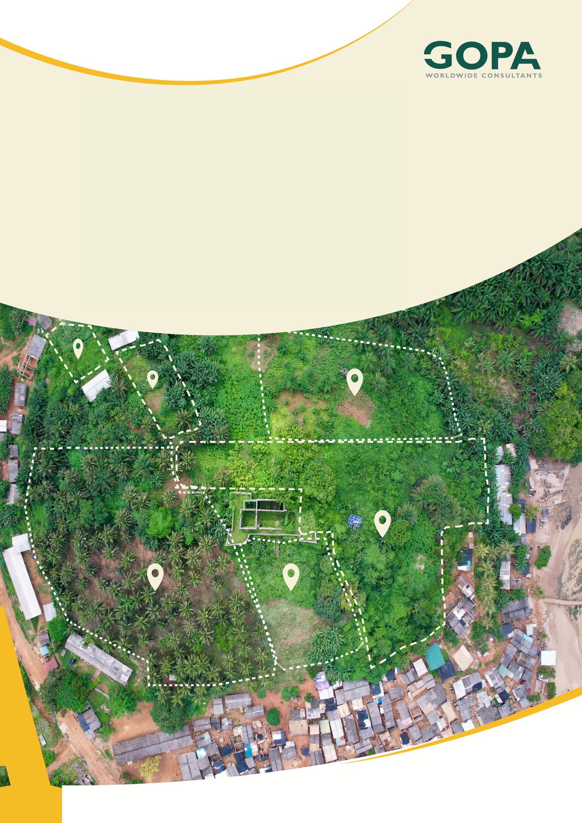
GHANA
Development of a Spatial Planning and Management Information System for Ghana
LUPMIS2 Database Schema Summary
Condensed Data Dictionary · August 2026

Database Schema Summary
Condensed from the generated data dictionary · August 2026
What this is. A reading guide to the LUPMIS database, condensed from the 96-page data dictionary generated on 20 August 2026. It explains how the database is organised and what the table-name prefixes mean, then lists every table with one line on what it holds. The generated dictionary remains the authority on columns, types and indexes; this document is the one to read first.

1. Purpose and scope
The database team maintains a data dictionary generated directly from the live database. It is complete and correct, and it is 96 pages long: every column, type, index and function signature, with no commentary. That makes it an excellent reference and a poor introduction — a reader who wants to know what the database contains has to reconstruct it from several hundred column names.
This summary covers the same ground in a form that can be read in one sitting. It does not replace the generated dictionary and does not repeat its detail. Where the two disagree, the generated dictionary is correct: it is produced from the database itself, whereas this document is written by hand and will drift as the schema changes.
Source: DataDictionary_20260820110253.pdf, generated with Navicat from server pg-l4l-ssh on 20 August 2026. One database (postgres), four schemas, 59 tables and 116 stored functions. No views are defined.

2. How the database is organised
The database is divided into four schemas, each owned by a different part of the system. The division is clean: the mapping application reads almost exclusively from spatial, the permitting system from permit, and neither touches the other's tables directly.
Schema | What it is for | Tables | Functions
admin | Users, roles, menus, privileges, API tokens and access logging. Shared by every LUPMIS subsystem. | 13 | 28
dataroom | Catalogue of published datasets with versioning, licensing, checksums and download tracking. | 5 | 18
permit | Development and mining permit applications: applicants, agents, documents, stages and status history. | 10 | 43
spatial | All mapping data — boundaries, parcels, land use, infrastructure, facilities and elevation. This is what the PWA reads. | 32 | 30

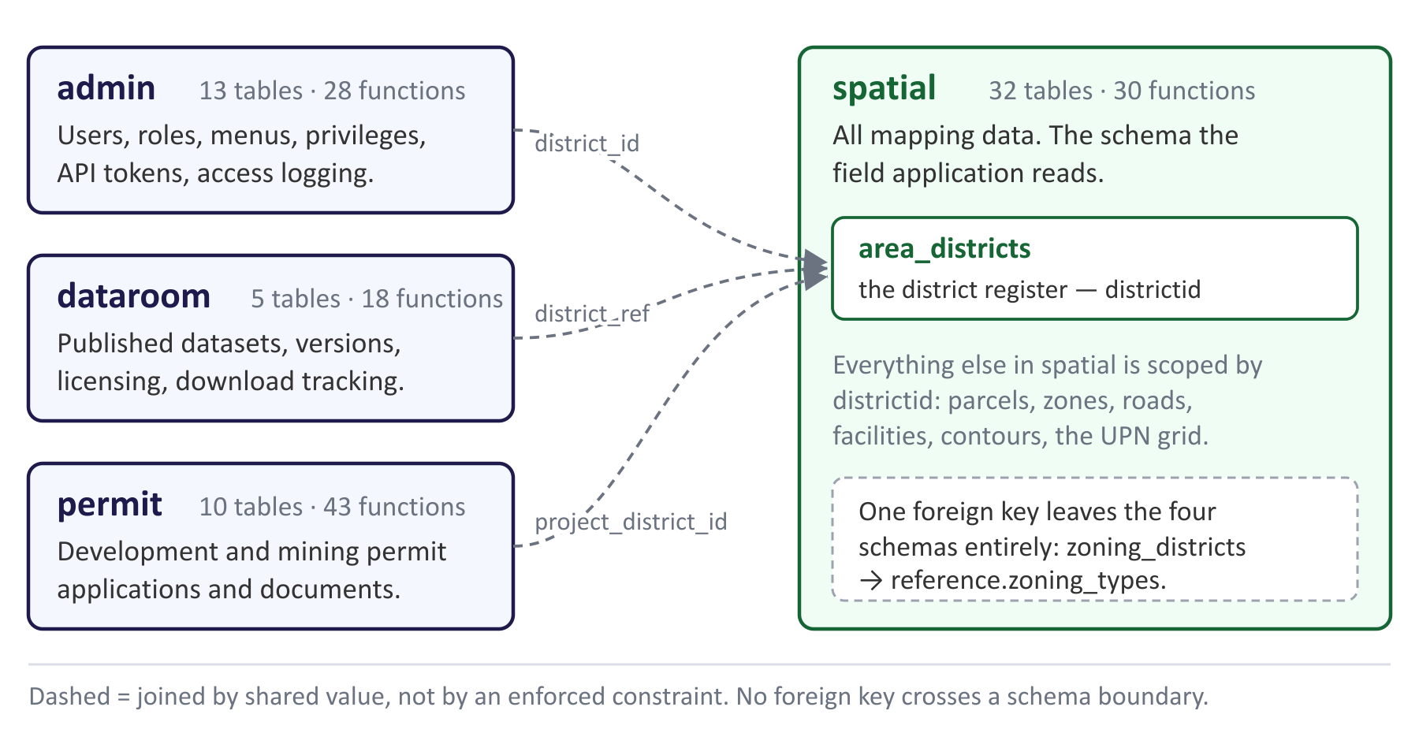
Figure 1. The four schemas. Each of the other three carries its own name for the district it refers to, and none of those references is enforced by the database.

3. How the tables relate
The dictionary lists nine foreign keys across the whole database. Every other relationship is a shared value that two tables happen to agree on, with nothing stopping them drifting apart. That distinction matters more than any single table definition, so it is drawn out here.

3.1 The declared foreign keys
Table | Column | References | On delete
permit.application_agents | application_id | permit.applications.id | CASCADE
permit.application_consultants | application_id | permit.applications.id | CASCADE
permit.application_documents | application_id | permit.applications.id | CASCADE
permit.application_status_history | application_id | permit.applications.id | CASCADE
permit.mining_applications | application_id | permit.applications.id | CASCADE
spatial.buildings | parcel_id | spatial.parcels.id | NO ACTION
spatial.pi_buildings | parcel_id | spatial.parcels.id | NO ACTION
spatial.zoning_districts | zoning_type_id | reference.zoning_types.id | NO ACTION

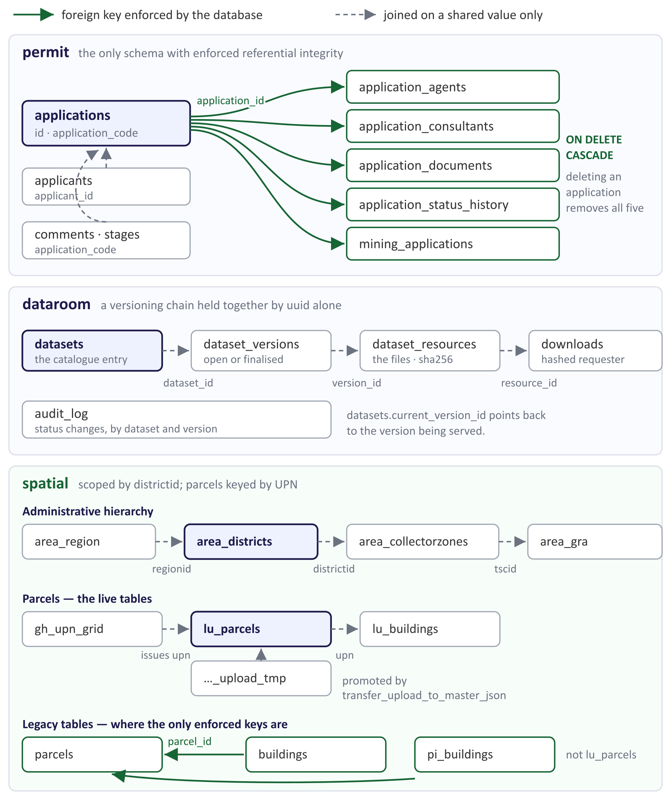
Figure 2. Relationships by schema. Solid arrows are foreign keys the database enforces; dashed arrows are joins that exist only by agreement.

3.2 What the picture shows
— permit is the only schema with referential integrity. Five child tables cascade from applications, so deleting an application cannot leave orphaned agents, consultants, documents or history behind. Comments and stages are the exception: they join on the application_code text rather than the id, and are not covered by a constraint.
— dataroom's versioning chain is held together by uuid alone. datasets, dataset_versions, dataset_resources and downloads form a clean chain, but nothing in the database enforces it. The unique constraints on dataset_versions do guard against two versions claiming the same number.
— spatial is held together by districtid. The administrative hierarchy runs region to district to collector zone, and almost every other table carries the district it belongs to. Parcels are keyed by UPN, issued from gh_upn_grid, and field uploads reach lu_parcels through the staging table rather than directly.
— The two enforced keys in spatial point at the wrong parcel table. buildings and pi_buildings both reference spatial.parcels — the legacy table described in section 9 — not the live lu_parcels. Worth checking before either building table is relied on.
One reference leaves the documented database. spatial.zoning_districts.zoning_type_id points at reference.zoning_types, in a schema the dictionary does not cover. Either the reference schema should be included in the next generated dictionary, or the constraint is left over from an earlier arrangement and should be removed.

4. Naming conventions
Table names in the spatial schema carry a prefix that says which thematic group the data belongs to. The prefixes are not decoration: they correspond to the layer groups the officer sees in the application's layer switcher, which are themselves defined in the lay_layers table. Reading the prefix tells you where a table's contents will appear on the map.

4.1 Table prefixes
Prefix | Meaning | Where it appears in the app | Examples
area_ | Administrative boundaries — the nested hierarchy from country down to collector zone | Administration group | area_ghana, area_region, area_districts, area_collectorzones, area_gra
lu_ | Land use — parcels and what is on them | Land Use group | lu_parcels, lu_buildings, lu_agric
pi_ | Physical infrastructure — the built network | Physical Infrastructure group | pi_osm_roads, pi_buildings
be_ | Biophysical environment — terrain and natural features | Biophysical Environment group | be_contours_hillshade
scs_ | Social and community services — schools, clinics and other public facilities | Facilities layers | scs_facilities, scs_fac_education, scs_fac_health
hlp_ | Helper and lookup tables — reference values, not map data | Not shown as a layer | hlp_broad_lu_colours
lay_ | Layer registry — defines the groups themselves | Drives the layer switcher | lay_layers
gh_ | Ghana-wide reference data, not scoped to one district | Administration group | gh_upn_grid
(none) | Tables predating the convention, or imported from elsewhere. See section 9. | Mostly not used by the app | parcels, buildings, osm_roads, zoning_districts

The convention is applied to the spatial schema only. Tables in admin, dataroom and permit are named for what they hold, because those schemas are already single-purpose and a prefix would add nothing.

4.2 Column conventions
Column | Meaning | Note
id | Surrogate primary key | Present on nearly every table. Not the business identifier.
upn | Unique Parcel Number | The business identifier for a parcel. Issued from gh_upn_grid.
districtid | District the row belongs to | The main scoping key. Almost every spatial query filters on it.
geom | Geometry, current convention | EPSG:4326 unless a separate column says otherwise (lu_parcels also has geom_utm).
fid | Feature identifier from the source dataset | Carried over from imports; not a key LUPMIS issues.
tscid, tsczonenr | Tax service centre and zone number | Links spatial data to the revenue collection structure.
created_at, updated_at | Row timestamps, current convention | Older tables use dt_create / dt_edit or createdate / editdate instead.
client_uuid | Identifier generated on the device | Lets the server de-duplicate records uploaded from the field.

4.3 Suffixes and special names
— _tmp — a staging table that data passes through before it becomes live. lu_parcels_upload_tmp holds field uploads until a supervisor promotes them.
— _log, _history — append-only records of what happened: user_access_log, application_status_history, audit_log.
— _assigned — a join table linking a user to something granted to them: user_menu_assigned, user_priviledges_assigned.
— A trailing date — a dated snapshot of an import, kept for reference: gis_osm_roads20260519 is an OSM extract from 19 May 2026.
— Trailing digits on lu_parcels (0, 00, 000, 1, 2) — successive generations of the parcel table from earlier migrations, not a numbered series with current meaning.

4.4 Function naming
The 116 stored functions follow a verb-first pattern. The verb says what the function does; the rest names the thing it acts on and, where relevant, how the result is shaped.
Pattern | Meaning | Examples
select_get_… | Read a set of rows, usually scoped by district | select_get_parcels_per_district, select_get_upn_grid_per_district
get_…, list_… | Read one record or a list | get_dataset_by_id, list_datasets
insert_…, add_… | Create a record | insert_lu_parcel_json, add_applicant
update_…, delete_… | Modify or remove a record | update_lu_parcel_json, delete_mining_document
…_json | Takes or returns JSON rather than columns | select_lu_parcels_json, insert_application_comment_json
contours_… | The one family named after its table rather than its verb | contours_get_by_district, contours_add, contours_update
review_…, transfer_… | Steps in the staged-upload workflow | review_lu_parcel_upload_json, transfer_upload_to_master_json

5. The spatial schema
Thirty-two tables, listed below in prefix order. These are the tables the mapping application reads, and the ones most likely to be asked about.
Table | What it holds
area_ghana | The national outline. A single row.
area_region | The regions, with the region code used by the finance side of LUPMIS.
area_districts | District boundaries with districtid, district_name and regionid. The districtid here is the key almost everything else is scoped by.
area_collectorzones | Collector zones within a district, with the zone's display colour and centroid.
area_gra | Ghana Revenue Authority area offices and tax service centres.
be_contours_hillshade | Elevation contours, one row per line, with the elevation in metres in elev. Scoped by district. Derived from OpenTopography and Copernicus 30 m elevation models.
lu_parcels | The current parcel table and the centre of the whole schema: UPN, land use, zoning, address, height limits, and geometry in both WGS 84 and UTM.
lu_parcels_upload_tmp | Staging for parcels uploaded from the field. Adds the device-generated client_uuid, who uploaded and who reviewed, review timestamps, and a migrated flag.
lu_parcels0, lu_parcels00, lu_parcels000, lu_parcels1, lu_parcels2, lu_parcels_colours | Six earlier generations of the parcel table, retained from previous migrations. Mixed-case column names and sp_boundary geometry mark them as superseded.
lu_buildings | Building footprints tied to a parcel's UPN, with a flag for whether the footprint falls inside its parcel.
lu_agric | Agricultural land use, held as point, boundary and centroid geometry.
pi_osm_roads | The road network from OpenStreetMap, scoped by district. Carries the road classification in fclass, plus name, surface and one-way status.
pi_osm_roads_highway | The full OpenStreetMap tag set in osm2pgsql layout — 70 columns including highway, geometry in way.
pi_buildings | Building features with type, storeys, height and floor area.
scs_facilities | Social and community facilities generally, classified by fclass and scoped by region and district.
scs_fac_education | Schools, with enrolment, streams, classrooms, teaching and non-teaching staff, water source, sanitation and condition.
scs_fac_health | Health facilities, with beds, doctors, nurses, outpatient availability, cold-chain equipment and power source.
gh_upn_grid | The Unique Parcel Number grid. Each cell carries its prefix and a last_serial counter, from which the next UPN in that cell is issued.
hlp_broad_lu_colours | Lookup from broad land-use class to display colour, as separate RGB components and as hex.
lay_layers | The layer registry: the groups that structure the layer switcher in the application.
osm_roads | An earlier OpenStreetMap roads import, scoped by district and zone.
gis_osm_roads20260519 | A dated snapshot of an OpenStreetMap roads import taken on 19 May 2026.
buildings | Same column set as pi_buildings.
parcels | A parcel table in a non-Ghanaian layout — assessor's parcel number, city, state, postal code, county, and areas in square feet and acres.
zoning_districts | Zoning districts with a zone code and an ordinance number.
overlay_districts | Overlay zoning districts, with ordinance number and effective and expiry dates.
environmental_constraints | Environmental constraint areas, with constraint type, source and effective date.

6. The permit schema
Ten tables covering two application types — ordinary development permits and mining permits — with a shared applicant register. Several tables carry both a server id and a client_generated_id, and a synced_at timestamp, because applications can be captured offline and reconciled later.
Table | What it holds
applicants | The applicant register: individual or organisation, contact details, national identification, and group-application members.
applications | Development permit applications: type, project description and location, estimated cost, status, review and approval fields.
mining_applications | Mining permit applications. The largest table in the database at 62 columns, covering concession, mineral types, production scale, distances to sensitive features, and impact declarations.
application_documents | Documents attached to an application, with verification state and who verified them.
mining_application_documents | The equivalent for mining applications.
application_agents | Agents acting on behalf of an applicant.
application_consultants | Consultants engaged on an application, with their speciality.
application_stages | Which stage of the workflow an application has reached.
application_status_history | Every status change, with who made it and why.
application_comments | Reviewer comments against an application.

7. The admin schema
Thirteen tables holding identity and access for all LUPMIS subsystems, not just the mapping application. This is where a user's district assignment lives — the value the PWA uses to decide which district to open.
Table | What it holds
user_accounts | The user register: credentials, name and title, position, contact details, assigned region and district, allowed applications, and account state.
roles, designation | Role and job-designation reference values.
user_menus, user_menu_assigned | The menu structure, and which menu items each user has.
user_priviledges, user_priviledges_assigned | Privilege definitions and their assignment to users. (The spelling is as it appears in the database.)
api_auth | API accounts and their tokens, with expiry and the client application version.
api_token_access, token_permissions | Which endpoints and methods a token is allowed to call.
user_access_log | Sign-in and sign-out events, with district, address, browser and language.
user_logs | General user activity.
error_log | Errors raised inside stored functions, with the function name and stack.

8. The dataroom schema
A dataset catalogue, and the newest part of the database. It is built around versioning rather than files: a dataset has versions, a version has resources, and only a finalised version is published. It is the natural home for the external datasets the mapping application can now add at run time.
Table | What it holds
datasets | The catalogue entry: title, description, category, reference year, district and region, licence code and URL, attribution and rights statement, and publication state.
dataset_versions | Numbered versions of a dataset, each open or finalised, with a changelog and who finalised it.
dataset_resources | The files in a version: original filename, storage key, SHA-256 checksum, size, format, and — for geographic files — coordinate reference system, bounding box and feature count.
downloads | Download events, with the requester's address stored as a hash rather than in the clear.
audit_log | Status transitions on datasets and versions, with actor and district.

9. Observations
The following are things a reader of the dictionary will notice and ask about. None is a fault and none is urgent; they are recorded so that the answers are written down, and so that the database team can decide which are worth tidying.
Observation | Detail
Six superseded parcel tables | lu_parcels0, lu_parcels00, lu_parcels000, lu_parcels1, lu_parcels2 and lu_parcels_colours all predate the current lu_parcels. Worth confirming they are no longer read, then archiving them, so that a newcomer cannot query the wrong one.
Four road tables | pi_osm_roads is current. osm_roads, gis_osm_roads20260519 and pi_osm_roads_highway hold earlier or parallel imports. pi_osm_roads_highway is the only one with the full OpenStreetMap tag set.
Tables in a non-Ghanaian vocabulary | parcels, buildings, zoning_districts, overlay_districts and environmental_constraints use assessor's parcel numbers, county and state, ordinance numbers, and imperial units. They appear to come from a template schema rather than from LUSPA data, and are not read by the mapping application.
buildings and pi_buildings | Identical column sets. One is presumably the prefixed replacement of the other.
Geometry column names vary | geom (current), geometry, way (osm2pgsql), sp_boundary / sp_point / sp_centroid (older LUPMIS), wkb_geometry and footprint. New tables should use geom.
The district key varies | districtid in spatial, district_id in admin.user_accounts, district_ref in dataroom, project_district_id in permit. In area_districts it is float8 where elsewhere it is an integer.
Road classification is present but may not be served | pi_osm_roads carries fclass, yet the roads returned to the application have been observed without it. If confirmed, the fix is in the function that serves the layer rather than in the data, and would not require a re-import.
Leftover functions | select_get_osm_roads_copy1 and select_update_user_old read as working copies. admin.select_get_all_users appears twice with different signatures.

10. What the mapping application uses
For anyone tracing behaviour in the PWA back to the database, these are the tables and functions behind what an officer sees on screen.
— The district the map opens on comes from admin.user_accounts.district_id, delivered through the single-sign-on session.
— The layer groups in the layer switcher are built from spatial.lay_layers.
— Parcels come from spatial.lu_parcels via select_get_parcels_per_district, and are cached on the device for offline use.
— Boundaries, collector zones and the UPN grid come from the area_ and gh_ tables through their per-district functions.
— Roads and building footprints come from pi_osm_roads and lu_buildings; facilities from scs_facilities.
— Contours come from be_contours_hillshade through contours_get_by_district, labelled with elev.
— Field uploads land in spatial.lu_parcels_upload_tmp and are promoted to lu_parcels by transfer_upload_to_master_json once a supervisor approves them.

