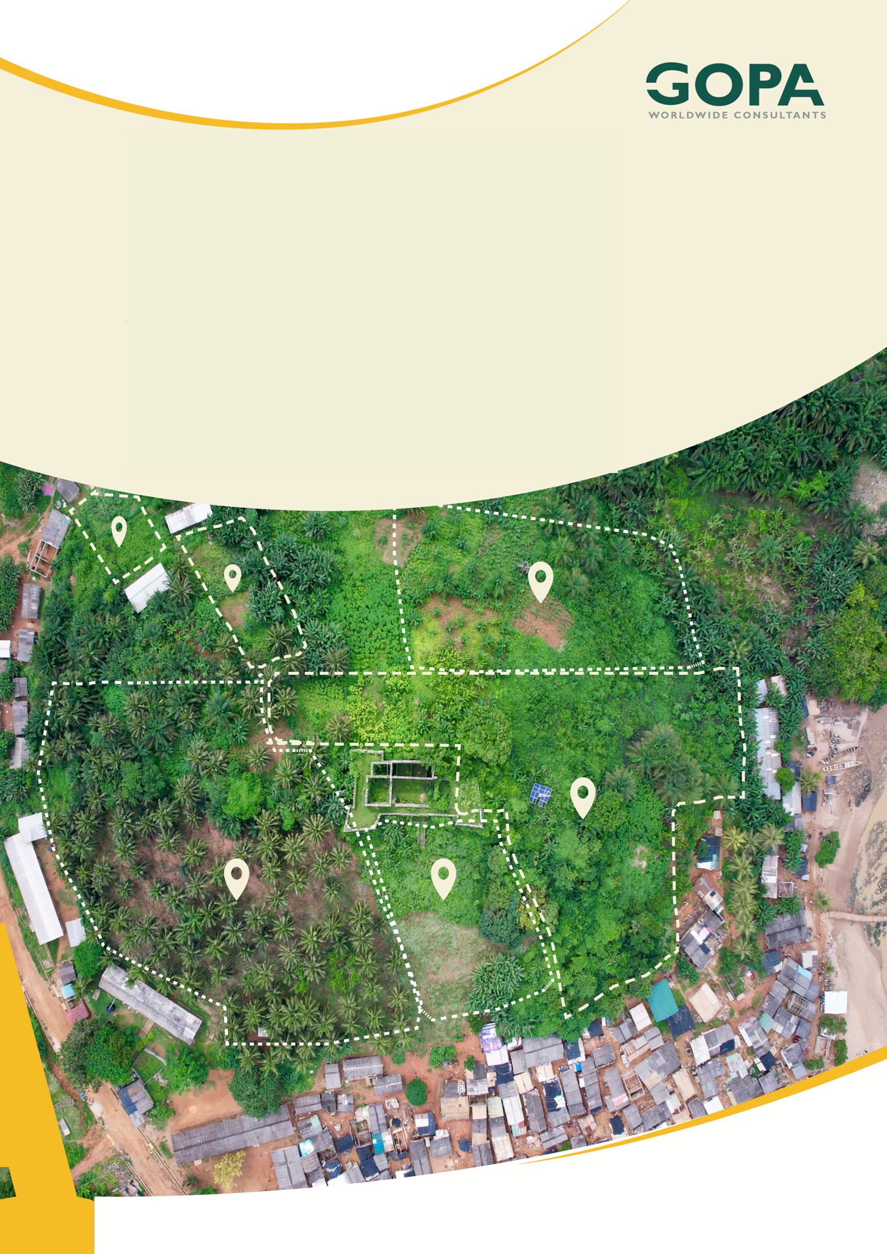
GHANA
Development of a Spatial Planning and Management Information System for Ghana
LUPMIS2 Training — Topic 2 Exercises
Version control and secrets · self-paced · September 2026

Topic 2 — Version control, collaboration and secrets: exercises
Self-paced exercises for Training Plan section 6.2 · LUPMIS2 capacity building for LUSPA

1. How to use these exercises
Section 6.2 of the Training Plan sets four learning outcomes. These eight exercises work towards them in order: first Git on your own computer, then the real LUPMIS2 history, then working together through the LUSPA Gitea server, and finally what to do about secrets — including the case where object-store keys were committed to Gitea. Each exercise has a goal, numbered steps and Check yourself questions; the answers are in section 5.
Exercise | Learning outcome (Training Plan 6.2) | Time
1 Your first repository | Use Git: commit, and see what changed | 45 min
2 Reading the LUPMIS2 history | Use Git: read the history | 60 min
3 Commit messages that explain why | Write a message that explains why, not only what | 45 min
4 Branches and merging | Use Git: branch and merge | 60 min
5 Resolving a conflict | Use Git: resolve a conflict | 60 min
6 Working through Gitea | Push, pull, open and review a change | 90 min
7 Keeping secrets out | Keep credentials out of source control | 45 min
8 When a secret has been committed | Know what to do when a secret has been committed | 75 min

Altogether about eight hours, within the four days the Training Plan gives the topic.
Practise on your own repository. Exercises 1 and 3 to 8 use a practice repository that belongs to you alone — break it as often as you like. In exercise 2 you only read the LUPMIS2 repository: do not commit or push anything there. Every key and token in these exercises is fake and marked as such.

2. Before you start
1. Finish Topic 1 first — the practice code is a small version of the formatLength function you met there.
2. Check Git is installed: git --version. You need version 2.28 or newer. On Windows, install Git for Windows and use Git Bash, so the commands below work exactly as written.
3. Ask your trainer for an account on the LUSPA Gitea server, https://gitea.lupmis4luspa.org, and for read access to the LUPMIS2 repository.
4. Tell Git who you are. This name and address are written into every commit you make:
git config --global user.name "Your Name"
git config --global user.email "your.work@address"

Avoid the editor trap. Some Git commands open a text editor for a message, and on many systems that editor is Vim. These exercises always give the message on the command line with -m, or use --no-edit, so it should not happen. If you do find yourself in Vim, press Esc, type :wq and press Enter. Commit IDs (the seven-character codes such as a6c7665) in the example output will be different on your computer; everything else should match.

3. Exercises

Exercise 1 — Your first repository
Outcome: use Git — commit, and see what changed · About 45 minutes
Goal. Make a repository, record two commits, and see how Git shows a change before and after you save it.
1. Somewhere outside the LUPMIS2 folder, create the practice repository:
mkdir lupmis-git-practice
cd lupmis-git-practice
git init -b main

2. Create a file README.md containing the single line # LUPMIS git practice. Run git status.
3. Run git add README.md, then git status again, and compare.
4. Record it: git commit -m "Start the practice repository".
5. Create units.js with exactly this content, then add and commit it with the message Add formatLength for distance labels:
export function formatLength(metres) {
if (metres > 1000) {
return (Math.round(metres / 10) / 100) + ' km';
}
return Math.round(metres) + ' m';
}

6. In your editor, change metres > 1000 to metres >= 1000 and save. Run git status --short, then git diff.
7. Run git restore units.js, then git status, and look at the file in your editor.
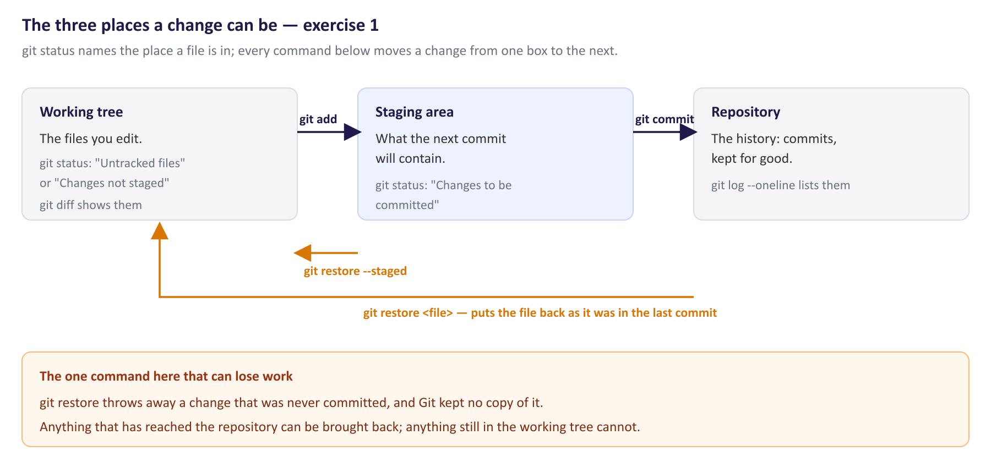
The three places a change can be, and the commands that move it between them.
8. Run git log --oneline.
Check yourself
a) What was different between the two git status outputs in steps 2 and 3?
b) In the git diff output, what do the lines starting with - and + mean?
c) What did git restore do? Can you get your change back?
d) Why does Git make you add and then commit, rather than committing in one step?

Exercise 2 — Reading the LUPMIS2 history
Outcome: use Git — read the history · About 60 minutes
Goal. Answer real questions about LUPMIS2 from its history alone. Everything here only reads; nothing changes.
1. Clone the repository into its own folder, next to your practice repository — not inside it:
git clone https://gitea.lupmis4luspa.org/ekke/pwaLUPMIS2.git
cd pwaLUPMIS2

2. See the whole history, oldest first, with dates: git log --reverse --format="%h %ad %s" --date=short. Press q to leave the listing.
3. Find the commit that created the ignore file: git log --oneline -- .gitignore — the oldest is at the bottom. Look at it with git show --stat <id>; the last line is a summary. Then read its message on its own with git show -s <id>.
4. Count what the first commit contained: git ls-tree -r --name-only 3009a11b | grep -c "^node_modules/".
5. Run git blame src/units.js and find the line if (metres > 1000) {.
6. Find a commit by its message: git log --oneline -i --grep=apache. Look at the hardening commit with git show --stat <id> and read its message.
7. Compare git log --oneline --grep=".env" with git log --oneline -F --grep=".env".
Check yourself
a) When was the first commit made, and what does its message tell you?
b) Which commit created .gitignore, how many files did it change, and what were most of them?
c) Are those files gone from the repository now?
d) Which commit last changed the if (metres > 1000) line, and when?
e) Which files did the Apache hardening commit change? According to its message, why is a web server that exposes the .git folder worse than one that exposes a .env file?
f) Why does one --grep find four commits and the other only one?

Exercise 3 — Commit messages that explain why
Outcome: write a commit message that explains why a change was made, not only what changed · About 45 minutes
Goal. See the difference a message makes to the next person — who is often you, six months later — and practise writing one.
1. In the LUPMIS2 clone, read four real messages with git show -s <id> for each of 3009a11b, 4d594f58, 5967b99a and 664c2429.
2. Rank them from least to most useful. For each, note whether it says what changed, why, and how it was checked.
3. Write a subject line and a short body for each of these three changes. The first line should say what the change does, in under about 60 characters, starting with a verb; after a blank line, the body says why, and how you checked.
a) You changed metres > 1000 to metres >= 1000 in formatLength, because exactly 1000 m was shown as “1000 m” while 1000.4 m showed as “1 km”. You checked 999.99, 1000 and 1000.4.
b) You raised the offline tile limit from 5,000 to 8,000, because downloading one district at zoom 10–15 needed about 6,500 tiles and the first tiles were deleted before the download finished. You checked that a full district download now keeps every tile.
c) You added .env to .gitignore, because each computer keeps its own keys in that file. You checked with git check-ignore.
4. Back in the practice repository, make a small change, commit it with the message stuff, then replace the message: git commit --amend -m "<your better message>". Check with git log --oneline -2.
Check yourself
a) How did you rank the four messages, and why?
b) When is it safe to use --amend, and when is it not?

Exercise 4 — Branches and merging
Outcome: use Git — branch and merge · About 60 minutes
Goal. Make changes on branches and bring them back, and see the two ways a merge can turn out.
1. In the practice repository, start a branch: git switch -c exact-kilometre.
2. Change metres > 1000 to metres >= 1000 in units.js and commit with a message that explains why (exercise 3).
3. Go back and merge: git switch main, then git merge exact-kilometre. Read the output.
4. Start a second branch, git switch -c metre-decimals, and change the last return line to return (Math.round(metres * 10) / 10) + ' m';. Commit.
5. Switch back to main, add a second line to README.md saying what the repository is for, and commit that.
6. Merge the branch: git merge --no-edit metre-decimals. Read the output.
7. Draw the history: git log --oneline --graph --all.
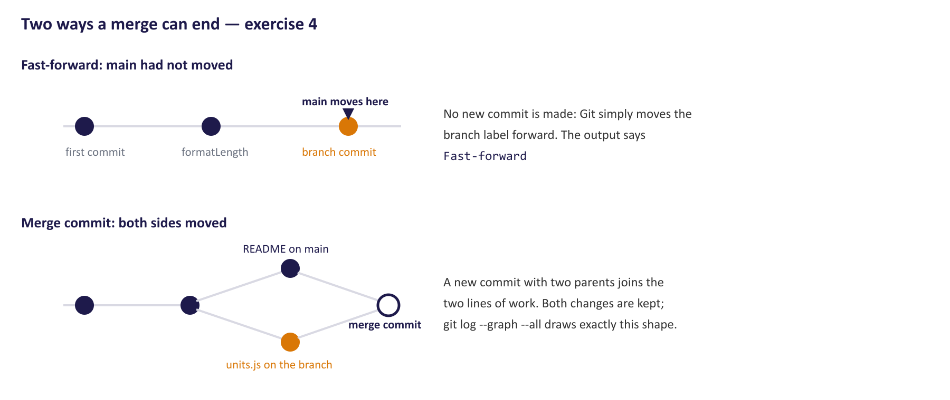
Why one merge printed Fast-forward and the other made a commit.
8. Delete the branches you have finished with: git branch -d exact-kilometre metre-decimals.
Your graph should have this shape (the IDs will differ):
* 99b8a1f Merge branch 'metre-decimals'
|\
| * 662b36e Show short distances to 0.1 m
* | 49b666b Say what the repository is for
|/
* b3f4209 Show exactly 1000 m as 1 km
* a6c7665 Add formatLength for distance labels
* fee1fc1 Start the practice repository

Check yourself
a) The first merge said Fast-forward. What does that mean?
b) Why did the second merge create a new commit, when the first did not?
c) Both branches changed something, yet Git merged them without asking you anything. Why?
d) Why is git branch -d safe to run here?

Exercise 5 — Resolving a conflict
Outcome: use Git — resolve a conflict · About 60 minutes
Goal. Create a conflict on purpose, read it, back out of it, and then resolve it properly.
1. Start a branch: git switch -c one-decimal-km. In units.js, change the kilometre line so it shows one decimal place: (Math.round(metres / 100) / 10) + ' km'. Commit with the message Show kilometres to one decimal place.
2. Switch back to main. Change the same line differently: keep / 10) / 100, but change ' km' to ' kilometres'. Commit with the message Write kilometres in full on printed reports.
3. Merge: git merge one-decimal-km. Read the output, run git status, and open units.js.
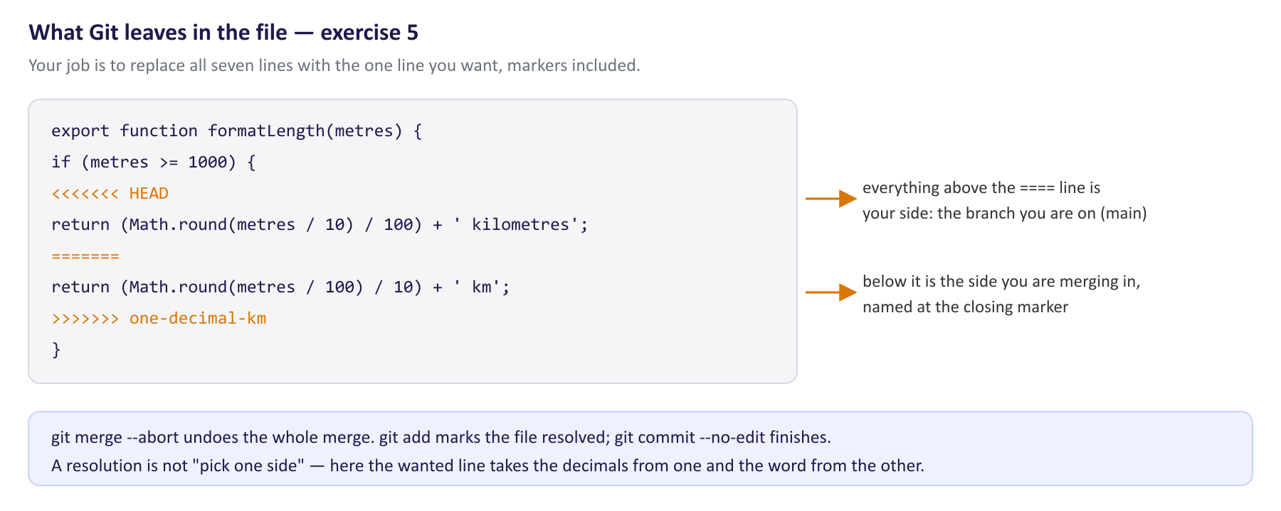
What Git leaves in the file when it cannot decide, and what each marker means.
4. Back out: git merge --abort. Check git status and the file again.
5. Merge again, and this time resolve it. Edit units.js so it contains exactly what you want — both intentions, one decimal place and the full word — with all three marker lines removed.
6. Mark it resolved and finish: git add units.js, then git commit --no-edit. Look at git log --oneline --graph -5.
After step 3, the file looks like this:
export function formatLength(metres) {
if (metres >= 1000) {
<<<<<<< HEAD
return (Math.round(metres / 10) / 100) + ' kilometres';
=======
return (Math.round(metres / 100) / 10) + ' km';
>>>>>>> one-decimal-km
}
return (Math.round(metres * 10) / 10) + ' m';
}

Check yourself
a) What do the three marker lines mean?
b) Why could Git merge exercise 4’s branches by itself, but not this one?
c) What did your resolved line look like?
d) Without running it, what does your resolved formatLength(1234) return?

Exercise 6 — Working through Gitea
Outcome: work with the LUSPA Gitea server — push, pull, open and review a change · About 90 minutes
Goal. Take a change through the full cycle the team uses: branch, commit, push, pull request, review, merge. This is the first half of the Training Plan’s hands-on task.
Part A — put the practice repository on Gitea
1. Sign in to Gitea. Use + at the top right and choose New Repository. Name it lupmis-git-practice, make it private, and leave the options that create a README or a .gitignore unticked — your repository already has history, and Gitea’s must start empty.
2. Copy the repository’s HTTPS address from the page Gitea shows. Connect and upload:
git remote add origin https://gitea.lupmis4luspa.org/<your-user>/lupmis-git-practice.git
git push -u origin main

3. Git asks for your Gitea user name and password. If your account uses two-factor sign-in, it needs an access token instead: in Gitea, Settings › Applications, generate one with repository read and write permission, and paste it as the password.
4. Reload the repository page in Gitea and look at the files and the commit list.
A token is a secret too. Never write a token into the remote address (https://user:token@…): Git saves the address in .git/config in plain text. Let Git’s credential helper store it — Git for Windows and macOS do this securely by default.

Part B — a pull request, reviewed and merged
5. Start a branch, git switch -c area-format, and add this function to the end of units.js:
export function formatArea(sqMetres) {
if (sqMetres >= 10000) {
return (Math.round(sqMetres / 100) / 100) + ' ha';
}
return Math.round(sqMetres) + ' m²';
}

6. Commit it with a message that explains why, and push the branch: git push -u origin area-format.
7. In Gitea, open a pull request from area-format into main (Gitea offers it after the push, or use Pull Requests › New Pull Request). In the description say what the change does, why, and how you checked it.
8. Review it: open Files Changed, click the + beside a line, and leave a comment — for example, whether 9,999.6 m² should really show as 10000 m². Submit the review. Gitea does not let you approve your own pull request; if you are working with a colleague, review each other’s instead.
9. Answer the comment with a new commit on the same branch, and git push. The pull request updates by itself.
10. Merge it in Gitea with Create merge commit, and delete the branch when Gitea offers.
11. Bring your computer up to date and tidy up:
git switch main
git pull
git branch -d area-format
git fetch --prune

Part C — when someone else got there first
12. In Gitea, open README.md, use the pencil icon to edit it, add a line, and commit directly to main in the browser. This stands in for a colleague’s change.
13. On your computer, without pulling, change and commit something else — a comment at the top of units.js will do. Now git push.
14. Run git pull and read the message.
15. Choose merging as your way of pulling, then pull and push:
git config --global pull.rebase false
git pull --no-edit
git push

Check yourself
a) What does a pull request give the team that merging on your own computer does not?
b) Why was your push in step 13 rejected?
c) What did git pull say in step 14, and what does pull.rebase false choose?
d) Why use an access token rather than your password, and where must it never go?

Exercise 7 — Keeping secrets out
Outcome: keep credentials out of source control · About 45 minutes
Goal. Set a repository up so keys stay on the machine that needs them, and learn the one situation where .gitignore does nothing.
1. In the practice repository, create a file .env containing MAP_KEY=practice-not-a-real-key. Run git status --short.
2. Create .gitignore containing the line .env. Run git status --short again, then git check-ignore -v .env.
3. Create .env.example containing just MAP_KEY=. Commit .gitignore and .env.example together, with a message that explains why.
4. Now the trap. Create settings.local.json containing {"lastDistrict": 12}, add it and commit it. Then add the line settings.local.json to .gitignore, change the file to {"lastDistrict": 7}, and run git status --short.
5. Stop tracking it without deleting it: git rm --cached settings.local.json. Run git status --short, commit, and check the file is still in your folder.
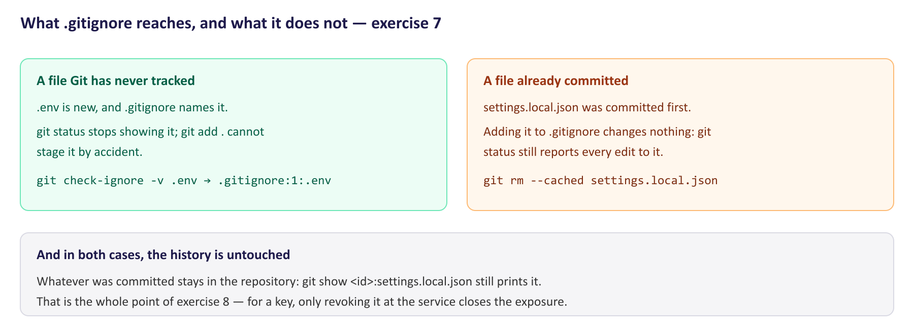
Why .gitignore worked for .env and did nothing for settings.local.json.
6. Look for it in the history: git log --oneline -- settings.local.json, then git show <id of "Add local settings">:settings.local.json.
7. In the LUPMIS2 clone, run git check-ignore -v .env.local, open .gitignore at that line, and read .env.example.
Check yourself
a) In step 1, what would git add . have done?
b) In step 4, why was settings.local.json still reported as changed, although .gitignore now names it?
c) After step 5, is the old {"lastDistrict": 12} gone from the repository?
d) Which rule did Git name for .env.local in LUPMIS2, and why that one?
e) What is .env.example for, and why is it safe to commit?

Exercise 8 — When a secret has been committed
Outcome: know what to do when a secret has been committed · About 75 minutes
Goal. See for yourself why deleting a key from the code does not un-publish it, what does, and how LUPMIS2 handled a real case. This is the second half of the Training Plan’s hands-on task.
Part A — a key that was pushed
1. In the practice repository, create map.js with the line below, commit it as Add map key, and git push.
const MAP_KEY = 'FAKE-KEY-7f3a-practice-only';
export default MAP_KEY;

2. “Fix” it: change the first line to const MAP_KEY = process.env.MAP_KEY;, commit as Read the map key from the environment, and push.
3. Search the current files with git grep FAKE-KEY. Then search the history with git log -S "FAKE-KEY" --oneline, and print the old file with git show <id of "Add map key">:map.js.
4. In Gitea, open the commit list and click Add map key.
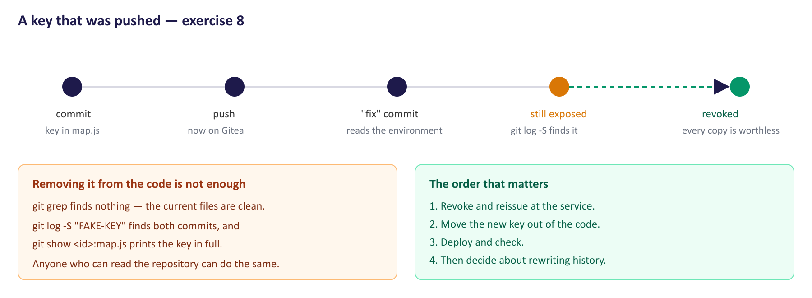
The sequence in Part A, and why the response has to start at the right end.
Part B — the response, in the right order
Read this, then answer the questions below it. When a real secret has been pushed:
1. Revoke it and issue a new one at the service it belongs to. This is the step that actually closes the exposure: every copy of the old key, wherever it is, stops working.
2. Move the new one out of the code — into an environment variable or a git-ignored file, as in exercise 7.
3. Deploy with the new key and check the service works.
4. Decide about the history. Tools such as git filter-repo can rewrite history to remove the key, but every clone must then be replaced, and copies already made — other people’s clones, backups, a server that exposed .git — are out of reach. Once the key is revoked, the copy in the history is worthless, which is why step 1 comes first.
5. Record what happened and what was done.
Part C — caught before pushing
5. Create upload.js containing const TOKEN = 'FAKE-TOKEN-b21c-practice-only'; and commit it as Add upload helper. Do not push.
6. Change the line to const TOKEN = process.env.UPLOAD_TOKEN; and fold the fix into the same commit: git commit -a --amend --no-edit.
7. Search: git log -S "FAKE-TOKEN" --oneline, then git log -S "FAKE-TOKEN" --oneline --reflog.
Part D — the LUPMIS2 case
The MinIO object store that holds LUPMIS2’s raster files is reached with an access key and secret. Those were once written directly into the PHP files of the upload service, and those files are tracked in Gitea. In the LUPMIS2 clone, read the message of commit 664c2429 again (git show -s 664c2429), and section 17 of the Development Status Report, which describes the fix: the keys are now read from environment variables through a small configuration module that stops with a clear error if they are missing, and the previous keys are to be revoked in the MinIO console by the infrastructure team.
Check yourself
a) After Part A, is the fake key still exposed? Where, and to whom?
b) Why does the response start with revoking the key, and not with removing it from the code?
c) After Part C, is the fake token gone? Did it ever leave your computer?
d) The LUPMIS2 configuration module stops with an error instead of falling back to a built-in key. Why does that matter?
e) In the LUPMIS2 case, which single action removes the risk from the keys in the Gitea history, and who can take it?

4. After the exercises
Bring your answers, your Gitea pull request from exercise 6, and your three commit messages from exercise 3 to the next session with your trainer. Exercise 8 is best finished as a discussion: the steps in Part B are easy to agree with and hard to follow under pressure, which is why they are worth rehearsing. You can delete the practice repository from Gitea afterwards (Settings of the repository, at the bottom).

5. Answers
Produced by running every command in a scratch repository with Git 2.54. Commit IDs will differ on your computer; wording can differ slightly between Git versions.
Exercise 1
a) Step 2 lists README.md under Untracked files: Git sees it but is not recording it. Step 3 lists it under Changes to be committed as new file: it is staged, and the next commit will include it.
b) - is the line as it was in the last commit; + is the line as it is now. Here - if (metres > 1000) { and + if (metres >= 1000) {. The @@ -1,5 +1,5 @@ line says where in the file the change sits.
c) It threw your uncommitted change away and put the file back as it was in the last commit. No, you cannot get it back: it was never committed, so Git never had a copy. That is the one command in this exercise that loses work.
d) Staging lets you choose what goes into a commit. If you changed three files for two different reasons, you can commit them as two separate, explainable changes.
Exercise 2
a) 4 March 2026: 3009a11b intial pwa LUPMIS2 commit. It says only that this was the first commit — nothing about what the application did at the time — and it contains a typo.
b) 9b57ff9e Add .gitignore and untrack node_modules / IDE state, which changed 5,686 files. Its message says 5,679 of them were the node_modules folder, which had been committed with everything else in the first commit.
c) No. The count in step 4 is 5679: those files are still inside the first commit, and everyone who clones the repository downloads them. Removing a file from tracking does not remove it from history — the same fact exercise 8 turns on.
d) ef12e447, 26 May 2026: Offline tile cache, polygon Divide, topographic layer integrations.
e) public/.htaccess, dist/.htaccess and docs/apache-hardening.conf. An exposed .env file leaks the settings in it now; an exposed .git folder lets anyone rebuild the whole repository including its history, so any credential ever committed is exposed, even after it was removed from the code.
f) --grep takes a regular expression, in which . means “any character”, so .env also matches “ envelope”, “ environment” and “ env files” in the messages of three other commits. -F makes it search for the literal text .env.
Exercise 3
a) From least to most useful: 3009a11b (says nothing, and has a typo); 4d594f58 (subject only names a version number, but the body says why: to evict stale caches so devices pick up the changes); then 5967b99a and 664c2429, which say what changed, why — the problem as a user saw it, or the attack being prevented — how it was verified, and the details that are easy to get wrong. Someone debugging either area later starts from those messages.
b) Only on commits you have not pushed. Amending replaces the commit with a new one; if others already have the old one, your histories no longer match and pushing is rejected.
Example messages for step 3 (yours can differ; the test is whether they say why and how it was checked):
Show exactly 1000 m as 1 km

formatLength used '> 1000', so exactly 1000 m stayed in metres while
1000.4 m became '1 km'. Now '>= 1000'. Checked 999.99, 1000 and 1000.4.

Raise the offline tile limit to 8,000

One district at zoom 10-15 needs about 6,500 tiles; at 5,000 the first
tiles were deleted before the download finished. Checked that a full
district download now keeps every tile.

Keep .env out of the repository

Each computer holds its own keys in .env. Checked with git check-ignore.

Exercise 4
a) main had not moved since the branch started, so Git simply moved main forward to the branch’s last commit. No new commit was needed.
b) This time both sides had new commits — the branch changed units.js, main changed README.md — so Git made a merge commit with two parents to join them. The graph shows the fork and the join.
c) They changed different files (and could equally have changed different lines of one file). Git merges automatically whenever changes do not touch the same lines.
d) -d refuses to delete a branch whose commits are not merged. Both are merged into main, so nothing is lost; use -D only when you really mean to throw work away.
Exercise 5
a) <<<<<<< HEAD starts your side (the branch you are on, main); ======= separates it from the other side; >>>>>>> one-decimal-km ends the side you are merging in. Git printed CONFLICT (content): Merge conflict in units.js and git status listed the file as both modified.
b) Both branches changed the same line in different ways. Git cannot know which you want — or, as here, that you want parts of both — so it asks.
c) return (Math.round(metres / 100) / 10) + ' kilometres';
d) "1.2 kilometres": 1234 / 100 = 12.34, rounded to 12, divided by 10.
Exercise 6
a) A place where someone other than the author reads the change before it reaches main, with the discussion kept next to the code, and a record of who reviewed and merged what.
b) Gitea’s main had a commit you did not have: ! [rejected] main -> main (fetch first). Git will not let a push overwrite work on the server that you have not seen.
c) fatal: Need to specify how to reconcile divergent branches. Both sides had new commits. pull.rebase false tells Git to reconcile them by merging, making a merge commit as in exercise 4. The alternative, rebasing, is covered later in the programme.
d) A token can be limited to what it is for and revoked on its own without changing your password. It must never go into a file in a repository or into the remote address — both would store it in plain text.
Exercise 7
a) It would have staged .env — and the next commit would have recorded the key. git status showed ?? .env: untracked, but not ignored.
b) .gitignore only applies to files Git is not tracking yet. Once a file has been committed, Git keeps tracking it until you tell it to stop with git rm --cached.
c) No. git show prints {"lastDistrict": 12} from the commit that added it. Stopping tracking affects the future, not the past — like node_modules in exercise 2.
d) .gitignore:35:*.local. Line 33 names .env.local exactly, and the *.local rule on line 35 matches it too. When several rules match, the last one decides, and that is the one Git reports.
e) It tells a new developer which settings they need to create, without containing any values. LUPMIS2’s lists VITE_CARTO_API_KEY with a comment on where to get one.
Exercise 8
a) Yes. git grep finds nothing in the current files, but git log -S finds both commits — the one that added it and the one that removed it — and git show prints the key. Anyone who can read the repository on Gitea, or who has cloned it, can see it.
b) Removing it from the code changes only the future. Revoking it makes every copy that already exists — in the history, in clones, in backups — useless, which nothing else can do.
c) It is gone from the branch: the first search finds nothing. --reflog still finds the replaced commit, because Git keeps a local record of where your branch has been; unreachable entries expire after a few weeks. It never left your computer, because you never pushed it. If there is any doubt, revoke it anyway.
d) A built-in fallback lets a key live on in the code unnoticed, because everything keeps working. Stopping with a clear error makes a missing configuration impossible to overlook.
e) Revoking the previous keys in the MinIO console. Only the infrastructure team has console access. Until then, the old keys in the Gitea history still work.

