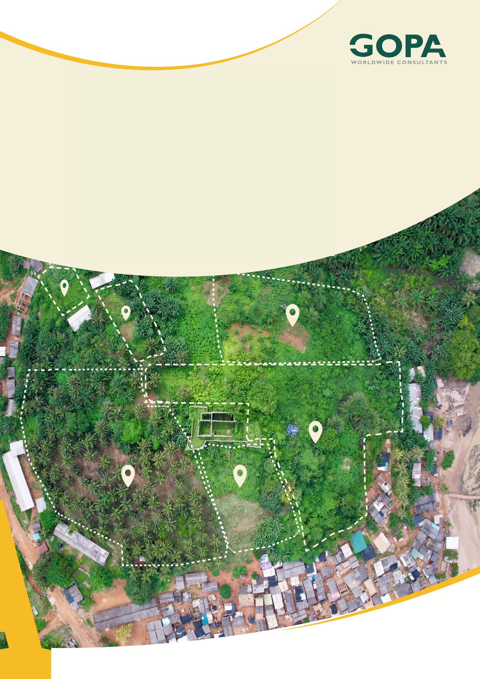
GHANA
Development of a Spatial Planning and Management Information System for Ghana
LUPMIS2 Buffer (Circle) Tool — User Guide
Measuring a radius around a point · August 2026

Buffer (Circle) Tool — User Guide
How to measure a radius around a point and see what falls inside it · August 2026

1. First — what the tool is called
There is no button named “Buffer”. The tool that creates a buffer around a point is the Circle button (the circle icon) in the toolbar at the bottom of the map. A circle drawn around a point is a buffer — everything within a fixed distance of that point — which is why the two names are used for the same thing. Look for Circle, not “Buffer”.

This guide explains how to draw one, how to read what it tells you, and — the part most often missed — how to see which parcels and zones fall inside it.

2. What the tool gives you
The Circle tool does two separate jobs. Most users find the first one immediately and never discover the second.
What you get | How you get it
The distance and the area — the radius of the circle and the ground area it covers | Shown automatically while you draw
The analysis — a list of the parcels, zones and other features that fall inside the circle | Only appears when you DOUBLE-CLICK the finished circle

If you have been drawing circles and only seeing a distance, this is what you were missing: double-click the circle after you finish it.

3. Drawing a circle — it is two clicks, not a drag
This is the second common source of confusion. The circle is not created by holding the mouse button down and dragging outwards. It takes two separate clicks.
1. Click the Circle button in the bottom toolbar. It stays highlighted while the tool is active.
2. Click once on the map at the centre of your buffer — the point you are measuring from. Then release the mouse.
3. Move the mouse outwards. The circle grows as you move, and a label follows the pointer showing the current radius and area.
4. Click a second time when the radius is the distance you want. The circle is now finished.
On a phone or tablet: tap once for the centre, then tap a second time at the edge. The same two-step gesture.
A short line is drawn from the centre to the edge after you finish. That is the radius line, there to make the circle easy to see — it is not a separate measurement.
A finished measurement cannot be reshaped. Earlier versions showed small round handles on the circle and its radius line while the Digitise tool was active, and dragging one quietly changed the shape without changing the radius and area reported — so the figures no longer matched the area being measured. Measurements are now read-only: no handles appear, and the numbers always describe the circle you drew. To measure something different, draw another circle, or press Clear and start again.

4. Reading the measurement
While you are drawing, and after you finish, the label shows two figures:
• The radius (the larger, bold figure) — the distance from the centre to the edge of the circle.
• The area (the smaller figure below) — the ground area the whole circle covers.
The units follow the Measurement System setting in Settings:
Setting | Radius shown as | Area shown as
Metric | metres (m), or kilometres (km) for long distances | m², or km² for large areas
Imperial | feet (ft), or miles (mi) for long distances | ft², acres, or mi² for large areas

Setting the radius to an exact figure. There is no box to type a radius into, so the distance is set by eye: move the pointer slowly and watch the label, then click when it reads the value you need. Zoom in first — the further in you are zoomed, the finer the control, so a 50 m buffer is far easier to hit accurately at street level than at district level.

5. Seeing what falls inside the circle
This is the step most users miss. Once the circle is finished, double-click anywhere inside it. A panel opens listing everything the circle touches — parcels, zones and any other data layers you have switched on.
Double-click the circle itself, not the thin radius line. Double-clicking the radius line does nothing at all, which can make it look as though the feature is broken.
From that panel you have two further options:
Button | What it does
Analyse | Opens the Spatial Analysis panel with the scope already set to the features the circle caught — so overlays or zonal statistics run on just that area. See the Spatial Analysis user guide.
Export | Saves the intersecting features as GeoJSON, Shapefile or KML, or produces a PDF summary report of the figures.

6. A worked example — what is within 200 m of this borehole?
1. Switch on the layers you want to test against — Parcels, and any others of interest.
2. Zoom in so the area of interest fills most of the screen. This makes the radius easier to set accurately.
3. Click Circle, then click once on the borehole.
4. Move outwards until the label reads about 200 m, then click again to finish.
5. Double-click inside the circle. The panel lists the parcels and zones within 200 m.
6. Click Export to save the list, or Analyse to summarise it further.

7. Removing circles
Circles stay on the map until you clear them, so you can draw several and compare. Use the Clear button in the toolbar to remove all measurements at once.
Drawing a second circle does not remove the first. If the map becomes cluttered, clear everything and start again.

8. If something does not work
What you see | Why | What to do
Nothing happens when you drag on the map | The tool expects two clicks, not a drag. A drag pans the map instead. | Click once for the centre, move, then click again
You get a distance but no list of parcels | The analysis only opens on a double-click | Double-click inside the finished circle
Double-clicking does nothing | You may be double-clicking the thin radius line rather than the circle | Double-click well inside the circle, away from the line
The panel opens but lists nothing | No features fall inside, or the layers are not loaded | Switch on the layers you want to test and check they have loaded
The radius is in feet, not metres | The Measurement System is set to Imperial | Settings → Measurement System → Metric
The circle is hard to size accurately | You are zoomed too far out, so each pixel covers a long distance | Zoom in and draw again
Old circles are cluttering the map | Circles stay until cleared | Press Clear in the toolbar
You cannot drag or reshape a finished circle | Measurements are read-only by design, so the figures always match the shape | Draw a new circle at the size you need

9. Quick reference
Task | How
Start a buffer | Circle button in the bottom toolbar
Set the centre | Click once on the map
Set the radius | Move outwards, watch the label, click again
Read the distance and area | The label on the circle
See what is inside | Double-click inside the circle
Analyse what is inside | Analyse in that panel
Save what is inside | Export in that panel
Change the units | Settings → Measurement System
Remove the circles | Clear in the toolbar

10. Related documents
This guide is one of a set. The manual is the place to start; the guides go deeper on one tool each.
• LUPMIS2 User Manual — Part 1: Core Map Tools — the map, layers, locations, measuring, exporting and working offline. Section 8 covers all three measuring tools; this guide is the detail behind the Circle.
• Spatial Analysis (Analyse) — User Guide — what to do with the features a circle catches: overlays and zonal statistics.

