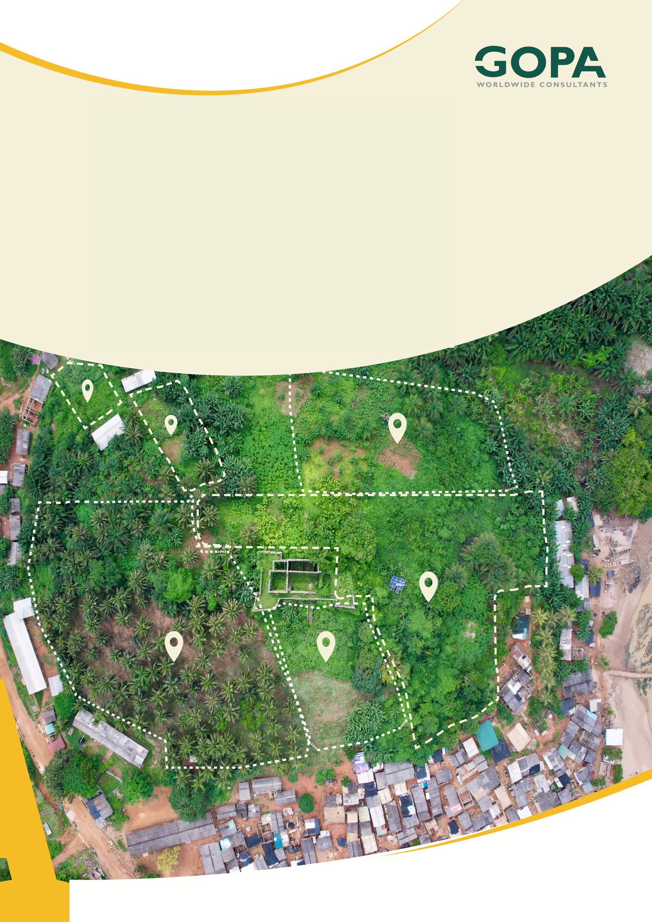
GHANA
Development of a Spatial Planning and Management Information System for Ghana
LUPMIS2 User Manual — Part 1
Core Map Tools · August 2026

User Manual — Part 1: Core Map Tools
LUPMIS2 · For district planning officers · August 2026
What this part covers. Everything you need to open the application, find your district, choose what to look at, measure and analyse it, export the result, and keep working when there is no network. The drawing and data-collection tools changed recently and are covered in Part 2, once that behaviour has settled in the field.

1. About this manual
This manual is written for the district planning officer using LUPMIS2 on a laptop, tablet or phone. It assumes no GIS training. Where a term has a particular meaning in LUPMIS2 — a layer, a zone, a UPN — it is explained the first time it appears.
It is published in parts so that each part can be trusted:
• Part 1 (this document) — the map, layers, locations, measuring, analysing, exporting, and working offline.
• Part 2 (to follow) — the drawing and digitising tools, and adding or editing data in the field.
• Part 3 (to follow) — uploading to the central database and supervisor review, once those endpoints are in service.
Two companion guides go into more depth than this manual does, and are referred to where relevant: the Spatial Analysis (Analyse) User Guide and the Buffer / Circle Tool tutorial.
Which version this describes. Application version 23, August 2026. The version is shown in the page header of this document. If a screen does not match what you read here, check with your administrator which version is installed — an older installation may behave differently, particularly around the drawing tools.

2. Signing in and your district

2.1 Signing in
LUPMIS2 shares one sign-in with the other LUPMIS systems. You do not have a separate password for the map.
1. Open pwa.lupmis4luspa.org in your browser.
2. If you are not already signed in, you are taken to the LUSPA sign-in page. Sign in there.
3. You are returned to the map, and the menu button in the top-right shows your name.
If you see a small orange dot on the menu button, you are not signed in. Open the menu to see why and to sign in.

2.2 The district you see
The map opens on the district recorded against your account. Parcels, zones, roads, facilities and contours are all limited to that district — this is what keeps the application quick on a field device.
If you are shown the wrong district. Your district comes from your user account, not from the map. If it has recently been changed for you, sign out and sign in again: the district is read once when your session begins. Signing out fully is what picks up the change — see 2.3.

2.3 Leaving the application
The menu offers two different ways out, and they are not the same:
• Back to Landing Page — returns you to the LUSPA portal and leaves you signed in. Use this to move to another LUPMIS system.
• Logout — ends your session completely, here and at the portal. Use this on a shared device, and whenever your district has been changed.
Signing out needs a connection. Logout hands you over to the portal to close the session there. If you are offline, your session on this device is still ended and the device is left safe, but finish signing out at the portal when you are next online.

2.4 Installing on a phone or tablet
LUPMIS2 can be installed like an app, which gives it its own icon and a full screen without the browser bars. Nothing is downloaded from an app store.
1. Open the application in the browser.
2. Tap Install App when it appears, or use the browser's own “Add to Home Screen”.
3. Open it from the home-screen icon from then on.
Installing also makes offline use more reliable, because the application keeps its own copy of the map interface on the device.

3. The map screen
The screen has five areas. They are the same on every device, although on a phone they are smaller and some labels are hidden.
Area | Where | What it is for
Top bar | Across the top | The GPS read-out, the number of saved locations, and the menu button with your name and the sign-out options.
Bottom dock | Across the bottom | The tools: Circle, Distance, Area, Digitise, Analyse and Clear.
Tools panel | Left edge, ◀ button | Importing files, the local database viewer, exports, and refreshing cached layers.
Saved Locations | Right edge, ▶ button | The list of locations recorded on this device.
Settings | Bottom edge, ▼ button | Display, units, coordinate format, default base map and offline map tiles.

The map itself carries a few floating controls: zoom and search at the top-left, and the layer switcher and My Location at the bottom-right.

4. Moving around the map
To do this | On a computer | On a phone or tablet
Zoom in or out | The + and − buttons, or the mouse wheel | Pinch with two fingers, or the + and − buttons
Move the map | Click and drag | Drag with one finger
Find a place by name | The magnifying glass at the top-left | The magnifying glass at the top-left
Return to your data | Fit All in the Tools panel | Fit All in the Tools panel

The scale bar at the bottom-left shows the current scale both as a ratio (for example 1 : 25,000) and as a distance bar. Use the ratio when you need to state the scale a plan was read at.

5. Base maps
The base map is the background your data is drawn on. Only one is shown at a time. Choose it from the base-map button beside the layer switcher, or set the one you want to start with in Settings.
Base map | Best for
Topographic | General planning work. Shows relief, roads and place names. This is the default.
OpenStreetMap | Streets, buildings and local detail in built-up areas.
Satellite | Seeing what is actually on the ground — buildings, cultivation, encroachment.
Google Sat | A second satellite view, useful when the first is cloudy or out of date for your area.
Carto Light | A pale background that lets your own layers stand out. Good for printing and for reports.
Carto Dark | The same idea in dark tones, easier on the eyes indoors or at night.
OSM Cycle map | Paths and tracks that other base maps leave out.
None (no base map) | Your data alone on a blank background, when the backdrop would distract.

Base maps need a connection the first time. Each base map is fetched from its provider as you use it, then kept on the device. An area you have already looked at will still draw when you are offline; an area you have never visited will not. See section 11.

6. Layers
A layer is one kind of information drawn on the map — parcels, roads, contours, health facilities. You control which are shown from the layer switcher, the button with the stacked-sheets icon at the bottom-right.

6.1 The layer groups
Layers are grouped by what they describe. The groups follow the way the data is organised in the central database, so a name here matches the name the database team uses.
Group | Contains
Administration | District boundary, collector zones, the UPN grid.
Land Use | Parcels and their land-use classification, building footprints, agricultural land.
Physical Infrastructure | Roads and buildings.
Biophysical Environment | Terrain and natural features, including the contours.
External Source | Layers you or a colleague have added from an outside service.
Drawings, Measurements, Markers | Your own work on this device: sketches, measurements, and saved locations.
Base Maps | The backgrounds from section 5, managed by the base-map button rather than here.

6.2 Turning layers on and off
• Tick or untick a layer to show or hide it.
• The count in the panel header tells you how many layers are currently shown — useful when the map looks busier than you expect.
• Reset overlays at the foot of the panel hides every overlay at once. Base maps are not affected.
• The small tag beside each name says what kind of layer it is: VEC for map features, WMS or XYZ for a service, COG for a raster image, BASE for a background.
Some layers only appear once their data has been fetched for your district. If a layer is ticked but nothing is drawn, check first that you are looking at the right place, then see section 14.

6.3 Adding a layer from another service
If another agency publishes a map service, you can add it without waiting for it to be built into LUPMIS2.
1. Open the layer switcher and press the green + on the External Source group.
2. Choose the kind of service — WMS, WFS, XYZ tiles or a Cloud-Optimized GeoTIFF — and paste its address.
3. Give it a name and add it. It appears in External Source, and can be removed again from the same place.
Added layers are not saved for anyone else. A layer you add is available on this device, in this session. Ask the database team if a source should become a permanent LUPMIS2 layer for everybody.

7. Locations
A location is a point you have recorded — a water point, a school, a site you inspected. Locations are stored on the device, and are listed in the Saved Locations panel on the right.

7.1 The Saved Locations list
Open it with the ▶ button on the right edge. The number of locations is also shown in the top bar. Tapping an entry moves the map to that location and highlights it.

7.2 The Markers layer
Locations are drawn by a layer called Markers, in the layer switcher. Its behaviour is worth knowing, because it explains something that otherwise looks like data loss:
• On a district with no locations, the Markers layer is switched off, so the map opens uncluttered.
• As soon as there is at least one location, the layer is switched on for you — when the application starts, and again whenever you add one.
• If you switch Markers off yourself, it will be switched back on the next time locations are loaded or you save a new one.
If your locations are not on the map. Check the Markers layer in the layer switcher first. A location that is listed in the Saved Locations panel is safely stored on the device even if nothing is drawn — the list and the map read from the same place, so the record is not lost.

7.3 Seeing a location's details
Tap a marker on the map to select it and show its details. This works when no tool is active. If you have a measurement or the Digitise tool running, a tap belongs to that tool instead — close it first.

8. Measuring
Three measuring tools sit in the bottom dock. All three report in the unit system chosen in Settings, and all three do more than measure: where the shape you draw overlaps data on the map, you are told what it caught.
Tool | What you draw | What you are told
Circle | A centre point, then drag to set the radius | Radius and area, and the parcels, zones and other features inside the circle.
Distance | A line, clicking each turn; double-click to finish | The length of each segment and the total.
Area | A polygon, clicking each corner; double-click to finish | The enclosed area and its perimeter, and what falls inside it.

Double-click a finished circle or area to bring its summary back. From that summary you can export the result (section 10) or send it straight to the Analyse tools (section 9).
Measurements are working notes: they stay until you press Clear in the dock, and they are not saved to the database. The Circle tool is covered in more depth in the Buffer / Circle Tool tutorial, including what the small handles on the radius line do.
Measurements cannot be edited by accident. While the Digitise tool is open, measurement shapes are deliberately not selectable, so you cannot drag one out of shape while editing something else. To change a measurement, clear it and draw it again.

9. Analysing
The Analyse tools answer questions about the data already on your map: which parcels fall inside a zone, how many facilities each zone has, what the highest and lowest ground in an area is. They run on the device, so they work offline.
• Overlays — combine two polygon layers to find where they intersect, differ or coincide.
• Zonal statistics — summarise one layer per zone of another: a count, a total, an average, a minimum or a maximum.
Open them with the Analyse button in the dock, or from a circle or area summary so that the analysis is limited to what that shape caught. Results are added to the map as a new layer, and a zonal statistics table can be exported to Excel together with the settings that produced it.
Full instructions are in the Analyse guide. The Spatial Analysis (Analyse) User Guide covers each operation, the “Apply to” scopes, worked examples and the messages the tool gives when a layer is not suitable. This section is only an orientation.

10. Exporting
Anything you can see, you can take away — for a report, for a colleague, or to open in QGIS or ArcGIS.
What you want | Format | Where to start
Map features for another GIS | GeoJSON, Shapefile or KML | Export on a circle or area summary; or Export in the Tools panel.
A report to print or attach | PDF | Export on a circle or area summary, then choose PDF. Carries the LUSPA letterhead, a table and a date stamp.
Analysis figures for a spreadsheet | Excel | Export on a zonal statistics result. A second sheet records the settings that produced the table.
A copy of everything on this device | Database file | Local Data in the Tools panel.

Why the Excel export has two sheets. The Results sheet is the table you asked for. The Parameters sheet records which layers, which statistics and which area it came from, so that months later the figures can still be explained and repeated.

11. Working offline
LUPMIS2 is built for districts where the network is not dependable. Once a district's data has been fetched, the application keeps a copy on the device and works from that.

11.1 What keeps working
• The map interface and all of its tools.
• District data already downloaded — parcels, zones, boundaries, roads, facilities, the UPN grid.
• Base-map tiles for areas you have already looked at.
• Recording locations and measuring, and the Analyse tools, which run on the device.

11.2 What needs a connection
• Base-map tiles for an area you have not visited before.
• Fetching a district's data for the first time, or refreshing it.
• Signing in and out.

11.3 Preparing for a field visit
Do this while you still have a connection, ideally the day before. It is the single most useful habit for field work.
1. Open the district and the layers you expect to need, so their data is fetched.
2. Move to the area you will visit and zoom in to the detail you will want, on the base map you will use.
3. Open Settings ▸ Offline Map Tiles and use Download offline map to keep that area's tiles.
4. Check that the area draws with the network switched off before you travel.

11.4 Managing stored tiles
The same Settings card lists each base map with the tiles kept for it, and lets you clear them — one provider at a time, or all at once. Clear them when the device is short of space, or when a base map has been updated and you want the newer imagery.
A connection that is present but not working. The application checks the server at start-up and gives up after about five seconds, so a network that is connected but not reaching the server does not leave you waiting. You are told it is working from cached data.

12. My Location and GPS
The My Location button at the bottom-right shows where you are. Your device will ask permission the first time; the application cannot use the GPS until you allow it.
• Locate me centres the map on your position and draws a circle showing how accurate the fix is.
• The read-out in the top bar shows your position and its accuracy in metres, updating as you move.
• Record starts a GPS trail, drawing your track as you walk or drive.
The read-out can show latitude and longitude, UTM, or both — choose in Settings ▸ GPS Coordinate Format. Use UTM when you are working with surveyors or with the national grid.
Two limits worth knowing. The satellite count shows a dash: a web browser is told how accurate a fix is, but not how many satellites produced it — read the accuracy in metres instead. And recorded trails are held on the device: sending them to the central database is not yet available, so do not clear the device's data with trails on it that you still need.

13. Settings
Settings are on the device, not the account: each device is set up for the way it is used. Open them with the ▼ button.
Setting | What it does
Fieldwork Mode | Larger buttons and stronger contrast for use outdoors, in sunlight, with one hand.
Dark Mode | A dark interface for indoor or night work.
Measurement System | Metric (m, km) or Imperial (ft, mi, acres). Applies to every measurement and report.
GPS Coordinate Format | Latitude and longitude, UTM, or both, in the top-bar read-out.
Default Base Map | Which background the application opens with.
Offline Map Tiles | Download an area for offline use, and clear stored tiles. See section 11.

14. If something looks wrong
What you see | Most likely reason | What to do
The map opens on the wrong district | Your district is read once when your session starts | Use Logout — not Back to Landing Page — then sign in again.
Locations are listed but not drawn | The Markers layer is switched off | Tick Markers in the layer switcher. Your locations are safe; see 7.2.
A layer is ticked but nothing appears | Its data has not been fetched, or there is none here | Check you are in the right area, then use Refresh cached layers in the Tools panel.
The background is blank but data draws | Base-map tiles for this area are not on the device | Reconnect, or work from the stored area. See section 11.
Tapping a marker does nothing | A tool is active and owns the tap | Close the measurement or Digitise tool, then tap the marker.
A screen does not match this manual | The installed version is older or newer | Check the version with your administrator. This manual describes version 23.

The application keeps a log of what it has done, reachable from the Tools panel. If you report a problem, saying what you were doing and roughly when will let the team match it to that log.

