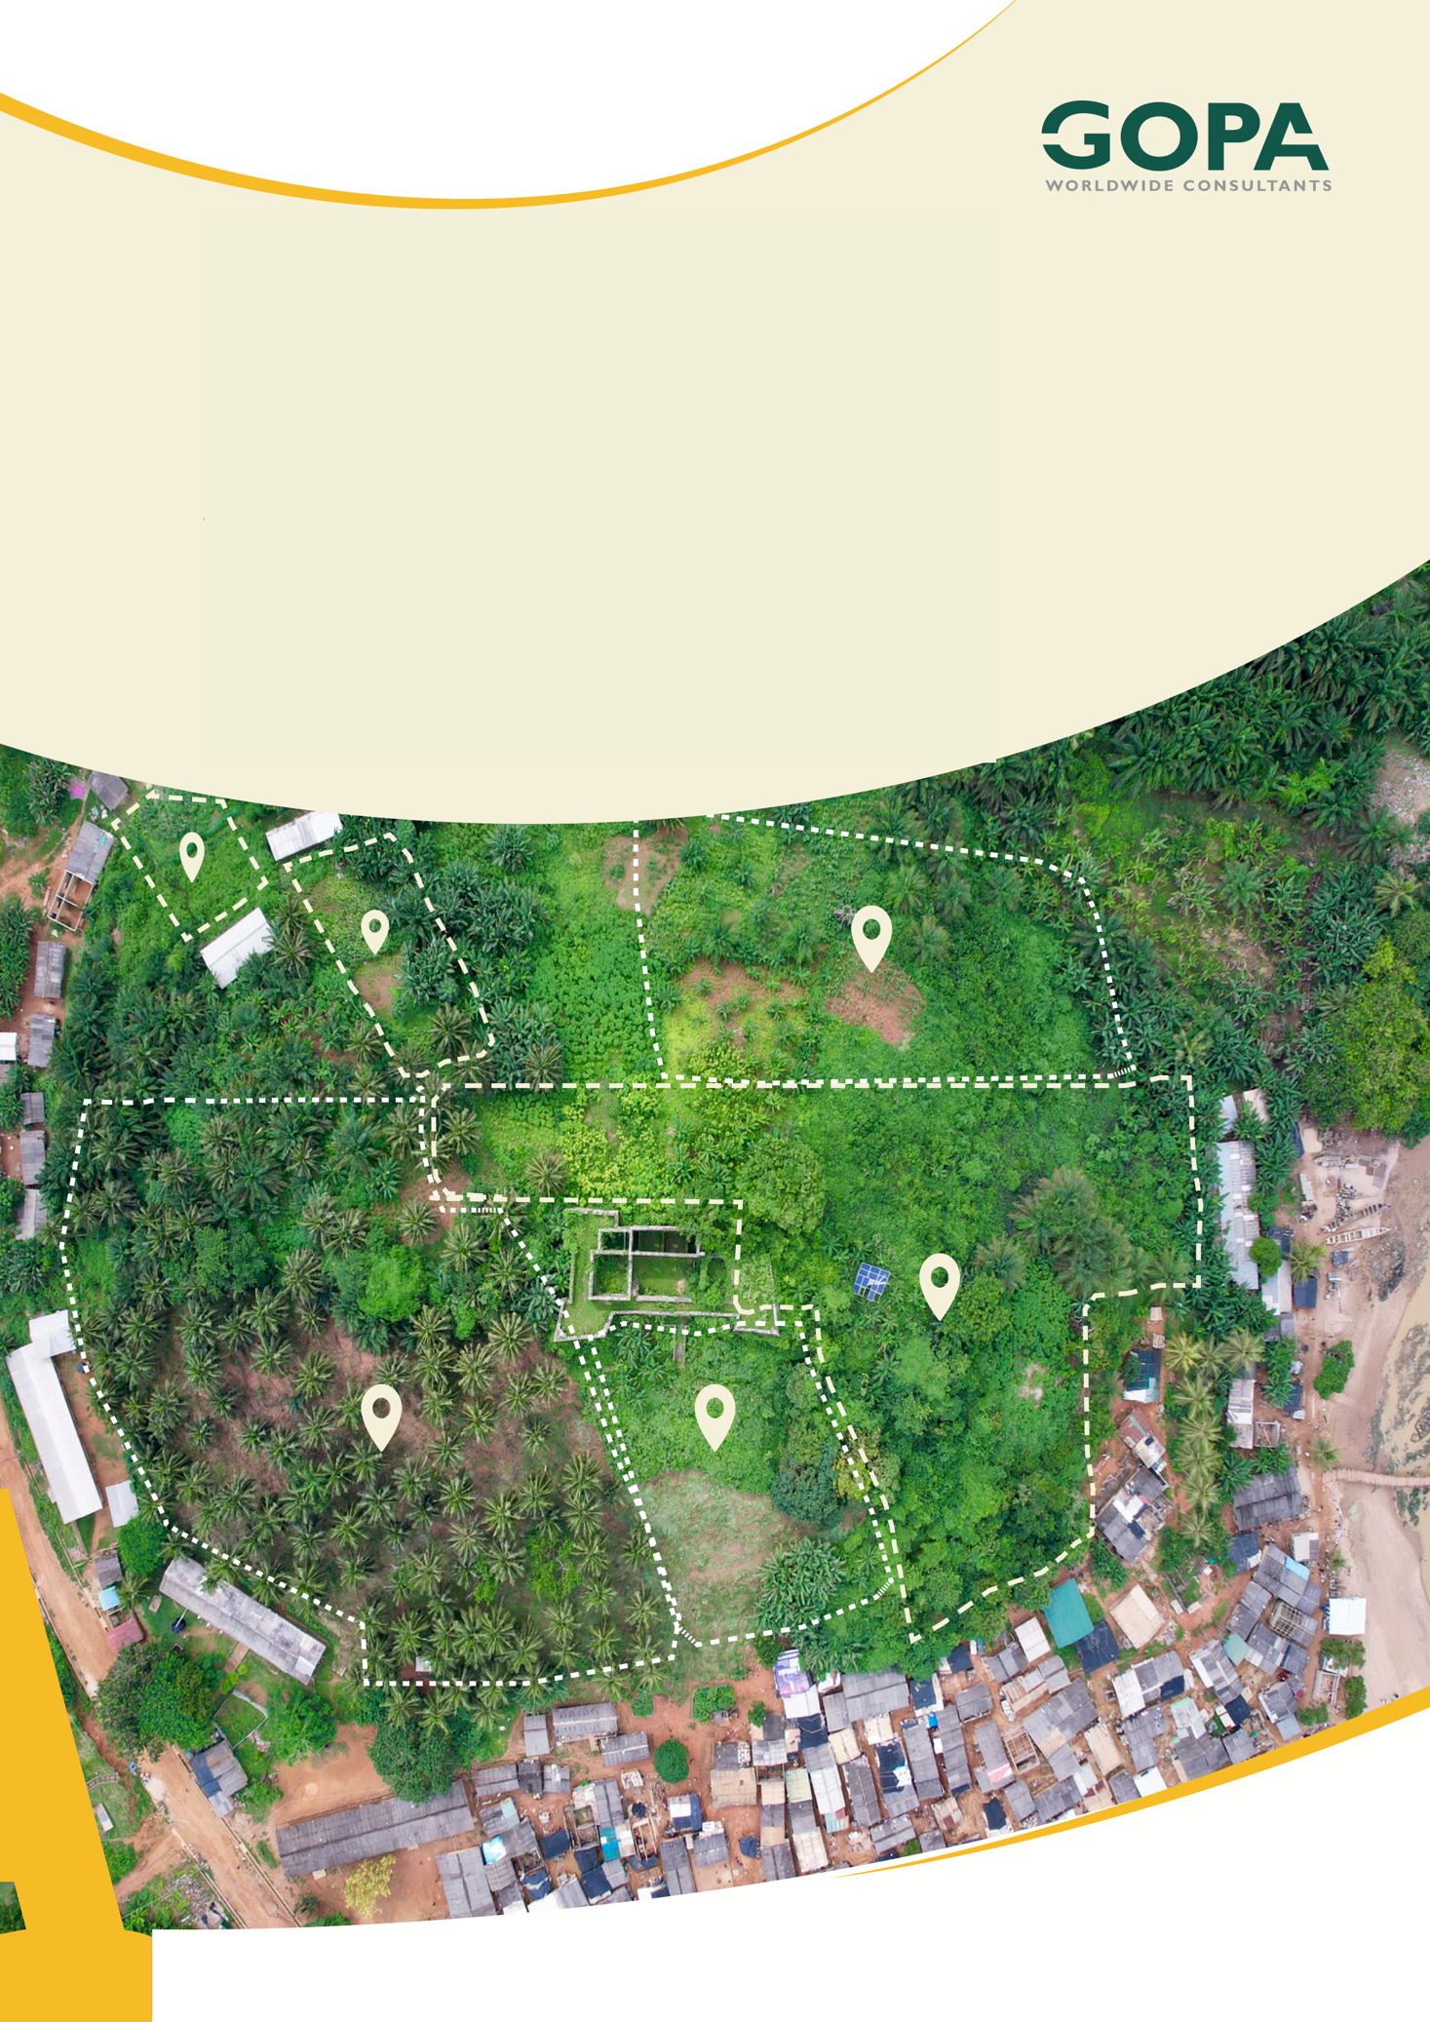
GHANA
Development of a Spatial Planning and Management Information System for Ghana
LUPMIS2 Training — Topic 4 Exercises
OpenLayers — building the map · self-paced · September 2026

Topic 4 — OpenLayers: building the map
Self-paced exercises for Training Plan section 6.4 · LUPMIS2 capacity building for LUSPA

1. How to use these exercises
Section 6.4 sets four learning outcomes and one hands-on task: add a new data layer to LUPMIS2 end to end — fetch it, style it, place it in the right group, and give it a click pop-up. Exercises 1 to 5 take the map apart piece by piece on the real application; exercise 6 is the task itself. Each has a goal, numbered steps and Check yourself questions; the answers, with a complete tested solution for exercise 6, are in section 5.
Exercise | Learning outcome (Training Plan 6.4) | Time
1 The map, the view, the projection | Explain the OpenLayers model | 60 min
2 Layers, sources and the switcher | Add vector layers and control them in the switcher | 75 min
3 Styling, and styling by zoom | Style vector layers | 75 min
4 External layers, and why one fails | WMS, XYZ and COG — and diagnosing failures | 90 min
5 Clicks, pop-ups and what wins | Map interactions: clicks, pop-ups, selection | 75 min
6 A new data layer, end to end | The hands-on task | 3 hours

About nine hours in total, inside the six days the Training Plan gives the topic.
Work on a branch. Exercises 1 and 6 change files. Start a branch before you touch anything (git switch -c topic4-practice, Topic 2), and you can always get back with git switch main. Exercises 2 to 5 only read the code and experiment in the Console, where nothing survives a reload.

2. Before you start
1. Finish Topic 1 — the developer tools, the Console and breakpoints are used throughout — and Topic 2, for the branch.
2. Start the development server in your clone (npm run dev) and open the application.
3. The map needs an internet connection for base-map tiles. District data comes from the LUPMIS server and may not be available on your computer; only exercise 5 mentions it, and there is a way round.

3. Exercises

Exercise 1 — The map, the view, and the projection
Outcome: explain the OpenLayers model — map, view, layers, sources, features and projections · About 60 minutes
Goal. Get hold of the live map object and ask it where it is, what it is made of, and in what units it thinks.
1. Open src/components/MapView.js and find this.map = new Map({. Read what it is given: a target, a list of layers, and a view. Then read the new View({…}) beside it.
2. The map object is not reachable from the Console, so expose it — the standard way to inspect anything in a running application. In main.js, just after loadUpnGrid(); in initApp, add:
window.mapView = mapView; // temporary, for exercise 1

3. Save, let the page reload, and in the Console run each of these. Write down what each one answers before you run the next:
const map = window.mapView.getMap();
map.getView().getZoom();
map.getView().getResolution();
map.getView().getCenter();
const { toLonLat, fromLonLat } = await import('/node_modules/.vite/deps/ol_proj.js');
toLonLat(map.getView().getCenter());
map.getView().getProjection().getCode();
map.getLayers().getLength();

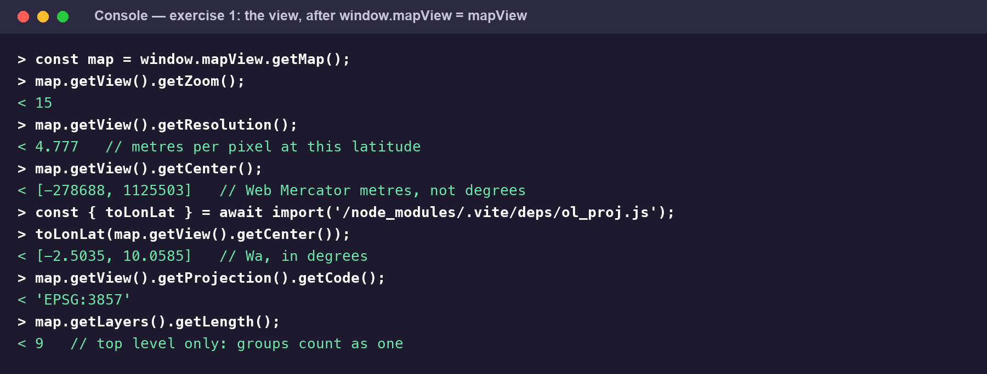
Exercise 1 in the Console, with the map centred on Wa. Note what getCenter() returns.
4. Move the map from the Console: map.getView().setCenter(fromLonLat([-2.5035, 10.0585])); then map.getView().setZoom(15);. Watch the map while you do it.
5. Ask for something impossible: map.getView().setZoom(25); then read the zoom back. Find in MapView.js why you did not get 25.
6. Leave the window.mapView line in place for now — exercises 2, 3 and 5 use it. Exercise 6 ends by taking it out.
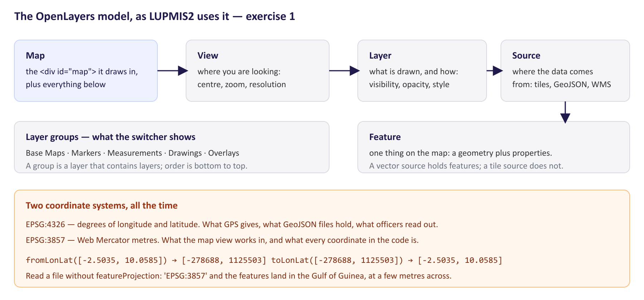
The pieces, and the two coordinate systems every LUPMIS2 map coordinate lives between.
Check yourself
a) What did getCenter() return, and why is it not a pair of degrees?
b) What is a resolution, in plain words, and how does it relate to the zoom?
c) Why did setZoom(25) not give you zoom 25?
d) getLayers().getLength() returns a single-figure number, although the switcher lists far more layers than that. Why?
e) Which part holds the data, and which part decides how it looks?

Exercise 2 — Layers, sources and the switcher
Outcome: add and style vector layers, and control them through the layer switcher · About 75 minutes
Goal. Walk the layer tree, and put a layer of your own into it from the Console.
1. Print the tree, so you can see what the switcher is showing:
const walk = (coll, depth = 0) => coll.getArray().forEach((l) => {
console.log(' '.repeat(depth) + (l.get('title') || '(untitled)'));
if (l.getLayers) walk(l.getLayers(), depth + 1);
});
walk(map.getLayers());

2. Open the layer switcher on the map (the LUSPA badge at the top right) and compare. Note which groups exist, and in which order they are drawn.
3. Find one layer by title and look at it:
let parcels = null;
const find = (coll, title) => coll.getArray().forEach((l) => {
if (l.get('title') === title) parcels = l; else if (l.getLayers) find(l.getLayers(), title);
});
find(map.getLayers(), 'Parcels');
parcels.getVisible();
parcels.getSource().getFeatures().length;
parcels.setOpacity(0.4); parcels.setVisible(true);

4. Now add a layer of your own, with two points in Wa. addGeoJSONLayer is the same call every vector layer in LUPMIS2 goes through:
const demo = { type: 'FeatureCollection', features: [
{ type: 'Feature', properties: { name: 'Office' },
geometry: { type: 'Point', coordinates: [-2.5035, 10.0585] } },
{ type: 'Feature', properties: { name: 'Depot' },
geometry: { type: 'Point', coordinates: [-2.4950, 10.0640] } },
]};
const layer = window.mapView.addGeoJSONLayer(demo, 'Practice points',
{ strokeColor: '#b91c1c', pointRadius: 7 });

5. Look at the switcher again: the layer is there, at the top. Toggle it, drag its opacity, and find it in the tree you printed in step 1.
6. Read addGeoJSONLayer in MapView.js, from the top down to the new VectorSource. Find where the GeoJSON becomes features, and what featureProjection is doing.
7. Remove it again: map.removeLayer(layer) — and if that does nothing, work out from step 1 why, and remove it from the group that actually holds it.
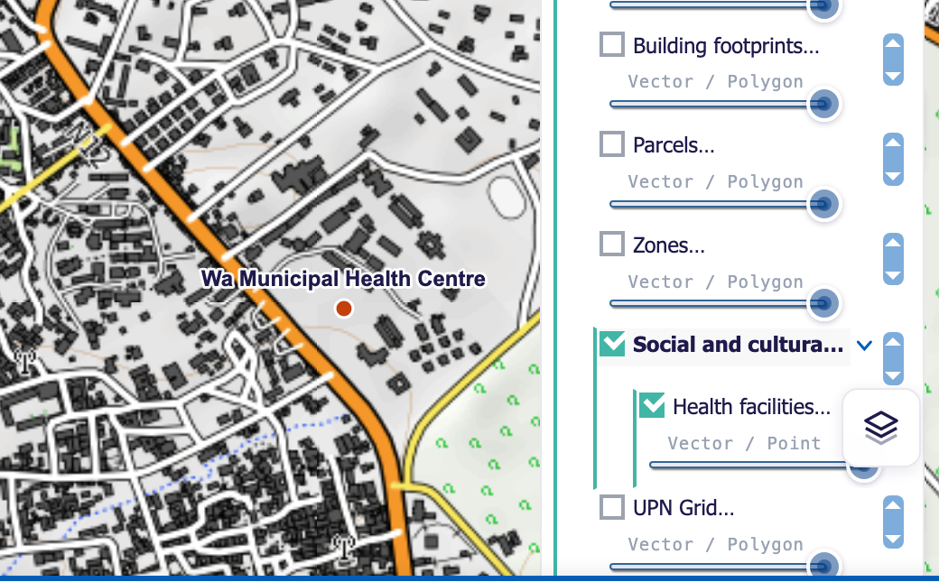
The switcher showing a group with a vector layer inside it — the arrangement exercise 6 aims for.
Check yourself
a) Which groups did you find, and in what order are they drawn on the map?
b) What is the difference between a layer and a source?
c) What does featureProjection: 'EPSG:3857' do in addGeoJSONLayer, and what would the map look like without it?
d) Why did map.removeLayer(layer) not remove your layer?
e) The switcher shows “Vector / Point” under some layers. Where does that text come from?

Exercise 3 — Styling, and styling by zoom
Outcome: add and style vector layers · About 75 minutes
Goal. Understand the three pieces of an OpenLayers style, and write a style that changes with the scale — the technique the UPN grid uses, and the one you will need in exercise 6.
1. In addGeoJSONLayer, read the block that builds fillStyle, pointStyle and mainStroke. Note which piece draws which geometry type, and read the comment about points.
2. Add the practice layer from exercise 2 again, then restyle it from the Console:
const { Style, Fill, Stroke, Circle, Text: OlText } =
await import('/node_modules/.vite/deps/ol_style.js');
layer.setStyle(new Style({
image: new Circle({ radius: 9, fill: new Fill({ color: '#15803d' }),
stroke: new Stroke({ color: '#ffffff', width: 2 }) }),
}));

3. Now make the style depend on the feature. Give the two points different colours by reading a property inside a style function — a function OpenLayers calls for every feature:
layer.setStyle((feature) => new Style({
image: new Circle({
radius: 8,
fill: new Fill({ color: feature.get('name') === 'Office' ? '#b91c1c' : '#0369a1' }),
stroke: new Stroke({ color: '#ffffff', width: 1.5 }),
}),
}));

4. A style function also receives the current resolution. Add a label that only appears when the map is close enough — about 1:25,000, which in Web Mercator is roughly 7 metres per pixel:
layer.setStyle((feature, resolution) => {
const styles = [new Style({ image: new Circle({ radius: 8,
fill: new Fill({ color: '#0369a1' }),
stroke: new Stroke({ color: '#ffffff', width: 1.5 }) }) })];
if (resolution <= 7) {
styles.push(new Style({ text: new OlText({ text: String(feature.get('name')),
font: '600 12px Arial, sans-serif', offsetY: -16,
fill: new Fill({ color: '#1e1a4b' }),
stroke: new Stroke({ color: 'rgba(255,255,255,0.95)', width: 3 }) }) }));
}
return styles;
});

5. Zoom in and out across that threshold and watch the labels appear and vanish. Check the resolution at the moment they change with map.getView().getResolution().
6. Find the same technique in the application: in main.js, search for UPN_LABEL_MAX_RESOLUTION and read the style function under it. Note the white casing drawn underneath, and why it is there.
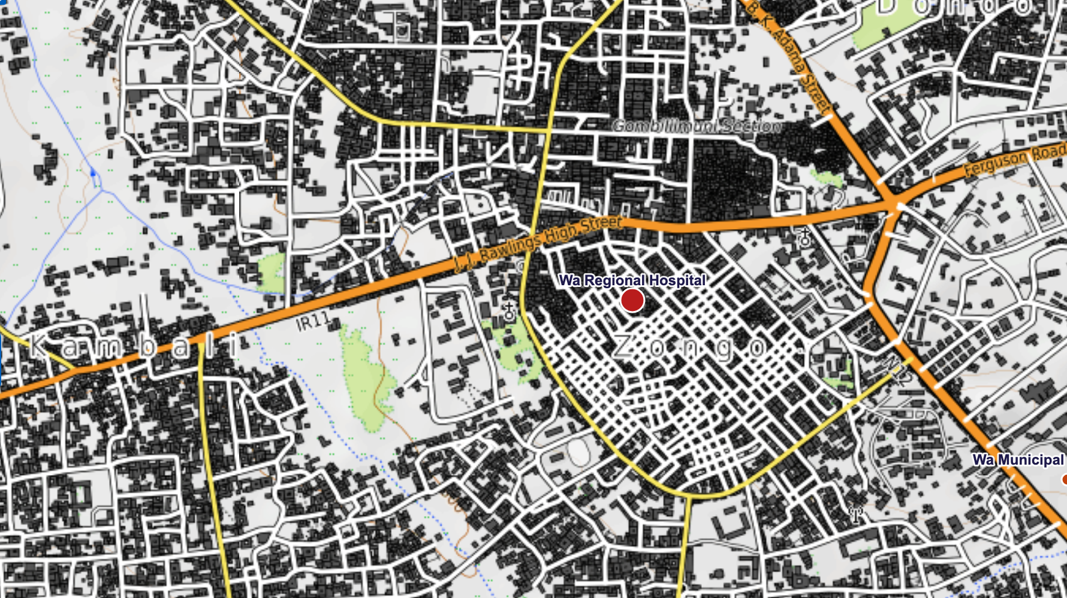
A layer styled by category and labelled by zoom — the health facilities of exercise 6, with the labels switched on because the map is close enough.
Check yourself
a) Which part of a Style draws a point, which a line, and which the inside of a polygon?
b) Why does a style with only stroke and fill leave points invisible?
c) What is the difference between passing a Style and passing a function?
d) Why does the label rule use a resolution rather than a zoom level?
e) In the UPN grid style, why is a white stroke drawn before the violet one?

Exercise 4 — External layers, and why one fails
Outcome: add external layers — WMS, XYZ and Cloud-Optimized GeoTIFF — and diagnose why one fails to appear · About 90 minutes
Goal. Add layers from other people’s servers, then break them on purpose and learn to read what the application tells you.
1. On the map, open the layer switcher and use Add layer. Look at the four types it offers and the note under each.
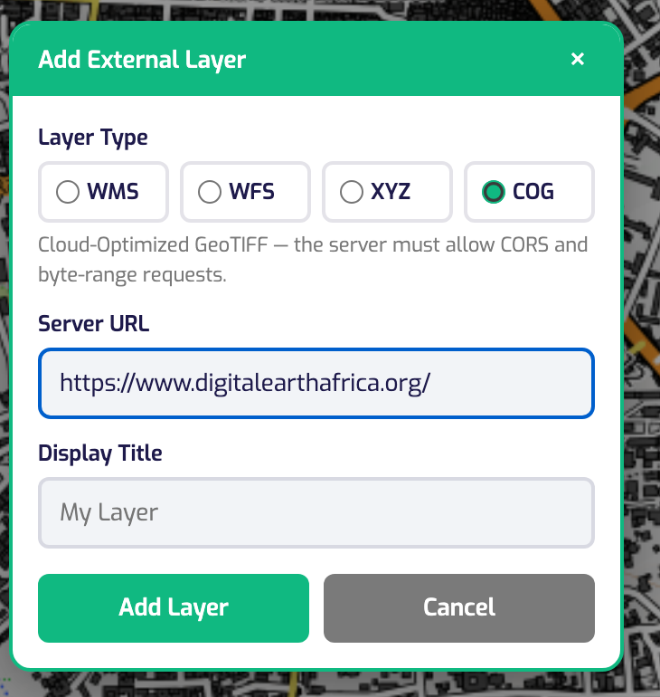
The Add External Layer dialog, with COG chosen. Each type shows what the server has to support.
2. Add an XYZ layer — any tile service with a {z}/{x}/{y} address. This one is OpenStreetMap’s own, which is also what LUPMIS2 uses as a base map:
https://tile.openstreetmap.org/{z}/{x}/{y}.png

3. Add a WMS layer. Digital Earth Africa serves one LUPMIS2 already uses; main.js has the details — search for digitalearth. Note what a WMS needs that an XYZ does not: a layer name.
4. Now the failures. Try a COG layer with the address of a web page rather than a file:
https://www.digitalearthafrica.org/

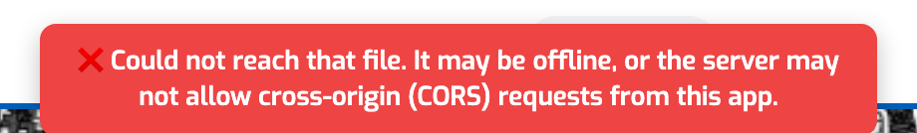
The application checks the address before handing it to the raster reader. It names both possible causes because the browser does not reveal which one it was.
5. Read _probeCOGUrl in MapView.js — it is short. Match each return in it to a cause, and note which case is a warning rather than a refusal.
6. Try two more: an address that does not exist (a 404), and an http:// address while the application is on https://. For the second, read what the Console says rather than the map.
7. Finally, a WMS with a layer name that does not exist on that server. Nothing appears — and nothing complains. Open the Network panel, find the GetMap requests, and look at what comes back.
Check yourself
a) What does a WMS request need that an XYZ address does not?
b) Which failures does the pre-flight check catch before the raster reader is even loaded?
c) One pre-flight case lets the layer load but warns. Which, and why is it worth a warning?
d) Why can the browser not tell you whether a failure was CORS or the server being down?
e) A wrong WMS layer name produces no error at all. How did you find out what was wrong?

Exercise 5 — Clicks, pop-ups and what wins
Outcome: handle map interactions — clicks, selection, pop-ups and zoom-dependent styling · About 75 minutes
Goal. Follow a click from the screen to a pop-up, and find out how the application decides which of several layers under the pointer it means.
1. In main.js, find the map click handler (search for forEachFeatureAtPixel). Read it from the top: which layer is asked about first, which second, and what each does.
2. Note how each branch recognises its own features — the _layerType property — and what return true inside the callback does.
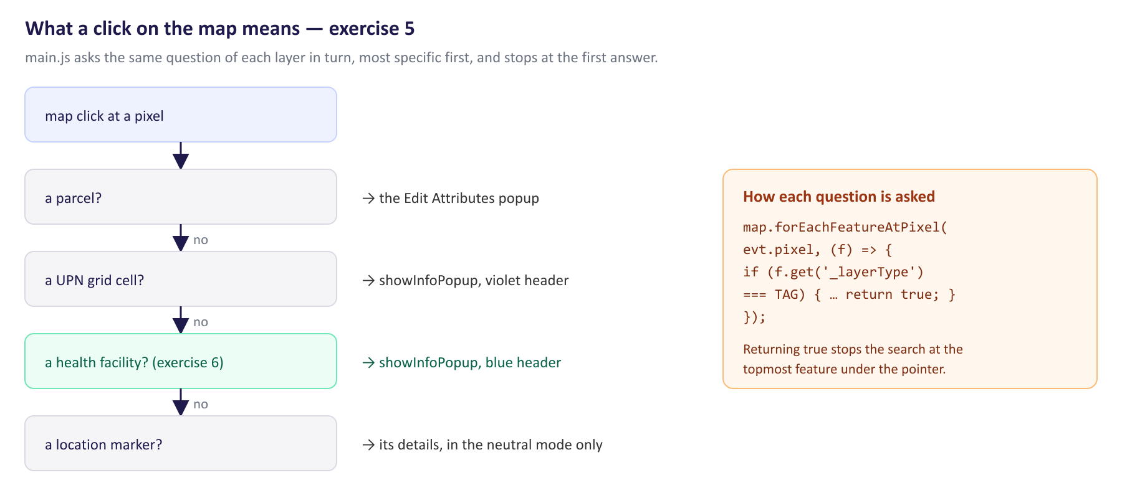
The order the handler asks in. The first layer that answers wins, so the most specific question comes first.
3. Try it from the Console. Add the practice layer from exercise 2 again, tag its features, and find one at a pixel:
layer.getSource().getFeatures().forEach(f => f.set('_layerType', 'practice'));
const px = map.getPixelFromCoordinate(fromLonLat([-2.5035, 10.0585]));
map.forEachFeatureAtPixel(px, (f) => { console.log(f.get('name')); return true; });

4. Open a pop-up on it, the same call the handler makes:
const f = layer.getSource().getFeatures()[0];
window.mapView.showInfoPopup(f, f.getGeometry().getCoordinates(), {
title: 'Practice point', color: '#0369a1',
});

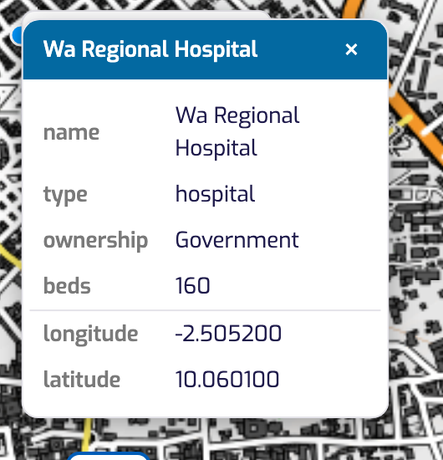
What showInfoPopup builds: the title and colour you pass, the feature’s properties, and — for a point — its longitude and latitude.
5. Read showInfoPopup in MapView.js. Find which properties it leaves out of the table, and what it adds for a polygon that it does not add for a point.
6. Drag the pop-up by its title bar, and close it. Then look at _makePopupDraggable to see how little it takes.
Check yourself
a) In what order does the handler ask, and why that order?
b) What does return true in the forEachFeatureAtPixel callback do?
c) How does a branch tell its own features from every other layer’s?
d) Which properties does the pop-up table leave out, and why those?
e) Clicking a marker only opens its details in one mode. Which, and why not in the others?

Exercise 6 — A new data layer, end to end
Outcome: the topic’s hands-on task — fetch a layer, style it, place it in the right group, give it a click pop-up · About 3 hours
Goal. Add a Health facilities layer to LUPMIS2: six facilities in Wa, coloured by kind, sized by how many beds they have, labelled when the map is close enough, sitting in its own group in the switcher, and opening a pop-up when clicked. Build it from what exercises 1 to 5 showed you before you look at the solution in section 5 — it was built and run exactly as printed there.
Part A — the data
1. On your branch, create public/practice/health-facilities.geojson. Anything under public/ is served as it stands, so the file will be available at practice/health-facilities.geojson. Use these six facilities, or your own district’s:
{ "type": "FeatureCollection", "features": [
{ "type": "Feature",
"properties": { "name": "Wa Regional Hospital", "type": "hospital",
"ownership": "Government", "beds": 160 },
"geometry": { "type": "Point", "coordinates": [-2.5052, 10.0601] } },
{ "type": "Feature",
"properties": { "name": "Bamahu Clinic", "type": "clinic",
"ownership": "Mission", "beds": 12 },
"geometry": { "type": "Point", "coordinates": [-2.5218, 10.0394] } }
// … and four more: a health centre and three CHPS compounds
]}

2. Check it is served: open http://localhost:5173/practice/health-facilities.geojson in a tab.
Part B — the layer
3. Create src/practice-layer.js, exporting one function, loadHealthFacilities(mapView). Inside it, in this order: find the group Social and cultural services with getLayerGroupByTitle, and if it is not there — it comes from the server catalogue, which may not have loaded — make it with addLayerGroup.
4. Create the layer with addGeoJSONLayer, empty to begin with, into that group, and make it start switched off so the officer decides when to see it.
5. Give it a style function (exercise 3): colour by type, radius from beds, and the name as a label when the resolution is 7 or less.
6. Fetch the file, read the features with featureProjection: 'EPSG:3857', set _layerType on each one, and add them to the layer’s source. Handle the failure case: if the file cannot be read, warn in the Console and leave the layer empty rather than throwing.
Part C — connect it
7. In main.js, import your function and call it in initApp directly after loadUpnGrid();.
8. In the map click handler, add a branch for your tag directly after the UPN-grid branch, following that branch exactly: find the feature, call showInfoPopup with a title and a colour, and return.
Part D — test it
9. Reload. The layer should be in the switcher, inside its group, switched off. Switch it on and find the points — zoom to Wa if the map is elsewhere.
10. Zoom in until the labels appear, and out until they go. Click a facility: the pop-up should carry its name as the title and its properties in the table.
11. Click where two things overlap, if you have district data — a facility on top of a parcel — and check which wins. Is that the order you want?
12. Take out the window.mapView line from exercise 1, reload, and confirm the layer still works without it.
13. Commit on your branch with a message that says what the layer is for (Topic 2). Do not push to the LUPMIS2 repository; show the branch to your trainer.
The finished layer where it belongs: inside its group in the switcher, marked “Vector / Point”.
Check yourself
a) Why create the layer before the file has arrived, rather than after?
b) Why does the layer start switched off?
c) What would happen if you left out featureProjection when reading the file?
d) Your style function runs for every feature, on every redraw. What does that mean for what you put in it?
e) Where would this layer come from in the real application, and what would change in your code?

4. After the exercises
Bring your branch and your answers to the next session with your trainer. Exercise 4 is worth going through together: the failures there — a page instead of a file, a blocked cross-origin request, a layer name that does not exist — are exactly the ones that will happen with LUSPA’s own servers, and knowing which message means what saves hours.

5. Answers
Produced by running the code in a browser against the development server. The exercise 6 solution was applied to a copy of the project, run, and clicked before it was printed here; the pictures in exercises 3 and 6 are of that layer.
Exercise 1
a) A pair of Web Mercator metres — around [-278688, 1125503] for Wa. The view works in the map’s own projection, EPSG:3857, not in degrees; toLonLat converts, and gives [-2.5035, 10.0585].
b) Metres of ground per pixel of screen. At zoom 15 near Wa it is about 4.8, so a 250-pixel measurement covers roughly 1.2 km. Zoom is the same idea counted in steps: one zoom level halves the resolution.
c) new View({ … maxZoom: 19 }) in MapView.js. The view clamps what you ask for to the range it was given, and answers 19.
d) Because most of those entries are inside groups. The top level holds the base-map group, the markers, the overlay group and a few more; a group is itself a layer, and counts once.
e) The source holds the data — tiles or features. The layer decides how it is drawn: visibility, opacity, z-index and style. One source can feed more than one layer.
Exercise 2
a) Base Maps, Markers, Measurements, Drawings and Overlays, plus the catalogue groups inside Overlays. They are drawn in the order of the list, bottom first, so Overlays is on top of everything and the base maps are underneath.
b) See exercise 1 answer (e): the source is the data, the layer is how it appears. In the code they are always created as a pair.
c) It tells the GeoJSON reader that the file’s coordinates are degrees and the map works in metres, so every coordinate is converted on the way in. Without it the features are read as if -2.5 and 10.05 were metres, and land off the coast of Ghana, a few metres across.
d) Because map.removeLayer only looks at the top level, and addGeoJSONLayer put your layer inside the overlay group. Remove it from the group that holds it: window.mapView.overlayGroup.getLayers().remove(layer).
e) From the layer’s own properties: addGeoJSONLayer sets a typeDescription, which the switcher shows under the title. The external-layer code sets typeTag the same way for WMS, XYZ and COG.
Exercise 3
a) image draws points — in LUPMIS2 a Circle; stroke draws lines and the outline of polygons; fill fills polygons. A text piece draws a label for any of them.
b) Because a point has no outline and no interior to fill: with no image, OpenLayers has nothing to draw. The comment in addGeoJSONLayer records that this is what made imported shapefile points invisible.
c) A Style is fixed for every feature at every scale. A function is called with the feature and the current resolution, so the same layer can look different per feature and per zoom — which is how the UPN grid labels itself only when close in.
d) Because resolution is what the drawing works in, and it is continuous: the view can sit between two zoom levels. The comment converts it for you — the OGC convention is scale = resolution / 0.00028, so 7 metres per pixel is about 1:25,000.
e) It is a casing: a thicker white line drawn underneath, so the violet grid stays readable whether it falls on pale imagery or on the sky-blue parcels layer.
Exercise 4
a) The name of the layer on that server, in the LAYERS parameter. An XYZ address already names everything it needs; a WMS server hosts many layers behind one address.
b) A URL that cannot be reached at all (offline, or cross-origin refused), a 404, any other error status, and a URL that answers with a web page or JSON instead of image data. All four are decided by a one-byte range request, before the 257 kB raster reader is fetched.
c) A server that answers 200 instead of 206 is ignoring byte-range requests, so the whole raster will be downloaded rather than the tiles in view. It still works — badly — so the code warns and carries on.
d) The browser deliberately hides the difference: revealing that a server exists but refuses cross-origin requests would leak information about private networks. The message therefore names both possibilities instead of guessing.
e) In the Network panel: the GetMap requests are there, with a status of 200, and what comes back is an XML ServiceException — a WMS reports its errors in the image’s place, so the map simply stays empty.
Exercise 5
a) Parcel, then UPN grid cell, then (after exercise 6) health facility, then location marker. The specific object beats the contextual one: a parcel sits inside a grid cell, and clicking it should open the parcel.
b) It stops the search. forEachFeatureAtPixel walks the features under the pointer from the top down, and returning a truthy value ends the walk — so the branch gets the topmost feature of its own kind.
c) By a property the code sets when the features are created: _layerType, 'upn_grid' for the grid and 'health_facility' for exercise 6. Nothing else on the map carries it.
d) geometry and _layerType. The geometry is not readable as text, and the tag is internal bookkeeping — neither means anything to an officer.
e) Only in the neutral mode. In a measurement or drawing mode a click means “put a point here”, and opening a form over the map would interrupt what the officer is doing.
Exercise 6 — the solution
Applied to a copy of the project and run: the layer appears in the switcher inside Social and cultural services, the six facilities are coloured by kind and labelled below 7 metres per pixel, and clicking Wa Regional Hospital opens a pop-up titled with its name.
public/practice/health-facilities.geojson (the first two of six shown in Part A; all six are in the file):
{
"type": "FeatureCollection",
"features": [
{ "type": "Feature", "properties": { "name": "Wa Regional Hospital", "type": "hospital", "ownership": "Government", "beds": 160 },
"geometry": { "type": "Point", "coordinates": [-2.5052, 10.0601] } },
{ "type": "Feature", "properties": { "name": "Wa Municipal Health Centre", "type": "health centre", "ownership": "Government", "beds": 24 },
"geometry": { "type": "Point", "coordinates": [-2.4934, 10.0553] } },
{ "type": "Feature", "properties": { "name": "Kpaguri CHPS Compound", "type": "CHPS", "ownership": "Government", "beds": 4 },
… four more facilities …
]}

src/practice-layer.js — the whole layer:
/**
* practice-layer.js — the health-facilities layer, added end to end.
*
* Topic 4 hands-on: fetch a GeoJSON file, style it by category, put it in the
* right group in the layer switcher, and let a click open a popup.
*
* await loadHealthFacilities(mapView);
*
* Written to match the layers already in LUPMIS2 — loadUpnGrid() in main.js is
* the closest relative: same addGeoJSONLayer() call, same zoom-aware style
* function, same `_layerType` tag so the map-click handler can recognise it.
*/

import { Style, Fill, Stroke, Circle, Text as OlText } from 'ol/style.js';

/** The group the layer belongs in; created if the catalogue has not made it. */
const GROUP_TITLE = 'Social and cultural services';

/** Tag carried by every feature, so the click handler can tell them apart. */
export const FACILITY_TAG = 'health_facility';

/** One colour per kind of facility, and one for anything unexpected. */
const COLOURS = {
hospital: '#b91c1c',
'health centre': '#c2410c',
clinic: '#0369a1',
CHPS: '#15803d',
};
const OTHER_COLOUR = '#6b7280';

/** Labels appear at about 1:25,000 and closer (OGC scale = resolution / 0.00028). */
const LABEL_MAX_RESOLUTION = 7;

function colourFor(feature) {
return COLOURS[feature.get('type')] || OTHER_COLOUR;
}

/** A bigger dot for a hospital than for a CHPS compound. */
function radiusFor(feature) {
const beds = Number(feature.get('beds'));
if (!Number.isFinite(beds)) return 5;
return Math.max(5, Math.min(11, 4 + Math.round(beds / 25)));
}

export async function loadHealthFacilities(mapView) {
if (!mapView) return null;

// 1. The group. The catalogue creates the groups when the server is
// reachable; offline it has not, so make it rather than fail.
const group = mapView.getLayerGroupByTitle(GROUP_TITLE)
|| mapView.addLayerGroup('practice-social', GROUP_TITLE, 'Practice layers (Topic 4)');

// 2. The layer, empty for now: the file may take a moment, and a layer that
// exists straight away appears in the switcher in its proper place.
const layer = mapView.addGeoJSONLayer(
{ type: 'FeatureCollection', features: [] },
'Health facilities',
{ strokeColor: '#0369a1', typeDescription: 'Vector / Point' },
group
);
if (!layer) return null;
layer.setVisible(false); // the officer switches it on

// 3. Style: colour by kind, size by beds, and a name once close enough.
layer.setStyle((feature, resolution) => {
const styles = [
new Style({
image: new Circle({
radius: radiusFor(feature),
fill: new Fill({ color: colourFor(feature) }),
stroke: new Stroke({ color: '#ffffff', width: 1.5 }),
}),
}),
];
if (resolution <= LABEL_MAX_RESOLUTION) {
styles.push(new Style({
text: new OlText({
text: String(feature.get('name') || ''),
font: '600 12px Arial, sans-serif',
offsetY: -16,
fill: new Fill({ color: '#1e1a4b' }),
stroke: new Stroke({ color: 'rgba(255,255,255,0.95)', width: 3 }),
overflow: true,
}),
}));
}
return styles;
});

// 4. The data. A file under public/ is served as it is, and the Service
// Worker caches it, so this works offline after the first visit.
try {
const response = await fetch('practice/health-facilities.geojson');
if (!response.ok) throw new Error(`HTTP ${response.status}`);
const geojson = await response.json();

const features = new (await import('ol/format/GeoJSON.js')).default()
.readFeatures(geojson, { featureProjection: 'EPSG:3857' });
for (const f of features) f.set('_layerType', FACILITY_TAG);

layer.getSource().addFeatures(features);
console.log('[Practice] Health facilities loaded:', features.length);
} catch (err) {
console.warn('[Practice] Could not load the health facilities file:', err);
}

return layer;
}

main.js — the import, beside the other imports:
import { loadHealthFacilities, FACILITY_TAG } from './src/practice-layer.js';

main.js — in initApp, directly after loadUpnGrid():
loadHealthFacilities(mapView);

main.js — in the map click handler, directly after the UPN-grid branch:
// A health facility: same pattern as the UPN grid above — find a feature
// carrying our tag, and show its attributes.
let facilityFeature = null;
mapView.getMap().forEachFeatureAtPixel(evt.pixel, (f) => {
if (f.get('_layerType') === FACILITY_TAG) {
facilityFeature = f;
return true;
}
});
if (facilityFeature) {
mapView.showInfoPopup(facilityFeature, evt.coordinate, {
title: facilityFeature.get('name') || 'Health facility',
color: '#0369a1',
});
return;
}

a) So that the layer takes its place in the switcher straight away, in the right group and the right order. A layer that appears a second later jumps into the list while the officer is looking at it.
b) Because an officer should decide what is on their map. Every catalogue layer in LUPMIS2 starts switched off for the same reason; the Markers layer is the one exception, and section 18.4 of the status report records why that was needed.
c) The six points would be read as Web Mercator metres — a few metres apart, just off the coast of Ghana, at latitude and longitude near zero. The layer would be there, and you would never find it.
d) That it must stay cheap: no fetching, no heavy calculation, no new objects that could be made once outside it. The colour lookup and the radius are simple property reads for that reason.
e) From the server, like the other catalogue layers: loadLayers() creates the groups from the API, and a loader like loadCollectorZones() fetches the features and caches them locally. Your fetch of a local file would become a call in src/remotedb.js, and the rest — the group, the style, the tag, the pop-up branch — would stay exactly as it is.

