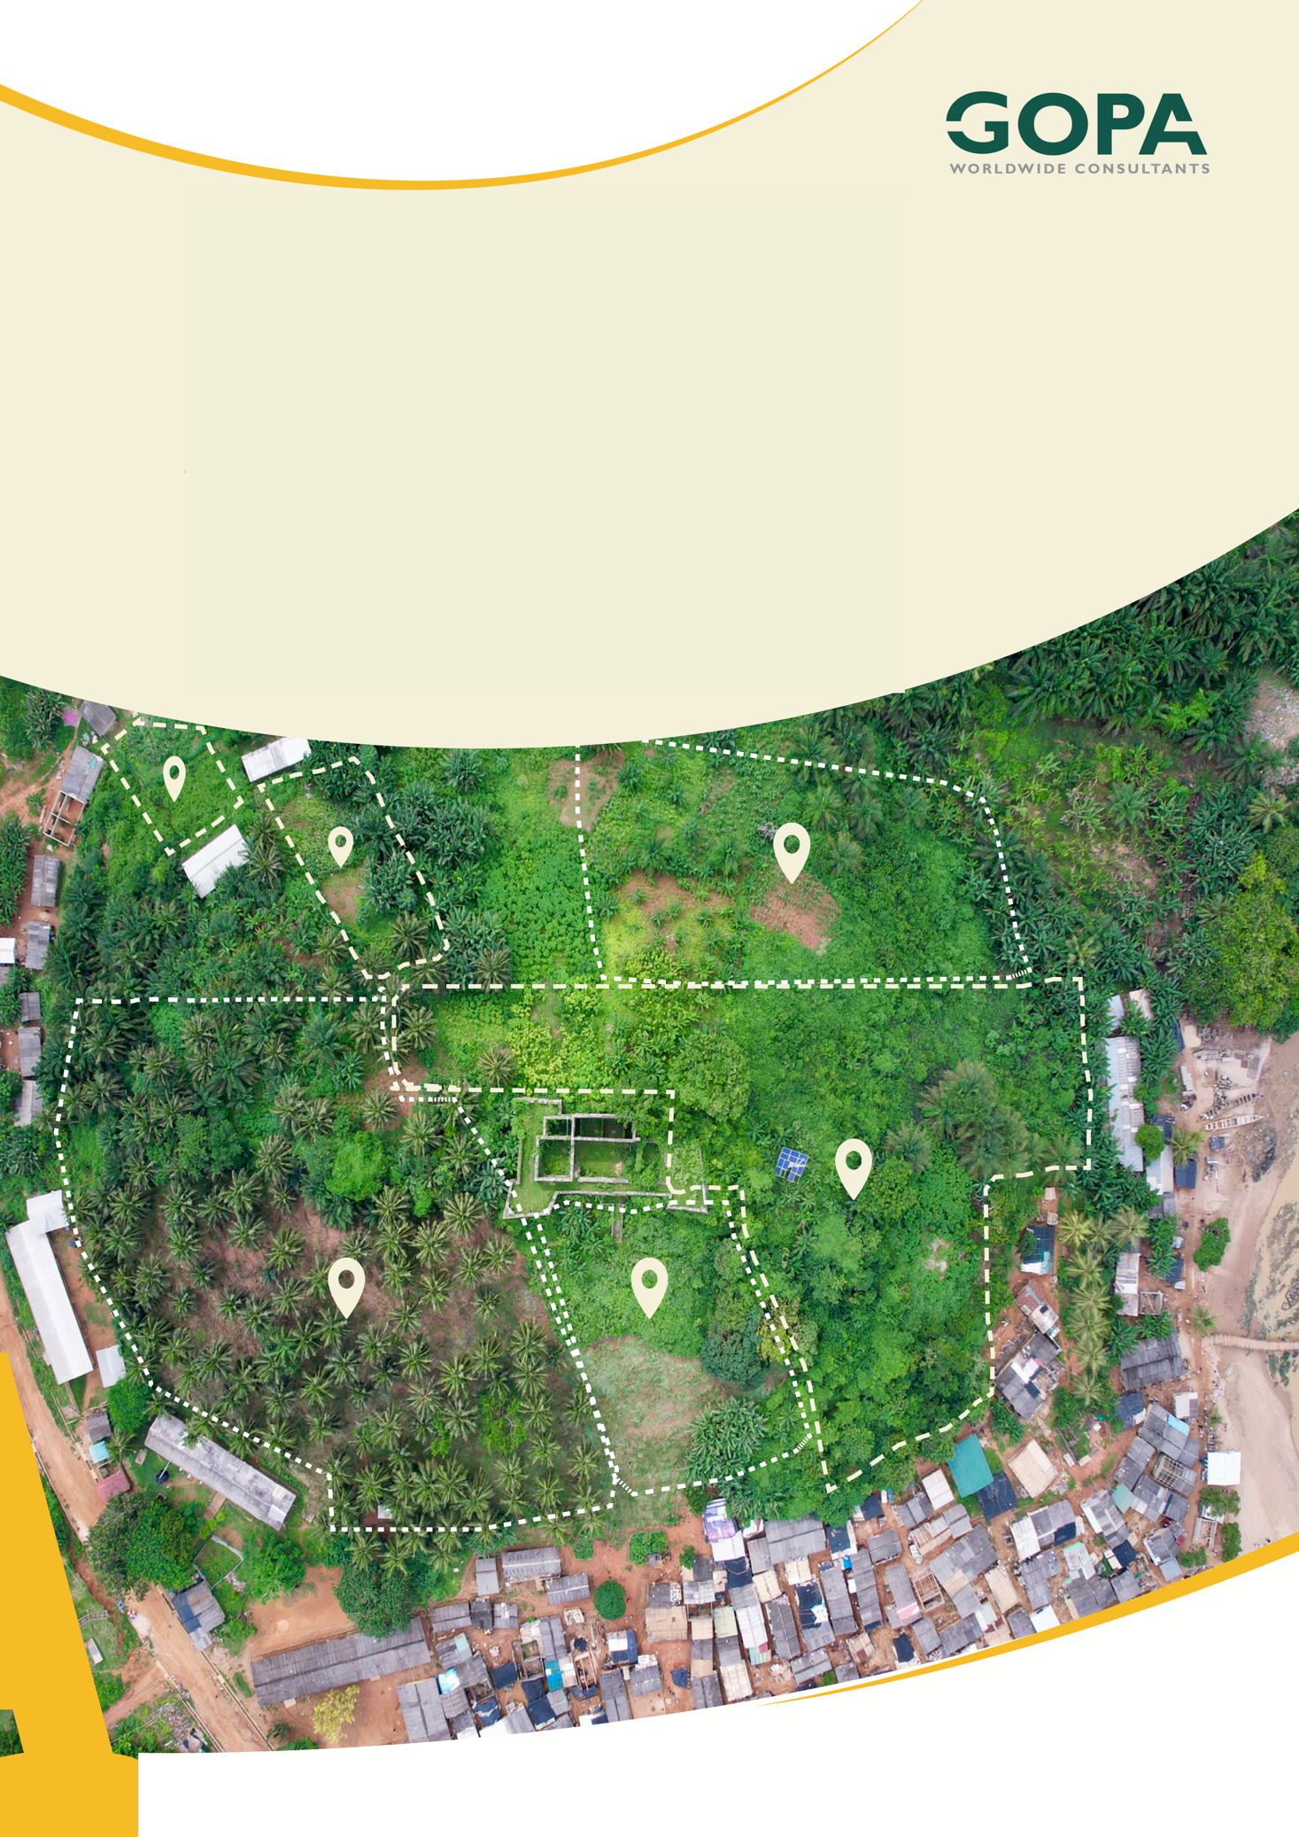
GHANA
Development of a Spatial Planning and Management Information System for Ghana
LUPMIS2 Training — Topic 6 Exercises
Progressive Web Apps and offline architecture · self-paced · September 2026

Topic 6 — Progressive Web Apps and offline architecture
Self-paced exercises for Training Plan section 6.6 · LUPMIS2 capacity building for LUSPA

1. How to use these exercises
Section 6.6 sets four learning outcomes and one hands-on task: add a new table to the local database, cache a new resource for offline use, and demonstrate the whole feature working with the network disabled. Exercises 1 to 5 take the offline machinery apart on the real application; exercise 6 is the task itself, and it ends by proving that a fix the feature rests on is really doing something. Each exercise has a goal, numbered steps and Check yourself questions; the answers, with the complete tested solution for exercise 6, are in section 5.
Exercise | Learning outcome (Training Plan 6.6) | Time
1 Proving the service worker is there | How a service worker intercepts requests | 75 min
2 Four strategies, and who gets which | The caching strategies LUPMIS2 uses | 90 min
3 Releasing a new version | Version and release without leaving users stale | 90 min
4 The database in the browser | SQLocal, SQLite and what OPFS is | 90 min
5 Switching the network off on purpose | Reason about offline, and test it deliberately | 90 min
6 A feature that works with no network | The hands-on task | 3.5 hours

About eleven hours in total, inside the six days the Training Plan gives the topic.
Work on a branch. Exercises 3, 5 and 6 change files. Start a branch before you touch anything (git switch -c topic6-practice, Topic 2), and you can always get back with git switch main. Exercises 1, 2 and 4 only read the code and experiment in the Console.

2. Before you start
1. Finish Topic 1 — the developer tools are used in every exercise here — and Topic 3, because half of this topic is about what the build produces and how it is released.
2. You need the Application panel of the developer tools as well as Console and Network. In Chrome and Edge it is called Application; in Firefox the same things live under Storage and under about:debugging.
3. One rule that costs people a day if they learn it the hard way: the service worker only does its job in a built application. The development server (npm run dev) serves your source files one by one through its own machinery, and the service worker is written to keep out of its way. Everything about offline behaviour has to be tested against a build:
npm run build
npm run preview # serves the build, usually on http://localhost:4173

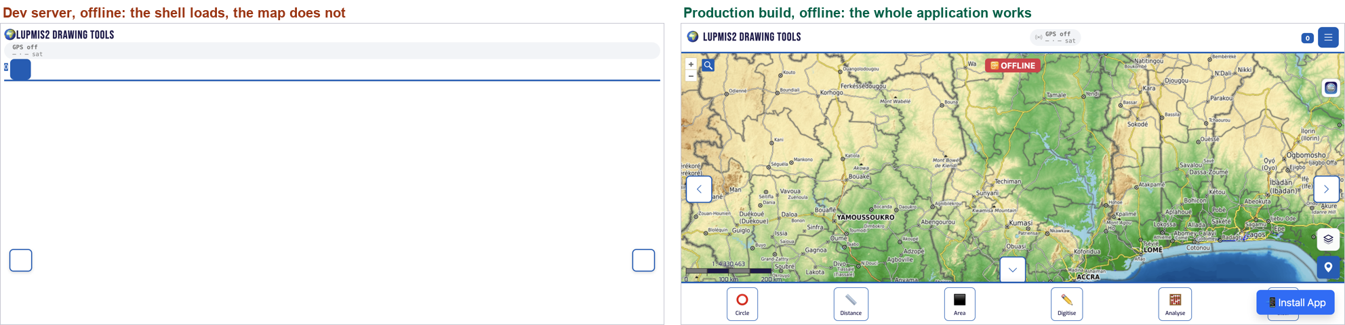
The same application with the network switched off. On the left the development server: the shell loads and the map never appears. On the right the built application.
Use a private window, and close it afterwards. A service worker outlives the tab that installed it, so an experiment you forget about will still be serving you stale files tomorrow. Application ▸ Service Workers ▸ Unregister, and Application ▸ Storage ▸ Clear site data, are the two buttons to know before you start.

3. Exercises

Exercise 1 — Proving the service worker is there
Outcome: explain how a service worker intercepts requests · About 75 minutes
Goal. Find the service worker, watch it take control, and see for yourself that it — not the server — is answering the page.
1. Build and preview the application as above, and open it. Open the developer tools, go to Application ▸ Service Workers, and read what it says: the source file, the status, and the words activated and is running.
2. Find the two halves in the code. src/pwa.js has registerServiceWorker(); note the scope it asks for. public/sw.js is the worker itself — it is in public/ rather than src/ for a reason you should be able to state by the end of exercise 3.
3. Ask the page about it from the Console:
navigator.serviceWorker.controller.scriptURL;
await navigator.serviceWorker.getRegistration();
await caches.keys();

4. Now watch it work. Open the Network panel and reload. Sort or look at the Size column: some rows say a number of kilobytes and some say (ServiceWorker). Write down three of each.
5. In Application ▸ Service Workers, tick Bypass for network and reload again. The same rows now come from the server. Untick it.
6. Open Application ▸ Cache Storage and look inside shell-v27. Compare the list with SHELL_ASSETS at the top of sw.js — it is longer. Work out where the extra entries came from before you read exercise 2.
7. Finally, look at what a service worker is not allowed to do. Find the three guards at the top of the fetch listener and say, for each, what it is refusing to handle and why.
Check yourself
a) The service worker is registered with scope: '/'. What does the scope decide, and why would a worker served from /js/sw.js be a problem?
b) The fetch handler returns early for anything that is not a GET. What would go wrong if it did not?
c) shell-v27 holds more files than SHELL_ASSETS lists. How did they get there?
d) A service worker has no access to the DOM, and it can be stopped and restarted at any time. What does that mean for anything you would want to keep in a variable inside sw.js?
e) The first visit to the application is not controlled by the service worker at all. Why, and what does that mean for testing?

Exercise 2 — Four strategies, and who gets which
Outcome: explain the caching strategies LUPMIS2 uses · About 90 minutes
Goal. Read the routing table in sw.js the way the browser reads it, then confirm each branch from the Network panel.
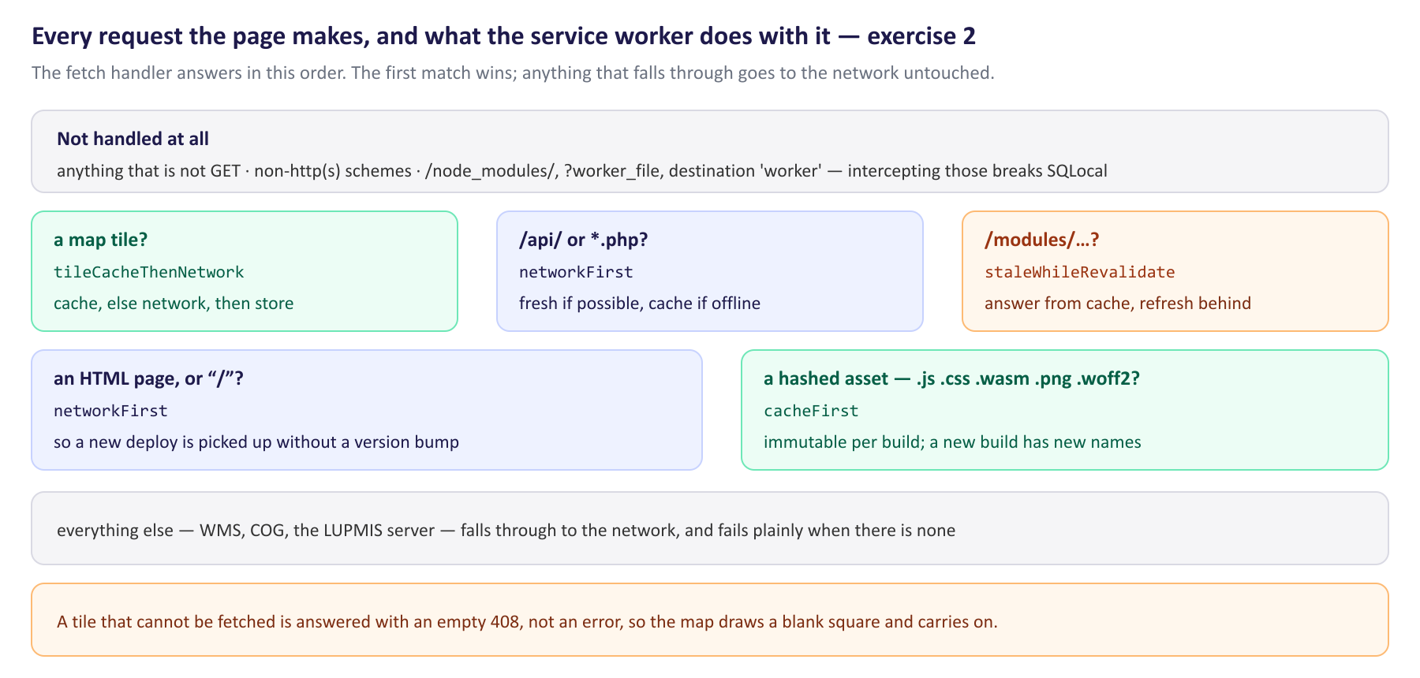
The fetch handler, in the order it decides. The first match wins.
1. Open public/sw.js at the fetch listener. Follow it top to bottom and write out the order of the questions it asks. Then find the four strategy functions at the bottom of the file and read them — each is about fifteen lines.
2. For each strategy, answer in one sentence: what does the user see when the network is slow, and what do they see when it is gone?
3. Now confirm it. Reload with the Network panel open and find: an HTML document, a hashed /assets/*.js file, and a map tile. Say which strategy served each, and check it against the diagram.
4. Ask the caches directly:
await caches.keys();
const shell = await caches.open('shell-v27');
(await shell.keys()).map((r) => new URL(r.url).pathname);
const tiles = await caches.open('tiles-topo-v24');
(await tiles.keys()).length;
await navigator.storage.estimate();

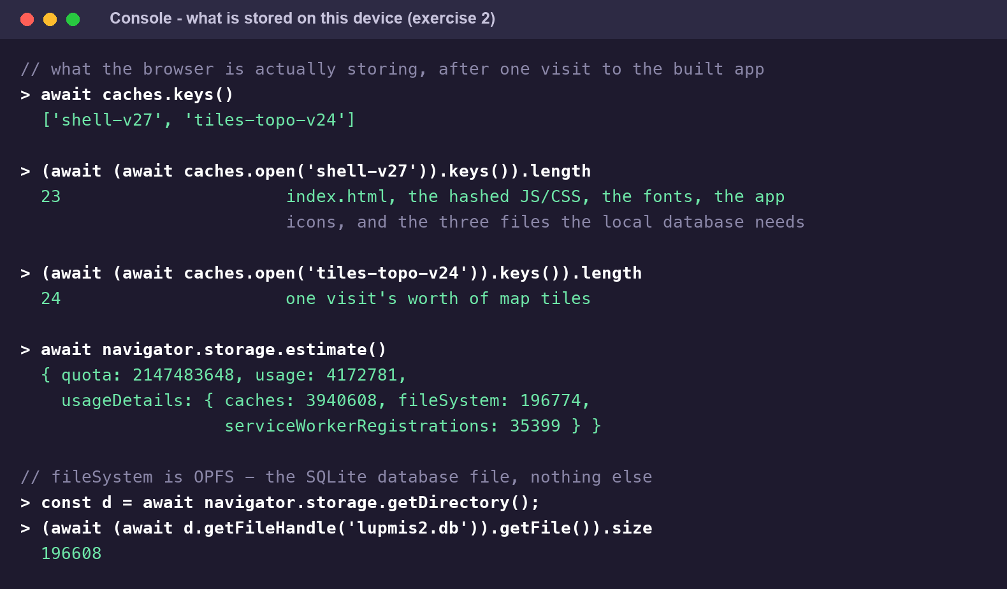
One visit to the built application, measured. Note what the shell cache actually contains.
5. Pan and zoom the map for a minute, then run the tile count again. Tiles are cached simply because you looked at them — read tileCacheThenNetwork and say where that happens.
6. Find TILE_LIMITS and EVICTION_CHECK_INTERVAL. Work out how many tiles the application will store at most, and how often it goes looking for ones to throw away. Read the comment above _tileInsertCounters — it records a real failure on real devices.
7. Find getTileCacheName(url). One provider is deliberately returned as null. Find it, and find the one-line reason in the comment.
8. Read the last four lines of tileCacheThenNetwork. When the network is gone it does not throw — it answers with something. Find out what, and explain what the officer sees because of it.
Check yourself
a) HTML is fetched network-first and hashed JavaScript cache-first. Both are files on the same server. Why the different treatment?
b) What is the risk of stale-while-revalidate, and why is it acceptable for /modules/?
c) Why are map tiles never fetched with network-first, however good the connection is?
d) A tile that cannot be fetched is answered with an empty 408 rather than an error. What would the officer see if it threw instead?
e) Google tiles are never cached. Is that a technical decision or a legal one, and where is it written down in the code?

Exercise 3 — Releasing a new version
Outcome: version and release a service worker without leaving users on stale files · About 90 minutes
Goal. Make a release, watch the old one being cleared away, and prove that the officer's downloaded map tiles survive it.
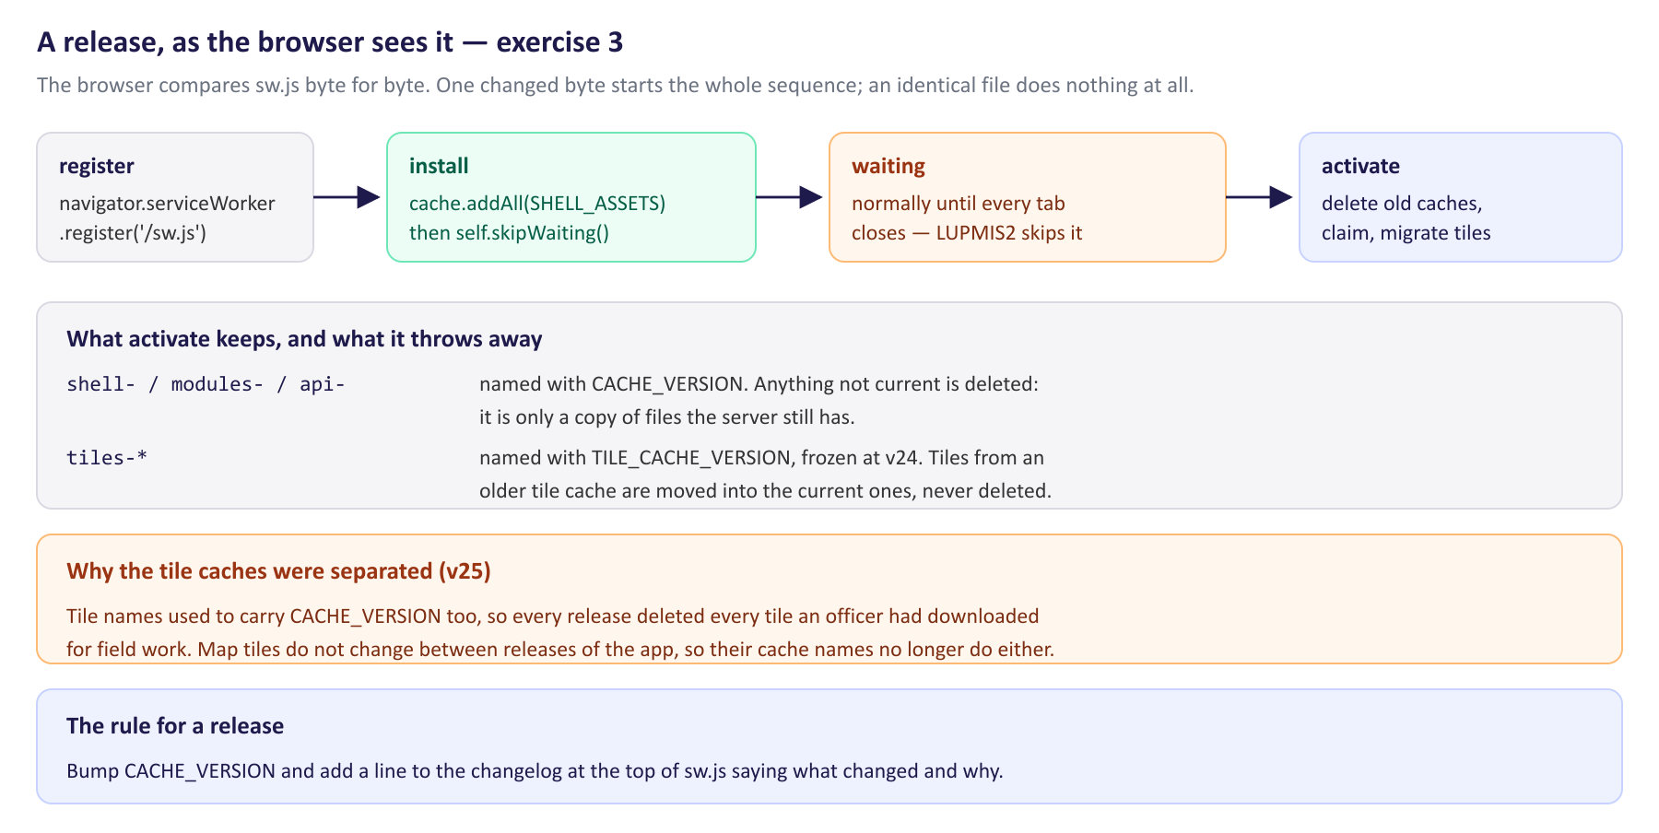
What happens between saving sw.js and the officer having the new version.
1. Read the changelog at the top of sw.js — it is the first hundred and fifty lines of the file. Every release since v3 has a line saying what changed and why. Read v25 in full; it is the release that fixed the defect exercise 3 is about.
2. Note the two version constants and how they differ. CACHE_VERSION is bumped every release. TILE_CACHE_VERSION is frozen at v24 and the comment says when it may be changed.
3. Make a release on your branch. Bump CACHE_VERSION to 'v28' and add a changelog line above it in the same style as the others — what changed, and why.
4. Before you rebuild, write down the numbers you will compare afterwards:
await caches.keys();
(await (await caches.open('tiles-topo-v24')).keys()).length;

5. Rebuild (npm run build), reload the preview, and watch Application ▸ Service Workers. You will see a second worker appear, and the application will offer to reload. Accept it.
6. Run the two commands again. shell-v27 should be gone and shell-v28 there in its place — and the tile count should be exactly what it was. That is the whole point of the v25 fix.
7. Now read the code that did it. In the activate handler, find the keep set, the filter that decides what is deleted, and migrateTileCache. Note the order: clients.claim() comes before the tile migration, and the comment says why.
8. Read migrateTileCache properly. It refuses to copy some tiles, and it deletes the old cache only at one particular moment. Find both, and say what each protects against.
9. Follow the update prompt through the code: updatefound in pwa.js, then statechange, then showUpdateNotification, then applyUpdate. Then look again at what install does in sw.js, and work out whether applyUpdate's postMessage can normally find anything to send to.
Check yourself
a) The browser decides whether to install a new worker by comparing the file byte for byte. What does that mean for a release where only the bundled JavaScript changed and sw.js did not?
b) Why is it safe to delete shell-, modules- and api- caches on activation, but not the tile caches?
c) install calls self.skipWaiting() unconditionally. What does that buy, and what does it cost — think about a page that is already open and running the previous build's JavaScript.
d) activate claims the clients before it starts moving tiles. What would the officer notice if it were the other way round?
e) migrateTileCache deletes the old cache only after a successful copy, and its whole body is in a try. What happens on the next activation if the copy fails half way?

Exercise 4 — The database in the browser
Outcome: work with the local SQLite database, and explain what OPFS is · About 90 minutes
Goal. Find the database, look at it, write to it, and understand where the file is.
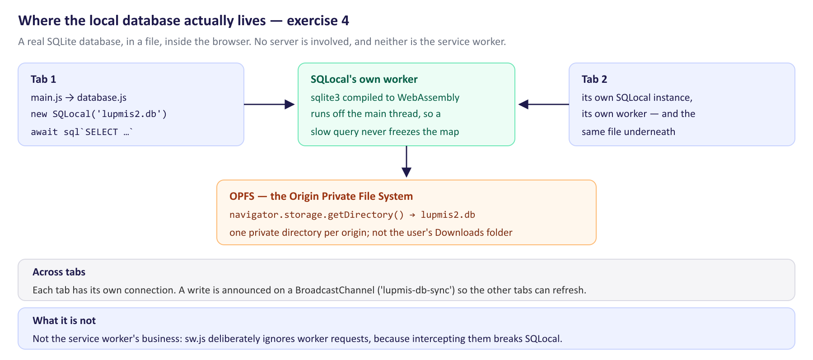
SQLite, a worker and a file — and why the service worker is not part of this picture.
1. Open src/database.js and read the header comment, then initSchema(). Count the tables it creates. Note that every one is CREATE TABLE IF NOT EXISTS, and say why that matters for a database that is already on an officer's device.
2. Find the block that creates the parcels table. Before the CREATE, there is a PRAGMA table_info(parcels) and a DROP TABLE under a condition. Read it and the comment above it: this is a schema migration, written by hand, and you will need the same pattern one day.
3. In the application, open the left panel and press Local Data. You get the table list straight out of the database.
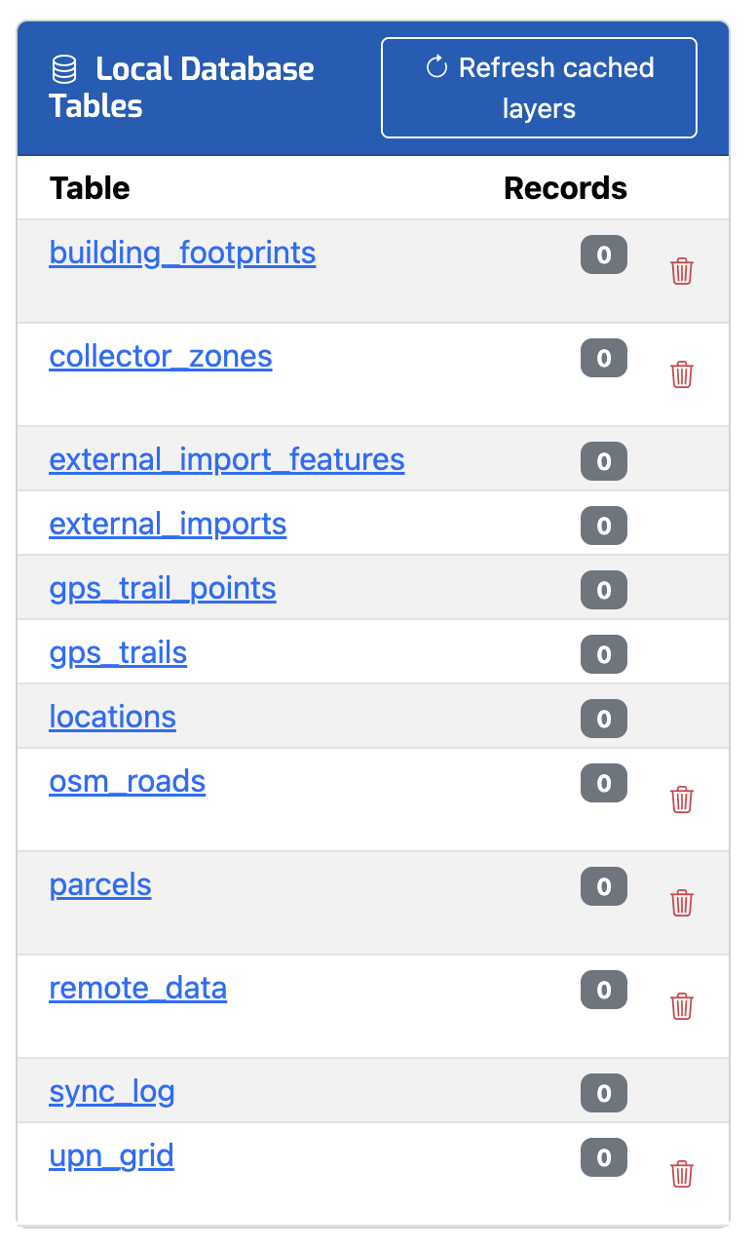
The Local Database Tables panel. The list is read from sqlite_master, so a table you add appears here without any UI work.
4. Find getTableStats() in database.js and confirm where that list comes from. Then find clearTable and CACHED_LAYER_TABLES, and say why some rows in that panel have a delete icon and some do not.
5. Now find the file. In the Console:
const dir = await navigator.storage.getDirectory();
for await (const [name, handle] of dir.entries()) console.log(name, handle.kind);
const file = await (await dir.getFileHandle('lupmis2.db')).getFile();
file.size;
await navigator.storage.estimate();

6. That file is a real SQLite database. Compare file.size with the fileSystem figure in the storage estimate, and say what OPFS is in one sentence, in your own words.
7. Open the same application in a second tab and read src/database.js again — the BroadcastChannel, broadcastChange() and onDatabaseChange(). Each tab has its own connection to the same file. Say what the channel is for, and what it is not for.
8. Read the fetch guard in sw.js about worker requests once more, now that you know what SQLocal is. Write down what you think would happen to the database if the device were offline. Exercise 5 checks your answer.
Check yourself
a) What is OPFS, and how is it different from the user's Downloads folder?
b) Why does SQLocal run SQLite in a worker rather than on the page's own thread?
c) Two tabs are open and one saves a location. What does the other tab know, and how?
d) getTableStats() builds its query by pasting table names into a string. Normally that is how SQL injection happens. Why is it acceptable here — and what exactly makes it acceptable?
e) The database survives a reload, a release, and closing the browser. What does destroy it?

Exercise 5 — Switching the network off on purpose
Outcome: reason about what happens when the device is offline, and test that behaviour deliberately · About 90 minutes
Goal. Take the network away and find out what actually survives — not what is supposed to. Do this against a build, not the development server.
1. Load the built application once with the network on, and let the map draw. Then open Settings and look at the Offline Map Tiles card: it reports what is cached per provider, against the per-provider limits you found in exercise 2.
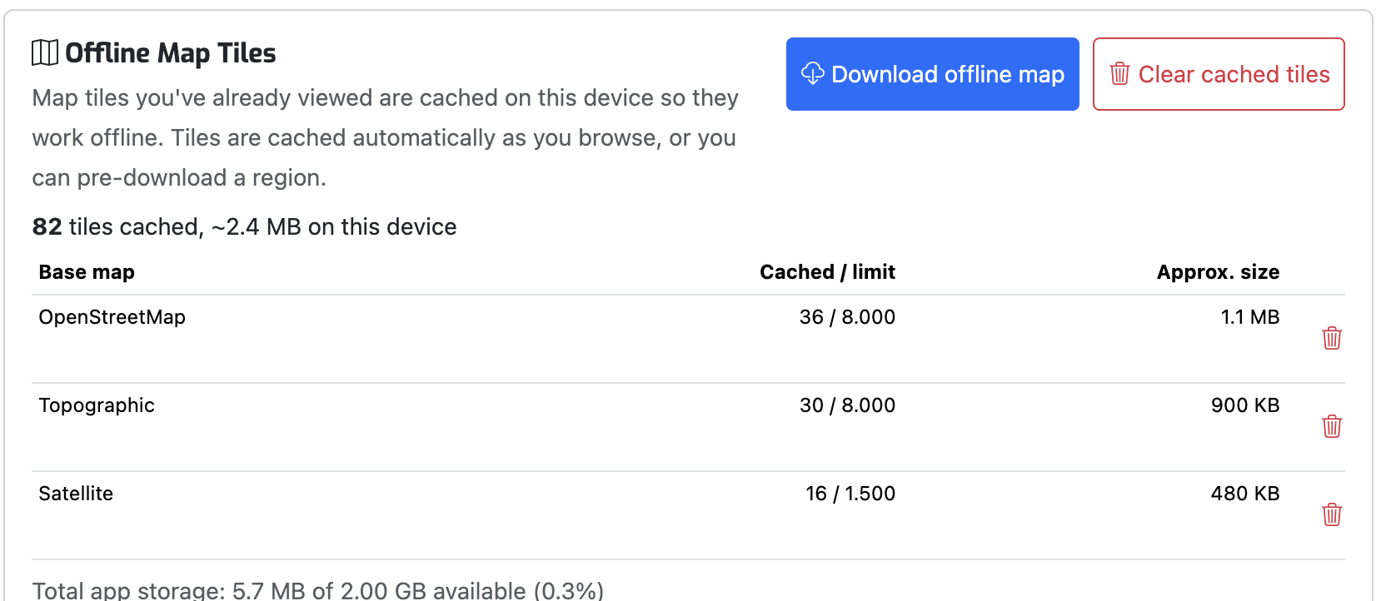
The Offline Map Tiles card in Settings, after visiting three base maps. The numbers come from the service worker through a postMessage round trip.
2. Find how that card is filled: getTileCacheStats() in src/pwa.js, the message handler in sw.js, and replyTo. Note that the “clear one provider” message validates the cache name against a list before acting, and say what that guards against.
3. Now switch the network off — Network ▸ Offline in the developer tools, not the Wi-Fi on your laptop, so that only this page is affected. Do not reload yet. Pan the map into an area you have not visited. Note what you get, and tie it back to the 408 from exercise 2.
4. Reload with the network still off, and check navigator.onLine afterwards — some reloads reset the Offline switch, and a test you think is offline but is not will waste an hour. Then write down, item by item, what worked and what did not: the page itself, the map, the tiles, the district data, the toolbars, the Settings panel.
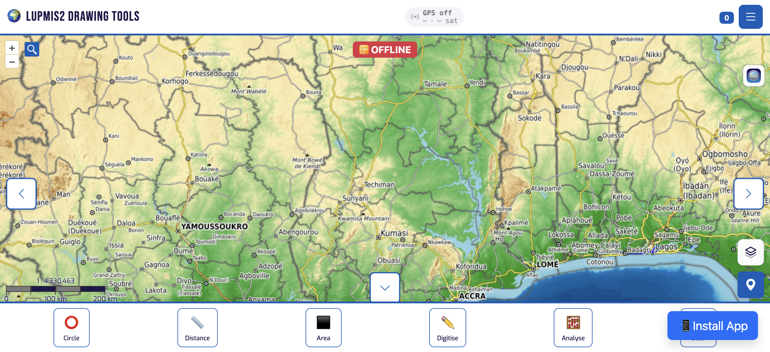
The built application after a reload with the network switched off: the shell from the cache, the map from tiles that were cached while browsing.
5. Press Local Data in the left panel. The table list comes up, from a SQLite database inside the browser, with no server anywhere. That is the whole promise of the topic, and it is worth pausing on.
6. Until recently it did not work, and the fault is worth reproducing because it is the kind you will meet again. In sw.js, find the two guards in the fetch handler that keep the service worker away from worker scripts, and merge them back into the single guard they used to be:
// the old version — everything with destination 'worker' skipped
if (url.pathname.includes('node_modules') ||
url.search.includes('worker_file') ||
request.destination === 'worker') return;

7. Rebuild, load once with the network on, then switch it off and reload. Press Local Data again. Note exactly what you get, and note what the Console does — and does not — say.
8. Diagnose it as if it were new. In the Network panel, with the Failed filter on, find the one request that did not complete. Note its name and its Type, and say which line you just restored sent it to the network.
9. Read the comment that used to sit above that guard. It was accurate when it was written, about the development server. Say in one sentence what had changed since.
10. Put your two guards back, rebuild, and confirm the table list returns. Then write the fault up in three sentences as you would in a ticket: what the officer sees, what the immediate cause is, and why nobody noticed.
Check yourself
a) navigator.onLine is false. Does that mean there is no network? Give a case where it lies in each direction.
b) Switching the developer tools to Offline and switching off your Wi-Fi are not the same test. Which is the better one for this work, and why?
c) Which parts of the application degrade gracefully when the network goes, and which simply stop? Answer from what you observed, not from what the code intends.
d) The comment on the old worker guard said that intercepting those requests breaks module workers. That was written about the development server, and it was true. What did it cost in a built application, and what had changed between the comment being written and that becoming true?
e) An officer works all day in the field with no signal. From what you have seen — both with the guard merged and with it split — what exactly can they do, and what would they have lost?

Exercise 6 — Hands-on: a feature that works with no network
Hands-on (Training Plan 6.6): add a table, cache a resource, and demonstrate the feature with the network disabled · About 3.5 hours
The task. Officers record observations on site — a blocked culvert, a boundary that does not match the map, a building where the record says none. Build field notes: a new table in the local database, a small reference file cached for offline use, and a way to write and read a note. Then demonstrate the whole thing with the network switched off. The demonstration is the deliverable; the code is only how you get there.
Part A — the table
1. On your branch, add a field_notes table to initSchema() in src/database.js, beside the others. Decide the columns yourself; look at locations first, and keep the two conventions it follows — a created_at with a default, and a synced flag for what has not yet gone up to the server.
2. Add addFieldNote() and getFieldNotes(). Follow addLocation(): the insert, the sync_log row, and broadcastChange(). Do not copy its console logging — that is debugging left in.
3. Reload and press Local Data. Your table should be in the list, with no UI work at all. If it is not, find out why before going on.
Part B — the resource
4. A note has a category, and the list of categories belongs on the server so it can be corrected without a release. Add public/reference/note-categories.json with five or six categories, each with a code and a label.
5. Write a small module that reads it — src/field-notes.js — with a loadNoteCategories() that fetches the file, caches the result in memory, and falls back to something usable if the file cannot be read at all.
6. Now make it work offline. Add the file to SHELL_ASSETS in sw.js and bump CACHE_VERSION (exercise 3), with a changelog line. Rebuild, reload twice, and confirm in Application ▸ Cache Storage that the file is in the new shell cache.
Why precache this one? Most files reach the cache simply because somebody asked for them once. A reference file that is read at start-up is different: if the first time an officer opens the application is in the field, a file that was never fetched is a file that is not there. That is what SHELL_ASSETS is for, and it is the reason the task says cache a new resource rather than fetch a new resource.

Part C — wire it in, and demonstrate it
7. Call loadNoteCategories() at start-up in main.js, and expose the three functions on window so you can drive them from the Console. Put the call where it does not depend on the server: offline, everything district-related gives up early, and the notes have to work anyway.
8. Rebuild, load once online, then switch the network off and reload. Run the acceptance test: read the categories, write a note, read it back, reload again — still offline — and confirm the note is still there.
Part D — prove the ground you are standing on
The first time this task was attempted it could not be finished: the note could not be written, because the local database never opened with the network off. That is the fault you reproduced in exercise 5, and it was fixed in the release you have. Before you call your own feature done, prove that the fix underneath it is load-bearing — a habit worth having, because a fix nobody can demonstrate is a fix that gets refactored away.
9. Open Application ▸ Cache Storage and find the entries in the shell cache that have to do with the database — there are three. Two of them are only there because of that fix; one would have been cached anyway. Work out which is which, and why.
10. Merge the two guards back into one, as you did in exercise 5, rebuild, and run your acceptance test again. It should fail — and you should be able to say, before you run it, exactly which line of your own feature will be the first to stop.
11. Put the guards back, rebuild, and run the acceptance test once more, from a fresh tab — a tab that has been reloaded a dozen times under network emulation is not a clean test.
12. Confirm the other half of the promise as well: after your version bump, the tile count from exercise 3 must be unchanged.
Part E — write it down
13. Add your release to the changelog at the top of sw.js: the field-notes feature in one sentence, and what a reader six months from now needs to know about it.
14. Write down the acceptance test itself, as a short list of steps somebody else could follow. This is the part that is worth more than the code: an offline feature that nobody knows how to test is an offline feature that will quietly stop working.
15. Take out anything you put on window, rebuild, and confirm the feature still works without it.
16. Commit on your branch, one commit per idea (Topic 2). Do not push to the LUPMIS2 repository; show the branch to your trainer.
The question to take away. The application was described as working offline, and the shell, the map and the tiles all did. The database — the part the officer's work actually goes into — did not, and nothing said so: it hung silently and the rest of the application carried on looking healthy. Ask, of any feature that is meant to survive without a network, what it would look like if it did not, and who would find out first.

4. After the exercises
Bring your branch, your acceptance test and your ticket from exercise 5. Two things are worth going through with your trainer. The first is the shape of that fault: a comment that was accurate when it was written, about a problem that had since moved. The second is the testing habit — offline behaviour has to be tested against a build, on purpose, on a clean profile, and it is worth agreeing as a team when that gets done, because it is not something a developer stumbles into during ordinary work.

5. Answers
Everything quoted here was measured in a browser against a production build served with vite preview. The exercise 6 solution was written, built, run online and then run again with the network switched off before it was printed here; the console card at the end is that run.
Exercise 1
a) The scope is the set of URLs the worker may control: its own directory and everything below it. A worker served from /js/sw.js could only ever control /js/…, so it would never see a single one of the application's requests. That is why sw.js lives in public/ — the build copies public/ to the site root, so the file is served from /sw.js.
b) Nothing useful, and one thing harmful: cache.put() rejects a non-GET request, so every attempt to store one would throw. More to the point, a POST is an action, not a document — there is no sensible cached answer to “save this location”. Returning early keeps the worker out of the way of every upload, login and save.
c) cacheFirst put them there. Precaching only seeds the cache with the four entries in SHELL_ASSETS; every hashed asset the page then asks for is fetched, stored in the same cache and served from it next time. After one visit to the built application the shell cache held 23 entries — the HTML, the hashed JS and CSS, two fonts, the app icons and the three files the local database needs.
d) That nothing in a module-level variable can be relied on. The browser stops an idle worker and starts a fresh one for the next event, so _tileInsertCounters comes back empty. That is deliberate here — the counter only decides how often an eviction sweep runs, and starting over costs nothing. Anything that has to survive belongs in a cache or in IndexedDB.
e) Because a page that was already loading when the worker registered made its requests before there was anything to intercept them. LUPMIS2's activate calls clients.claim(), so the worker does take over that page part-way through — but what you see in the Network panel on that first load is not what an officer sees on any later one. Reload once before you conclude anything, and clear site data between experiments.
Exercise 2
a) Because the HTML names the hashed files. A stale index.html points at asset names that are no longer on the server, and the application fails in a way a reload does not cure. The hashed files themselves can never go stale: a change produces a new name, so an old name is either right or gone.
b) The risk is that the user gets the previous copy this time and the new one next time — one visit behind, silently. It is acceptable for /modules/ because those are optional feature modules, not the entry point. Worth noticing while you are there: after a visit to the current build there is no modules-v27 cache at all, because nothing in the application is served from /modules/ any more. The branch is still correct; it simply never fires.
c) Because a tile never changes. The same z/x/y is the same picture, so network-first would spend a round trip to be told what the cache already knew — and in the field it would spend a timeout to be told nothing.
d) An unhandled rejection for every missing tile. The tile would still be blank, and the console would fill with errors that hide the ones worth reading. The 408 is a polite way of saying “nothing here”, which is exactly what the renderer needs.
e) Legal. The comment above getTileCacheName says it plainly: caching is forbidden by Google's terms of service, so the function returns null for those hosts and the request falls through to the network like any other.
Exercise 3
a) Nothing installs. The browser compares the worker byte for byte, sees the same file, and leaves everything as it is. That is usually fine — the new bundle has new hashed names, so it is fetched on demand, and index.html is network-first, so the new names are picked up immediately. The bump is needed when what has to change is the cache itself: a new entry in SHELL_ASSETS, a change to the routing, or a fix inside the worker.
b) Because those three hold copies of files the server still has. Deleting them costs a download. A tile cache holds what an officer deliberately downloaded for work where there is no network, and a deleted tile cannot be fetched again in the field.
c) It buys the release: the new worker takes over on the next reload instead of waiting for every tab to close, which on a device that is never closed could be never. It costs a moment of mismatch — a page still running the previous build's JavaScript, now controlled by a worker whose caches belong to the new one. If that page then asks for a lazily-loaded chunk by its old hashed name, the name may be gone from the server. That is why the application offers a reload as soon as it notices. It is also why applyUpdate() mostly does nothing interesting: because install already called skipWaiting(), registration.waiting is normally null by then, the postMessage goes nowhere, and it is the location.reload() that actually delivers the new version.
d) A pause. Moving tiles can run to thousands of entries; if clients.claim() came afterwards, the page would have no controller for that whole time and every request in it would go straight to the network — slow on a good connection, and simply failing on a bad one.
e) The old cache is still there, so the next activation finds it in the tiles- list and tries again, picking up where it left off — nothing already copied is copied twice, because the loop skips anything the target cache already has. Nothing is lost; the worst case is that the old cache lingers for another release.
Exercise 4
a) A private file system the browser gives to the origin. Its files are not in the user's file system in any way they can see — not in Downloads, not visible to any other site, reachable only through navigator.storage.getDirectory(). It is also fast, and it offers the synchronous access handles inside a worker that SQLite needs to behave like SQLite.
b) Because SQLite compiled to WebAssembly does real work: a query across tens of thousands of parcels blocks whatever thread it runs on, and on the main thread that is a frozen map and dead buttons. The other half of the answer is that the synchronous OPFS access SQLite wants is only available in a worker at all.
c) It knows that something changed, and nothing more. broadcastChange() posts { table, action, id } on the lupmis-db-sync channel; the other tab's listeners re-read whatever they were showing. The channel carries a notification, not data — the data is in the one file both tabs are already connected to.
d) Because the names are not the user's. They are read out of sqlite_master in the query immediately above, so they are names SQLite itself reported. The moment a name comes from anywhere else the rule changes, and getTableContent() shows the pattern for that case: it checks the caller's name against sqlite_master before it uses it.
e) Clearing the site's data — Application ▸ Storage ▸ Clear site data, the browser's own “delete cookies and site data”, or removing the installed app. A release does not, a reload does not, and closing the browser does not. That is the whole point: the officer's unsynced work has to still be there on Monday.
Exercise 5
a) It means the device believes it has no usable network interface. It lies in both directions: true on a Wi-Fi with no route to anywhere — a hotel portal, an office router with a dead uplink — and false under the developer tools' Offline mode while everything on the machine still answers. Treat it as a hint for the badge in the corner. The only proof is a request that succeeds or fails.
b) The developer tools, because it affects one page, is repeatable, and leaves the rest of your machine working — including the preview server you are testing against, which switching off Wi-Fi may well take with it. Turning off the radio is worth doing once at the end, on a real device, as a sanity check; it is a poor way to work.
c) What was observed: the page itself, the map, the cached tiles, both toolbars and the Settings panel all work. Tiles outside the cached area come back blank rather than broken. District data does not load, and the application says so in a warning. The local database opens and the table list comes up — and with the guard merged back into one, as step 8 asks, it does not open at all: silently, with nothing on screen to say why.
d) It cost the local database, which is most of what offline means here. In a build, SQLocal's worker is a hashed file under /assets/; the old guard skipped every request whose destination was worker, so that file was never cached. With the network down the request fails, initSchema() never resolves, and everything awaiting the database stops — with no error, because nothing rejected. What had changed is where the worker comes from. The comment was written about the development server, which really does serve it out of node_modules with a ?worker_file query; once the same code ran against a build, the guard was matching an ordinary hashed asset. The comment stayed true and stopped being the whole truth.
e) They can use the map where they have already been — pan, zoom, measure, draw, the analysis tools that work on what is on screen — and they can read and write the local database, which is where a location or a note goes. With the old guard they could do everything except the last of those, which is to say everything except the part that produces work.
Exercise 6
Part A — the table. In initSchema(), beside the others:
await sql`
CREATE TABLE IF NOT EXISTS field_notes (
id INTEGER PRIMARY KEY AUTOINCREMENT,
title TEXT NOT NULL,
category TEXT DEFAULT 'general',
body TEXT,
longitude REAL,
latitude REAL,
created_at TEXT DEFAULT CURRENT_TIMESTAMP,
synced INTEGER DEFAULT 0
)
`;

and the two functions, following addLocation() without its debugging:
export async function addFieldNote(title, options = {}) {
const { category = 'general', body = null,
longitude = null, latitude = null } = options;

await sql`
INSERT INTO field_notes (title, category, body, longitude, latitude)
VALUES (${title}, ${category}, ${body}, ${longitude}, ${latitude})
`;
const idResult = await sql`SELECT last_insert_rowid() as id`;
const newId = idResult[0]?.id;

await sql`
INSERT INTO sync_log (table_name, record_id, action)
VALUES ('field_notes', ${newId}, 'INSERT')
`;
broadcastChange('field_notes', 'INSERT', newId);
return { id: newId };
}

export async function getFieldNotes(limit = 100) {
return sql`SELECT * FROM field_notes
ORDER BY created_at DESC, id DESC LIMIT ${limit}`;
}

Part B — the resource. public/reference/note-categories.json:
{
"version": 1,
"categories": [
{ "code": "boundary", "label": "Boundary dispute" },
{ "code": "condition", "label": "Site condition" },
{ "code": "access", "label": "Access / road" },
{ "code": "service", "label": "Services and utilities" },
{ "code": "general", "label": "General observation" }
]
}

and src/field-notes.js — note that the fallback is what makes the module honest: it says out loud that the file might not be there, instead of letting the feature fail on a missing list.
import { addFieldNote, getFieldNotes } from './database.js';

export const CATEGORIES_URL = '/reference/note-categories.json';
const FALLBACK = [{ code: 'general', label: 'General observation' }];
let _categories = null;

export async function loadNoteCategories() {
if (_categories) return _categories;
try {
const response = await fetch(CATEGORIES_URL);
if (!response.ok) throw new Error(`HTTP ${response.status}`);
const data = await response.json();
_categories = Array.isArray(data.categories) && data.categories.length
? data.categories : FALLBACK;
} catch (error) {
console.warn('[FieldNotes] Could not read the category list:', error);
_categories = FALLBACK;
}
return _categories;
}

export { addFieldNote, getFieldNotes };

In public/sw.js, the file joins the precache list and the version goes up:
const SHELL_ASSETS = [
'/', '/index.html', '/offline.html', '/manifest.json',
'/reference/note-categories.json'
];

Part C — wiring. In main.js, immediately after initSchema() resolves — before anything that talks to the server, because offline those calls give up and the notes still have to work:
import { loadNoteCategories, addFieldNote, getFieldNotes }
from './src/field-notes.js';

// … in initApp, right after '[App] Database ready':
loadNoteCategories().then((cats) => {
window.fieldNotes = { loadNoteCategories, addFieldNote, getFieldNotes };
console.log('[App] Field note categories ready:',
cats.map((c) => c.code).join(', '));
});

Where this goes matters more than what it does. Put the call further down, beside loadUpnGrid(), and it works perfectly online and not at all offline — because the server checks above it never return and the line is never reached. That was the first version of this solution, and the symptom was window.fieldNotes being undefined with no error anywhere.

Part D — the ground underneath. The guard in the fetch handler is in two parts, and the feature depends on the second one. The development server's worker plumbing is still skipped; a built worker is a hashed asset like any other, and is cached like one:
// Skip the Vite dev server's own module plumbing — it serves worker
// scripts straight out of node_modules with a ?worker_file query, and
// intercepting those breaks module workers (e.g. SQLocal/SQLite).
if (url.pathname.includes('node_modules') ||
url.search.includes('worker_file')) return;

// A worker script in a BUILT app is a hashed file under /assets/, as
// immutable as any other asset — and it has to be cached, or SQLocal
// cannot start its worker when the device is offline and the local
// database never opens.
if (request.destination === 'worker' && !isAppAsset(url)) return;

Merge those two back into one and two entries disappear from the shell cache: /assets/worker-*.js, which is SQLocal's worker, and /assets/sqlite3-opfs-async-proxy-*.js. The third file of the set, /assets/sqlite3-*.wasm — SQLite itself — is cached either way, because the page fetches it rather than a worker doing so, and it therefore never matched the guard. That is worth noticing: two thirds of the database's machinery was offline-ready, which is exactly why the gap was easy to miss.
Part E — the acceptance run. Build, serve with vite preview, load it once, then stop the preview server and reload. Stopping the server is the better test: the developer tools' Offline switch is reset by some reloads, and a cached tile answering with a 200 can make it look as though the network is up. From a fresh tab:
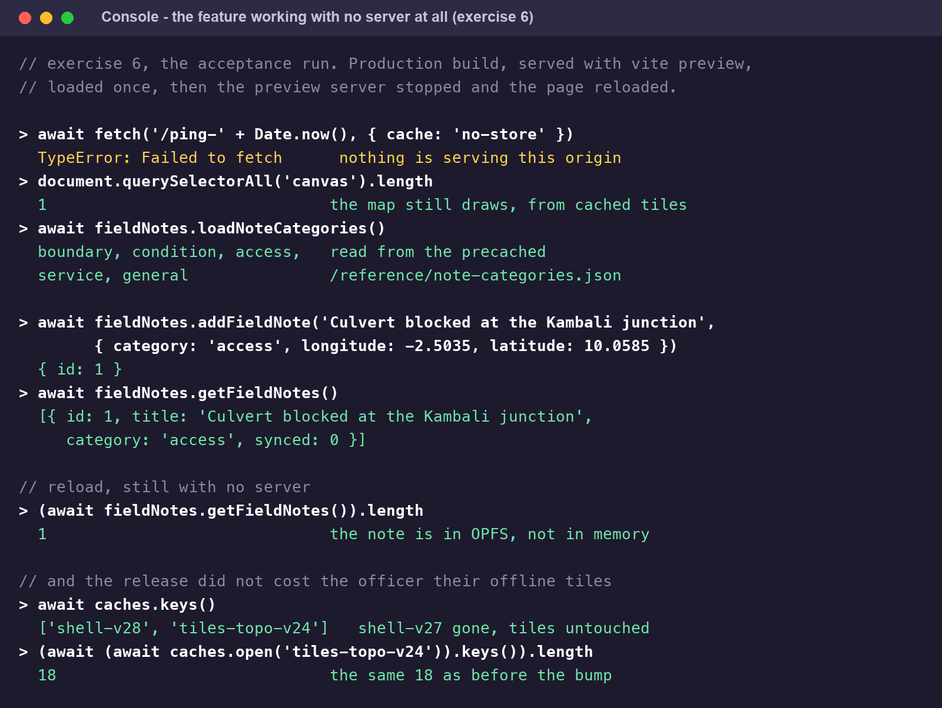
The measured result: the map, the precached reference file and the local database all working with the network off — and the tile count unchanged by the release.
Three details in that run are worth keeping. The first request proves there is nothing serving the origin at all — a stronger test than the developer tools' Offline switch, and the one to use when you want to be certain. The note survives a second reload, which is the only thing that proves it went into OPFS rather than staying in memory. And caches.keys() shows shell-v27 gone while tiles-topo-v24 still holds its tiles — the release cost the officer nothing.
A trap while you are testing. caches.open('shell-v27') creates that cache if it does not exist. Check for an old cache with caches.keys(), not by opening it — otherwise you will “find” the cache you just made and conclude that activation is broken.

