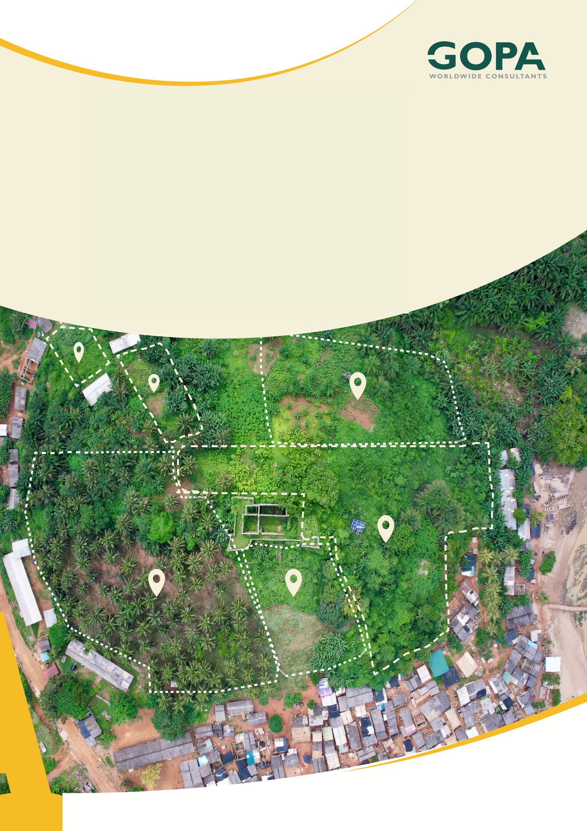
GHANA
Development of a Spatial Planning and Management Information System for Ghana
LUPMIS2 Spatial Analysis — User Guide
Stage 1 · July 2026

Spatial Analysis (Analyse) — User Guide
LUPMIS2 Stage 1 · Overlays and Zonal Statistics · July 2026

1. What Analyse does
The Analyse tool answers spatial questions about the data already on your map — for example “which parcels fall inside this zone?” or “how many parcels are in each collector zone, and what is their average size?”. It produces a new map layer that you can style, inspect and export.
Everything in Stage 1 runs inside your browser, so it also works offline in the field.
Two families of analysis are available:
• Overlays — combine two layers to find where they intersect, differ or coincide.
• Zonal statistics — summarise features (or one of their numeric fields) per zone.

2. Before you start — which layers must be open
The analysis works on layers that are already loaded in the map. A layer appears in the Analyse drop-down lists when it meets these conditions:
Condition | Detail
Vector layer | Parcels, zones, roads, drawn features, imported files. Raster layers (WMS, COG) cannot be analysed in Stage 1 — they are for display only.
Contains features | The layer must have at least one feature loaded. Empty layers are hidden from the lists.
Not a helper layer | System layers — the vertex-edit dots, GPS trail and GPS position — are excluded automatically.

The layer does not have to be switched on. A layer that is loaded but hidden in the Layer Switcher still appears in the lists and can be analysed. What matters is that its data has been loaded — so zoom to your district first and let the parcels and zones finish loading before you open Analyse.

Each entry in the list shows the layer name followed by its feature count, for example Parcels (25,004). Use this to confirm the data you expect is actually loaded.

3. Opening the Analyse panel
There are two ways in, and they differ only in what the analysis is applied to.

3.1 From the toolbar
Click the 🧮 Analyse button in the bottom toolbar. Use this route for whole-layer work — for example a district-wide summary of parcels per zone.

3.2 From a Circle or Area measurement
Use this route when you want to analyse one area of interest.
1. Draw a circle or an area with the Circle or Area tool.
2. The analysis pop-up lists what the shape caught.
3. Click 🧮 Analyse in that pop-up.
The panel opens with the scope already set to the features your shape caught — shown as, for example, From Circle Analysis (37 features).

4. Choosing what to analyse — “Apply to”
The Apply to list at the top of the panel limits which features take part. This is the main way to keep a large layer manageable and to focus on a specific area.
Option | What it uses | When to use it
Whole layer | Every feature in the chosen layer | District-wide summaries and reports
Features in current map view | Only what is inside the visible map window | Zoom to a neighbourhood, then analyse just that
Selected features only | Features you picked by hand | A specific handful of parcels
From Circle / Area | What the drawn shape caught | Appears only when opened from a measurement pop-up

To select features by hand: open the Digitise tool, then Shift-click features one at a time, or hold Ctrl (Cmd on Mac) and drag a box around them. The panel shows how many features are currently selected.

5. Tutorial A — Overlay: which parcels fall inside a zone
Overlays work on polygon layers only. Point and line layers are ignored by this operation.
1. Load the two layers you want to combine — for this example Parcels and Collector Zones.
2. Open Analyse and keep the Overlay tab selected.
3. Choose an Operation (see the table below). For this example choose Intersect.
4. Set Layer A to Parcels and Layer B to Collector Zones. Order matters — the result is built from layer A.
5. Set Apply to if you want to limit the area.
6. Give the result a name, then click Run analysis.
The four operations:
Operation | What you get | Attributes on the result
Intersect | The parts of A that fall inside B | From both layers. If a field name exists in both, B's copy is prefixed b_
Clip | The parts of A that fall inside B — same shapes as Intersect | From layer A only
Difference | The parts of A that fall outside B | From layer A
Union / Dissolve | All features merged into one outline. Layer B is optional | A field named parts, giving the number of shapes merged

6. Tutorial B — Zonal statistics: parcels per zone
Zonal statistics answers “how much, per zone?”. The zone layer must be polygons; the features you summarise can be points, lines or polygons.
1. Open Analyse and switch to the Zonal statistics tab.
2. Set Zone layer to the polygons you want results for — for example Collector Zones.
3. Set Features to summarise to the layer being counted — for example Parcels.
4. Choose Counted when (see below).
5. Tick the Statistics you need. Count is ticked by default.
6. For Sum, Mean, Minimum or Maximum, also choose a Numeric field — for example a plot-size field.
7. Click Run analysis.
Counted when decides how a feature is assigned to a zone:
Option | Meaning | Effect
Centroid inside zone | A feature belongs to the zone containing its centre point | Each feature counted once. Recommended for totals.
Any overlap with zone | A feature belongs to every zone it touches | A feature crossing a boundary is counted in both zones

Only numeric fields are offered. If the field you expect is missing from the list, its values are stored as text in the source data. Count and Total area do not need a field at all.

7. Reading the results
A successful run produces two things.

7.1 A table in the panel
Zonal statistics shows an immediate table of the figures, one row per zone. Use this for a quick read or to copy numbers into a report.
Export the table to Excel. After a zonal run, an Export table (Excel) button appears at the bottom of the panel. It downloads an .xlsx workbook with two sheets:
Sheet | Contains
Parameters | Every setting that produced the table — the zone layer and the layer summarised (with their feature counts), the Apply to scope, the Counted when rule, the statistics chosen, the numeric field, and the date exported
Results | The table itself, one row per zone, with the figures as real numbers ready for further calculation

Why the parameters sheet matters. A table of numbers on its own cannot be checked or repeated later. Because the workbook records how the figures were produced, a colleague can verify the result — or reproduce it — months afterwards. Always keep the two sheets together.

7.2 A new map layer
The result is added to a layer group called Analysis in the Layer Switcher, drawn in orange so it stands out from the source data. Click any feature to inspect its attributes.
Zonal statistics writes its figures onto each zone as new fields, all prefixed zs_:
Field | Contains
zs_count | Number of features in the zone
zs_sum | Sum of the chosen numeric field
zs_mean | Average of the chosen numeric field
zs_min / zs_max | Lowest and highest value of that field
zs_area_m2 | Combined area of the counted features, in square metres

Results are layers like any other. They can be styled, switched on and off, and exported through the normal GIS export (GeoJSON, Shapefile or KML) for use in QGIS or a report.

8. If something does not work
What you see | Why | What to do
A layer is missing from the drop-down | It has no features loaded, or it is a raster layer | Zoom to the district and let the data load. Raster layers cannot be analysed in Stage 1.
“No result features — the layers may not overlap.” | The two layers genuinely do not meet in the chosen area | Check you have the right layers, and that Apply to is not limiting you to the wrong area
“Layer A has no features.” | The scope has filtered everything out | Set Apply to back to Whole layer, or zoom out so the features fall inside the view
“Sum / mean / min / max need a numeric field.” | A statistic needing a field was ticked, but no field chosen | Pick a numeric field, or untick those statistics
A message about too many overlapping pairs | The area chosen is genuinely very large | Narrow it with Apply to — current map view, a selection, or a drawn Circle / Area
Nothing appears on the map | The result layer may be switched off, or lie outside the current view | Check the Analysis group in the Layer Switcher
The Export table button is missing | It appears only after a zonal statistics run — overlays produce map features, not a table | Run a zonal statistics analysis first

Performance note: a district-scale run — 43 zones against about 25,000 parcels — completes in well under a second, so normal district work does not need to be filtered.

9. Quick reference
Task | Route
Analyse a whole layer | Toolbar → 🧮 Analyse → Apply to: Whole layer
Analyse one area | Draw Circle or Area → Analyse in the pop-up
Analyse a few parcels | Digitise → Shift-click or Ctrl/Cmd-drag → Analyse → Apply to: Selected features
Parcels inside a zone | Overlay → Intersect (A = Parcels, B = Zones)
Cut a layer to a boundary | Overlay → Clip
Everything outside an area | Overlay → Difference
Merge shapes into one outline | Overlay → Union / Dissolve
Count per zone | Zonal statistics → Count
Average plot size per zone | Zonal statistics → Mean + numeric field
Export the zonal table | Run the analysis → Export table (Excel)
Find the results | Layer Switcher → Analysis group
Export the results | Open the layer's export option → GeoJSON / Shapefile / KML

