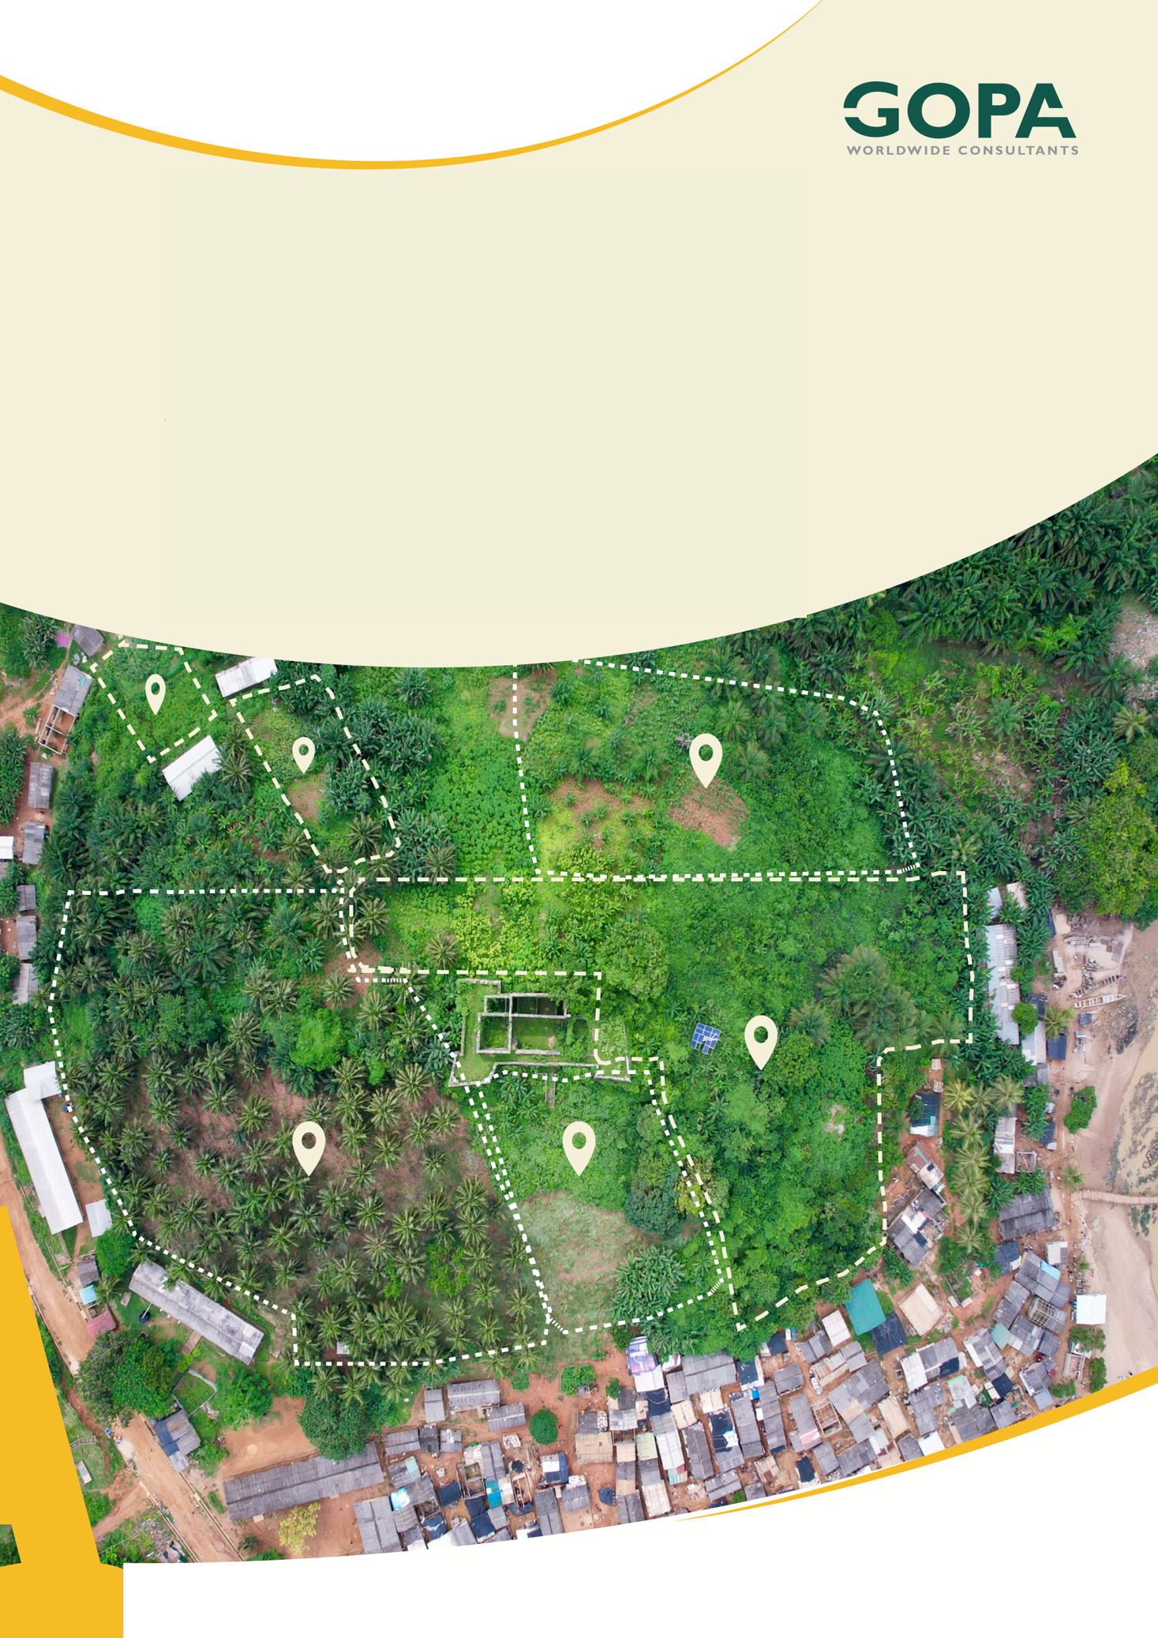
GHANA
Development of a Spatial Planning and Management Information System for Ghana
LUPMIS2 Training — Topic 3 Exercises
Tooling, dialogs and reports · self-paced · September 2026

Topic 3 — Frontend tooling, user interface and reporting: exercises
Self-paced exercises for Training Plan section 6.3 · LUPMIS2 capacity building for LUSPA

1. How to use these exercises
Section 6.3 of the Training Plan sets four learning outcomes and one hands-on task: add a new dialog to LUPMIS2, following the existing pattern, with an export button that produces a spreadsheet. Exercises 1 to 5 each take one piece of that apart on the real application; exercise 6 puts the pieces together. Each exercise has a goal, numbered steps and Check yourself questions; the answers, including a complete tested solution for exercise 6, are in section 5.
Exercise | Learning outcome (Training Plan 6.3) | Time
1 From source to dist/ | Run the development server, build, understand dist/ | 60 min
2 What loads, and when | Code-splitting and loading heavy libraries on demand | 75 min
3 Anatomy of a LUPMIS2 dialog | Build a Bootstrap dialog that matches LUPMIS2 | 45 min
4 An Excel file from data | Generate Excel output from application data | 45 min
5 A PDF report | Generate PDF output from application data | 30 min
6 The Location summary dialog | The hands-on task: new dialog with a spreadsheet export | 3 hours

Altogether about seven and a half hours, within the four days the Training Plan gives the topic.
Build outside the repository. npm run build writes into dist/, and in LUPMIS2 dist/ is committed: a build on your computer would show up as dozens of changed files. In these exercises always build into a folder next to your clone instead, with --outDir ../lupmis-build. The one exercise that changes source code, exercise 6, does it on a branch — exactly as in Topic 2.

2. Before you start
1. Finish Topics 1 and 2. You need the LUPMIS2 clone from Topic 2, with npm install run in it (Topic 1, section 2).
2. Make sure the clone has no changes of yours: git status should say the working tree is clean.
3. Have a spreadsheet program to open .xlsx files — Excel or LibreOffice Calc — and a PDF viewer.
Your numbers will differ slightly. File names in a build carry a code such as index-BzlrAJOS.js, and sizes change whenever the code does. The figures below come from the application as of Service Worker v26 (September 2026). What matters is the pattern, not the exact numbers.

3. Exercises

Exercise 1 — From source to dist/
Outcome: run the development server, produce a production build, and understand what ends up in dist/ · About 60 minutes
Goal. See what a build does to the application: what it keeps, what it combines, what it renames, and what it copies without touching.
1. In the clone, build into a folder next to it, and read the output as it scrolls past:
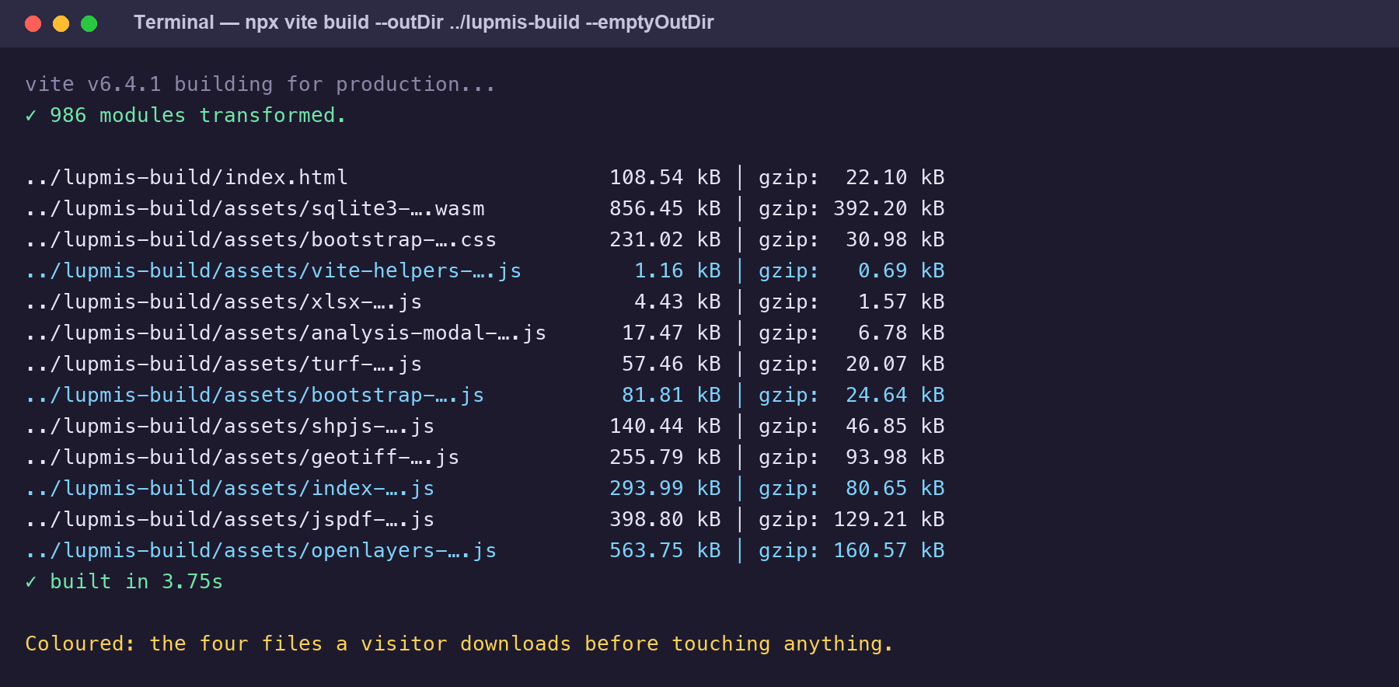
The build, reporting every file it wrote. The second figure on each line is the compressed size — roughly what travels to a phone.
npx vite build --outDir ../lupmis-build --emptyOutDir

2. List what was produced: the files at the top of ../lupmis-build, and the assets folder. Then list the project’s public/ folder and compare.
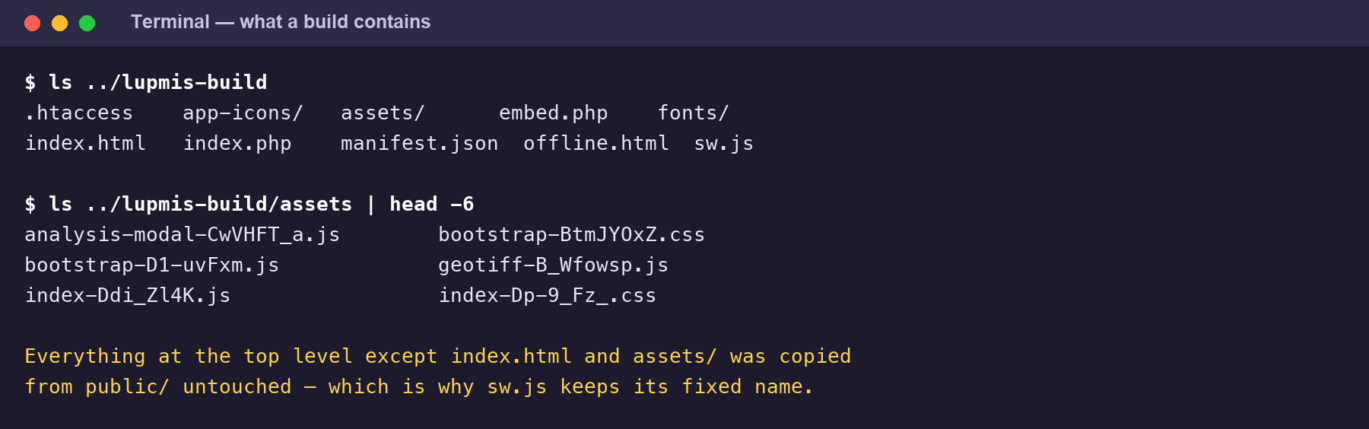
What a build contains. Compare the top level with the project’s own public/ folder.
3. Open ../lupmis-build/index.html in your editor. Search for <script type="module" and for modulepreload. Compare with the last lines of the project’s own index.html (Topic 1, exercise 1).
4. Serve the build and open it: npx vite preview --outDir ../lupmis-build, then http://localhost:4173. In the Network panel, with Disable cache ticked, reload and filter for JS. Compare the number of files with what you saw from the development server in Topic 1.
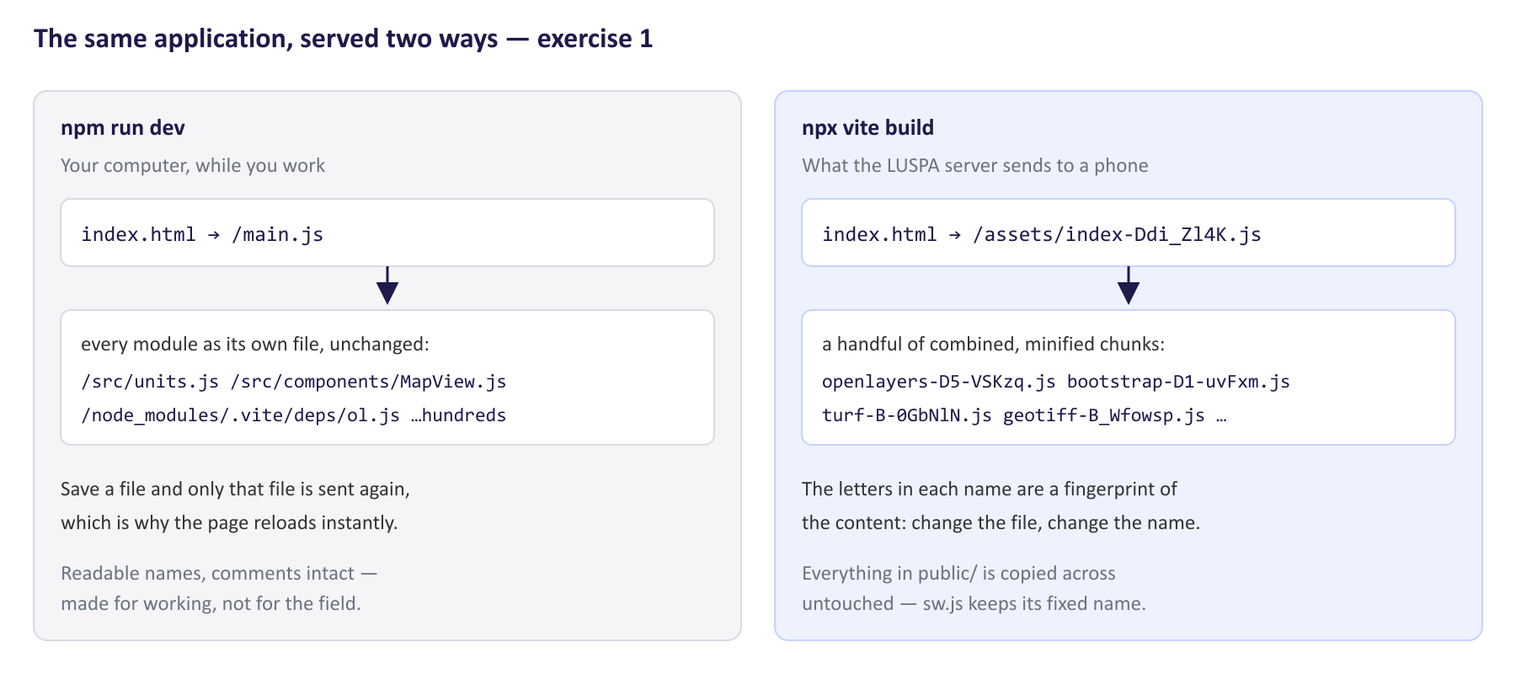
The same application as the development server sends it, and as the LUSPA server sends it.
5. Stop the preview (Ctrl+C) and build again without changing anything. Compare the file names in assets with the first build.
6. Now change one word: in src/analysis/zonal.js, change label: 'Mean' to label: 'Average'. Build again and find which file names in assets changed. Then put the file back with git restore src/analysis/zonal.js.
Check yourself
a) Which files in the build came straight from public/, unchanged?
b) What replaced <script type="module" src="/main.js">, and what are the modulepreload lines for?
c) Which is the largest file in the build, and why is it not JavaScript?
d) Most JavaScript files have a .map file next to them. What are they for, and what do they mean for who can read the source?
e) Which names changed after your one-word edit? Why did a second file change, although you did not touch it?
f) The build reports two sizes for most files. Which one says how much a phone has to download?

Exercise 2 — What loads, and when
Outcome: explain code-splitting and why heavy libraries are loaded only when first needed · About 75 minutes
Goal. Find out what a phone downloads before an officer has touched anything, what waits until it is needed — and what it takes to be sure, since this is a place where the code can say one thing and the application do another.
1. Open vite.config.js and read the manualChunks function and its comments. Write down which libraries it says should load only when needed, and why each is split out.
2. In main.js, search for await import(. Each one is a place where code is fetched on first use. Note what each loads, and what the user has to do to trigger it.
3. Start the preview of your build from exercise 1. In the Network panel, filter for JS, tick Disable cache, reload, and write down every file from /assets/ that arrives before you touch anything.
4. Click Analyse in the dock and watch what arrives. Compare the size of those files with what was already loaded.
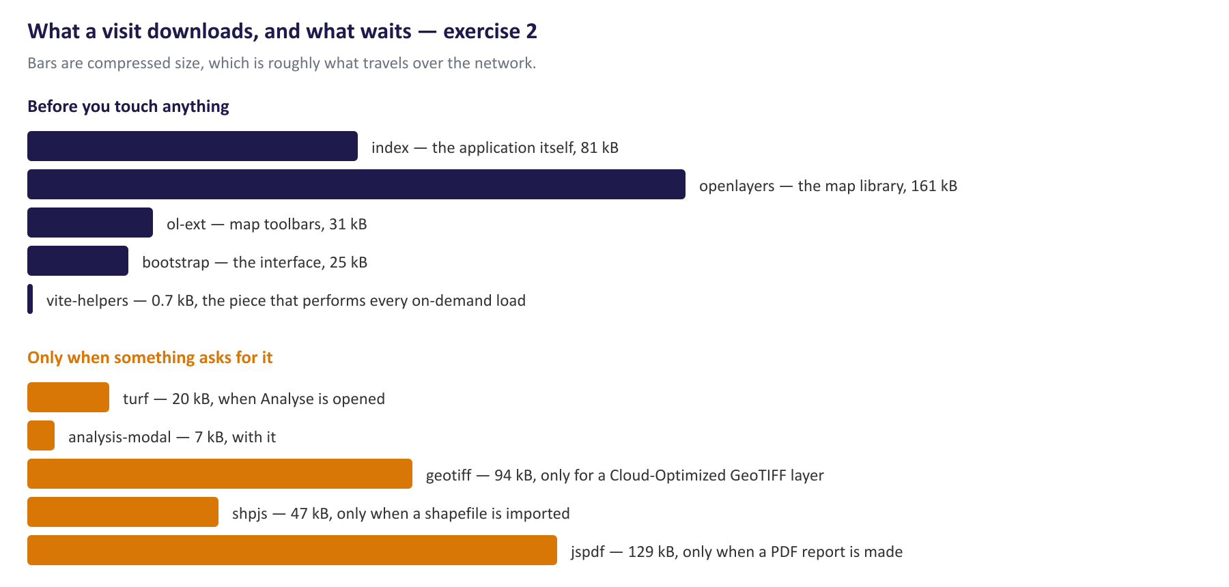
Measured on the build from exercise 1: five files before anything is touched, everything else on demand.
5. Ask the build directly. In ../lupmis-build/assets, find the entry file (the one named in index.html) and list the chunks it imports without being asked:
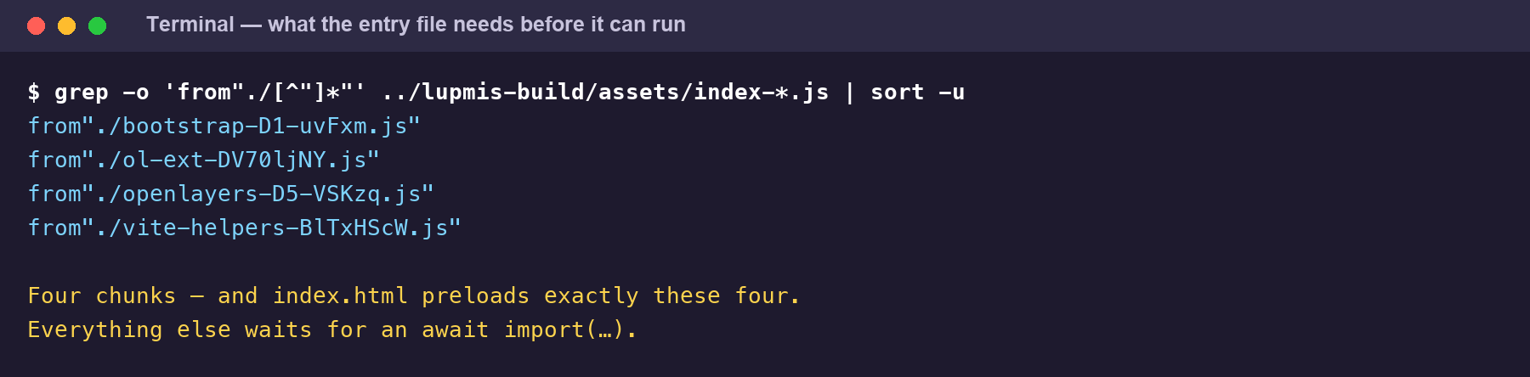
The chunks the entry file names in its own import lines — and exactly what index.html preloads.
grep -o 'from"./[^"]*"' ../lupmis-build/assets/index-*.js | sort -u

6. Those, and only those, must arrive before the application can start. Compare them with the modulepreload lines in ../lupmis-build/index.html, and with your list from step 3.
7. Now the history. Until late September 2026 this did not hold: two chunks meant to be lazy arrived on every visit. Find the change that fixed it and read what it says:
git log --oneline --grep=startup
git show -s <the id you found>

8. Read git show <id> -- vite.config.js to see exactly which rules were added, and check against your own measurements in steps 3 and 6 that the problem is really gone.
Check yourself
a) Which libraries does vite.config.js intend to load only when needed, and what triggers each?
b) What loaded before you touched anything, and what arrived when you clicked Analyse?
c) Which chunks does the entry file import directly, and why must those load first?
d) According to the commit, what used to be preloaded that should not have been, and what were the two causes?
e) Why does vite.config.js give pako a chunk of its own?
f) Code-splitting has a cost too. Why not put every library in its own chunk?
g) Reading vite.config.js alone would not have found this. What would?

Exercise 3 — Anatomy of a LUPMIS2 dialog
Outcome: build a dialog with Bootstrap that matches the existing LUPMIS2 patterns · About 45 minutes
Goal. Take an existing dialog apart, so that the one you build in exercise 6 follows the same pattern.
1. In index.html, find id="exportGisModal". Sketch its nesting: which element sits inside which, and what goes in the header, the body and the footer.
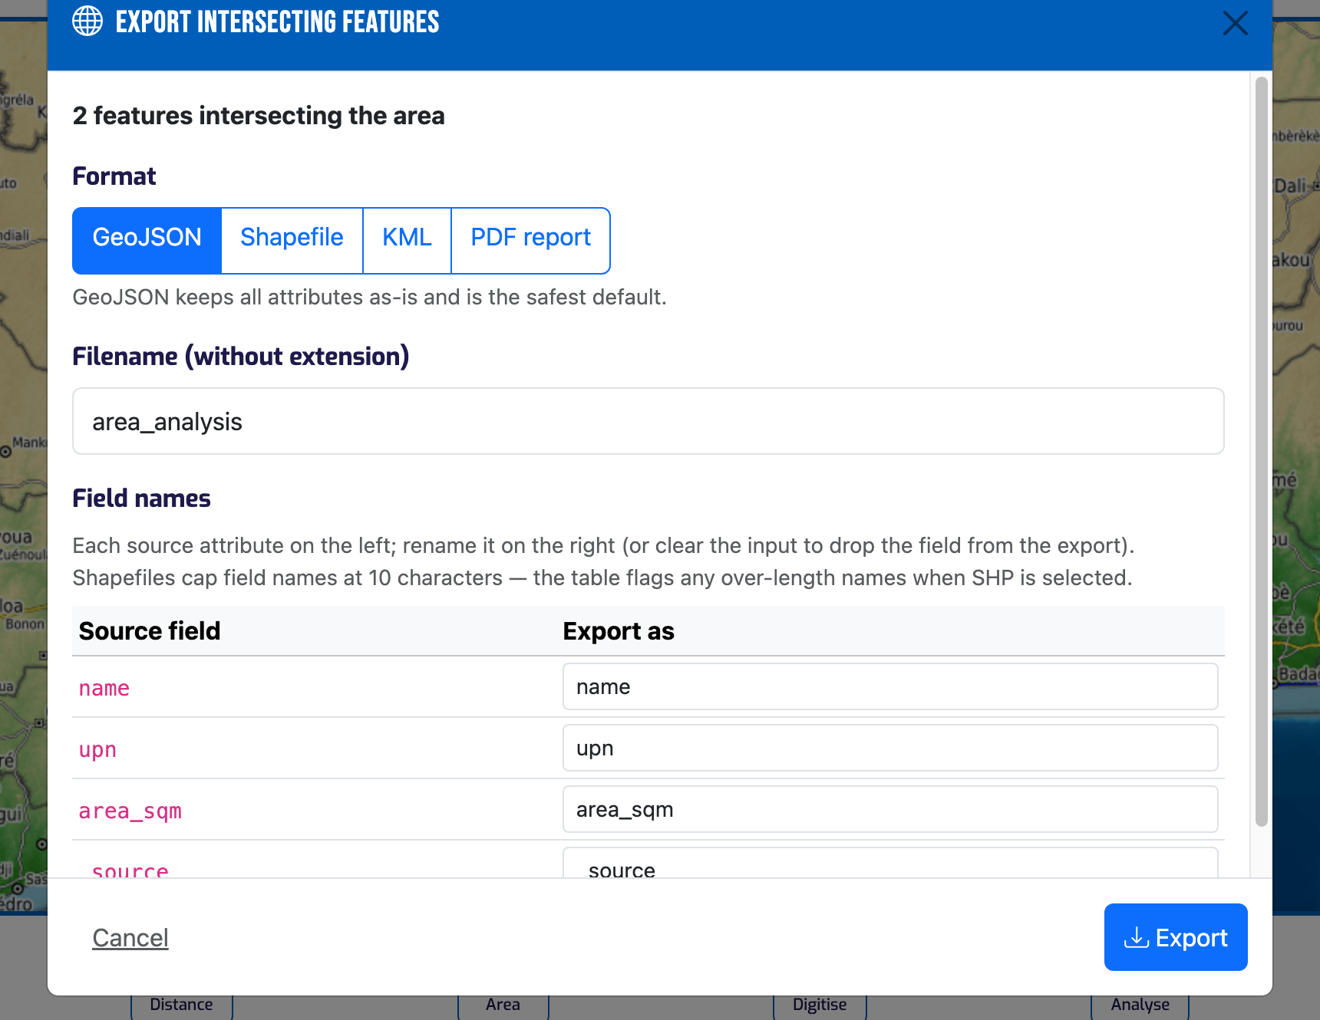
The dialog you are taking apart: header, body and footer, with the primary action on the right of the footer.
2. Note the classes that give LUPMIS2 dialogs their look: on the header, on the close button, and on the two footer buttons.
3. Open src/export-gis-modal.js. Find cacheEls, the dataset.wired check, and openExportGisModal. Follow what happens from the moment openExportGisModal is called to the moment the dialog is visible.
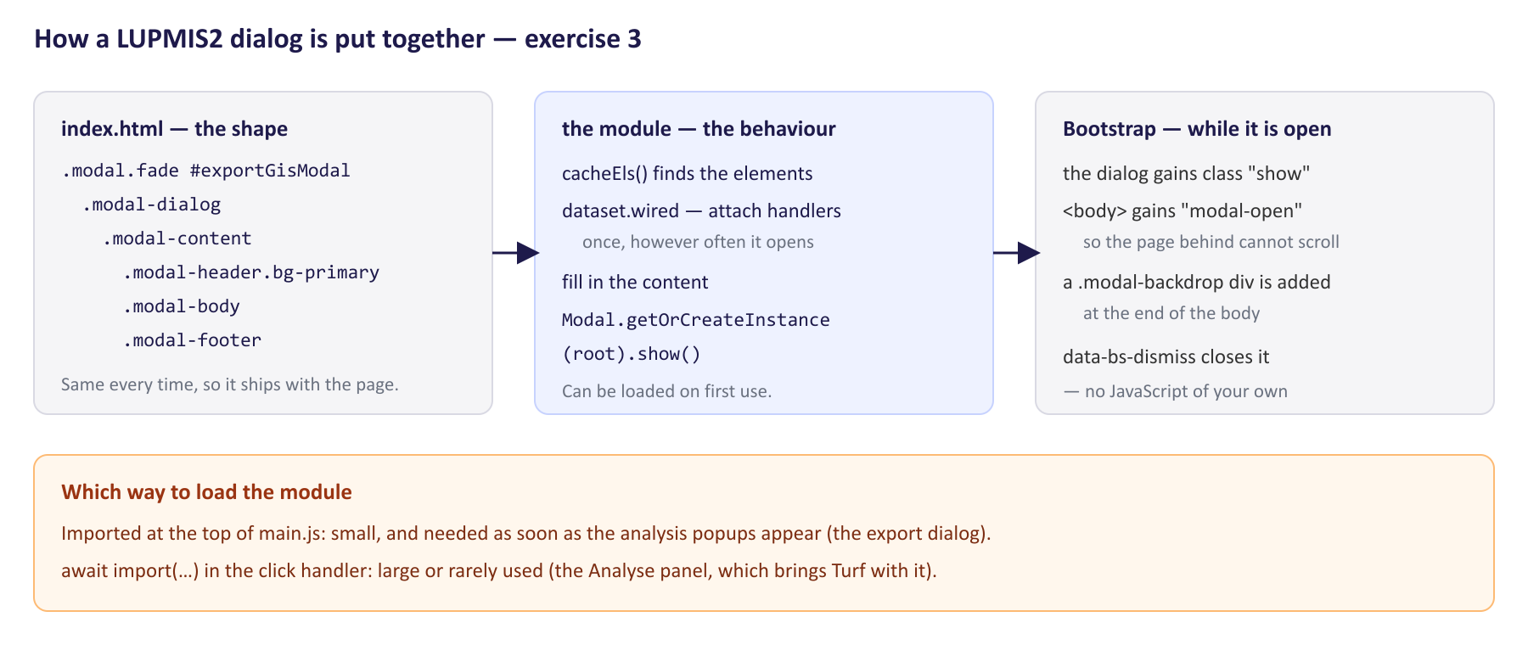
The three parts of a LUPMIS2 dialog, and which way to load the module.
4. In main.js, compare how the export dialog is loaded (search for export-gis-modal) with how the analysis dialog is loaded (search for analysis-modal).
5. In the running application, open the right-hand panel and click Status. In the Elements panel, look at the <body> element and at the very end of the body while the dialog is open. Close it and look again.
Check yourself
a) Why is the dialog’s markup in index.html, but its behaviour in a separate module?
b) What does the dataset.wired check prevent?
c) Why Modal.getOrCreateInstance(…) rather than new Modal(…)?
d) The close button has no JavaScript of its own. What makes it work?
e) What changed on the page while the Status dialog was open?
f) The export module is imported normally at the top of main.js; the analysis module with await import(…) when the button is clicked. What decides which way to choose?

Exercise 4 — An Excel file from data
Outcome: generate Excel output from application data · About 45 minutes
Goal. Produce a workbook with LUPMIS2’s own writer, open it, and look inside it.
1. Read the comment at the top of src/analysis/xlsx.js: what the module does, and why LUPMIS2 uses its own writer rather than a library.
2. Start the development server (npm run dev), open the application, and in the Console run:
const x = await import('/src/analysis/xlsx.js');
x.exportXlsx([{ name: 'Practice', rows: [
{ cells: ['Category', 'Count'], bold: true },
['School', 3],
['Market', '1'],
]}], 'practice.xlsx');

3. Open practice.xlsx. In an empty cell, add up the two counts with =SUM(B2:B3).
4. Build the same workbook without downloading it, and look at the result: const b = x.buildXlsxBlob([...]) with the same sheet as above, then b.size and b.type.
5. Try a sheet name with forbidden characters: change 'Practice' to 'Results: 2026/09', export again, and look at the sheet tab.
6. Make a copy of practice.xlsx, rename the copy to practice.zip, and open it. Find xl/worksheets/sheet1.xml and find the cells for 3 and for ‘1’.
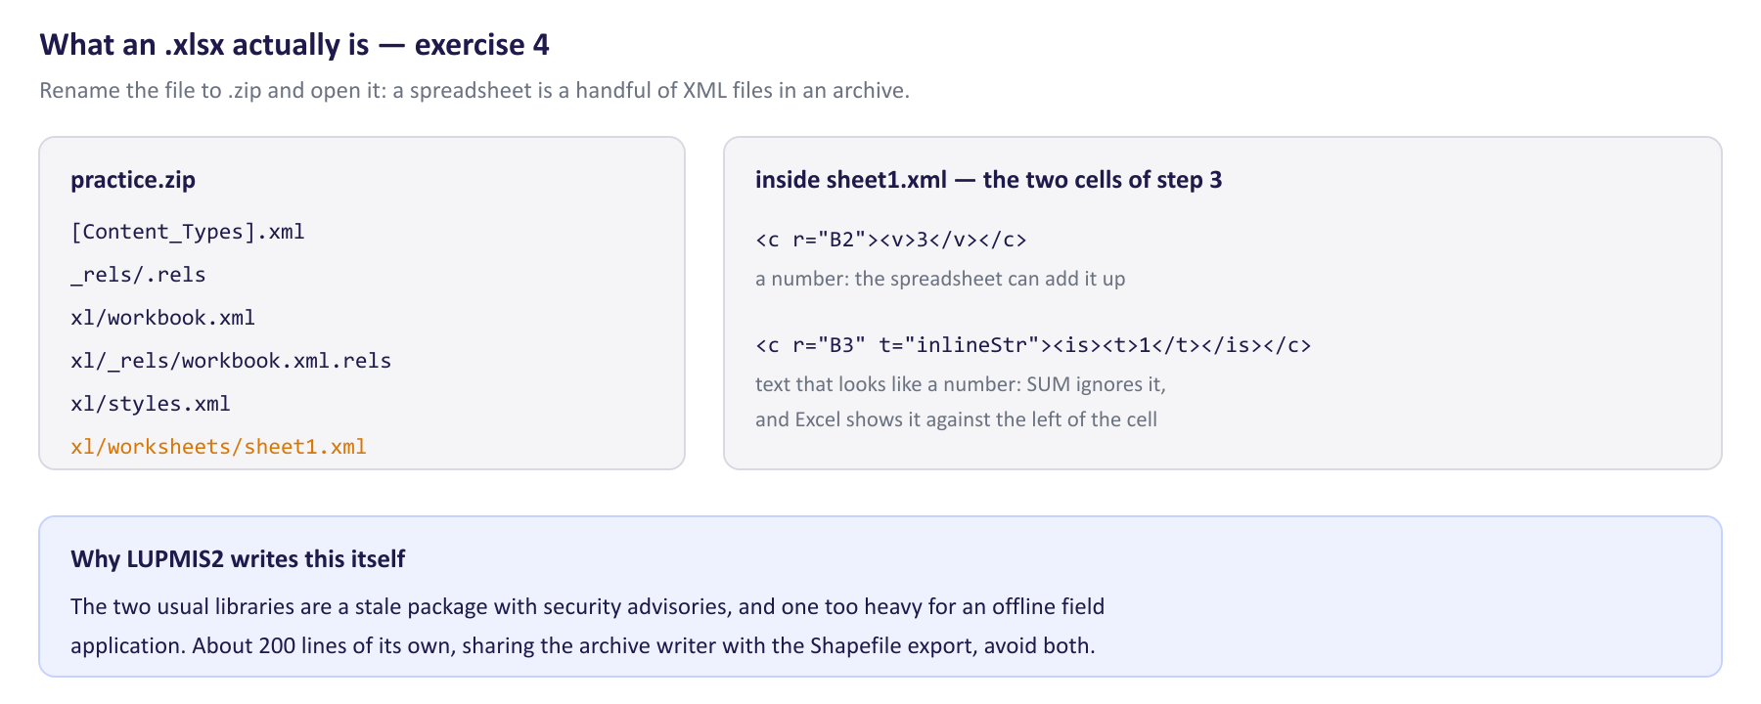
Inside the file you just made, and the difference between a number and text that looks like one.
Check yourself
a) What did =SUM(B2:B3) give, and why?
b) What are b.size and b.type, and what is a Blob?
c) What happened to the sheet name?
d) How do the cells for 3 and ‘1’ differ inside sheet1.xml?
e) Why does LUPMIS2 write its own .xlsx files instead of using a library?

Exercise 5 — A PDF report
Outcome: generate PDF output from application data · About 30 minutes
Goal. Produce LUPMIS2’s branded PDF report from your own data, and see what it costs to load.
1. Read src/pdf-export.js: what exportAnalysisPDF expects, what it draws, and what it does at the end with the finished document.
2. In the Console of the development server, run:
const p = await import('/src/pdf-export.js');
await p.exportAnalysisPDF({ title: 'Practice report', rows: [
{ label: 'Schools', value: '2' },
{ label: 'Markets', value: '1' },
]});

3. Look at the report: the logo, the title, the date and the table.
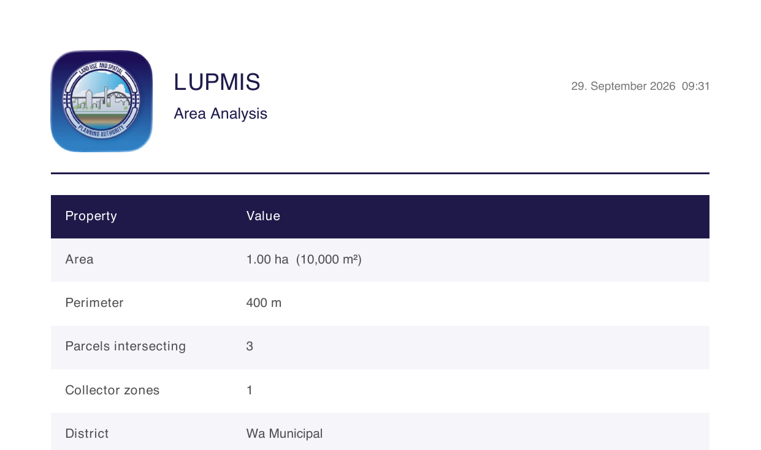
The report produced by the code in step 2, as it opens in the browser.
4. In your build’s output from exercise 1, find the size of the jspdf-….js chunk, and find where in the application pdf-export.js is imported (search the project).
Check yourself
a) What shape does rows have to be?
b) What does the function do if the browser blocks the new tab, and when does that happen?
c) How large is jsPDF, and when does a user’s device download it?

Exercise 6 — The Location summary dialog
Outcome: the topic’s hands-on task — a new dialog following the existing pattern, with a spreadsheet export · About 3 hours
Goal. Add a Summary button to the right-hand panel. It opens a dialog that counts the saved locations by category, shows the counts in a table, and has an Export to Excel button. Try to build it from what you learned in exercises 3 and 4 before you look at the solution in section 5 — it was built and tested exactly as described there.
Part A — prepare
1. In the clone, start a branch: git switch -c location-summary.
2. Decide on the ids you will use before you write anything. The solution uses location-summary-btn for the button, locationSummaryModal for the dialog, and location-summary-caption, location-summary-tbody and location-summary-export inside it.
Part B — the markup
3. In index.html, find the Status button (id="status-btn") and add a Summary button directly after it, in the same style.
4. Find the comment <!-- Status Modal --> and, directly before it, add the dialog. Copy the structure of exportGisModal: header with a title and close button, a body with a short caption and a two-column table (Category, Locations), and a footer with Close and Export to Excel.
Part C — the module
5. Create src/location-summary-modal.js, following src/export-gis-modal.js: a cacheEls function that finds the elements and wires the export button once; a function that counts locations by category; and an exported openLocationSummaryModal that fetches the locations with getLocations() from ./database.js, fills the caption and table, and shows the dialog.
6. Handle the empty case: with no locations, the table says so and the export button is disabled.
7. Write the export handler. Load the writer only when it is clicked (await import('./analysis/xlsx.js')) and export a sheet with a bold header row, one row per category, and a bold total.
Part D — connect it
8. In main.js, find where the Status button is wired (statusBtn.addEventListener) and, after that block, wire the Summary button. Load your module with await import(…) inside the click handler, as the Analyse button does, and report a failure with showError(…).
Part E — test it
9. Start the development server and open the application. Click Summary before you have any locations: the dialog should say there are none, and Export to Excel should be greyed out.
10. Add a few test locations with different categories, either with Digitise › Point or from the Console:
const db = await import('/src/database.js');
await db.addLocation('Test school A', -1.62, 6.69, { category: 'school' });
await db.addLocation('Test school B', -1.61, 6.70, { category: 'school' });
await db.addLocation('Test market', -1.60, 6.68, { category: 'market' });
await db.addLocation('Unsorted point', -1.63, 6.71);

11. Open Summary again. Export, open the file, and check that the counts are numbers — =SUM over them should equal the total.
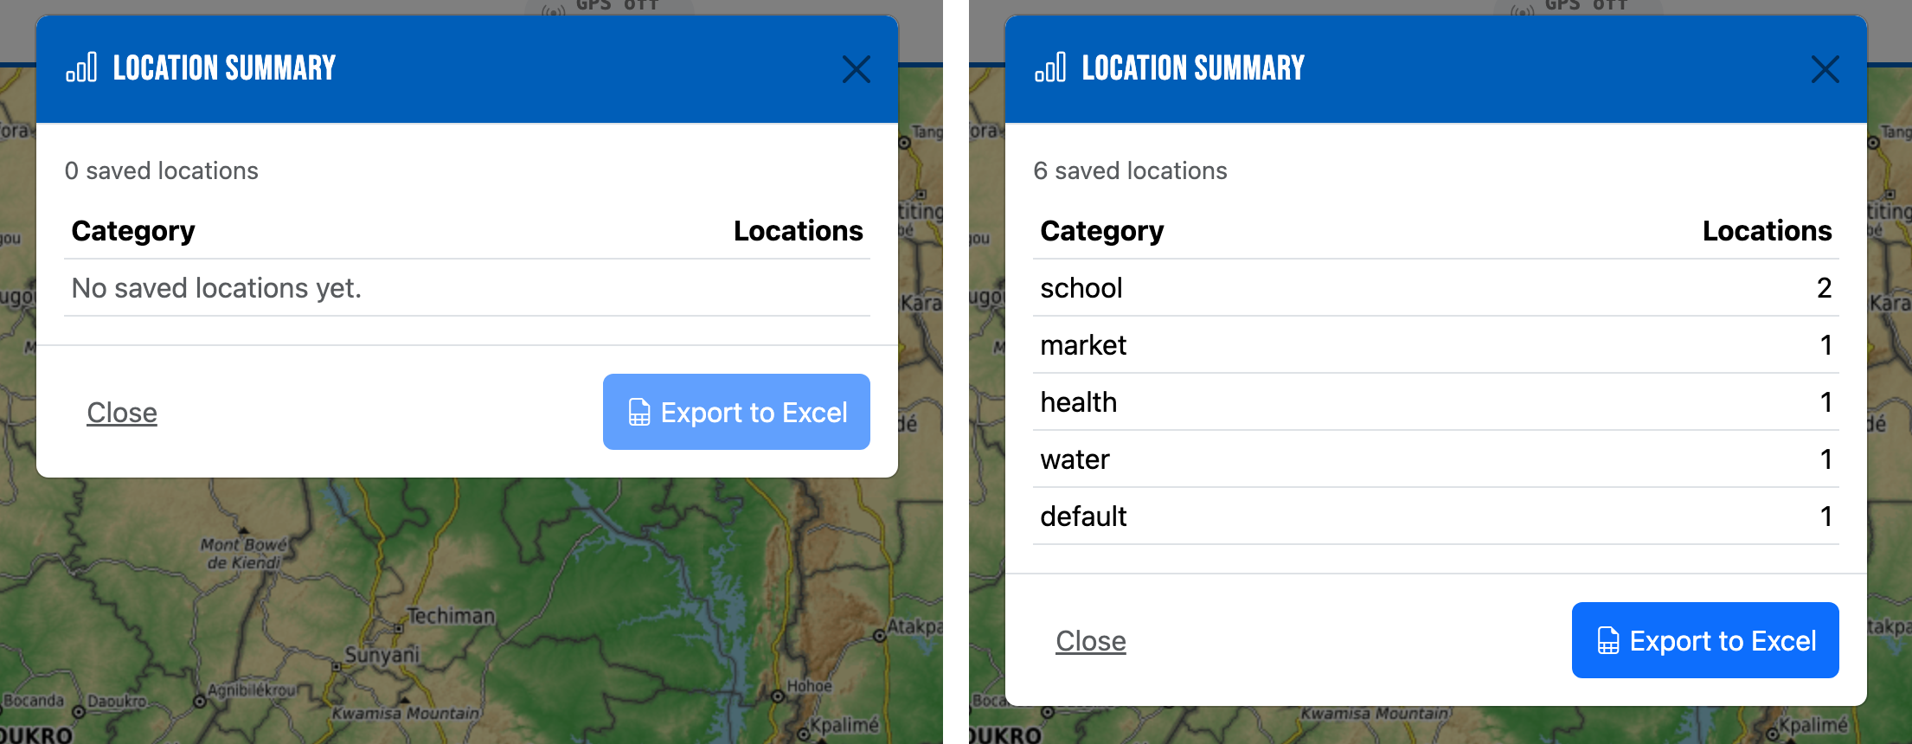
What you are building: the dialog with no locations yet, and with six in five categories. Both pictures come from the solution printed in section 5.
12. Close and reopen the dialog a few times, then export once. You should get exactly one file.
Part F — check the split, then commit
13. Build into ../lupmis-build and find your module in the output. Compare the size of the entry file (index-….js) with the build from exercise 1.
14. Preview the build, open the Network panel, and confirm that your module’s chunk arrives only when you first click Summary — and the xlsx-….js chunk only when you first export.
15. Commit on your branch with a message that says what the dialog is for (Topic 2, exercise 3). Do not push to the LUPMIS2 repository; show the branch to your trainer.
Check yourself
a) Why is your module loaded with await import(…) rather than imported at the top of main.js?
b) Why is the spreadsheet writer loaded inside the export handler, and not at the top of your module?
c) What would happen without the dataset.wired check, after opening the dialog three times?
d) Why escape the category names before writing them into the table?
e) What did your module add to the build, and to what users download at start-up?
Tidying up. The test locations live only in this browser’s local database on your computer. Delete them in the application, or leave them. To return the clone to where it was: git switch main — your branch keeps your work.

4. After the exercises
Bring your branch from exercise 6, and your notes from exercise 2, to the next session with your trainer. Exercise 2 is worth discussing in particular: the configuration says one thing and the build does another, and only measuring showed it — which is the habit this topic is meant to build.

5. Answers
Produced by building and running the application as of Service Worker v26 (September 2026); the exercise 6 solution was built, run and exported in a browser, and the workbook it produced was checked. Names and sizes on your computer will differ slightly.
Exercise 1
a) Everything in public/: sw.js, manifest.json, offline.html, index.php, embed.php, .htaccess and the app-icons and fonts folders. Files in public/ are copied as they are, which is why the Service Worker keeps its fixed name /sw.js — the browser must find it at the same address after every release.
b) <script type="module" crossorigin src="/assets/index-Ddi_Zl4K.js"> — the combined entry file. The modulepreload lines tell the browser to start fetching the chunks the entry imports straight away, in parallel, instead of discovering them one at a time.
c) sqlite3-….wasm, about 856 kB: the SQLite database engine that holds the local data, compiled to WebAssembly. Code-splitting does not apply to it, which is one reason vite.config.js raises the size-warning limit to 900 kB.
d) Source maps. They let the browser’s developer tools show the original source, with its names and comments, instead of the minified build — invaluable for debugging a problem on the live server. They also mean anyone can read that source; that is acceptable here because the source is not secret — which is exactly why no secret may ever be in it.
e) The analysis chunk (analysis-modal-….js, which contains zonal.js) and the entry file (index-….js). The name is a fingerprint of the content, and the entry file contains the analysis chunk’s name, to load it — so when that name changes, the entry’s content changes too. Every other file kept its name, so a browser that already has them does not download them again. A second build with no changes produces identical names.
f) The gzip figure: servers compress JavaScript before sending it, so that is roughly what travels over the network. The first figure is what the device then has to read and run.
Exercise 2
a) Turf, with the Analysis panel (the Analyse button); geotiff and the OpenLayers modules that use it, when a Cloud-Optimized GeoTIFF layer is added; shpjs, when a shapefile is imported; and jsPDF, when a PDF report is exported. main.js fetches shpjs and the analysis dialog with await import(…); MapView.addCOGLayer() and src/export-gis-modal.js do the same for the raster reader and the PDF writer.
b) Before touching anything: the entry file (about 294 kB, 81 kB compressed), vite-helpers (1 kB), bootstrap, openlayers, ol-ext, and the database worker. On clicking Analyse: analysis-modal (17 kB) and turf (57 kB, 20 kB compressed) — a library as large as a quarter of the application, which most officers never load at all.
c) vite-helpers, bootstrap, openlayers and ol-ext — the four the entry file names in its own import lines. An import at the top of a file must be resolved before that file runs, which is why index.html preloads exactly these; everything else is reached through await import(…) and can wait.
d) The geotiff chunk (about 257 kB) and the shpjs chunk (about 171 kB) — together about 428 kB, 152 kB over the network, on every visit. Two causes, both outside the source: the small helper that performs every await import(…) is a generated module with no path of its own, and the build had placed it inside the geotiff chunk, so the entry needed that whole chunk to start; and JSZip, which the Shapefile export needed straight away, had been filed under the shpjs chunk, which dragged the shapefile reader in with it. The helper and JSZip were given chunks of their own; JSZip then disappeared entirely when shp-write was replaced.
e) Both geotiff and jsPDF use pako. Without its own chunk, the build puts it in one of them, and the two chunks then import each other — the comment calls this a circular chunk.
f) Each chunk is a separate request, with its own round trip. For a small library used on every page, that costs more than it saves. Split what is large and not always needed.
g) Measuring. The configuration expressed an intention; the Network panel and the entry file’s own imports show what was actually built. The same habit applies to the rest of this topic: the sizes in a build report, the file you open in Excel, the PDF you look at.
Exercise 3
a) The markup is static and the same every time, so it sits with the rest of the page and loads with it. The module holds only behaviour, and can be loaded later, tested on its own, and read without scrolling through HTML.
b) Adding the click handler to the export button a second time each time the dialog opens — after three openings, one click would export three times.
c) Bootstrap keeps one controller per dialog element. getOrCreateInstance returns the existing one, or makes one the first time, so every opening uses the same controller. The older Status dialog in main.js (handleShowStatus) calls new Modal(…) on every click; it shows no visible problem — opening and closing it repeatedly leaves no stray backdrop — but the newer dialogs use getOrCreateInstance, and yours should too.
d) data-bs-dismiss="modal": Bootstrap watches for clicks on elements with that attribute and closes the dialog they are in.
e) The dialog gains the class show and becomes visible; <body> gains the class modal-open, which stops the page behind from scrolling; and a <div class="modal-backdrop"> is added at the end of the body to dim the page. Closing removes all three.
f) Size and how often it is used. The export dialog’s module is small and is opened from the analysis popups; the analysis dialog brings Turf with it, which is large and not needed until someone opens the panel.
Exercise 4
a) 3 — not 4. The first count was written as a number; '1' was a piece of text, so the spreadsheet shows it on the left of the cell and SUM ignores it. Numbers must be numbers before they reach the writer.
b) About 3,800 bytes and application/vnd.openxmlformats-officedocument.spreadsheetml.sheet. A Blob is a block of data held in the browser’s memory, with a type — a file that has not been saved anywhere yet. downloadBlob gives it a temporary address and clicks a link to it.
c) It became Results 2026 09: Excel forbids : \ / ? * [ ] in sheet names, and limits them to 31 characters, so the writer replaces those characters with spaces.
d) 3 is stored as a value, <c r="B2"><v>3</v></c>; ‘1’ as text written into the cell, <c r="B3" t="inlineStr"><is><t …>1</t></is></c>.
e) The comment gives the reasons: SheetJS’s npm package is out of date and has published security advisories, and ExcelJS is heavy for an application that has to work offline in the field. About 200 lines the project controls avoid both, and add nothing to the dependency list. The writer now packs its file with src/zip-store.js, which the Shapefile export shares.
Exercise 5
a) A list of objects, each with a label and a value — one table row each. Values should be text, formatted the way they should appear.
b) It downloads the file instead. Browsers, especially on phones, block new tabs that a page opens without a direct tap — and in some cases even with one.
c) About 399 kB (about 129 kB compressed), plus a small pdf-export chunk. src/export-gis-modal.js imports pdf-export.js with await import(…) only when a PDF export is requested, so most users never download it at all.
Exercise 6 — the solution
Built, run and tested exactly as below: the empty case, four test locations in three categories, and the exported workbook opened and read back — school 2, market 1, default 1 and a bold total of 4, all stored as numbers.
index.html — the button, directly after the Status button:
<button type="button" class="btn btn-outline-secondary" id="location-summary-btn" title="Saved locations by category">
📊 Summary
</button>

index.html — the dialog, directly before <!-- Status Modal -->:
<!-- Location Summary Modal (src/location-summary-modal.js) -->
<div class="modal fade" id="locationSummaryModal" tabindex="-1"
aria-labelledby="locationSummaryModalLabel" aria-hidden="true">
<div class="modal-dialog modal-dialog-scrollable">
<div class="modal-content">
<div class="modal-header bg-primary">
<h5 class="modal-title" id="locationSummaryModalLabel">
<i class="bi bi-bar-chart me-2"></i>Location summary
</h5>
<button type="button" class="btn-close btn-close-white"
data-bs-dismiss="modal" aria-label="Close"></button>
</div>
<div class="modal-body">
<p class="text-muted small mb-2" id="location-summary-caption"></p>
<table class="table table-sm mb-0">
<thead>
<tr><th>Category</th><th class="text-end">Locations</th></tr>
</thead>
<tbody id="location-summary-tbody"></tbody>
</table>
</div>
<div class="modal-footer">
<button type="button" class="btn btn-link text-muted me-auto"
data-bs-dismiss="modal">Close</button>
<button type="button" class="btn btn-primary" id="location-summary-export">
<i class="bi bi-file-earmark-spreadsheet me-1"></i>Export to Excel
</button>
</div>
</div>
</div>
</div>

src/location-summary-modal.js — a new file:
/**
* Location summary modal controller.
*
* openLocationSummaryModal()
*
* Counts the saved locations by category, shows the counts in a table, and
* offers them as an Excel workbook. Same Bootstrap modal pattern as
* src/export-gis-modal.js: the markup lives in index.html, this module fills
* it in and wires its buttons once.
*/

import { Modal } from 'bootstrap';
import { getLocations } from './database.js';

const els = {};
let counts = []; // [[category, count], ...], largest first

function cacheEls() {
if (els.root) return;
els.root = document.getElementById('locationSummaryModal');
els.caption = document.getElementById('location-summary-caption');
els.tbody = document.getElementById('location-summary-tbody');
els.btnExport = document.getElementById('location-summary-export');

if (els.root && !els.root.dataset.wired) {
els.root.dataset.wired = '1';
els.btnExport.addEventListener('click', onExportClick);
}
}

/** [[category, count], ...] sorted by count, largest first. */
function countByCategory(locations) {
const byCategory = {};
for (const loc of locations) {
const category = loc.category || 'default';
byCategory[category] = (byCategory[category] || 0) + 1;
}
return Object.entries(byCategory).sort((a, b) => b[1] - a[1]);
}

function escapeHtml(s) {
return String(s)
.replace(/&/g, '&amp;').replace(/</g, '&lt;').replace(/>/g, '&gt;')
.replace(/"/g, '&quot;').replace(/'/g, '&#39;');
}

export async function openLocationSummaryModal() {
cacheEls();
if (!els.root) {
console.warn('[LocationSummary] Modal missing from DOM');
return;
}

const locations = await getLocations();
counts = countByCategory(locations);

els.caption.textContent =
`${locations.length} saved location${locations.length === 1 ? '' : 's'}`;
els.tbody.innerHTML = counts.length
? counts.map(([category, n]) =>
`<tr><td>${escapeHtml(category)}</td><td class="text-end">${n}</td></tr>`).join('')
: '<tr><td colspan="2" class="text-muted">No saved locations yet.</td></tr>';
els.btnExport.disabled = counts.length === 0;

Modal.getOrCreateInstance(els.root).show();
}

/** Export the counts as a workbook. The writer is loaded on first use. */
async function onExportClick() {
els.btnExport.disabled = true;
try {
const { exportXlsx } = await import('./analysis/xlsx.js');
const total = counts.reduce((sum, [, n]) => sum + n, 0);
exportXlsx([{
name: 'Locations',
rows: [
{ cells: ['Category', 'Locations'], bold: true },
...counts,
{ cells: ['Total', total], bold: true },
[],
['Exported', new Date().toLocaleString()],
],
}], 'location_summary.xlsx');
} finally {
els.btnExport.disabled = false;
}
}

main.js — directly after the block that wires the Status button:
// Location summary — loaded on first use, like the Analysis panel.
const summaryBtn = document.getElementById('location-summary-btn');
if (summaryBtn) {
summaryBtn.addEventListener('click', async () => {
try {
const { openLocationSummaryModal } = await import('./src/location-summary-modal.js');
await openLocationSummaryModal();
} catch (err) {
console.error('[App] Could not open the location summary:', err);
showError('The location summary could not be opened.');
}
});
}

a) The dialog is used now and then, not at every start. Loaded on first click, it costs nothing until someone wants it — the same reason as for the Analyse button.
b) The writer is only needed if the user exports, which many will not. Loading it in the handler means opening the dialog does not download it.
c) Three click handlers on the export button, and three files from one click. The check makes the wiring happen exactly once, however often the dialog opens.
d) A category is text that came from outside the program — typed by a user, or imported from a file. Written into innerHTML unescaped, a value containing < would become part of the page, and could run code.
e) One new chunk of about 1.9 kB (about 1 kB compressed), loaded on first click. The entry file grew by about 0.6 kB — the click handler — which is all users download at start-up. The xlsx-….js chunk was already there for the zonal-statistics export and kept its name, because its content did not change.

