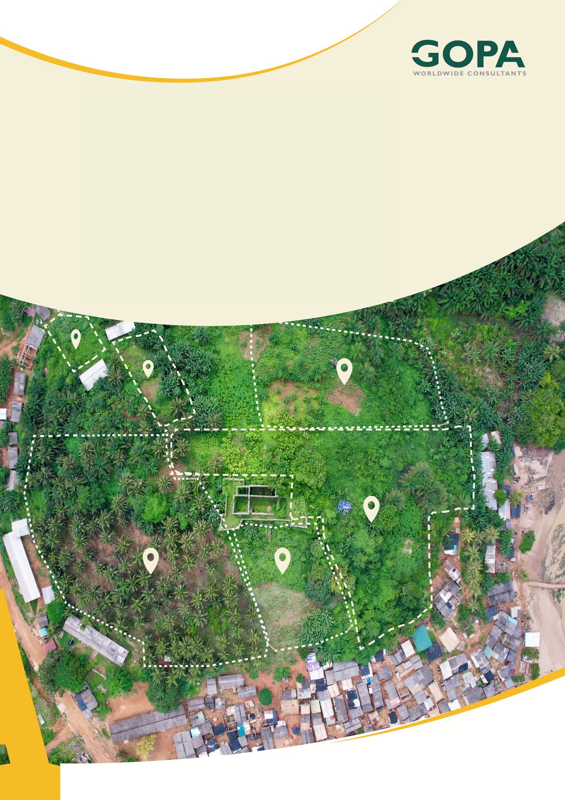
GHANA
Development of a Spatial Planning and Management Information System for Ghana
LUPMIS2 Training — Topic 1 Exercises
Web development foundations · self-paced · September 2026

Topic 1 — Web development foundations: exercises
Self-paced exercises for Training Plan section 6.1 · LUPMIS2 capacity building for LUSPA

1. How to use these exercises
Section 6.1 of the Training Plan sets four learning outcomes for the first topic. These seven exercises work towards them on the LUPMIS2 application itself, not on a teaching example, so everything you learn applies directly to the code you will later maintain. Work through them at your own pace, in order: each one uses what the previous one showed you.
Every exercise has the same parts: a goal, numbered steps, and Check yourself questions. Write your answers down before you look at section 5, where all the answers are. Getting an answer wrong and finding out why is worth more than reading the right one.
Exercise | Learning outcome (Training Plan 6.1) | Time
1 How the browser loads LUPMIS2 | HTML, CSS and JavaScript together; developer tools | 45 min
2 The dock in the Elements panel | HTML, CSS and JavaScript together; developer tools | 45 min
3 Modules and functions in the console | Modern JavaScript: modules and functions | 60 min
4 Arrays and objects | Modern JavaScript: arrays and objects | 60 min
5 Promises and async/await | Modern JavaScript: promises; following network requests | 75 min
6 From a click to the screen | What happens between a click and a change on screen | 90 min
7 A small, safe change | The topic’s hands-on task: trace, then modify | 60 min

Altogether this is about seven to eight hours, which fits comfortably alongside the five days the Training Plan gives the topic.
Nothing breaks. Exercises 1 to 6 do not change any file. Whatever you change in the developer tools lives only in the open page and is gone when you reload. Exercise 7 is the only one that edits the code, and it starts by showing you how to put everything back.

2. Before you start
You need a copy of the LUPMIS2 source code on your computer (ask your trainer for it), and Node.js version 18 or newer. To check Node.js, open a terminal and type node -v.
1. Open a terminal in the project folder — the folder that contains package.json.
2. Type npm install and press Enter. This downloads the libraries LUPMIS2 is built on into a folder called node_modules. It takes a few minutes and is only needed once.
3. Type npm run dev. The development server starts and prints an address, normally http://localhost:5173/. Leave this terminal open for as long as you work.
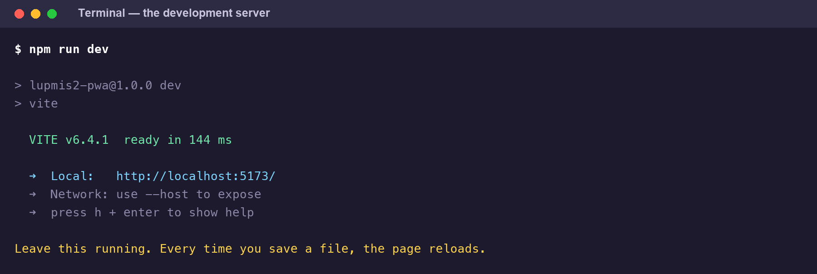
The development server after npm run dev. Open the address it prints — the number may differ.
4. Open that address in Chrome, Edge or Brave. The LUPMIS2 map appears.
5. Open the developer tools: F12 or Ctrl+Shift+I on Windows, Cmd+Option+I on a Mac. The tabs used below — Elements, Console, Sources, Network — are along the top of that panel.
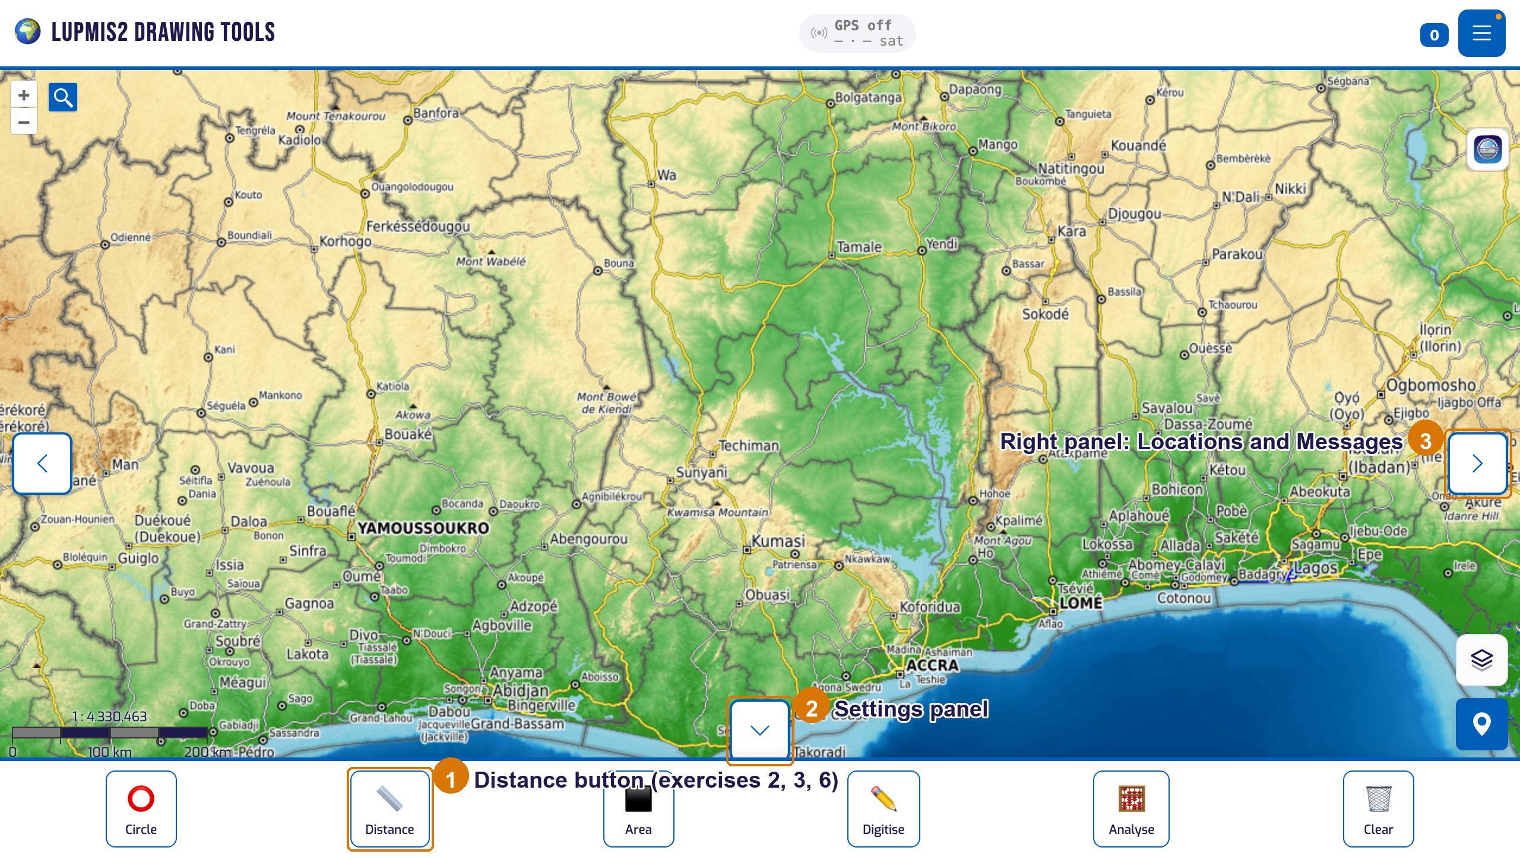
LUPMIS2 as it opens: ① the Distance button in the dock, ② the arrow that opens Settings, ③ the arrow that opens the right-hand panel with Locations and Messages.
If something looks wrong. Base-map tiles need an internet connection. District data comes from the LUPMIS server and may not load on your computer; none of the exercises need it. A console warning that VITE_CARTO_API_KEY is not set only affects the Carto base maps and can be ignored.

3. Exercises

Exercise 1 — How the browser loads LUPMIS2
Outcome: how HTML, CSS and JavaScript combine, and how the browser loads them · About 45 minutes
Goal. See what the browser actually receives when you open LUPMIS2, in what order, and who asked for each piece.
1. Press Ctrl+U (Mac: Cmd+Option+U) to view the page source. This is index.html, exactly as the server sent it. Near the top you will find two <style> blocks: that is the application’s own CSS, written straight into the page. Scroll to the very bottom and find this line:
<script type="module" src="/main.js"></script>

2. Close the source view. In the developer tools, open Network, tick Disable cache, and reload the page with Ctrl+R (Mac: Cmd+R).
3. Look at the first row in the list, then click the JS filter and find main.js. Look at its Initiator column.
4. Still on JS, scroll through the list. Count roughly how many JavaScript files arrive.
5. Click the Img filter. Drag the map a little, then zoom in one step, and watch new rows appear. Click one tile request and read its full address in the Headers tab.
6. Clear the filter and type .css into the filter box.
Check yourself
a) What is the first request, and what type is it?
b) What caused the browser to request main.js?
c) Why are there so many separate JavaScript requests? What would you expect on the live server instead?
d) A tile address ends in three numbers, for example /12/2031/1987.png. What do they mean? Why do new tile requests appear when you drag the map, but not always when you drag it back?
e) Where does the CSS for Bootstrap and for the map library come from, given that index.html contains only the application’s own styles?

Exercise 2 — The dock in the Elements panel
Outcome: how HTML, CSS and JavaScript combine; inspecting elements · About 45 minutes
Goal. Connect a button you can see to the HTML that describes it and the CSS that styles it, and watch JavaScript change it while you use it.
1. Right-click the Distance button in the bottom dock and choose Inspect. The Elements panel opens with the button highlighted. Note its tag, its id and its class, and the two <span> elements inside it.
2. In the Styles pane on the right, find the rule for .dock-btn. Untick one of its properties and watch the button change; tick it again.
3. In the Elements panel, double-click the word Distance inside the second <span> and change it to Length. Press Enter and look at the dock. Now reload the page.
4. Keep the button selected in the Elements panel and click Distance in the dock. Watch the button’s class attribute. Click Distance again.
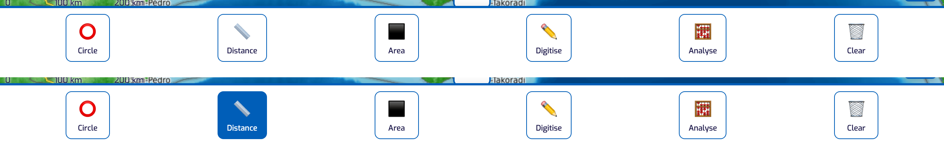
The dock with Distance off (above) and on (below). Switching it on is what adds the class “active”, which the stylesheet colours in.
5. Open the Settings panel with the small arrow button titled “Open bottom panel” (hover over the buttons at the edge of the map to see their titles) and turn on Dark Mode. In the Elements panel, scroll to the very top and look at the <html> element. Then select the Distance button again and look for a rule beginning .dark-mode in the Styles pane. Turn Dark Mode off again.
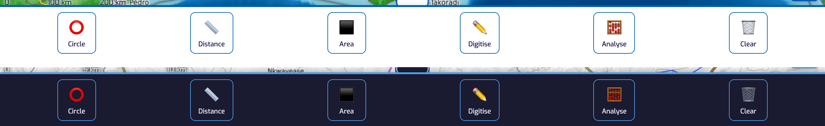
The same dock in dark mode. Nothing in the markup changed: one class on the <html> element switches every rule written for it.
Check yourself
a) What are the button’s id and class? What does each of the two <span> elements hold?
b) What changes on the button when Distance is switched on?
c) Why did your change to Length disappear when you reloaded?
d) Which element does dark mode change, and how?
e) In dark mode, both .dock-btn and .dark-mode .dock-btn set the button’s colours. Which wins, how does the Styles pane show it, and why?

Exercise 3 — Modules and functions in the console
Outcome: modern JavaScript — modules and functions · About 60 minutes
Goal. Load one of LUPMIS2’s own modules into the console, predict what its functions return, and find out why they sometimes return something unexpected.
1. Open the Console. Click Distance in the dock and read the lines that appear. They come from console.log calls in main.js — you will meet them again in exercise 6. Click Distance again to switch it off.
2. Load the module that formats measurements, and list what it offers:
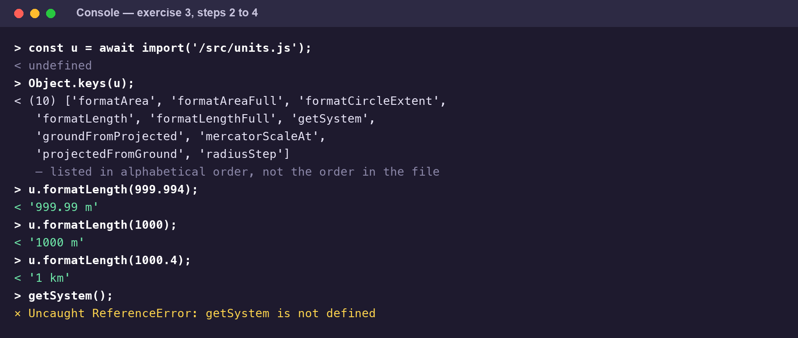
Exercise 3 in the Console. Note that Object.keys lists the exports alphabetically, not in the order they appear in units.js.
const u = await import('/src/units.js');
Object.keys(u);

3. Open src/units.js in your editor and read the function formatLength. Before running anything, write down what you expect each of these to return:
u.formatLength(999.994)
u.formatLength(1000)
u.formatLength(1000.4)
u.formatLength(1234.5)
u.formatLength(12345)

4. Now run them one at a time and compare with your predictions.
5. Read radiusStep at the bottom of the same file — it decides how far one tap on the circle’s − and + buttons moves the radius. Predict, then check, u.radiusStep(49.9), u.radiusStep(50), u.radiusStep(200), u.radiusStep(1000) and u.radiusStep(5000).
6. In Settings, flip the Measurement System switch to Imperial. Run u.formatLength(100) and u.formatLength(5000) again. Then run localStorage.getItem('measurement-system'). Switch back to Metric.
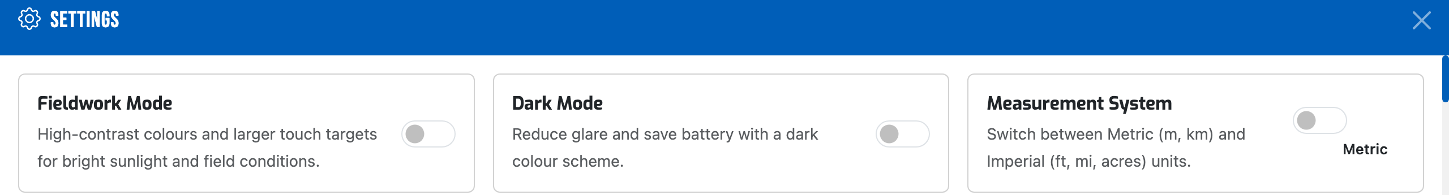
The Settings panel. The Measurement System switch is what getSystem() reads, through localStorage.
7. Type getSystem() on its own, without u. in front.
Check yourself
a) Why does formatLength(1000) show metres, while formatLength(1000.4) shows kilometres?
b) Why does it say 1 km and not 1.00 km?
c) formatLength takes only one argument, the number of metres. How does it know whether to answer in metres or feet?
d) What happened when you typed getSystem() on its own, and why?

Exercise 4 — Arrays and objects
Outcome: modern JavaScript — arrays and objects · About 60 minutes
Goal. Work with a real LUPMIS2 data structure: the list of statistics the Analyse tool offers for zonal statistics.
1. Load the module and show the list as a table:
const z = await import('/src/analysis/zonal.js');
console.table(z.STATS);

2. Read the table. Each row is an object with three properties; the whole thing is an array of six of them. Now write one expression for each of the following. Try on your own first; the answers show one way to do each.
a) A list of just the labels, in order.
b) The labels of only those statistics that need a numeric field.
c) The single object whose key is 'mean'.
d) One object that maps every key to its label, for example { count: 'Count', … }. Hint: Object.fromEntries.
e) Using destructuring, put the first statistic in first and all the others in rest. How many are in rest?
3. Try to replace the list: run z.STATS = [], then z.STATS.length.
4. In your editor, open src/analysis-modal.js and search for STATS.map. This is where the array becomes the checkboxes you see in the Analyse panel.
Check yourself
a) What did z.STATS.length show after you tried to replace the list, and why was there no error message?
b) Why is it useful that the list of statistics lives in one array, rather than being written out in the HTML of the Analyse panel?

Exercise 5 — Promises and async/await
Outcome: modern JavaScript — promises and async/await; following network requests · About 75 minutes
Goal. Fetch data the way LUPMIS2 does, and meet the trap that catches almost everyone the first time.
1. Put the Network panel and the Console side by side (or switch between them). In Network, choose the Fetch/XHR filter.
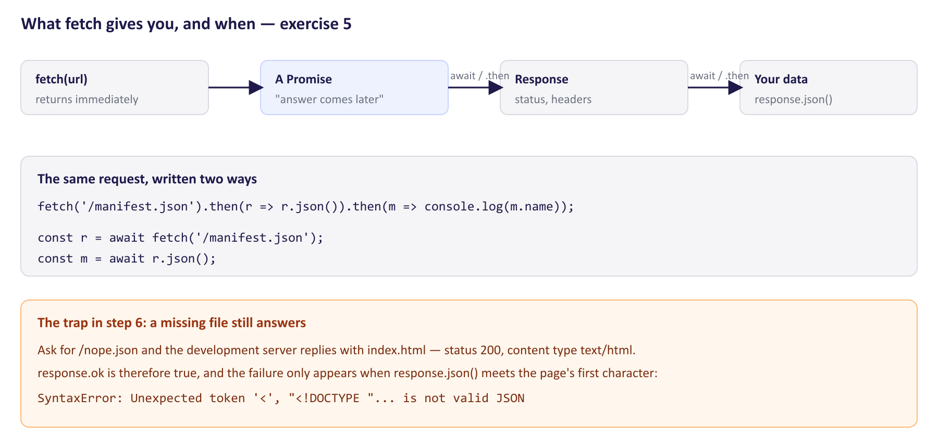
What fetch returns, and the trap waiting in step 6.
2. In the Console run fetch('/manifest.json') and look at what comes back. Look at Network too.
3. Get the data out with .then:
fetch('/manifest.json')
.then(response => response.json())
.then(manifest => console.log(manifest.name));

4. Do the same with await, which reads from top to bottom:
const response = await fetch('/manifest.json');
const manifest = await response.json();
manifest.icons.length;

5. Write a small reusable function and use it:
async function loadJson(url) {
const response = await fetch(url);
if (!response.ok) throw new Error(`HTTP ${response.status} for ${url}`);
return response.json();
}
await loadJson('/manifest.json');

6. Now ask for a file that does not exist: await loadJson('/nope.json'). Read the error. Then look at the request in the Network panel: its status, and in Headers its Content-Type.
7. Open src/remotedb.js and read the function remotePost — every request LUPMIS2 sends to the server goes through it.
Check yourself
a) In step 2, why did fetch return a Promise rather than the file?
b) What is the manifest’s name, and how many icons does it list?
c) Your function checks response.ok, yet /nope.json still failed with a confusing error. What status and content type did the server actually send, and why? How would you make loadJson catch this properly?
d) In remotePost: which lines wait for something; what happens when the server answers with an error status; what happens when it does not answer at all; and what does the finally block make sure of?

Exercise 6 — From a click to the screen
Outcome: explain what happens between clicking a button and something changing on screen · About 90 minutes
Goal. Follow the Distance button end to end: from the HTML, through the event handler, to the distance label that follows your mouse on the map. This is the first half of the Training Plan’s hands-on task for the topic.
Part A — read the path in your editor
Use your editor’s search across files (in VS Code, Ctrl+Shift+F). Search for text, not line numbers: the text stays the same when lines move.
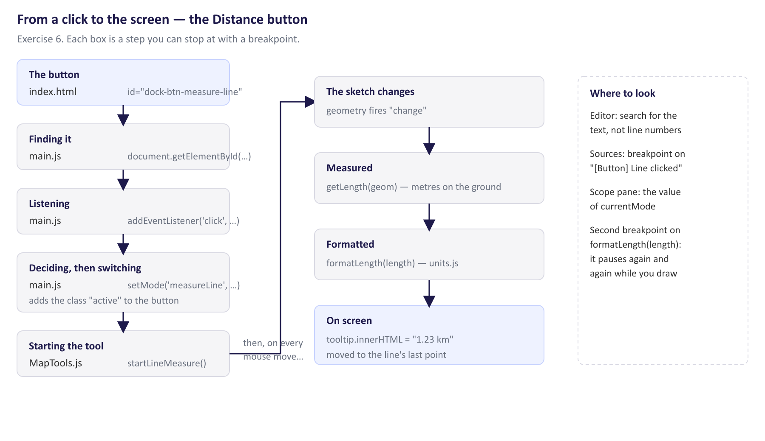
The whole path the click takes, which is what the table at the end of Part B asks you to fill in.
1. Search for dock-btn-measure-line. You find it twice: in index.html (the button itself) and in main.js (where the code looks it up).
2. In main.js, search for measureLineBtn.addEventListener. Read the handler: what does it do if Distance is already on, and what if it is not?
3. Search main.js for const setMode = and read the function to the end, including the switch.
4. Follow startLineMeasure into src/components/MapTools.js. Read the function down to the line that sets innerHTML.
Part B — watch it happen in the Sources panel
5. In the developer tools open Sources, press Ctrl+P (Mac: Cmd+P) and type main.js.
6. Press Ctrl+F inside the file and find [Button] Line clicked. Click the line number beside it to set a breakpoint (a blue marker).
7. Click Distance on the map. The page freezes and Sources shows the paused line. In the Scope pane, find the value of currentMode.
8. Use Step over (F10) to move line by line. When you reach the setMode(…) call, use Step into (F11) and follow it into setMode. Press Resume (F8) to let the page continue.
9. Open MapTools.js the same way and set a breakpoint on the line const output = formatLength(length); inside startLineMeasure. Click on the map to start a line, then move the mouse. Look at length in Scope, resume, and see how soon it pauses again.
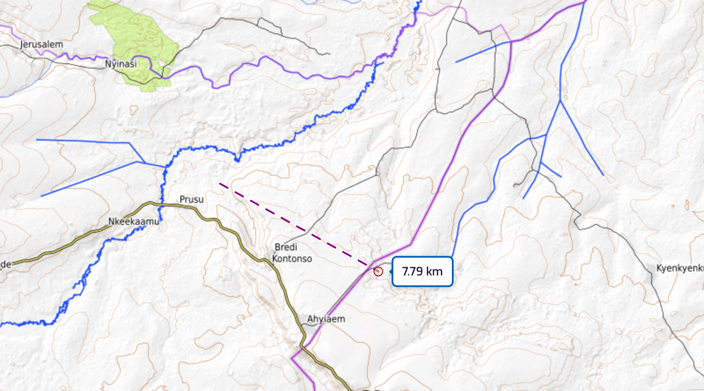
The label the last box in the chain writes: it follows the pointer and is rewritten on every small movement, which is why the breakpoint pauses again and again.
10. Remove both breakpoints (click the markers again), resume, and switch Distance off.
Fill in the chain
Complete this table from what you found. Answer 6 in section 5 has a completed copy.
Step | File | What happens here
1 The button
2 Finding it
3 Listening
4 Deciding
5 Switching mode
6 Starting the tool
7 On every mouse move
8 On screen

Check yourself
a) In mapTools?.startLineMeasure(), what does the ?. do, and why is it there?
b) Why did the breakpoint in MapTools.js pause again almost as soon as you resumed?
c) What makes the Distance button look pressed, and where does that happen?
d) Why does a second click on Distance switch it off?

Exercise 7 — A small, safe change
Outcome: the topic’s hands-on task — trace a feature, then make a small, safe modification · About 60 minutes
Goal. Change the code, see the effect, and put everything back exactly as it was.
First, a way back. Before editing, make copies of the two files you will change: copy main.js to main.js.orig and src/units.js to src/units.js.orig. Topic 2 of the Training Plan introduces version control, which does this properly; until then, copies are enough.

1. In main.js, find the Distance click handler from exercise 6. In the else branch, directly after the line setMode('measureLine', measureLineBtn);, add:
logMessage('info', 'Distance tool on — click to add points, double-click to finish.');

2. Save the file. The development server notices and the page reloads by itself. Click Distance, then open the right-hand panel (the arrow button titled “Open right panel”) and look under Messages. Look in the Console too.
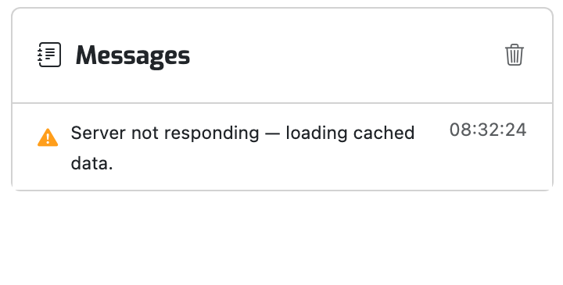
The Messages list in the right-hand panel, where your new line appears.
3. In src/units.js, in formatLength, change metres > 1000 to metres >= 1000. Save. Because the page has reloaded, load the module again in the Console (const u = await import('/src/units.js');) and run u.formatLength(1000).
4. Make a deliberate mistake: in main.js, change logMessage in your new line to logMesage. Save, click Distance, and read the Console. Is the Distance tool on or not?
5. Put everything back: copy main.js.orig over main.js and src/units.js.orig over src/units.js, then delete the two .orig files. Check that u.formatLength(1000) is back to ‘1000 m’ (load the module again first) and that Distance no longer writes a message.
Check yourself
a) logMessage is not imported anywhere in the handler. Why can you still call it?
b) With the misspelling, what did the Console say — and why was the Distance tool on anyway?
c) Search the project for formatLength(. Which other parts of LUPMIS2 would your change in step 3 have affected?

4. After the exercises
Bring your written answers, and your completed chain table from exercise 6, to the next session with your trainer. Mark anything that surprised you — the discussion is most useful there. Exercise 5’s missing file and exercise 7’s misspelling are worth talking through in particular: both show code that looks right and is not.

5. Answers
Values were produced by running the code in a browser against the development server. If yours differ, check that your units are set to Metric, and ask your trainer — the application may have changed since this was written.
Exercise 1
a) The page itself, localhost, of type document — that is index.html.
b) The Initiator is the page: the <script type="module" src="/main.js"> line at the bottom of index.html. Every other script is then requested by main.js, or by a module it imports.
c) In development, the server sends each module as a separate file, so that a change reloads only what changed. The live server receives a build (npm run build) that combines them into a few files in /assets/, with names like index-BzlrAJOS.js; the random part changes whenever the content does.
d) Zoom level, then column, then row. The map library keeps recently shown tiles in memory, so dragging back over an area you have just seen usually needs no new request — even with the browser cache disabled.
e) main.js imports them. In development, a stylesheet imported by JavaScript arrives as a small JavaScript module that adds a <style> to the page — which is why it shows up when you filter for .css but is listed as a script.
Exercise 2
a) id="dock-btn-measure-line", class="dock-btn". The first <span> holds the ruler icon; the second has the class dock-btn-label and holds the word Distance.
b) The class active is added. A second click removes it.
c) The developer tools change the page in the browser’s memory, not the file on disk. A reload builds the page again from index.html.
d) The <html> element at the very top gains the class dark-mode. Every rule written as .dark-mode … now applies to everything inside it.
e) .dark-mode .dock-btn wins, and the Styles pane shows the losing properties struck through. It is more specific — two classes against one — so it overrides the plainer rule wherever they disagree.
Exercise 3
Call | Returns
u.formatLength(999.994) | "999.99 m"
u.formatLength(1000) | "1000 m"
u.formatLength(1000.4) | "1 km"
u.formatLength(1234.5) | "1.23 km"
u.formatLength(12345) | "12.35 km"
u.radiusStep(49.9) · (50) · (200) · (1000) · (5000) | 1 · 5 · 10 · 50 · 100
Imperial: u.formatLength(100) · u.formatLength(5000) | "328 ft" · "3.11 mi"
localStorage.getItem('measurement-system') | "imperial" while Imperial is selected

a) The test is metres > 1000 — strictly greater. Exactly 1000 is not greater than 1000, so it stays in metres. This is the kind of detail that only shows up at the boundary, which is why it is worth testing boundaries on purpose.
b) The rounding uses Math.round(…) / 100, which produces the number 1, and JavaScript writes numbers without trailing zeros. To always show two decimals it would need toFixed(2), which produces text.
c) It calls getSystem(), which reads measurement-system from localStorage — the browser’s small per-site storage, where the settings panel saved your choice. The unit system is a hidden input: the same call gives different answers on different devices.
d) ReferenceError: getSystem is not defined. A module keeps its functions to itself; only what it exports can be used elsewhere, and only through the module — here, u.getSystem().
Exercise 4
z.STATS.map(s => s.label)
// ['Count', 'Sum', 'Mean', 'Minimum', 'Maximum', 'Total area (m²)']
z.STATS.filter(s => s.needsField).map(s => s.label)
// ['Sum', 'Mean', 'Minimum', 'Maximum']
z.STATS.find(s => s.key === 'mean')
// { key: 'mean', label: 'Mean', needsField: true }
Object.fromEntries(z.STATS.map(s => [s.key, s.label]))
// { count: 'Count', sum: 'Sum', mean: 'Mean', min: 'Minimum', max: 'Maximum', area: 'Total area (m²)' }
const [first, ...rest] = z.STATS; // first.label is 'Count'; rest.length is 5

a) Still 6. What a module exports cannot be replaced from outside. In module code, which runs in strict mode, the attempt throws a TypeError; the Console runs in the older, lenient mode, where the same mistake fails silently. Silent failures are the harder kind to find.
b) One list drives both the checkboxes and the calculation, so they cannot drift apart. Adding a statistic means adding one object to the array (and the code that computes it), not editing the panel’s HTML by hand.
Exercise 5
a) A network request takes time, and JavaScript does not stop and wait. fetch starts the request and immediately returns a Promise — a placeholder that is fulfilled with the response when it arrives. .then and await are the two ways of saying “continue when it has.”
b) "LUPMIS2 Drawing Tools", with 8 icons.
c) Status 200, so response.ok was true, with content type text/html: the development server answers any address it does not recognise with index.html, because single-page applications need that. response.json() then fails on the page’s first character: SyntaxError: Unexpected token '<', "<!DOCTYPE "... is not valid JSON. A status of 200 only means the server answered, not that it sent what you asked for. Check the content type as well, for example if (!response.headers.get('content-type')?.includes('application/json')) throw …. The live server may answer differently; code should not depend on either.
d) It waits at await fetch(…) and at await response.json(). An error status (!response.ok) throws HTTP 404: Not Found or similar. If the server does not answer in time, a timer aborts the request, and the resulting AbortError is turned into Request timed out: …. The finally block clears that timer whatever happened — success, error or timeout — so it can never fire later. Note also { ...API_CREDENTIALS, ...body }: the spread merges the credentials into every request.
Exercise 6 — the completed chain
Step | File | What happens here
1 The button | index.html | <button class="dock-btn" id="dock-btn-measure-line"> in the bottom dock
2 Finding it | main.js | const measureLineBtn = document.getElementById('dock-btn-measure-line')
3 Listening | main.js | measureLineBtn.addEventListener('click', () => { … }) runs the handler on every click
4 Deciding | main.js | If currentMode === 'measureLine', call setMode('none', null); otherwise setMode('measureLine', measureLineBtn)
5 Switching mode | main.js | setMode stores the mode, toggles active on the dock buttons, stops any other tool, and its switch calls mapTools?.startLineMeasure()
6 Starting the tool | MapTools.js | startLineMeasure creates an OpenLayers Draw interaction of type 'LineString' and adds it to the map
7 On every mouse move | MapTools.js | The line’s geometry fires change; the listener measures it with getLength(geom) and formats it with formatLength(length) from units.js
8 On screen | MapTools.js | this.measureTooltipElement.innerHTML = output writes the text; the tooltip moves to the line’s last point

a) Optional chaining: if mapTools is null or undefined — for example before the map has finished starting — the call is skipped instead of throwing an error.
b) The geometry’s change event fires every time the sketch changes — with each small mouse movement — so the length is recalculated and the label rewritten many times a second.
c) The class active, added in setMode by btn.classList.toggle('active', btn === activeBtn) for each of the mode buttons.
d) The handler checks currentMode first. If Distance is already the current mode, it switches to 'none' instead.
Exercise 7
a) logMessage is declared at the top level of main.js itself, and the handler is in the same file. Functions declared at the top level of a module can be used anywhere in that module; import is only needed to use something from another module.
b) ReferenceError: logMesage is not defined, reported when you click — not when the file loads, because the name is only looked up when that line runs. By then setMode had already run on the line before, so the tool was on; only the message was lost. An error stops the rest of that one function, not the whole application.
c) Besides the distance label, formatLength produces the circle’s radius label and the radius adjuster in MapTools.js, and the radius and perimeter in the analysis popups in MapView.js. A one-character change in a shared function changes every place that uses it — which is why exercise 7 ends by putting it back, and why the next topics cover version control and testing.

