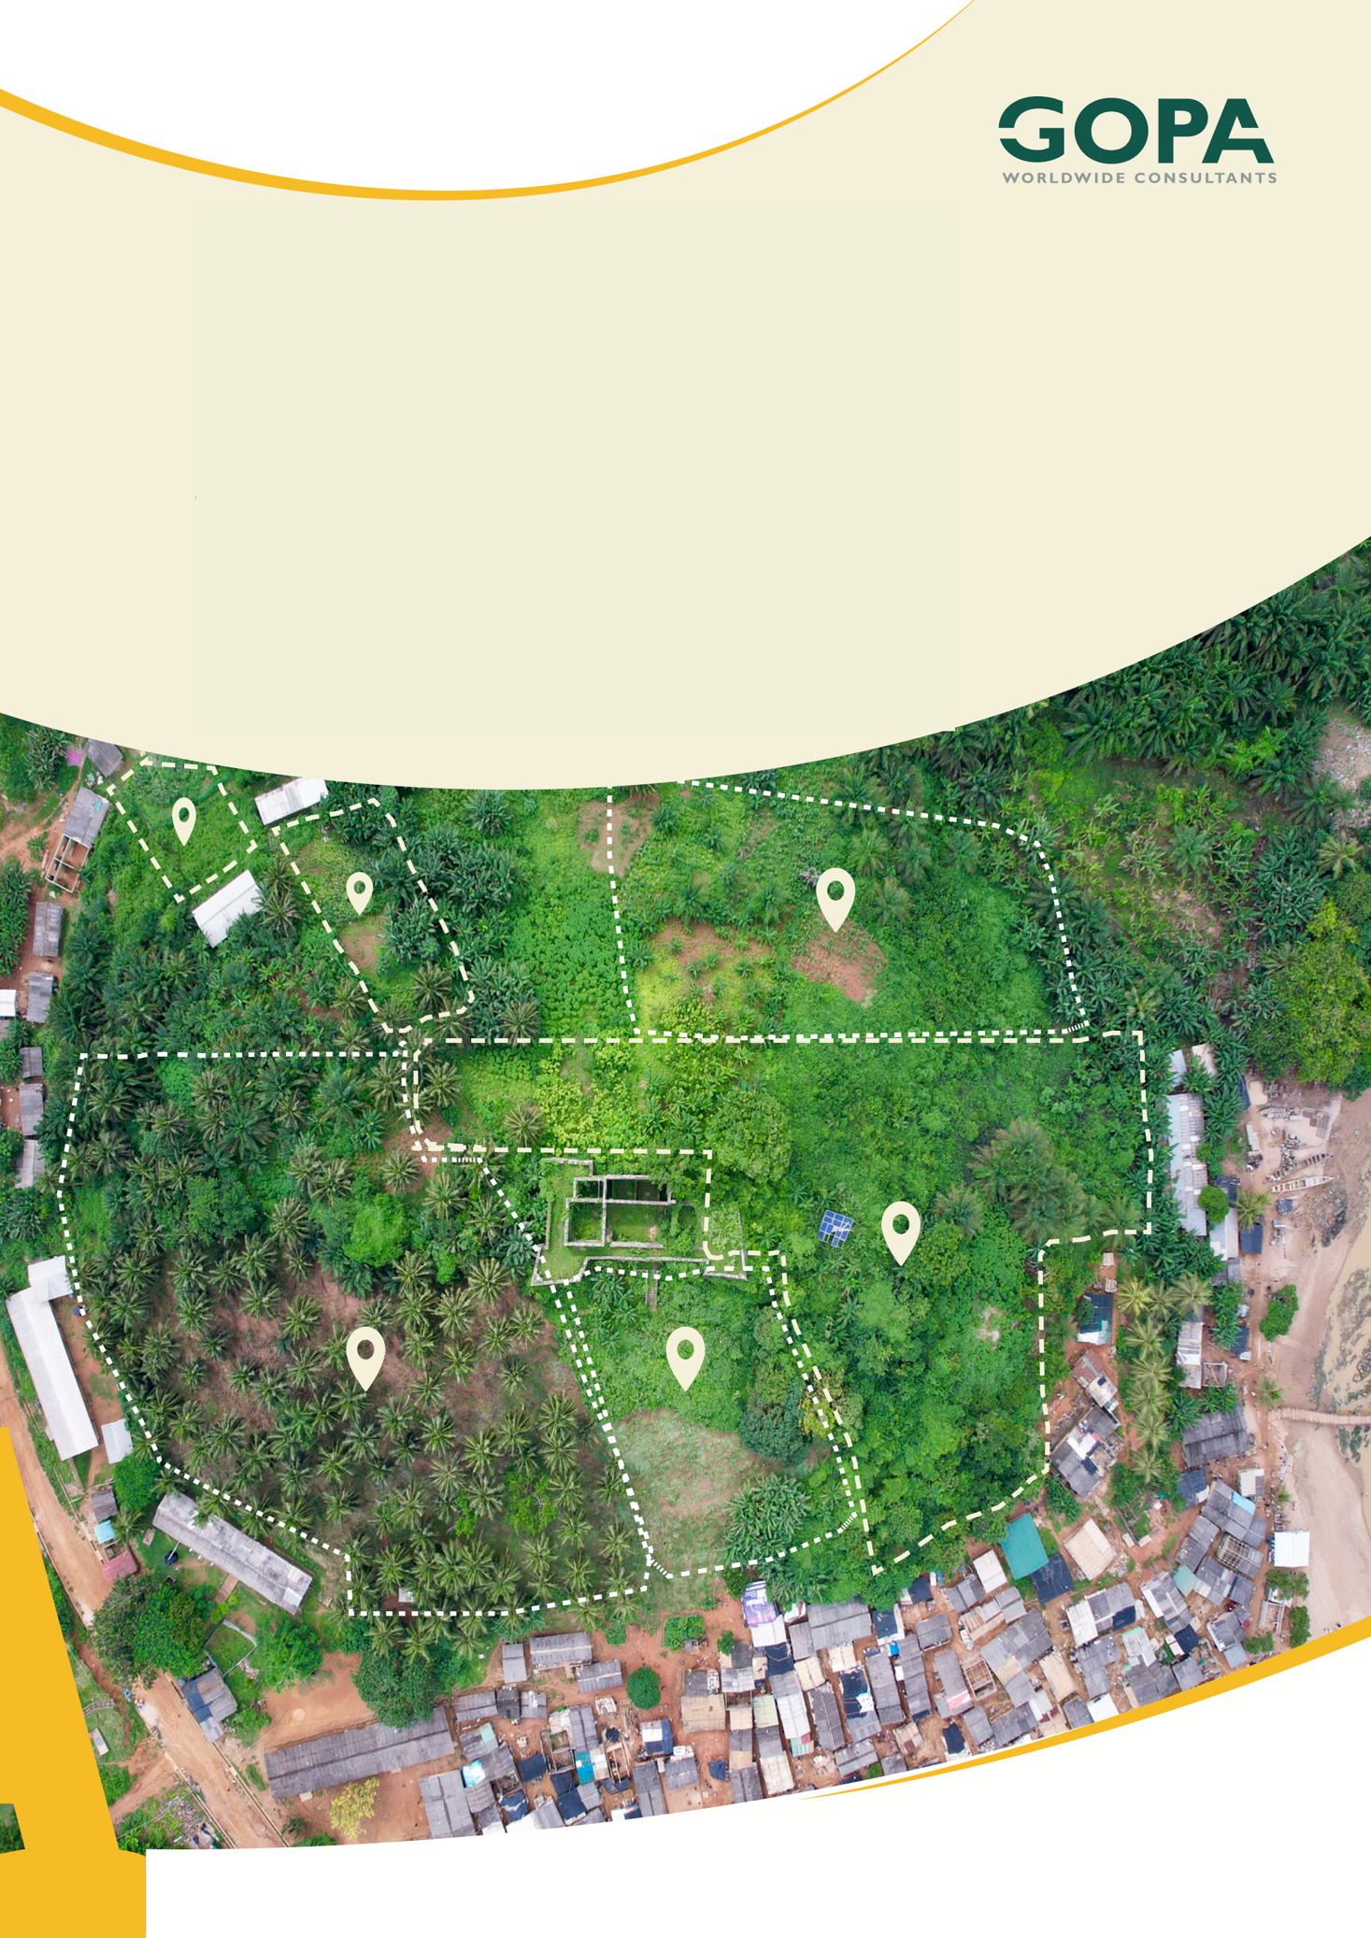
GHANA
Development of a Spatial Planning and Management Information System for Ghana
LUPMIS2 GIS Analytical Tools
Concept Note · July 2026

GIS Analytical Tools — Concept Note
Prepared for LUSPA and the Technical Working Group · LUPMIS2 project · July 2026

1. Executive Summary
LUSPA has requested a set of spatial-analysis tools for LUPMIS2 — Overlays, Zonal Statistics, Network Analysis, Interpolation, and Hydrology (including flood simulation). These operate mainly on raster data (elevation, imagery, modelled surfaces) but several also apply to the existing vector data (parcels, zones, and the OSM road network). This note sets out a pragmatic concept for adding these capabilities to the LUPMIS2 GIS and drawing tools.
The recommended approach is a hybrid architecture: lightweight vector operations run in the browser (offline-capable), while heavy raster and network analysis run server-side on the existing PostgreSQL/PostGIS platform, with results returned to the map and cached for re-use. This reuses infrastructure LUSPA already operates and keeps the client responsive.
Delivery is staged. Stage 1 delivers immediately useful, low-maintenance tools (vector overlays and zonal statistics) on the current stack. Stage 2 adds interpolation, network analysis, and a raster-upload pipeline. Stage 3 covers hydrology and flood simulation — the most valuable but also the most technically demanding tier, requiring specialist GIS/hydrology skills and heavier compute. Section 10 is explicit about what a small team can sustain and what is possible but high-maintenance.

2. Background — What LUSPA Asked For
During the pilot-district engagement, LUSPA asked for a broader set of analytical tools so that LUPMIS2 can support planning decisions directly, rather than only capturing and displaying data. Five tool families were named:
• Overlays — combine two or more layers to find where they intersect, differ, or coincide (e.g. parcels within a flood zone).
• Zonal Statistics — summarise raster values within each vector zone (e.g. mean slope or elevation per parcel).
• Network Analysis — routing and accessibility over the road network (shortest path, service/catchment areas).
• Interpolation — build a continuous surface from scattered sample points (e.g. groundwater levels, land values).
• Hydrology — derive drainage and simulate flooding/inundation from a digital elevation model (DEM).
The request is primarily raster-oriented, but the outputs are most useful when combined with the vector planning data already in LUPMIS2. The concept therefore treats raster and vector as complementary throughout.

3. Where LUPMIS2 Stands Today
LUPMIS2 already provides a strong vector foundation on which these tools can build:
• Map, drawing and editing (OpenLayers + ol-ext) with parcels, zones and OSM roads.
• A central PostgreSQL/PostGIS database with a local SQLite (OPFS) cache and offline service-worker tiles.
• Measurement and area/buffer analysis, GIS import/export (Shapefile, GeoJSON, KML), and a staged upload pipeline.
• An elevation dataset already exists in-house. District-scoped elevation contours (spatial.be_contours_hillshade) — polylines generated with gdal_contour at 10–20 m intervals from OpenTopography's SRTM 30 m / Copernicus 30 m DEM, and spatially indexed — a ready terrain basis for the analytical tools.
The main gaps are raster handling (no GeoTIFF display or raster analysis today) and geoprocessing (no overlay, zonal, routing, interpolation, or hydrology operations). Both are addressed below.

4. Guiding Principles
• Reuse before rebuild. PostGIS already performs most vector overlays and zonal statistics; pgRouting adds network analysis with no new server. Prefer these over new engines.
• Right tier for the job. Light vector ops run client-side (offline); heavy raster/network jobs run server-side and return results to the map.
• Staged and independently useful. Each stage ships value on its own; nothing depends on the hardest tier being built first.
• Honest about maintenance. Advanced hydrology is flagged as specialist work, not hidden inside an optimistic timeline.

5. Recommended Architecture — Hybrid
Analytical work is split across two tiers. The client runs the user interface and light vector operations; the server runs data-intensive geoprocessing as asynchronous jobs and returns compact results the map can draw. Results are cached locally so a completed analysis remains available offline.
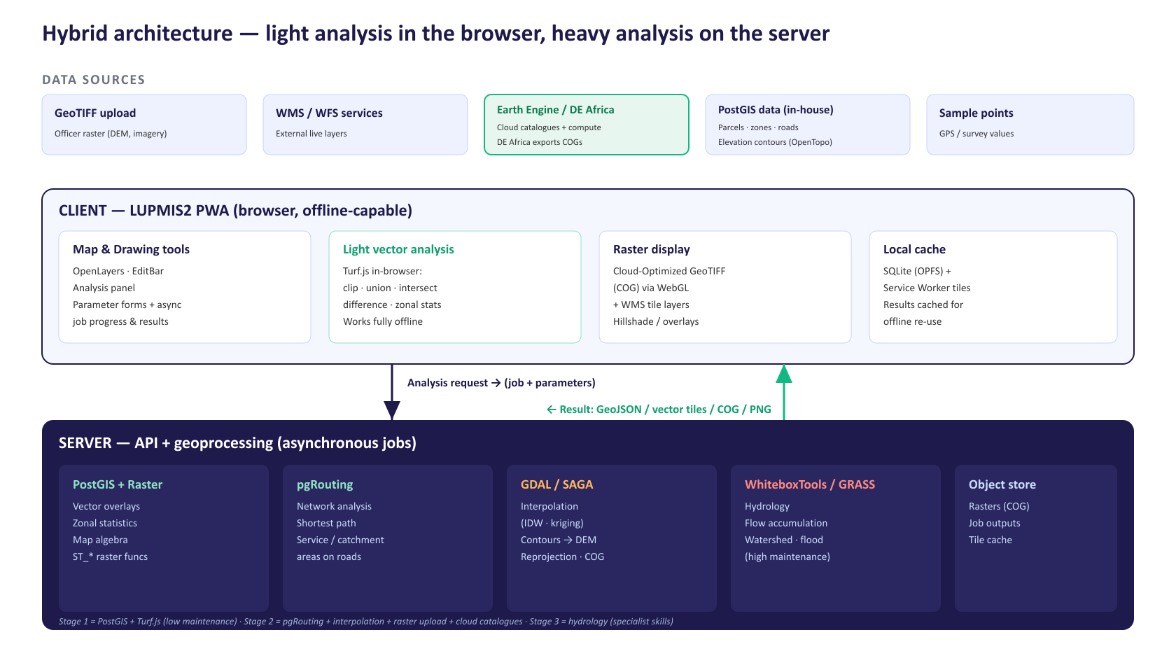
Figure 1 — Hybrid architecture for LUPMIS2 analytical tools.
Who does what:
Concern | Tier | How it is delivered
Analysis UI, parameter forms, job status | Client | OpenLayers panel + async job polling
Vector overlay / clip / buffer (small data) | Client | Turf.js in the browser — works offline
Vector overlay / zonal stats (large data) | Server | PostGIS spatial SQL
Network analysis (routing, service areas) | Server | pgRouting on the OSM road graph
Interpolation (IDW, kriging) | Server | GDAL / SAGA → raster surface (COG)
Hydrology (flow, watershed, flood) | Server | WhiteboxTools / GRASS on a DEM
Raster display | Client | Cloud-Optimized GeoTIFF via WebGL + WMS tiles
Catalogue data & optional cloud compute | Server | Google Earth Engine (service account)
Result storage & re-use | Client + Server | Object store on server; SQLite/OPFS cache on client

6. Bringing Raster Data In
Raster support is the enabling step for most of the requested tools. It has two distinct halves — how raster enters the system, and how it is displayed versus analysed.

6.1 Sources
• Officer GeoTIFF upload. Rasters (DEMs, imagery, scanned maps) enter through the existing staged-upload pipeline. On the server each file is validated, reprojected, and converted to a Cloud-Optimized GeoTIFF (COG) so it can be streamed and tiled efficiently.
• WMS / WFS external services. National or third-party imagery and layers are consumed as live web-service layers, with the results cached by the service worker for offline viewing.
• Google Earth Engine (GEE). Assuming a LUSPA Earth Engine account, GEE provides a very large, ready-to-use catalogue of satellite and derived data — and can run some of the analysis in Google's cloud. See Section 6.2.
• Digital Earth Africa (DE Africa). An open, Africa-focused platform whose Sandbox exports products directly as Cloud-Optimized GeoTIFFs. LUPMIS2 already consumes its slope service as WMS. See Section 6.3.
• Existing in-house terrain (PostGIS). District elevation contours (spatial.be_contours_hillshade), imported from OpenTopography (SRTM 30 m / Copernicus 30 m DEM) and served by get_contours_hillshade.php, are already stored and district-scoped — usable immediately and offline, and the basis for a locally-derived DEM (see Section 7.3).
A digital elevation model (DEM) is a prerequisite for hydrology, slope, and terrain interpolation. It can be supplied by upload, a WMS/WFS coverage, or — most conveniently — pulled from Google Earth Engine (e.g. Copernicus GLO-30 or MERIT Hydro). It can equally be interpolated locally from the existing elevation contours (spatial.be_contours_hillshade), with no external data.

6.2 Google Earth Engine as a data (and compute) source
Where a LUSPA Google Earth Engine account is available, much of the data these tools need can be sourced directly from GEE rather than acquired, stored, and processed in-house. GEE is both a petabyte-scale catalogue of satellite and derived datasets and a cloud processing engine, which means it can also carry out some of the heavy raster computation and return only compact results — reducing the load and maintenance on the LUSPA server.
How it fits the architecture. The server requests data or analysis from GEE for a district area of interest, using a service account. Two modes are used: (a) as a data source — export a clipped raster as Cloud-Optimized GeoTIFF into the normal pipeline, or stream GEE map tiles straight to the client for display; and (b) as a compute offload — run an operation inside GEE (e.g. zonal statistics, a flood extent from radar) and return GeoJSON or tiles. Either way the result is cached locally for offline re-use, consistent with the hybrid model.
Representative datasets and the tools they feed:
Dataset (in GEE) | Provides | Feeds
Copernicus GLO-30 / SRTM / MERIT Hydro | Elevation (DEM), hydrologically-conditioned terrain | Hydrology · slope · interpolation base · zonal stats
Sentinel-2 / Landsat 8–9 | Optical imagery, indices (NDVI, NDWI) | Overlays · display · land-cover context
Sentinel-1 (radar) | All-weather imagery; flood extent mapping | Hydrology / flood · display
ESA WorldCover / Dynamic World | Land-cover / land-use classification | Overlays · zonal statistics
JRC Global Surface Water / Global Flood DB | Historic water occurrence & flood extents | Hydrology / flood screening
CHIRPS / ERA5 | Rainfall & climate | Hydrology inputs
WorldPop / GHSL | Population & built-up surfaces | Accessibility · planning context

Considerations. GEE requires connectivity at request time (results are then cached offline); throughput is subject to Google quotas and export latency, which suits the asynchronous job model already proposed. Government/operational use should be checked against Google's Earth Engine terms and licensing, and a service account is needed for the server to call GEE without interactive sign-in.

6.3 Digital Earth Africa as a data source
Digital Earth Africa (DE Africa) is an open, free analysis platform holding satellite and derived products for the whole continent. LUPMIS2 relates to it in two distinct ways, and it is worth keeping them apart.
• As a live map service (runtime). DE Africa publishes OGC web services, and LUPMIS2 already consumes one — the SRTM-derived slope layer — as a WMS overlay. This works today and needs nothing new.
• As a preparation environment (batch). Everything else is reached through the DE Africa Sandbox, or a local install, where data is loaded, clipped to a district and exported as a Cloud-Optimized GeoTIFF. The export is then published on LUSPA infrastructure and consumed by LUPMIS2. This is a one-off ETL step per product — the same pattern already used for the OpenTopography contours — not a live connection.
Export is a single call. In the Sandbox, data is loaded from the data cube as an xarray object and written with datacube.utils.cog.write_cog() — for a single band or, via .to_array(), for a multi-band composite. The output is a COG intended for HTTP hosting, so no tile service or pyramid build is required.
Sandbox or local install. The hosted Sandbox needs no setup. A local environment is also supported (conda with GDAL, geopandas, rasterio and odc-stac), but DE Africa's own documentation cautions that functions depending on the Open Data Cube — dc.load and load_ard — will not work without additional configuration, meaning a database. For occasional district exports the Sandbox is the lower-maintenance choice; a local install is only worth it if exports become routine and need to run unattended.
Why this matters for LUSPA. DE Africa is a public good built explicitly for African institutional use, so it carries none of the operational/commercial licensing questions that Google Earth Engine raises for a government agency (see Section 13). It covers the same families of data needed here, and LUSPA already has a working relationship with the platform.
Representative products relevant to LUPMIS2:
DE Africa product | Provides | Feeds
Sentinel-2 / Landsat surface reflectance | Optical imagery and indices (NDVI, NDWI) | Overlays · display · land-cover context
Sentinel-1 radar | All-weather imagery, flood extent mapping | Hydrology / flood · display
SRTM-derived slope & terrain (srtm_deriv) | Slope, valley-bottom and terrain indices | Terrain analysis · zonal statistics
Water Observations from Space (WOfS) | Historic surface-water frequency | Hydrology / flood screening
Cropland extent & land cover | Agricultural and land-cover classification | Overlays · zonal statistics
Digital Elevation Model | Elevation and derived terrain | Terrain · hydrology · zonal statistics
Rainfall (CHIRPS) & climate (ERA5) | Precipitation and climate variables | Hydrology inputs
Waterbodies & water quality | Mapped water bodies and seasonality | Hydrology / flood screening

Practical note. write_cog() writes to the Sandbox filesystem or an object store. To display a product in LUPMIS2 the file must then be served over HTTPS with CORS enabled and byte-range requests supported — the publication step is the only part not covered by the Sandbox itself. Because the export is already a COG, an officer uploading one through the Stage 2 pipeline needs no server-side conversion, only validation.
The full product list is maintained as example notebooks in DE Africa's public Datasets catalogue, which is the practical starting point for identifying what is available and how to load it.
Earth Engine and DE Africa are complementary rather than exclusive: Earth Engine offers a wider global catalogue and in-cloud computation, DE Africa offers an Africa-focused, openly licensed catalogue with a direct COG export path. The recommendation is to start with DE Africa for terrain, imagery and water products, and use Earth Engine where a dataset or computation is only available there.

6.4 Display versus analysis
• Display (client). COGs render in the browser through OpenLayers/WebGL; hillshade and colour ramps are applied on the fly. This is lightweight and offline-friendly.
• Analysis (server). Pixel-level computation (map algebra, zonal statistics, flow accumulation) runs server-side with PostGIS Raster or GDAL/WhiteboxTools, never in the phone browser.

7. The Five Analytical Tool Families
The table gives the at-a-glance picture; the subsections add detail. “Tier” shows where the work runs; “Complexity” is the build-and-maintain burden for a small team.
Tool family | Data | Tier | Engine | Stage | Complexity
Overlays | Vector (raster opt.) | Client + Server | Turf.js / PostGIS | Stage 1 | Low
Zonal Statistics | Raster × Vector | Server | PostGIS Raster | Stage 1 | Low
Interpolation | Points → Raster | Server | GDAL / SAGA | Stage 2 | Medium
Network Analysis | Vector (roads) | Server | pgRouting | Stage 2 | Medium
Hydrology / Flood | Raster (DEM) | Server | WhiteboxTools / GRASS | Stage 3 | High

7.1 Overlays
Combine layers to answer “where does A meet B?” — parcels inside a flood zone, plots crossing a road reserve, land-use conflicts. Small vector overlays (clip, intersect, union, difference) run instantly in the browser with Turf.js and work offline; large overlays and raster map-algebra overlays run in PostGIS. This is the lowest-effort, highest-frequency tool and a natural Stage 1 starting point.

7.2 Zonal Statistics
Summarise a raster within each vector zone — mean/min/max/majority elevation, slope, or index value per parcel or planning zone. Delivered server-side with PostGIS Raster (or rasterstats); results attach as new attributes on the zones and can be styled or exported. Low complexity once raster upload exists. Where the raster lives in Google Earth Engine (e.g. elevation, land cover, NDVI), the summary can equally be computed in GEE (reduceRegions) and returned directly, avoiding a large download.

7.3 Interpolation
Turn scattered sample points (survey heights, groundwater, land values) into a continuous surface using IDW or kriging. Runs server-side (GDAL, SAGA) and returns a COG the client displays. Medium complexity: the maths is standard, but choosing method and parameters needs some GIS judgement, so sensible defaults and short guidance should ship with it.
A concrete first use is already available: interpolating the in-house elevation contours (spatial.be_contours_hillshade) into a continuous district DEM (TIN or IDW). This produces the DEM that slope, elevation zonal statistics, and screening-level hydrology depend on — sourced entirely in-house and available offline.

7.4 Network Analysis
Routing and accessibility over the existing OSM road network: shortest path, drive-time service areas, and nearest-facility queries (e.g. accessibility of a proposed development to schools or clinics). pgRouting runs inside the current PostgreSQL server; the main one-off effort is building and maintaining a clean, routable topology from the road data.

7.5 Hydrology and Flood Simulation
The most requested and most demanding family. From a DEM, standard tools derive flow direction, flow accumulation, stream networks, and watersheds, and can model simple inundation (fill-to-level / HAND approaches). Full hydrodynamic flood modelling is a specialist discipline — it needs quality elevation data, calibration, and hydrology expertise, and heavier compute. The recommendation is to deliver the derived-terrain products and a screening-level flood indication in Stage 3, and treat detailed flood modelling as an external/specialist activity whose outputs LUPMIS2 displays rather than computes.
Google Earth Engine helps most here. It supplies hydrologically-conditioned DEMs (MERIT Hydro), historic surface-water and flood extents (JRC Global Surface Water, Global Flood Database), rainfall (CHIRPS), and radar-derived flood mapping (Sentinel-1) — enough to drive a credible screening-level flood indication without LUSPA hosting large rasters or a hydrology model.
Because a district DEM can be interpolated from the in-house elevation contours, a first screening-level terrain and drainage analysis can run with no external data at all — Earth Engine then adds rainfall, surface-water history, and radar flood extents on top.

8. Integration into the GIS / Drawing Tools
The tools appear as an “Analysis” panel alongside the existing drawing toolbar, so they feel part of the same workflow rather than a separate application.
• Pick inputs — choose input layer(s) from those already loaded (drawn features, parcels, zones, uploaded rasters).
• Set parameters — a short form per tool, with sensible defaults and inline help.
• Run — light jobs return immediately; heavy jobs run server-side with a progress indicator, so the map stays usable.
• Results as layers — outputs are added as new map layers, styled, and can be edited, saved, or exported through the existing GIS export (GeoJSON / SHP / KML) and PDF report tools.
This reuses patterns already in the app — the analysis popups, the layer switcher, the import/export modal, and the staged-upload flow — which keeps both the code and the user experience consistent.

9. Staged Roadmap
Stage | Scope | Builds on | Dependencies | Maintenance
Stage 1 | Vector overlays (client); zonal statistics; raster display (COG + WMS) | PostGIS, OpenLayers, Turf.js | Raster display; small raster upload | Low
Stage 2 | Interpolation; network analysis; GeoTIFF upload pipeline; Google Earth Engine data ingestion | PostGIS Raster, pgRouting, GDAL, Earth Engine account | Routable road topology; object storage; GEE service account | Medium
Stage 3 | Hydrology: flow/watershed products; screening-level flood indication (DEM + GEE surface-water / radar) | WhiteboxTools / GRASS, quality DEM, GEE | DEM quality; specialist skills; compute | High

Each stage is usable on its own. If effort is constrained, Stages 1–2 already deliver the majority of day-to-day planning value at low-to-medium maintenance cost.
Because elevation contours already exist in PostGIS (from OpenTopography), terrain products — a derived DEM, slope, and elevation zonal statistics — can begin in Stage 1–2 without waiting for raster upload or Earth Engine.

10. Maintenance, Skills and What Is Possible
Sustainable for a small team. Stages 1 and 2 rely on well-documented, widely-used components that mostly extend the current stack: PostGIS spatial SQL, pgRouting, GDAL, and Turf.js. These are standard skills, stable, and do not require a dedicated GIS-analysis specialist to keep running.
Possible but demanding. Full raster map-algebra pipelines and, especially, hydrodynamic flood modelling are powerful but carry a real burden: specialist hydrology/GIS expertise, careful DEM preparation and calibration, heavier server compute and storage, and ongoing validation. Delivering these to a professional standard is closer to a modelling project than a feature. The pragmatic path is to ship the derived-terrain and screening-level products in-app, and to ingest and display detailed model outputs produced by specialists rather than compute them inside LUPMIS2.
Where Google Earth Engine reduces the burden. Sourcing DEMs, imagery, land cover, and surface-water data from GEE — and letting GEE perform some of the raster computation — removes much of the data-storage and heavy-compute load that would otherwise sit on the LUSPA server. The trade-off is an operational dependency on Google (account, connectivity, quotas, and licensing terms) rather than fully self-hosted data.
Capability | Skills needed | Compute / storage | Recommendation
Vector overlays, zonal stats | Standard SQL / web dev | Light | Build now (Stage 1)
Interpolation, routing | GIS-aware developer | Moderate | Build (Stage 2)
Terrain hydrology products | GIS + some hydrology | Moderate–heavy | Build screening level (Stage 3)
Detailed flood modelling | Hydrology specialist | Heavy | Outsource; display results in LUPMIS2

11. Alignment with the Terms of Reference and Functional Specifications
This chapter maps the proposed analytical tools to the requirements set out in the Terms of Reference (ToR §2.4.2, Spatial Analysis and Mapping) and the Functional Specifications (FS §2, Mapping & Spatial Analysis; with the closely-related terrain requirements in FS §3). Coverage is rated Full, Partial, Value-add (beyond the stated requirement), or Out of scope for this concept.
Requirement | Source | How the concept addresses it | Coverage
Interactive map — zoom, pan, query of land use / zoning / plans | ToR 2.4.2a; FS §2 | Existing LUPMIS2 map viewer; analysis outputs added as queryable layers | Full
Advanced spatial analysis — patterns, relationships, trends | ToR 2.4.2b | Overlays, Zonal Statistics, Network Analysis, Interpolation (§7) | Full
Heatmaps / density maps / visualisations | ToR 2.4.2b | Interpolation (IDW / kernel-density surfaces) styled as thematic layers | Full
Spatial queries — buffering, overlay, proximity | FS §2 | Buffering (existing) + Overlays + Network Analysis (proximity / accessibility) | Full
Simple & complex analysis; summaries, aggregation, statistics (mean, median, mode, variance, SD) | FS §2 | Zonal Statistics + attribute summaries per parcel / zone | Full
Layer management (vector & raster) | FS §2 | Existing layer switcher + new raster display (COG / WMS) | Full
Thematic mapping — custom symbology | FS §2 | Styling of analysis outputs; basic today, richer styling planned | Partial
Connect to global geoportals — Google Earth Engine, ERA5, WorldPop (land cover, rainfall, population, environmental) | FS §2 | Google Earth Engine integration (§6.2): ERA5, CHIRPS, WorldPop, land cover, imagery | Full
Terrain & elevation analysis — slope, aspect, hillshade | FS §3 | In-house OpenTopography contours → DEM; slope / aspect / hillshade + Hydrology (§7.5) | Full
Raster import/export & processing — GeoTIFF; resampling, reclassification, mosaic | FS §3 | Raster upload → COG; server-side raster ops / map algebra (some processing later) | Partial
Hydrology / flood screening | (beyond ToR / FS) | Hydrology tool family (§7.5) | Value-add
3D visualisation | FS §2 | Not part of this analytics concept — separate workstream | Out of scope
AI / ML–enabled capabilities | FS §2 | Not part of this concept; FS itself flags LUSPA to define the scope | Out of scope

Strong, direct alignment. The five proposed tools map onto ToR §2.4.2b's “advanced spatial analysis … patterns, relationships and trends” and FS §2's “Spatial Queries & Analysis”. Buffering, overlay and proximity are covered by Overlays and Network Analysis; the requested statistical summaries (mean, median, mode, variance, SD) are exactly what Zonal Statistics and attribute aggregation produce.
The concept answers an open Functional-Specification request. FS §2 explicitly asks the system to connect to Google Earth Engine and global geoportals (ERA5, WorldPop) for land cover, rainfall, population and environmental data — and the FS carries a margin note asking LUSPA to name the datasets. The Earth Engine integration in §6.2 gives a concrete, implementable answer to that request.
Terrain requirement met in-house. FS §3's slope, aspect and hillshade are satisfied by deriving a DEM from the existing OpenTopography elevation contours; Hydrology extends this to drainage and screening-level flood indication.
Value beyond the requirements. Hydrology and flood screening go beyond the explicit ToR/FS wording, adding decision-support value for land-use planning in flood-prone areas.
Deliberately out of scope. 3D visualisation and AI/ML capabilities are named in FS §2 but are separate workstreams — the FS itself marks AI/ML as pending LUSPA's definition. This concept does not attempt them; they should be scoped and planned separately.

12. Recommendations & Next Steps
• Adopt the hybrid architecture and confirm that server-side geoprocessing (PostGIS Raster, pgRouting, GDAL) may be added to the API server.
• Start with Stage 1 — vector overlays, zonal statistics, and raster display — which reuse the current stack and deliver quick wins.
• Stand up the raster-upload → COG pipeline early, since it unlocks zonal statistics, interpolation, and hydrology.
• Confirm the DEM source and data-sharing terms needed for hydrology and terrain interpolation.
• Use the LUSPA Google Earth Engine account as the primary source for DEMs, imagery, land cover and surface-water data, and offload suitable raster computation to GEE to reduce server load.
• Reuse the existing elevation contours (spatial.be_contours_hillshade, from OpenTopography) — interpolate a district DEM from them for slope, zonal statistics, and screening-level hydrology, with no external dependency.
• Scope detailed flood modelling separately as a specialist activity, with LUPMIS2 as the display and dissemination platform for its outputs.

13. Questions for LUSPA and the TWG
• Is server-side geoprocessing infrastructure on the API server acceptable, or are there hosting constraints to design around?
• Which DEM (source, resolution, licence) will be authoritative for hydrology and terrain analysis?
• For flood work, is a screening-level indication inside LUPMIS2 sufficient, or is calibrated hydrodynamic modelling required?
• Which external WMS/WFS services (national imagery, base layers) should be integrated first?
• Is the LUSPA Google Earth Engine account cleared for operational/government use, and can a service account be provided for the API server to call GEE?

Annex A. Developer Implementation Notes
This annex records concrete technical choices for the development team; it is not required reading for decision-makers.

A.1 Components and libraries
• Client: OpenLayers (map + WebGL raster), Turf.js (vector overlays/buffer), the existing EditBar and import/export modules.
• Server: PostgreSQL/PostGIS (+ PostGIS Raster), pgRouting, GDAL/OGR, SAGA or WhiteboxTools for interpolation and hydrology; a small job runner for async processing.

A.2 Data formats
• Cloud-Optimized GeoTIFF (COG) for rasters (stream + tile without full download).
• GeoJSON for small vector results; Mapbox Vector Tiles (MVT) for large result sets.

A.3 Asynchronous job pattern
Heavy analysis is submitted as a job: POST parameters → receive a job id → the client polls status → on completion, fetch the result (GeoJSON/COG/tile URL) and add it as a layer. Outputs are written to an object store and referenced from the job record; the client caches the result for offline re-use. This mirrors the existing staged-upload flow.

A.4 Indicative server operations
• Overlay: PostGIS ST_Intersection / ST_Difference / ST_Union.
• Zonal statistics: ST_SummaryStats / ST_Clip over raster × zones.
• Routing: pgRouting pgr_dijkstra / pgr_drivingDistance on a built road topology.
• Interpolation: gdal_grid (IDW/average) or SAGA kriging → COG.
• Hydrology: WhiteboxTools D8FlowAccumulation / Watershed; fill-to-level or HAND for screening-level inundation.

A.5 Google Earth Engine integration
• Auth: the API server authenticates to GEE with a service-account key (no interactive sign-in); requests are scoped to a district area of interest.
• Data pull: ee.Image/ee.ImageCollection filtered to the AOI and date range → Export.image.toCloudStorage as a COG, ingested by the normal pipeline; or getMapId() to stream XYZ tiles to the client for display.
• Compute offload: reduceRegions for zonal statistics; Sentinel-1 thresholding for flood extent; NDVI/NDWI indices — returned as GeoJSON or tiles.
• Caveats: online at request time (results cached after); export is asynchronous (fits the job pattern); mind Google quotas and Earth Engine licensing for operational use.

A.6 Security & governance
• Analysis endpoints are scoped by the authenticated session and district, consistent with existing API access control.
• Uploaded rasters are validated (type, size, extent) before processing; job outputs inherit the same district scoping.
• The Earth Engine service-account key is held server-side only and never exposed to the browser.

