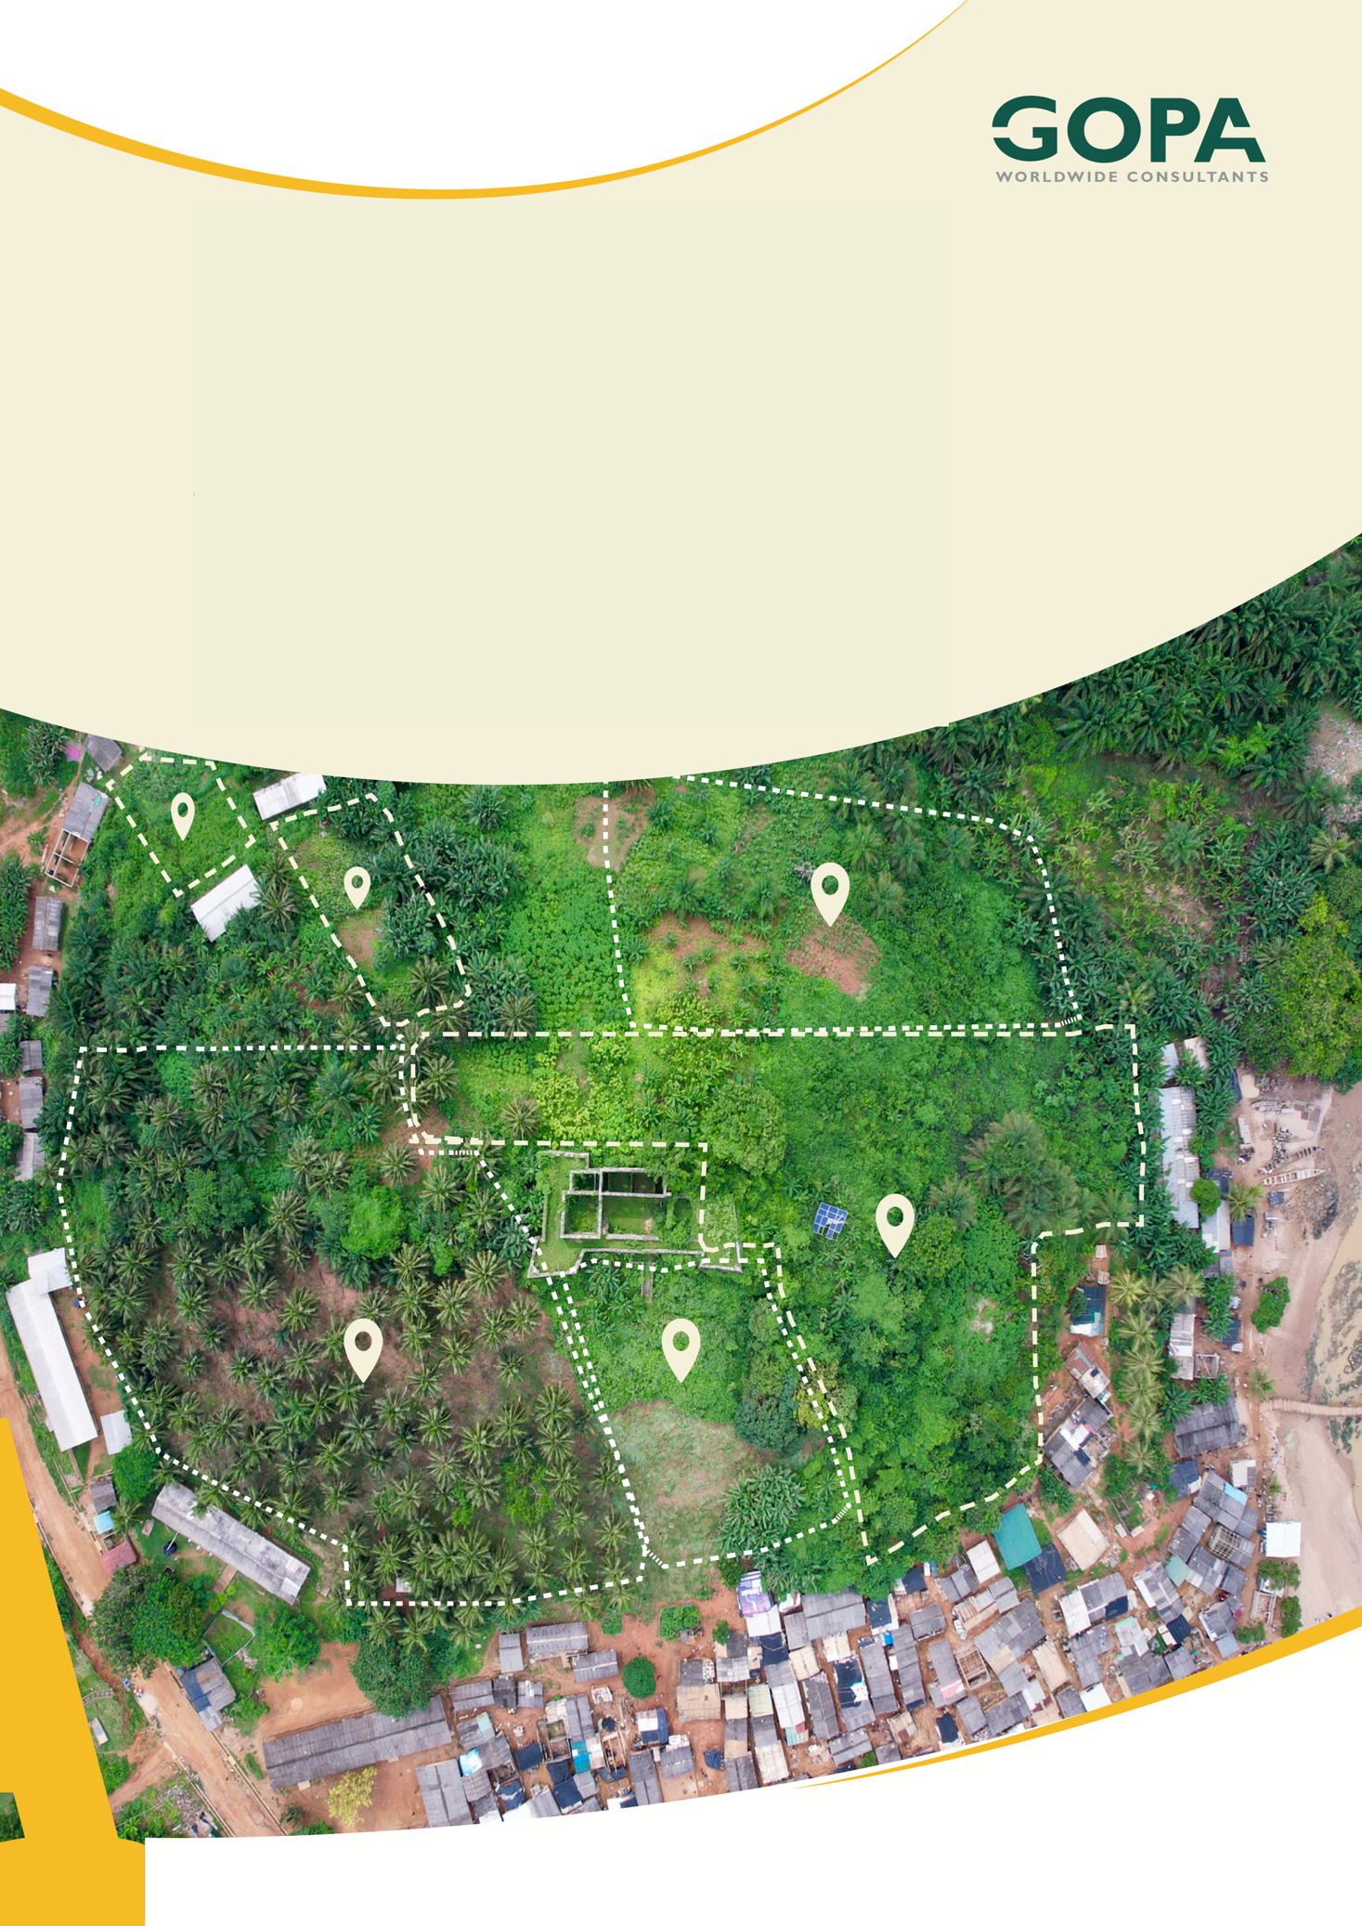
GHANA
Development of a Spatial Planning and Management Information System for Ghana
LUPMIS2 Technician Training Plan
LUSPA Capacity Building · July 2026

Technician Training Plan
LUPMIS2 capacity building for LUSPA · July 2026

1. Purpose
LUPMIS2 will be handed over to LUSPA to operate, maintain and extend. This plan sets out the training needed for LUSPA technicians to take on that responsibility with confidence.
The topics are not a generic IT syllabus. They were derived from the technologies actually used in the LUPMIS2 code base, so every day of training maps to something the team will genuinely have to support.
Guiding principle. Training is built around the LUPMIS2 source code itself. Exercises modify, debug and extend the real application rather than a teaching example, so on the final day of each topic the technician has already done the work they will later be asked to do unaided.

2. Audience and assumptions
The plan assumes the following. Where an assumption is wrong, the affected topic should be re-scoped before delivery.
Assumption | Detail
Audience | LUSPA technical staff with a general IT background — comfortable with computers and networks, but not necessarily experienced in web development or GIS programming
Group size | 4 to 8 technicians, so that every participant has a workstation and can be supported individually during laboratory work
Delivery | Instructor-led, roughly 40 % presentation and 60 % hands-on laboratory work on the real LUPMIS2 code base
Working day | One training day is 6 productive hours plus breaks
Equipment | One development workstation per participant, with administrator rights to install software, plus access to a non-production copy of the LUPMIS2 database

3. Technologies used in LUPMIS2
The table below is the technology inventory taken from the project. It is the basis for the training topics in Section 5, and it also serves as a maintenance checklist: every entry is something the LUSPA team will own after handover.

3.1 Client application (runs in the browser)
Technology | Where it is used in LUPMIS2 | Topic
JavaScript (ES modules) | The whole application — main.js and the src/ modules | 1
Vite | Build tool: bundling, code-splitting, the dist/ output that gets deployed | 3
Bootstrap 5 + Icons | All dialogs, panels, forms and the responsive layout | 3
OpenLayers 10 | The map: layers, sources, projections, interactions, WebGL raster | 4
ol-ext | Drawing and editing: EditBar, undo/redo, transform, snap guides | 5
Turf.js | Client-side spatial analysis — overlays and zonal statistics | 10
Service Worker | Offline caching of the app shell, map tiles and API responses | 6
SQLite via OPFS (sqlocal) | The local database in the browser — offline parcels, zones, imports | 6
shpjs / shp-write | Shapefile import and export | 9
jsPDF | PDF analysis reports | 3
OOXML (custom writer) | The Excel export of zonal statistics (src/analysis/xlsx.js) | 3

3.2 Server, data and security
Technology | Where it is used in LUPMIS2 | Topic
PHP | index.php and embed.php — session handling, SSO, security headers; the API endpoints | 8
REST API | api.lupmis4luspa.org — get_parcels, get_district_boundary, upload_parcels and others | 8
PostgreSQL / PostGIS | The central spatial database — parcels, zones, roads, contours | 7
pgRouting | Planned for Stage 2 network analysis | 10
SSO and sessions | sso_auth_token, PHP sessions, the district scoping of every API call | 8
Apache / reverse proxy | Hosting, .htaccess, CORS and X-Frame-Options headers, TLS | 12

3.3 Geospatial data engineering
Technology | Where it is used in LUPMIS2 | Topic
Coordinate systems | EPSG:4326 and 3857 throughout; UTM 32630/32631 for measurement | 9
GeoJSON / WKT / KML | Data exchange between the API, the local database and exports | 9
GDAL / OGR | gdal_contour for the elevation contours; gdal_translate for COG conversion | 9
Cloud-Optimized GeoTIFF | Raster display streamed by byte-range request | 9
WMS / WFS / XYZ | External layers, including the DE Africa slope service | 4
Digital Earth Africa | Sandbox and Open Data Cube; write_cog exports for the raster pipeline | 11
Google Earth Engine | Optional cloud catalogue and computation | 11
Python (boto3, datacube) | The ETL script that publishes rasters to the object store | 11
WhiteboxTools / GRASS | Planned for Stage 3 hydrology | 10

3.4 Infrastructure and ways of working
Technology | Where it is used in LUPMIS2 | Topic
Docker | The PWA and the permitting application run in separate containers | 12
MinIO / S3 | Object storage for rasters — bucket raster-objects, policies, CORS | 12
Git / Gitea | Source control and code review for all project code | 2
Progressive Web App | Installability, offline operation, service-worker versioning | 6

4. Structure of the plan
The plan contains 12 topics totalling 60 training days — an average of 5 days per topic. Topics are grouped into five blocks that build on one another. The term “block” is used rather than “phase”, which has a different meaning in LUSPA planning practice.
Block | Topics | Days | Purpose
A — Foundations | 1 – 2 | 9 | The common ground everything else depends on
B — The client application | 3 – 6 | 20 | Maintaining and extending what the officers actually use
C — Server and data | 7 – 8 | 11 | The database and the API behind the map
D — Geospatial engineering | 9 – 11 | 15 | Data formats, analysis and the external data pipelines
E — Infrastructure | 12 | 5 | Running and deploying the system

5. Topic overview
# | Topic | Days | Block
1 | Web development foundations | 5 | A
2 | Version control, collaboration and handling secrets | 4 | A
3 | Frontend tooling, user interface and reporting | 4 | B
4 | OpenLayers — building the map | 6 | B
5 | Drawing and editing tools with ol-ext | 4 | B
6 | Progressive Web Apps and offline architecture | 6 | B
7 | PostgreSQL and PostGIS | 6 | C
8 | PHP API development, authentication and security | 5 | C
9 | Coordinate systems, data formats and GDAL | 5 | D
10 | Spatial analysis | 5 | D
11 | Cloud geospatial platforms and Python ETL | 5 | D
12 | Docker containerisation and deployment | 5 | E
Total | 12 topics | 60

6. The topics in detail

6.1 Web development foundations (5 days)
Prerequisite: — Duration: 5 days
Learning outcomes — by the end the technician can:
• Read and write modern JavaScript: modules, functions, arrays, objects, promises and async/await
• Understand how HTML, CSS and JavaScript combine to make a page, and how the browser loads them
• Use the browser developer tools to inspect elements, read the console and follow network requests
• Explain what happens between a user clicking a button and something changing on screen
Hands-on: Trace a single LUPMIS2 feature end to end — from the dock button, through the event handler, to the change on the map — and then make a small, safe modification to it.

6.2 Version control, collaboration and handling secrets (4 days)
Prerequisite: Topic 1 Duration: 4 days
Learning outcomes — by the end the technician can:
• Use Git confidently: clone, branch, commit, merge, resolve a conflict and read the history
• Work with the LUSPA Gitea server: push, pull, open and review a change
• Write a commit message that explains why a change was made, not only what changed
• Keep credentials out of source control, and know what to do when a secret has been committed
Hands-on: Take a real change through the full cycle: branch, commit, review, merge. Then work through the case where MinIO keys were committed to Gitea — rotate, move to environment variables, and discuss why rotation alone does not remove them from history.

6.3 Frontend tooling, user interface and reporting (4 days)
Prerequisite: Topic 1 Duration: 4 days
Learning outcomes — by the end the technician can:
• Run the development server, produce a production build and understand what ends up in dist/
• Explain code-splitting and why heavy libraries are loaded only when first needed
• Build a dialog with Bootstrap that matches the existing LUPMIS2 patterns
• Generate PDF and Excel output from application data
Hands-on: Add a new dialog to the application following the existing modal pattern, and give it an export button that produces a spreadsheet.

6.4 OpenLayers — building the map (6 days)
Prerequisite: Topic 1 Duration: 6 days
Learning outcomes — by the end the technician can:
• Explain the OpenLayers model: map, view, layers, sources, features and projections
• Add and style vector layers, and control them through the layer switcher
• Add external layers — WMS, XYZ and Cloud-Optimized GeoTIFF — and diagnose why one fails to appear
• Handle map interactions: clicks, selection, pop-ups and zoom-dependent styling
Hands-on: Add a new data layer to LUPMIS2 end to end: fetch it, style it, place it in the correct group, and give it a click pop-up.

6.5 Drawing and editing tools with ol-ext (4 days)
Prerequisite: Topic 4 Duration: 4 days
Learning outcomes — by the end the technician can:
• Configure the EditBar and the drawing, modifying and transform interactions
• Explain how undo/redo works, and why grouping operations into blocks matters
• Work with selection: single, multiple and box selection, and act on a selection
• Diagnose the common editing faults — geometry not saving, undo behaving unexpectedly
Hands-on: Reproduce and fix a realistic editing defect in a training branch, such as an operation that cannot be undone in a single step.

6.6 Progressive Web Apps and offline architecture (6 days)
Prerequisite: Topics 1 and 3 Duration: 6 days
Learning outcomes — by the end the technician can:
• Explain how a service worker intercepts requests, and the caching strategies LUPMIS2 uses
• Version and release a service worker without leaving users on stale files
• Work with the local SQLite database in the browser and explain what OPFS is
• Reason about what happens when the device is offline, and test that behaviour deliberately
Hands-on: Add a new table to the local database, cache a new resource for offline use, and demonstrate the whole feature working with the network disabled.

6.7 PostgreSQL and PostGIS (6 days)
Prerequisite: Topic 1 Duration: 6 days
Learning outcomes — by the end the technician can:
• Write SQL confidently: joins, grouping, aggregation, indexes and query plans
• Store and query spatial data with PostGIS, and use the common ST_ functions
• Understand spatial indexing and why a query is slow without it
• Back up, restore and safely migrate the schema
Hands-on: Write the spatial queries behind a real requirement — for example parcels per zone — and compare the result with the same analysis run in the application.

6.8 PHP API development, authentication and security (5 days)
Prerequisite: Topics 2 and 7 Duration: 5 days
Learning outcomes — by the end the technician can:
• Read and extend the LUPMIS2 API endpoints
• Explain the SSO flow: the token, the PHP session, and how district scoping is enforced
• Work with HTTP correctly: status codes, CORS, and headers such as X-Frame-Options
• Apply the basics of secure development: input validation, least privilege, no secrets in code
Hands-on: Build a new API endpoint that returns district-scoped data, then verify that a user from another district cannot retrieve it.

6.9 Coordinate systems, data formats and GDAL (5 days)
Prerequisite: Topic 1 Duration: 5 days
Learning outcomes — by the end the technician can:
• Explain coordinate reference systems and choose correctly between EPSG:4326, 3857 and UTM
• Convert between GeoJSON, WKT, Shapefile and KML, and know the limitations of each
• Use GDAL/OGR from the command line to inspect, reproject and convert data
• Explain what makes a GeoTIFF cloud-optimized, and produce one
Hands-on: Take a supplied dataset, reproject it, convert it to a COG, publish it, and display it in LUPMIS2.

6.10 Spatial analysis (5 days)
Prerequisite: Topics 4 and 7 Duration: 5 days
Learning outcomes — by the end the technician can:
• Perform overlay analysis — intersect, clip, difference and union — and explain what each returns
• Produce zonal statistics and interpret the result correctly, including the membership rule
• Decide whether a given analysis belongs in the browser or on the server
• Understand the shape of the Stage 2 and 3 tools: routing with pgRouting, and terrain and hydrology
Hands-on: Answer a genuine planning question using the Analyse tools, export the result with its parameters, and reproduce the same figures independently in PostGIS.

6.11 Cloud geospatial platforms and Python ETL (5 days)
Prerequisite: Topics 9 and 12 Duration: 5 days
Learning outcomes — by the end the technician can:
• Write enough Python to read, run and adapt the project's ETL scripts
• Use the Digital Earth Africa Sandbox to find a product and export it as a COG
• Explain what Google Earth Engine offers, and the licensing question for government use
• Publish a raster to the object store and verify it is readable by the application
Hands-on: Run the DEM export for one pilot district from end to end — Sandbox to MinIO to a visible layer in LUPMIS2 — and record what needed to change.

6.12 Docker containerisation and deployment (5 days)
Prerequisite: Topic 2 Duration: 5 days
Learning outcomes — by the end the technician can:
• Explain images, containers, volumes, networks and ports, and why containers are used here
• Read and write a Dockerfile and a docker-compose file
• Run the LUPMIS2 stack locally in containers, including the database
• Deploy a new version, inspect logs, diagnose a failing container and roll back
• Manage configuration and secrets through environment variables rather than in the image
Hands-on: Containerise the application from scratch, run it locally with a database, then perform a deployment and a rollback.

7. Suggested sequence
The blocks are ordered so that each depends only on what came before. Delivering them in this order avoids teaching a topic before its prerequisite.
Weeks | Block | Topics | Notes
1 – 2 | A — Foundations | 1, 2 | Everyone attends; the shared basis for all later work
3 – 6 | B — Client application | 3, 4, 5, 6 | The largest block — this is the application the officers use
7 – 8 | C — Server and data | 7, 8 | Best delivered close together; the API depends on the database
9 – 11 | D — Geospatial engineering | 9, 10, 11 | Topic 11 assumes Docker, so it may be swapped with Block E
12 | E — Infrastructure | 12 | Can be brought forward if deployment duties start earlier

Do not deliver 12 consecutive weeks. Retention is far better when a block is followed by two to three weeks of supervised real work before the next one begins. A realistic calendar is six to nine months, with the technicians applying each block to live LUPMIS2 tasks in between.

8. Delivery and assessment
• Format. Roughly 40 % instruction and 60 % laboratory work. Every topic ends with an exercise on the real code base, not a teaching example.
• Assessment. Each topic is assessed by the hands-on exercise: the work is reviewed as a real change would be, through Gitea.
• Pairing. Laboratory work in pairs surfaces misunderstandings early and builds the habit of explaining code to a colleague.
• Documentation. Each participant adds to a maintenance handbook as they go, so the team finishes with a reference written in their own words.
• Reinforcement. After Block B, technicians should take real support requests under supervision. Nothing consolidates training as quickly as owning a genuine fault.

9. Points to confirm before scheduling
• How many technicians will attend, and what is their actual starting level? Topic 1 may be shortened if the group already programs, or lengthened if not.
• Will the same people cover both the client application and the server and database, or should the group split after Block A into a frontend and a backend track?
• Is a non-production copy of the LUPMIS2 database available for training use?
• Do the workstations permit installing Docker, Node.js, PostgreSQL and Python?
• Should training be delivered in one continuous programme or spread across the year, as recommended in Section 7?

