ECMWF open data — can we use it for the analysis?
The ecmwf-opendata package and the ECMWF real-time open dataset, against what LUPMIS2's Analyse tools actually do · October 2026
The short answer. The data is genuinely open, free and reachable from a dozen lines of Python — no account, no key, no cost. But it is a weather forecast on a 0.25° grid, and one cell of that grid is larger than a Ghanaian district. It cannot support analysis at parcel or zone level, which is the only kind LUPMIS2 does. It can support something else worth having — a district-level forecast overlay — and that is two days' work.
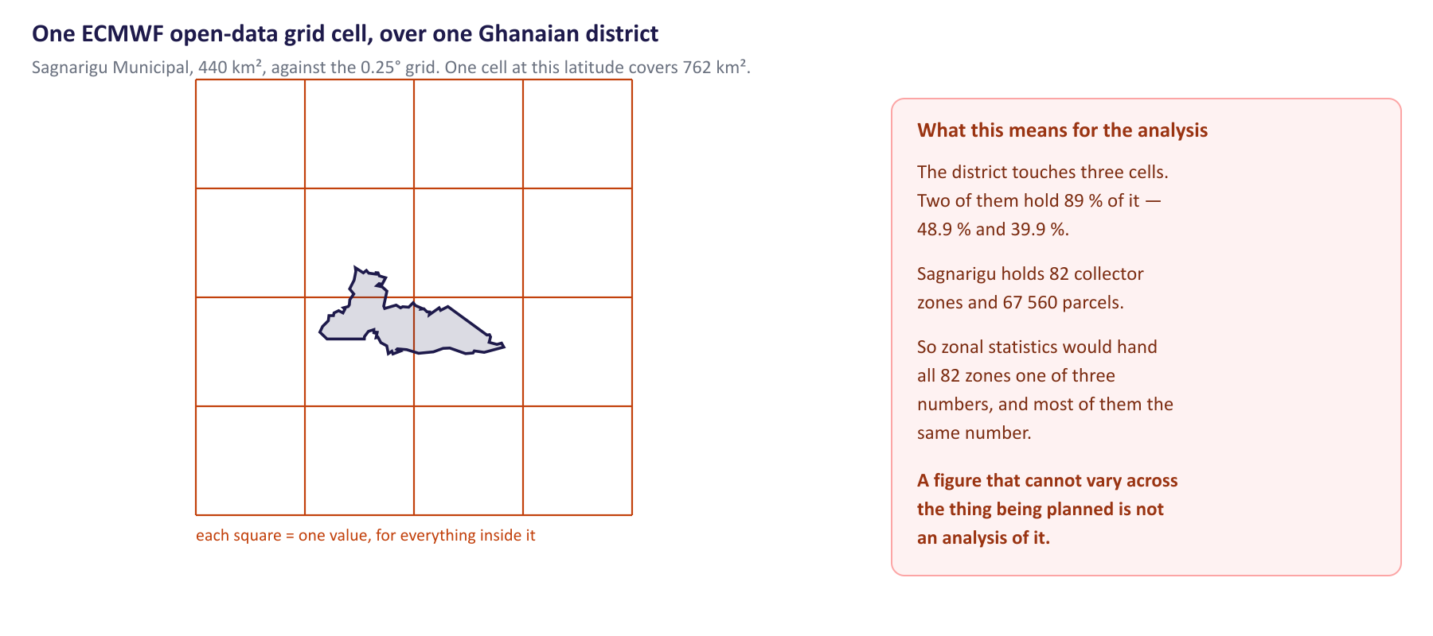
Measured against the real boundary: Sagnarigu Municipal touches three cells, two of which hold 89 % of it.
 | What the dataset gives | Consequence for LUPMIS2
Resolution | 0.25° (~28 km); one cell ≈ 762 km² | A 440 km² district fits in 2–3 cells. No within-district variation exists to analyse.
Kind of data | Forecast, 0–360 h ahead, four runs a day | Answers “what will happen next week”, not “what is this land like”. Planning asks the second.
Retention | Rolling archive of the last 12 runs (2–3 days) | No history can be fetched. A time series exists only if you harvest daily from now on.
Format | GRIB2, via the ecmwf-opendata client | Needs a conversion step; GDAL reads GRIB2, so this is routine.
Licence | CC-BY-4.0 plus the ECMWF Terms of Use | Usable and redistributable by a government agency; attribution required on the map.

What it cannot do here, and what it can
· Not zonal statistics, and not land suitability. LUPMIS2's zonal statistics reads features out of a vector source; a raster cannot be fed into it at all today — and if it could, all 82 collector zones in Sagnarigu would receive one of three numbers. Suitability and constraint mapping need climatology rather than a ten-day forecast: ERA5-Land (~9 km) or CHIRPS rainfall (~5 km), both free, both Python, and ERA5-Land is also ECMWF.
· But a district forecast overlay is real and cheap. Total precipitation and 2 m temperature for the next few days, over Ghana, as a raster layer officers can switch on: operational context for fieldwork planning, honest about its resolution, and it reuses a pipeline LUPMIS2 already has.

How it would be done
Nothing here is new ground. LUPMIS2 already publishes a raster this way — koforidua_dem.tif sits in the MinIO bucket and is registered as a cog layer in spatial.es_external_layers. This is the same pipeline with a different producer, and the one Training Plan topic 6.11 teaches for the Digital Earth Africa DEM.
1. Fetch the parameters and steps wanted, for the latest run. The only genuinely new part.
2. Clip and convert to Ghana's bounding box and write a Cloud-Optimized GeoTIFF — gdal_translate -of COG, since GDAL reads GRIB2 directly.
3. Publish the COG beside the DEM at minioapi.lupmis4luspa.org/raster-objects/…, overwriting the same object name so the layer URL never changes.
4. Register once: one row in spatial.es_external_layers with layer_type='cog', the URL, the attribution and a title that states the resolution. The script never touches the database again.
5. Schedule twice daily after the 00 and 12 UTC runs. A missed run breaks nothing — the previous COG is still served — so the run time must appear in the layer name, or stale data will look current.
from ecmwf.opendata import Client

Client(source="ecmwf").retrieve(
type="fc", param=["tp", "2t"], step=[24, 48, 72],
target="ghana_fc.grib2")

# gdal_translate -projwin -3.3 11.2 1.2 4.7 -of COG \
# -co COMPRESS=DEFLATE ghana_fc.grib2 ghana_tp_24h.tif

Two conditions. The object store must keep allowing CORS and byte-range requests — LUPMIS2 refuses a COG whose server answers 200 where it should answer 206, and the DEM works today. And the layer must state its resolution in the title: a rainfall raster looks continuous at district zoom and will be read as parcel-level unless it says otherwise. That is the biggest risk here, and it is a labelling problem, not a technical one.
Step | Work | Estimate
Fetch and convert script | Python, ~80 lines, including the Ghana clip and the COG write | 1 day
Publish and schedule | Upload to MinIO, cron entry, failure notification | 0.5 day
Register the layer | One SQL insert, with attribution and a resolution note | 1 hour
Check on a real district | Switch it on, confirm it draws and is legible | 0.5 day

Recommendation. Build the overlay — two days, a real benefit for fieldwork planning, and it exercises the Python → COG → MinIO path the team is being trained on in topic 6.11, on data that costs nothing to get wrong. Do not put it into the Analyse tools: a 28 km grid in zonal statistics over collector zones produces a table that looks like analysis and is not one. If raster input there is wanted — and it would be useful — build it on ERA5-Land or CHIRPS, and do raster-to-zone sampling first, which LUPMIS2 does not have.
And the timing is good. ECMWF is moving the open subset from 0.25° to 0.1° (~9 km), expected live by the end of October 2026 — a month away. A 0.1° cell is 122 km², so Sagnarigu would be covered by 10 cells instead of 3: a real overlay rather than three flat numbers. It still will not reach parcel level and will still be a forecast, so neither recommendation changes — but the pipeline is worth building now, because the picture improves by itself when the resolution lands.

