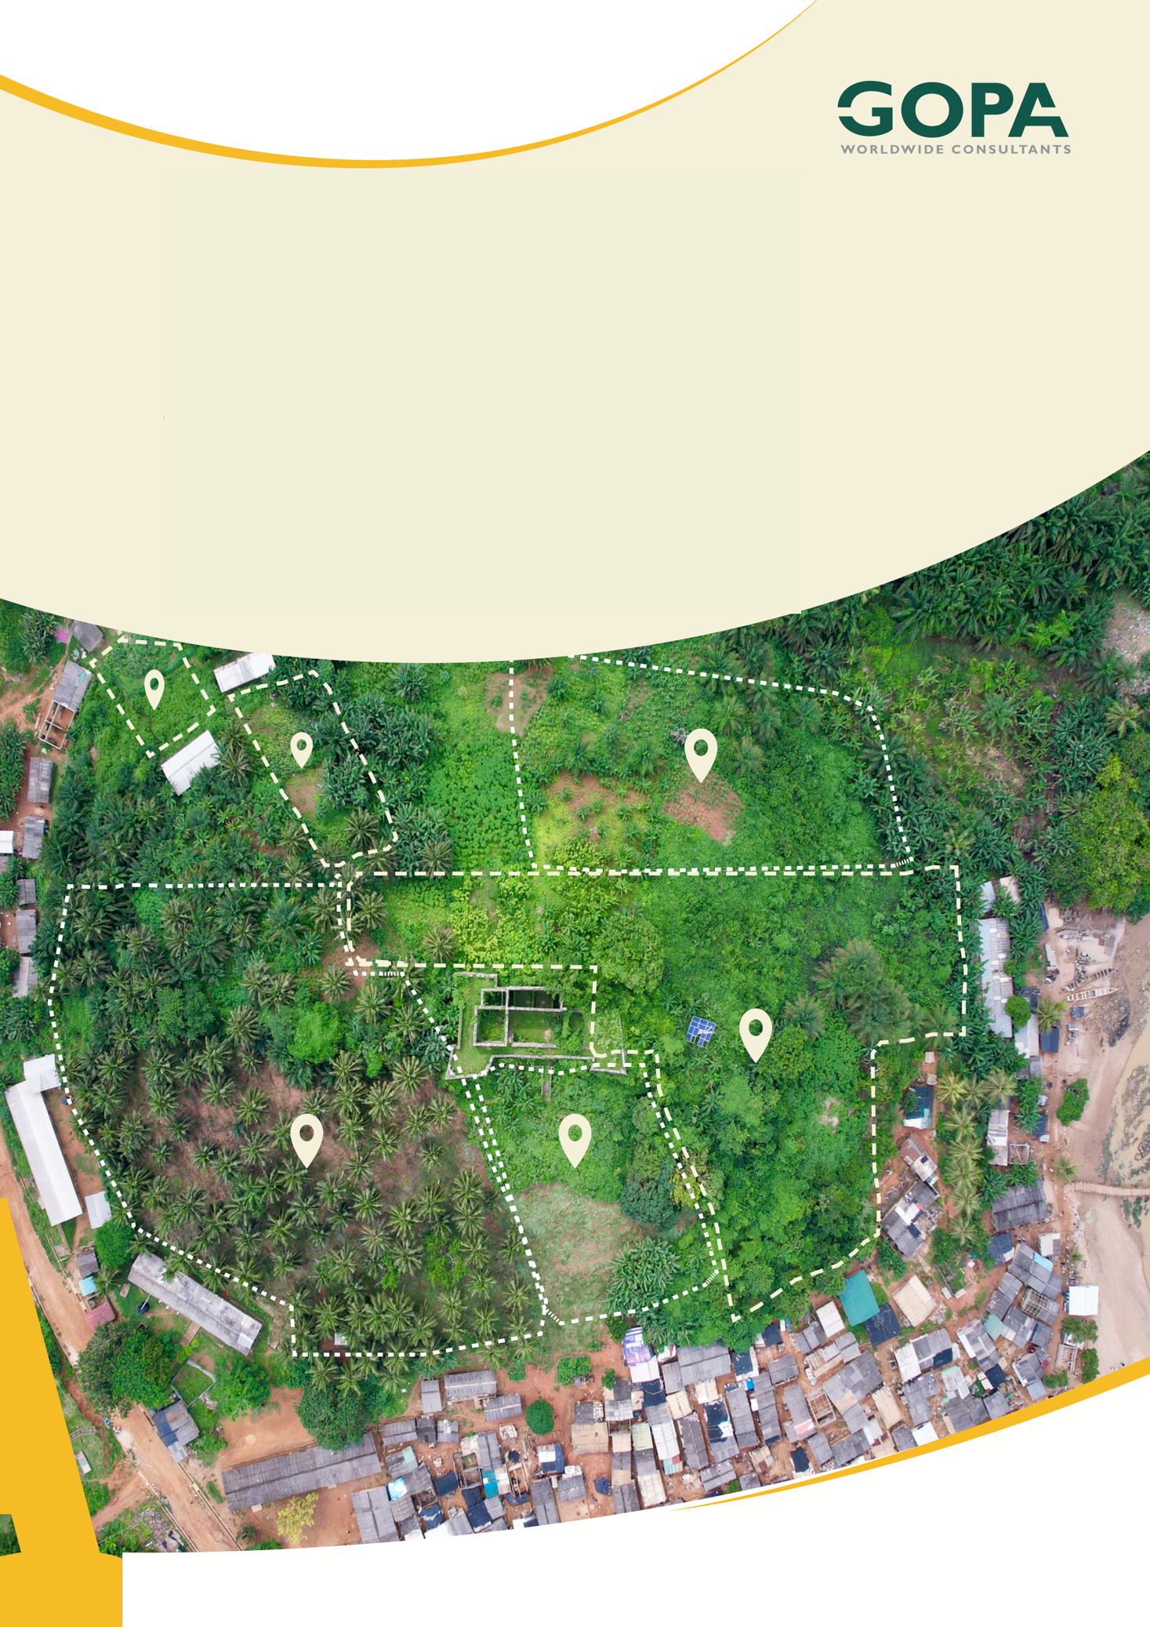
GHANA
Development of a Spatial Planning and Management Information System for Ghana
LUPMIS2 Training — Topic 0
Setting up your workstation · Windows and macOS · October 2026

Topic 0 — Setting up your workstation
The half day before Topic 1 · LUPMIS2 capacity building for LUSPA

1. What this is, and when to do it
Every other topic in this programme assumes a working machine. Topic 1 assumes an editor and a browser whose developer tools you can open; Topic 3 assumes Node.js; Topic 7 assumes PostgreSQL with PostGIS and a database restored into it. None of them say how to get there, and a room of eight people discovering that on the morning of Topic 3 loses a day.
So: do this at least a week before Topic 1 starts, finish with the readiness check in part F, and send the result to your trainer. A week is not caution — two of the items here are accounts that somebody else has to create, and one of them may need your IT department.
Part | What it covers | Time
A What goes on the machine | The list, and which topic needs each item | 15 min
B Windows, step by step | The eight installs, with the choices that matter | 2 hours
C macOS, in short | The same thing in a dozen commands | 45 min
D The LUPMIS2 project | Clone it, install it, see a map | 30 min
E The training database | Restore it, and prove PostGIS is really there | 30 min
F The readiness check | Nine commands. All nine must answer. | 15 min
G When it goes wrong | The five failures that actually happen | as needed

Half a day on Windows, rather less on macOS, and most of it is waiting for installers.
This is not a teaching day. There is nothing here to learn and nothing to be assessed on. It is a checklist, and the only part that matters is that the check in part F passes before Topic 1 begins. If your machine is already set up, skip to part F and prove it.

2. Before you install anything
1. Confirm you can install software on your machine. Everything below needs it, and two items — PostgreSQL and Docker Desktop — need a restart as well. If you cannot, stop here and give your IT department part A; it is written so it can be handed over as it stands.
2. Ask IT one question in writing: does the network inspect HTTPS traffic? If it does, npm install and Docker will fail with certificate errors that look like broken downloads, and the fix needs a file only IT can give you. Part G, item 2.
3. Request the two accounts now, because they are not instant: a Gitea account on the LUPMIS2 server, from your trainer, and a Digital Earth Africa Sandbox account, which you sign up for yourself at sandbox.digitalearth.africa. You will not need the second until Topic 11, and you will be glad it already exists.
4. Set aside about 20 GB of free disk. PostgreSQL with a district of parcels, Docker images and the Node packages add up faster than anyone expects.

3. The setup

Part A — What goes on the machine, and why
Install all of it in one pass, even the parts you will not touch for months. Getting a workstation opened up once is far easier than arranging it four times, and nothing here is large enough to be worth deferring.
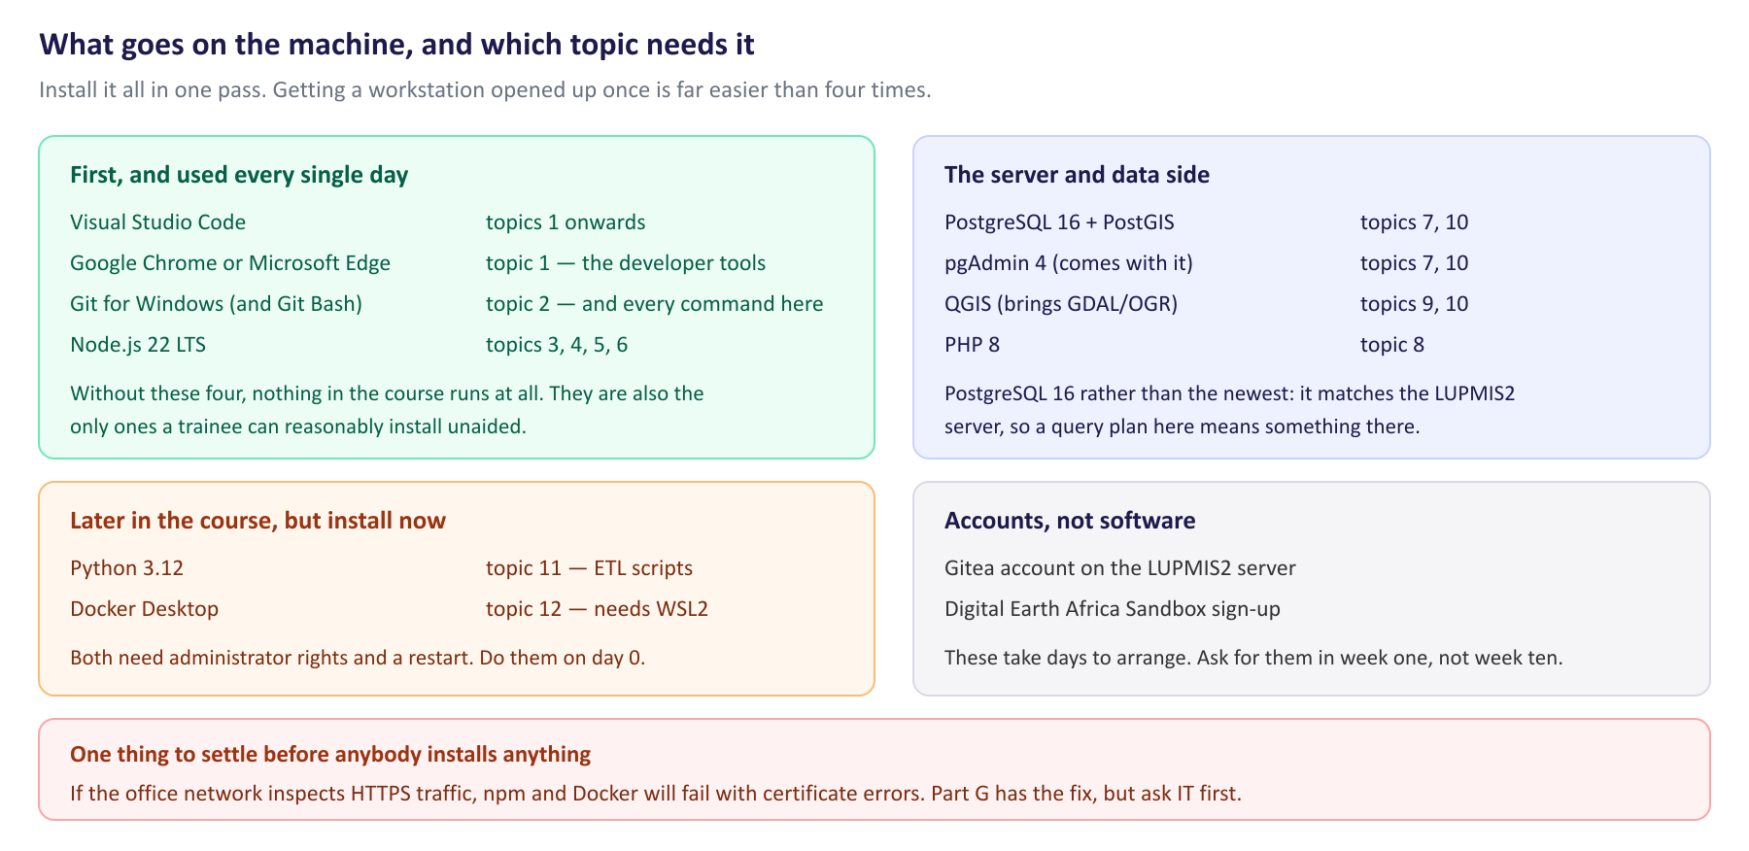
The full list. Hand this page to IT if somebody else installs for you.
Two choices in that list are deliberate and worth knowing about. PostgreSQL 16, not the newest release, because it is what the LUPMIS2 server runs — a query plan you measure at home then means something in production. And QGIS, which most people think of as a desktop GIS, is here mainly because on Windows it is also the least painful way to get GDAL and ogr2ogr, which Topic 9 is built on.

Part B — Windows, step by step
Versions move. Take the current stable release of each unless a version is named here, and install in this order — Git before Node, and PostgreSQL before its spatial extension.
1 · Windows Terminal
Windows 11 has it already. On Windows 10, install it from the Microsoft Store. You do not strictly need it, but every terminal screenshot in this programme looks like it.
2 · Visual Studio Code
1. Download from code.visualstudio.com and run the installer.
2. Tick Add to PATH — part F checks for it — and both “Open with Code” context-menu entries. They save more time than they look like they will.
3. Nothing else is required. The project has no linter or formatter configuration, so an extension that imposes one will fight the existing code. If you want three that help without arguing: GitLens, Docker, and PostgreSQL by Chris Kolkman.
3 · Git for Windows
1. Download from git-scm.com and run the installer. Three of its many screens matter:
· Default editor — choose Visual Studio Code. The default is Vim, and discovering that during your first merge conflict is a bad introduction to both.
· PATH environment — “Git from the command line and also from 3rd-party software”, which is the middle option and the default.
· Line endings — “Checkout Windows-style, commit Unix-style line endings”. This is the default, and changing it causes part G item 5.
2. It also installs Git Bash. Use it as your terminal for the whole course: every command in every topic document is written for a Unix-style shell, and in Git Bash they work as printed rather than needing translation into PowerShell.
3. Tell Git who you are, once:
git config --global user.name "Your Name"
git config --global user.email "you@luspa.gov.gh"
git config --global core.autocrlf true

4 · Node.js 22 LTS
1. Download the LTS installer from nodejs.org — the left-hand button, an even-numbered version. The “Current” release is for people who want new features more than they want things to work.
2. When the installer offers to “automatically install the necessary tools” — Chocolatey, Python, Visual Studio build tools — leave it unticked. LUPMIS2 has no packages that need compiling, and that option adds several gigabytes and a long wait for nothing.
5 · PostgreSQL 16, and then PostGIS
1. Get the PostgreSQL 16 Windows installer from postgresql.org/download/windows (it is produced by EDB). Run it.
2. Set a password for the postgres user and write it down somewhere you will still have in three months. There is no recovering it, only reinstalling.
3. Leave the port at 5432 and the locale at the default.
4. At the end the installer offers to launch Stack Builder. Say yes. This is the step people miss, and missing it makes the whole of Topic 7 impossible.
5. In Stack Builder choose your PostgreSQL 16 installation, open Spatial Extensions, tick PostGIS, and let it install. If you closed the installer already, Stack Builder is in the Start menu under PostgreSQL 16.
6. pgAdmin 4 came with PostgreSQL. You do not have to use it — most of Topic 7 is psql at the command line — but it is the easiest way to look at a table while you are learning.
psql is not on the PATH by default. The installer puts it in C:\Program Files\PostgreSQL\16\bin, which Windows does not add for you. Add that folder to your PATH — System Properties ▸ Environment Variables ▸ Path ▸ New — or part F's psql --version will fail even though PostgreSQL is installed and running perfectly.

6 · QGIS, and GDAL with it
1. Install the long-term release of QGIS from qgis.org. The standalone installer is simpler; the OSGeo4W network installer gives you more control if you want it.
2. QGIS brings GDAL, which is what Topic 9 needs. On Windows those tools are on the PATH only inside the OSGeo4W Shell that QGIS installs — a separate terminal from Git Bash. That is normal, and Topic 9 says which shell to use where.
7 · Python 3.12
1. Download from python.org/downloads.
2. Tick “Add python.exe to PATH” on the very first screen of the installer. It is unticked by default, it is easy to miss, and almost every “Python is not recognized” message in the world comes from this one checkbox.
8 · Docker Desktop
1. Install from docker.com/products/docker-desktop. It needs WSL2; the installer will enable it and ask for a restart.
2. If it complains that virtualization is disabled, that is a BIOS setting — “Intel VT-x”, “AMD-V” or “SVM Mode” — and IT may have to change it. Find this out now, in October, not on the first morning of Topic 12.
3. Start Docker Desktop once after installing, accept the terms, and leave it running long enough for docker --version to answer.
9 · PHP 8, for Topic 8
Topic 8 needs the PHP command-line binary and nothing more — its exercises use PHP's own built-in web server rather than Apache. Download the non-thread-safe x64 zip from windows.php.net/download, unzip it to C:\php, add that folder to your PATH, and copy php.ini-development to php.ini beside it.

Part C — macOS, in short
The same set, assuming Homebrew. If you do not have it, the one-line installer is at brew.sh, and it will ask for the Xcode command-line tools first.
xcode-select --install # if you have never built anything on this Mac

# the command-line side
brew install git node@22 postgresql@16 postgis python@3.12 php gdal
brew services start postgresql@16

# the applications
brew install --cask visual-studio-code google-chrome qgis docker-desktop

# put the versioned formulae on the PATH (zsh; use ~/.bash_profile for bash)
echo 'export PATH="/opt/homebrew/opt/postgresql@16/bin:$PATH"' >> ~/.zshrc
echo 'export PATH="/opt/homebrew/opt/node@22/bin:$PATH"' >> ~/.zshrc
exec zsh

Two differences from Windows worth knowing. brew install postgis installs the extension but does not enable it in any database — you still run CREATE EXTENSION postgis per database, exactly as part E does. And GDAL from Homebrew is on your normal PATH, so there is no separate shell to remember.
On an Intel Mac, Homebrew lives in /usr/local rather than /opt/homebrew; adjust the two PATH lines accordingly, or run brew --prefix and use what it prints.

Part D — The LUPMIS2 project
1. Clone the repository. Your trainer will give you the URL; it is on the LUPMIS2 Gitea server, which is why you needed the account:
git clone <the URL your trainer gives you> lupmis-pwa
cd lupmis-pwa

2. Install the packages. This downloads a few hundred megabytes into a node_modules folder and takes a few minutes the first time:
npm install

3. Create your local settings file. .env.example is in the repository and shows what is needed; .env.local is yours and is deliberately never committed:
cp .env.example .env.local
# then open .env.local and paste the Carto key after VITE_CARTO_API_KEY=
# a free one: https://carto.com/basemaps/apikey — or ask your trainer

4. Start the development server and open what it prints:
npm run dev

# VITE v6.4.1 ready in 149 ms
# -> Local: http://localhost:5173/

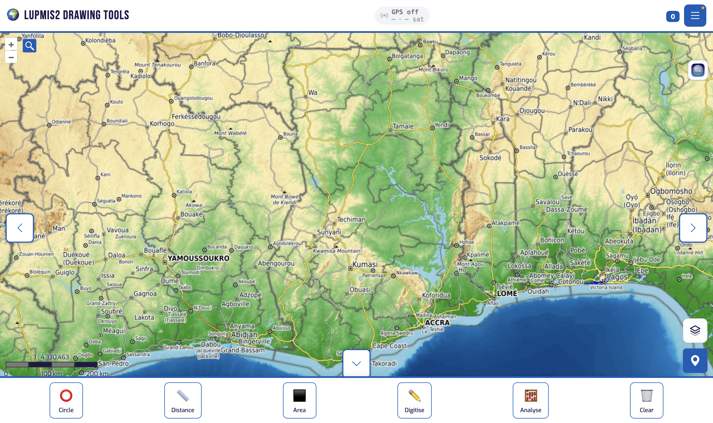
What success looks like: a map of Ghana, the tool buttons along the bottom, and no red in the browser console.
5. Press F12 to open the developer tools and look at the Console. Warnings are expected — the LUPMIS2 API is not reachable from your machine, and the application says so. Red errors are not. If you see any, note them for your trainer rather than trying to fix them.
6. Stop the server with Ctrl+C when you are done. Leaving it running is harmless but it holds port 5173.

Part E — The training database
Topic 7 works on a copy of the real LUPMIS2 database, and Topic 10 comes back to it. Your trainer will give you a dump file. Restoring it now means that when Topic 7 starts, it starts.
1. Check that PostgreSQL answers at all, and — separately — that PostGIS is available to it. These are two different questions and the second one is where people find out they stopped one step too early:
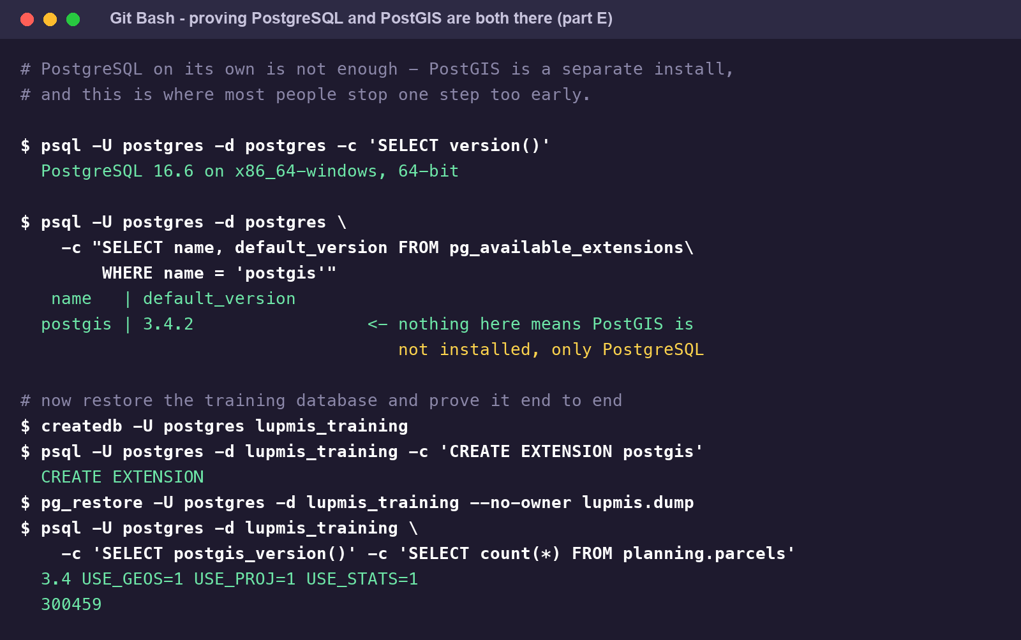
PostgreSQL and PostGIS are two installs. An empty answer to the second query means only the first one happened.
2. Create the database, enable the extension, and restore the dump your trainer gave you. The CREATE EXTENSION has to come before the restore:
createdb -U postgres lupmis_training
psql -U postgres -d lupmis_training -c 'CREATE EXTENSION postgis'
pg_restore -U postgres -d lupmis_training --no-owner lupmis_training.dump

3. Prove it worked by counting something. The exact number depends on which districts your dump contains — the one used throughout Topic 7 holds 300 459 parcels and 82 collector zones:
psql -U postgres -d lupmis_training \
-c 'SELECT count(*) FROM planning.parcels' \
-c 'SELECT count(*) FROM planning.zones'

Treat this database as disposable. Topic 7 asks you to create indexes on it, change its schema and restore over it. That is the point of having a copy. Never run those exercises against a database anybody else is using, and never against the LUPMIS2 server.

Part F — The readiness check
This is the part that matters. Open Git Bash on Windows, or Terminal on a Mac, and run all nine. Every one must answer with a version; none may say command not found.
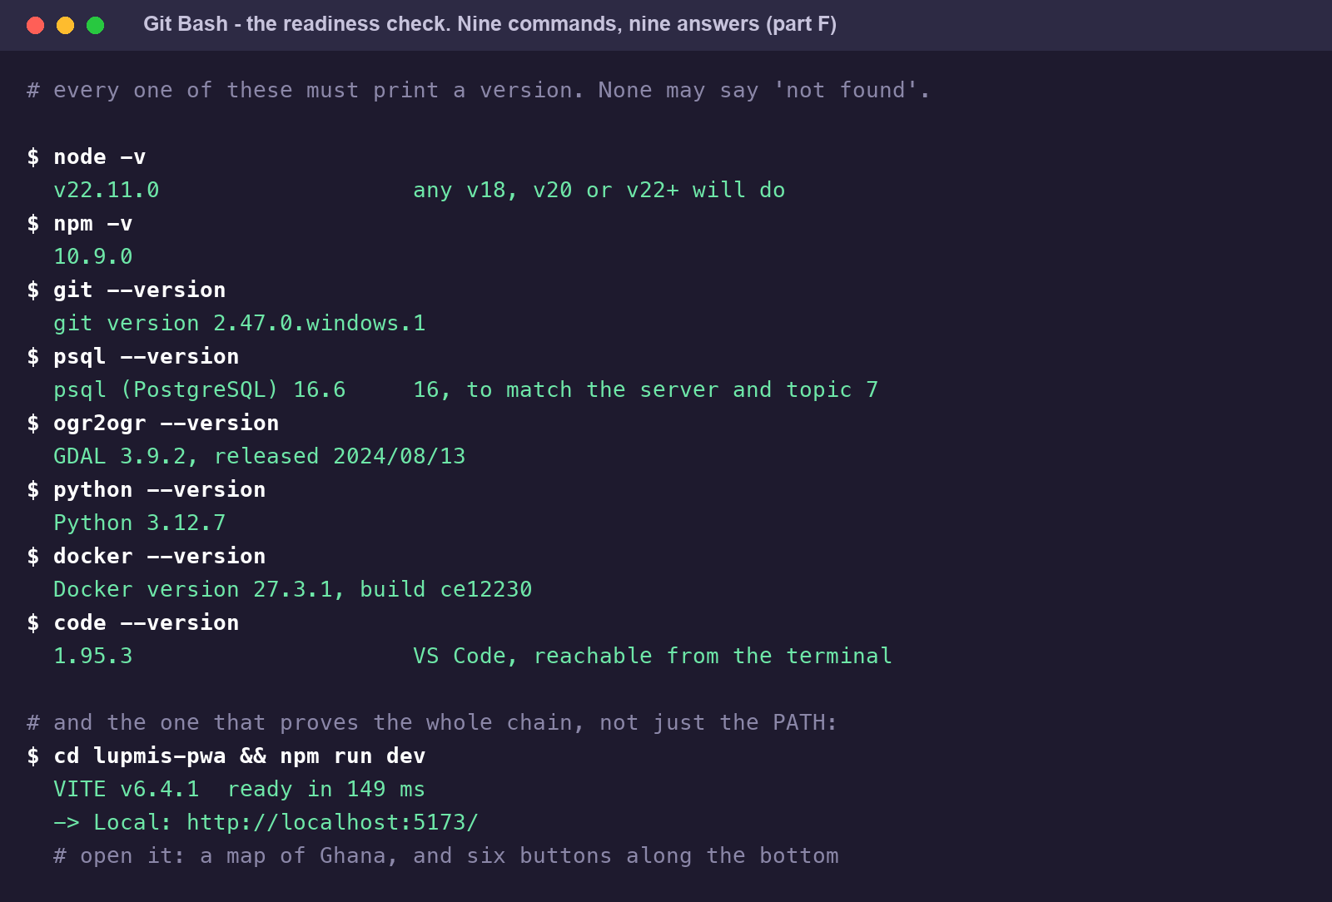
Nine commands. If all nine answer, you are ready for Topic 1 — and for Topic 12.
A command that fails here is almost always a PATH problem rather than a failed install — the software is on the machine, the terminal just cannot see it. Part G, item 1, and the note about psql in part B.
What to send your trainer
1. Copy the whole terminal output of those nine commands into an email or a message. Not a screenshot of part of it — the text, all of it.
2. Add one line saying whether npm run dev showed you a map, and one line with anything red that appeared in the browser console.
3. Say which items you could not install and why. “Docker needs a BIOS change and IT has the ticket” is a useful answer; silence is not.

Part G — When it goes wrong
Almost every setup failure on this list is one of five things. Work through them before asking, and when you do ask, say which of the five you have already ruled out.
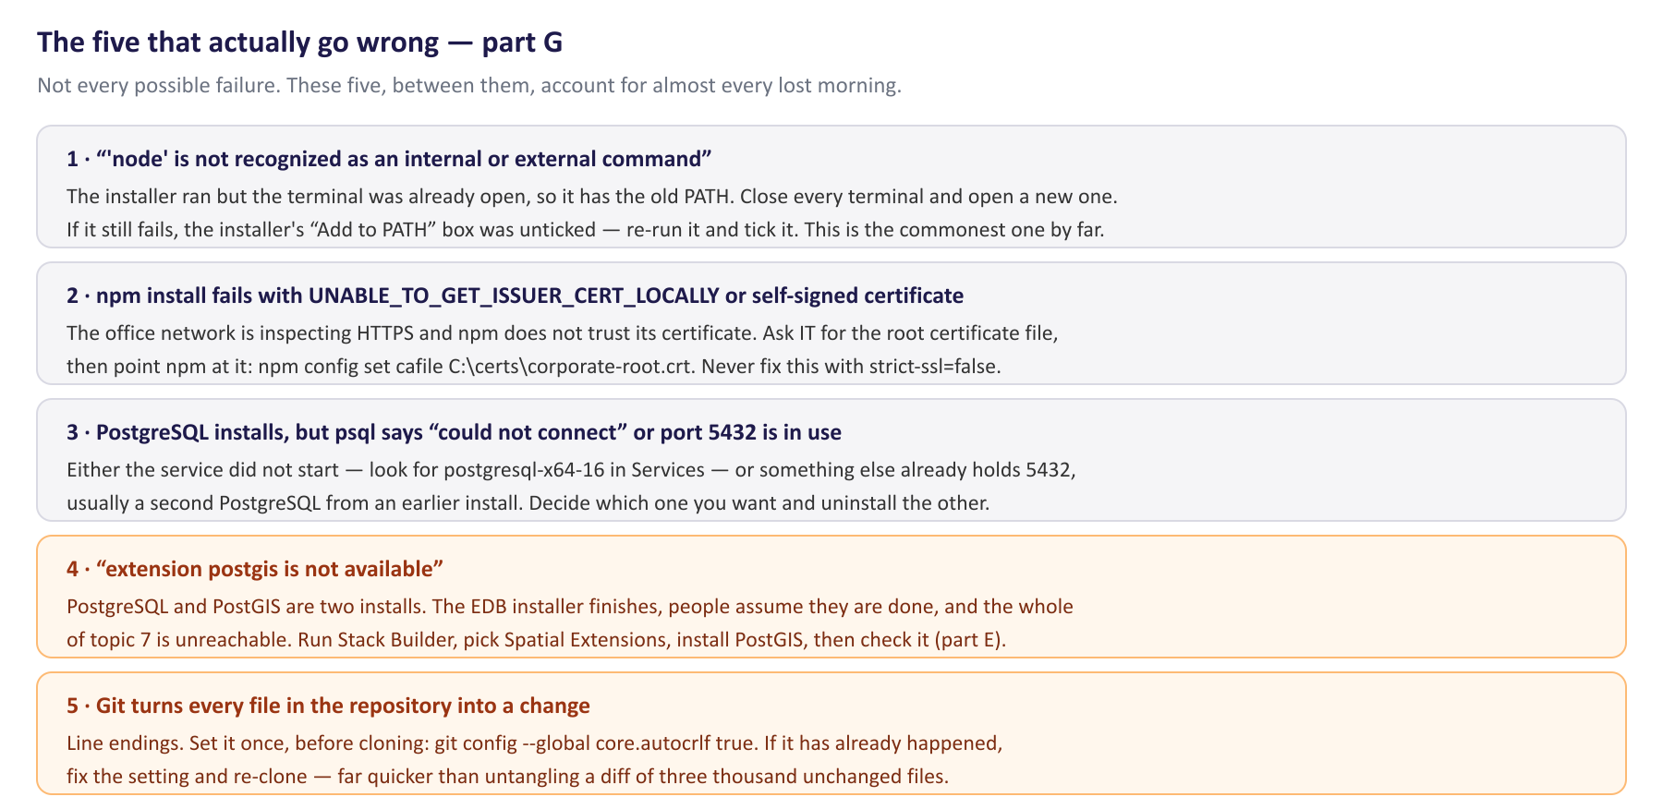
The five failures that account for nearly every lost morning.
If none of those is it
1. Read the error message to the end. The useful sentence is usually the last one, and people stop at the first.
2. Write down the exact command you ran and the exact message, and search for the message rather than for a description of it.
3. Then ask — in the group, not privately. On a course of eight people, the same failure will hit somebody else within the week, and an answer in the group is an answer twice.

4. After the setup
Keep this document. The readiness check in part F is worth re-running after any Windows update, after anything that “cleans up” your machine, and at the start of each new block of the programme — it takes a minute and it has caught a broken PATH more than once.
It is also the first page of the maintenance handbook the Training Plan asks each participant to build. By the end of the programme that handbook should say not only how to set a machine up, but what you had to change for yours — the proxy certificate, the BIOS setting, the second PostgreSQL somebody had installed years ago. That is the part nobody else can write for you, and it is the part the next technician will need.

